**Test 2 2023/05/24**

Input the dataset and perform the process of Feature Scaling (Ref. the following program codes of standard scaling.) Dividing the dataset into the training and testing sets, and the ratio is 4:1. Declare parameters for a SVC classifier as listed in the following picture, and choose the best parameters having the highest accuracy score in the training phase. Finally, output the values of accuracy and precision for the test data.

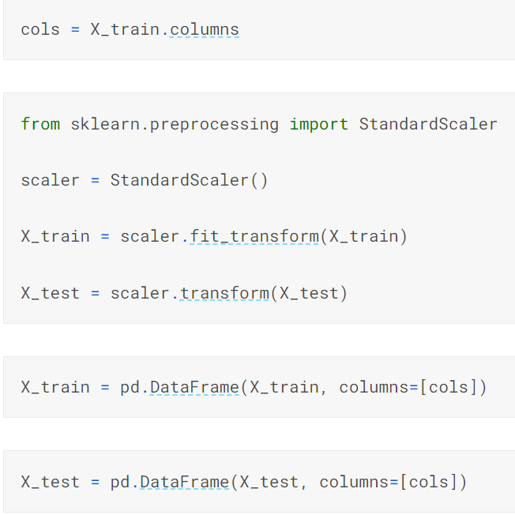

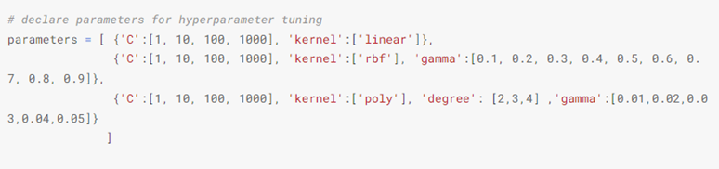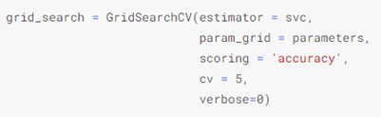

**The requirements of the report.**

List the program code including the detail description of the code, and the output results including the detected best parameters having the highest accuracy score in the training phase, and the values of accuracy and precision for the test data using the best parameters.The report should be submitted in WORD format before the due date.