Case Overview

Context
  - Academic course provided scenario
In many university-focused English language centers, the management of teaching schedules, student attendance, learning materials, and academic evaluation remains fragmented across multiple platforms, causing communication delays and operational inefficiencies. To address this issue, the proposed solution is the development of "EduConnect LMS – Integrated Academic Management System for English Centers" which connects students, teachers, academic staff, counselors, and administrators onto a unified platform to streamline course delivery and improve academic outcomes.
When students log into the system, they can view their registered courses, track their learning progress, and access official course materials. They can perform online tests, view immediate test results, check their attendance records, and rewatch recorded video lectures for review. Students can also complete homework assignments, submit leave requests, apply for class transfers, issue other administrative requests, and view or edit their personal profile.
Once class sessions begin, teachers access the platform to view their class schedules, class details, and student lists. Teachers can conduct digital attendance, review and approve leave requests, and enter grades for assignments and exams. They are also empowered to open active test modules for students, access supplementary teaching materials, and manage their instructor profile.
To maintain course quality, academic staff manage the core educational assets within the system. They create, upload, and update learning documents and study guides, as well as author, structure, and publish formal assessment tests across various English proficiency levels.
For personalized student care, academic counselors access student information and retrieve contact details to engage in direct, standard communication. Counselors track student performance, offer timely intervention, and provide tailored academic guidance throughout the learning process.
Finally, the administrator is responsible for overseeing overall website and platform configurations. This includes managing user accounts across all roles, regulating access rights, moderating platform content, and tracking system-wide metrics such as student retention rates, assessment trends, system usage statistics, and overall operational efficiency.

  - Relevant requirements extracted from the given scenarios

Case focus: This case focuses specifically on the relationship between student leave management and attendance, rather than the entire LMS.

Actor | Functional requirement
Student | Students can submit leave requests through the system.
Teacher | Teachers can review and approve student leave requests.

Activity diagram for initial workflow:
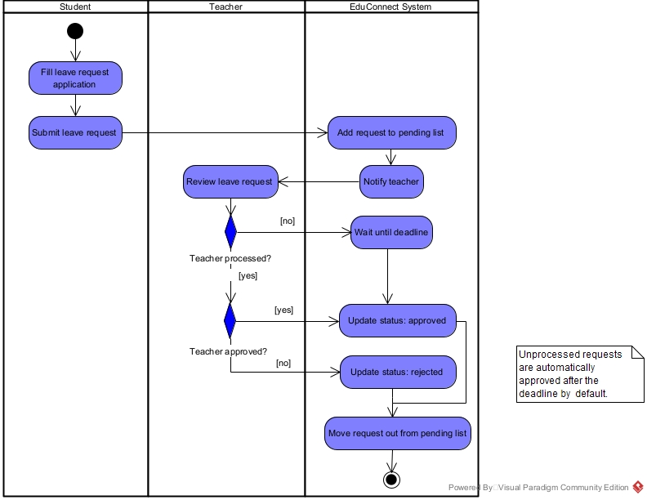
Initial assumption:
The requirement implies that student absence should be managed through a dedicated request-and-approval workflow before being reflected in attendance.

Contextual Observation

Requirement Gap

Problem Definition

Proposed Direction

Discusstion & Validation

To-Be Process

Design

Expected Impact

Reflection

Limitation

