BCSE307P Compiler Design Lab
Innovative Project

Rust Loop Vectorizer for LLVM 21

by
Reg No  24BCE0250  24BCE0016  24BAI0340 | Team Member Names  Sree Raj Muthaiya.A.L  Karnati Abhinav Reddy  Nidhurshek Prabakaran

Under the Supervision of
Prof. NIVITHA K
Assistant Professor Sr. Grade-2
School of Computer Science and Engineering


October 2026

- Abstract:
This report presents a Rust implementation of a bounded automatic loop vectorizer for LLVM 21. It explains the supported loops, legality and cost decisions, LLVM IR generation, validation, and recorded benchmark result. The pass emits fixed-width SIMD operations only when its checks establish safety; otherwise it keeps the scalar loop. In one recorded Apple M5 benchmark, the custom variant achieved a 3.009× geometric-mean speedup over scalar execution across seven kernels, with the result limited to that host and corpus.
- Introduction:
This project implements an automatic loop vectorization pass for LLVM 21 in Rust. It identifies a deliberately bounded class of loops, proves that their memory operations can be reordered safely, chooses a fixed vector width, and emits vector LLVM IR while retaining the scalar loop for short inputs and any remainder. The command-line driver accepts LLVM IR, bitcode, supported source files, or a project directory.
Loop vectorization combines several scalar iterations into one SIMD operation. A correct implementation must preserve data dependences before it asks whether vector execution is profitable. The project therefore separates discovery and legality checks from width selection and IR rewriting. Unsupported or uncertain loops remain scalar and receive a reason in report mode.
- Novelty in Project:
The main contribution is a correctness-first LLVM pass whose discovery, dependence classification, cost planning, and IR construction live in Rust. A small C++ adapter registers the pass with LLVM’s New Pass Manager and exposes only the LLVM operations required by the Rust implementation. The pass does not rely on an unchecked source-level pattern match: it validates the loop structure, data flow, memory layout, and alias relationships before modifying IR.
The tool also makes decisions observable. It reports the chosen vector factor, estimated vector coverage, issued-lane utilization, rejection reason, and per-loop analysis and transformation time. Its conservative, balanced, and aggressive policies expose the trade-off between accepting a legal loop and predicting a useful speedup. A terminal interface and project-directory mode make these decisions easier to inspect across files.
- Proposed Work:
The implemented workflow follows five stages. First, the driver obtains LLVM 21 IR from a direct input or a supported frontend. Second, the pass finds canonical one-block loops with a zero-based, unit-step i64 induction variable. Third, it checks supported operations, affine memory accesses, target data layout, aliasing, and loop-carried dependences. Fourth, a transparent cost model selects a fixed vector factor when the estimated trip count and gain meet the selected policy. Fifth, the transformer creates a vector loop and connects the original scalar loop as fallback and tail; LLVM verification checks the resulting module.
The accepted subset includes contiguous loads and stores and lane-wise arithmetic, casts, comparisons, and select operations. Calls, reductions, multi-block loops, unresolved pointer aliases, and nonzero loop-carried memory distances are rejected by the Rust pass. These boundaries keep its safety claim precise. Future work can add stronger translation validation, LLVM analysis integration, runtime alias checks, reductions, and broader target evaluation.
- Implementation & Screenshots:
The code is organized around src/vectorizer.rs for loop analysis and rewriting, src/dependence.rs for affine dependence classification, src/cost.rs for vector-factor planning, and native/pass_plugin.cpp for LLVM registration. The rv-vectorize driver runs the pass, LLVM verifier, and optional reporting; rv-vectorize-tui provides an interactive terminal view. The output IR contains real vector loads, arithmetic, and stores, with a scalar remainder path.
Figure 1 records a local run of the checked-in release binary on the repository’s positive LLVM fixture. The report marks add_f32 vectorized at VF 4, and the output IR contains <4 x float> load, fadd, and store instructions. The displayed coverage and lane-use values are compiler estimates for that loop; they are not measured hardware occupancy.
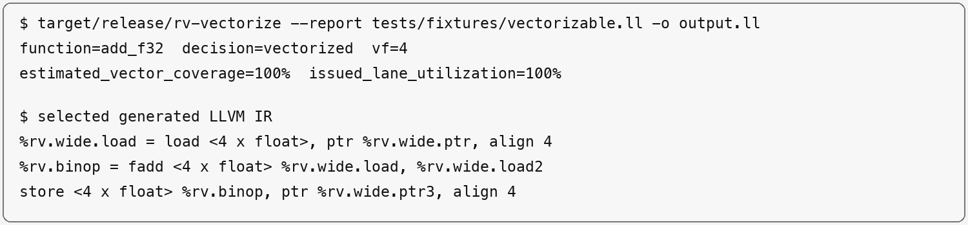
Figure 1. CLI decision and generated vector IR from a local fixture run
- Conclusion:
Validation includes Rust tests, accepted and rejected LLVM fixtures, IR verification, native differential execution, and guard-page tail checks. A recorded 8 September 2026 run on one Apple M5 with LLVM 21.1.3 passed correctness checks for all seven scalar, custom, and LLVM kernels. The geometric-mean speedups over scalar execution were 3.009× for this pass and 2.974× for LLVM LoopVectorize. On 128 cloned loops, this pass’s in-process analysis plus transformation measured 2.355 µs at p50, 8.790 µs at p95, and 31.404 µs at p99. These results apply to the recorded corpus and host.
The pass shows that a bounded legality contract can produce vector code with clear rejection reasons. Its current scope is canonical affine loops; stronger semantic validation should precede wider loop support.
- Project Repository Link:
https://github.com/Passive-Coder/llvm-vectorization

