Enable hosting of webpages via localhost for via python for javascript:

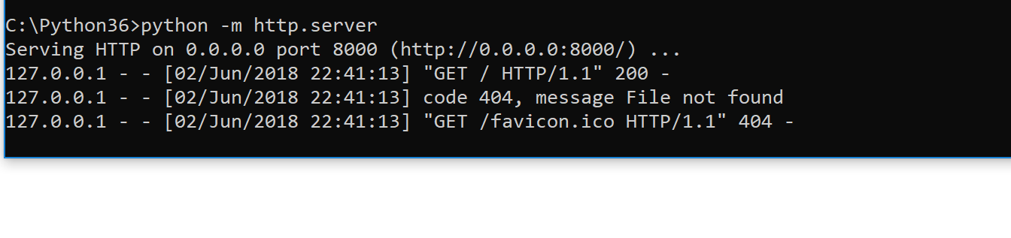

Check browser can access directory

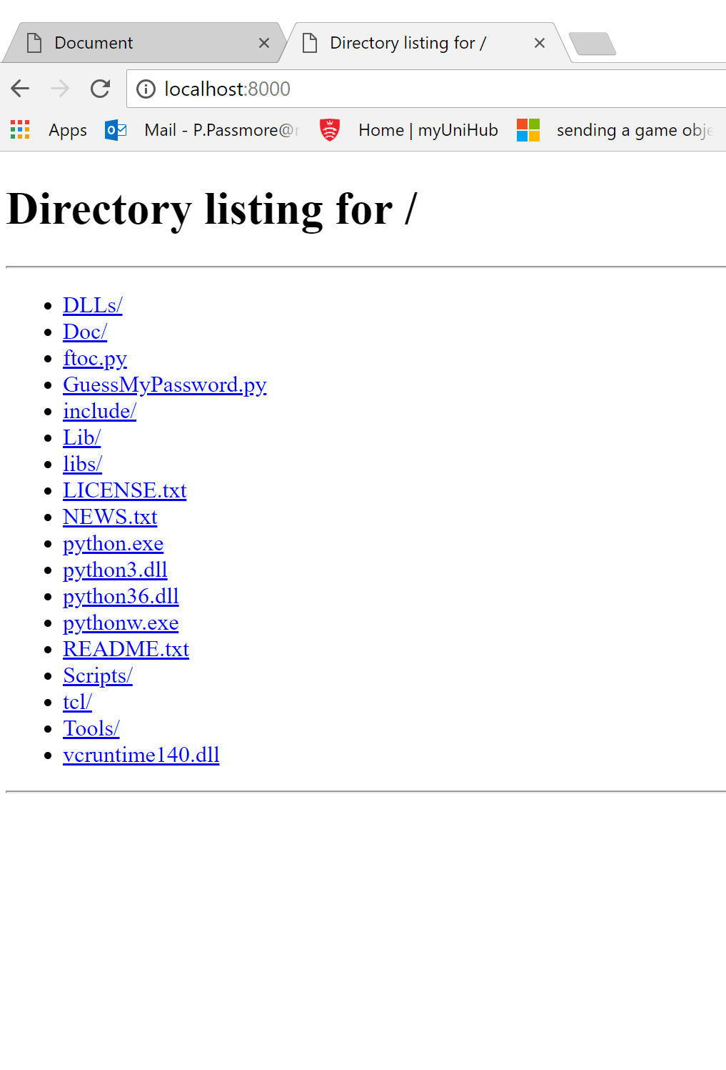

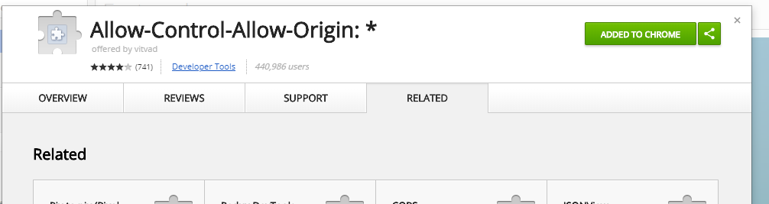

**Summary**

In C:\Python36 run python –m http.server

Put source file in C:/python36 e.g. “loadpp.csv”

Added the Allow-Control-Allow_Origin.* as an extension to chrome

ELHUMDO0LILA

Reference file in javascript by: csvURL: 'http://localhost:8000/loadpp.csv',