SentrySAP
Intelligent SAP Monitoring & Autonomous Action Platform
A Generative AI Decision Support System that learns a custom SAP landscape, detects operational problems with configurable rules, and attaches the company's own documented playbook to every alert before a human approves any action.
Submitted by: | Billa Blessy Priya
College / Institute: | Teegala Krishna Reddy Engineering College (TKREC)
Department: | Computer Science and Engineering
Academic Year: | 2026–2027(Final Year)
Guided by: | Raghavendra Rao
Project Domain: | Generative AI, Retrieval-Augmented Generation & Enterprise Process Automation
GitHub Repository: | https://github.com/Passwordon/SentrySAP.git

INDEX
S.No. | Title | Page No.
1 | Introduction (Overview, GenAI Role, Output Types & Key Features) | 2
2 | Problem Statement (Real-World Problem & GenAI Solution) | 4
3 | Objectives (Technical & Functional Goals) | 5
4 | Project Scope (Target Users, Inputs/Outputs & Boundaries) | 6
5 | Proposed System / Methodology (Workflows, Testing & Evaluation) | 7
6 | System Architecture / Workflow (Layered Architecture & Diagram) | 9
7 | Implementation (Tech Stack, Modules, Configuration & Source Code Reference) | 10
8 | User Interface / Application Screenshots (Screens & Action Workflows) | 13
9 | Challenges and Limitations (Technical & Operational Constraints) | 15
10 | Conclusion (Summary, GenAI Value & Learnings) | 16
11 | Future Scope (Real SAP Integration & Enhancements) | 17
12 | References (Frameworks, Research & Documentation Citations) | 18

1. Introduction

1.1 Project Overview
SentrySAP is a Generative AI-powered platform for organisations that run a customised SAP landscape. Over years of operation, such landscapes accumulate custom (Z/Y) transactions, bespoke ABAP programs, standard operating procedures (SOPs) and wiki pages. This knowledge is rarely searchable in one place, and it is almost never connected to the operational events that make it relevant. SentrySAP addresses both gaps with two cooperating modes that share a single knowledge base.
Mode | Description
Ask | Learns from uploaded SOPs, ABAP source and wiki pages through retrieval-augmented generation (RAG) and answers questions of the form "how do I do X here?". When the documents do not contain the answer, the system states that explicitly instead of guessing.
Watch | Monitors simulated SAP events, evaluates configurable YAML rules, drafts the remedial action and communication, and waits for a human decision before anything is executed.

1.2 Real-World Purpose and Problem Addressed
Operational staff in procurement, supply chain and master-data teams repeatedly face two questions: "what has gone wrong?" and "what is our approved procedure for this?". Answering the first requires monitoring of transactional data; answering the second requires finding the right internal document, which in a customised landscape often refers to non-standard transactions such as ZESCAL01 or ZVENDBLK rather than the standard SAP equivalents. SentrySAP converts this two-step manual effort into a single actionable alert card that states the problem, proposes an action, drafts the communication and displays the relevant company procedure beside it.

1.3 Role of Generative AI
Generative AI is used in three places. First, document embeddings enable semantic retrieval over unstructured SOPs and code. Second, a large language model (LLM) composes grounded answers in Ask mode, constrained by a relevance threshold and a fixed refusal sentence. Third, the same model writes the alert summary, the suggested action and the draft email or note in Watch mode, using structured facts from the rule engine together with the retrieved playbook excerpt. Deterministic logic (rule evaluation, de-duplication, approval gate, execution) deliberately remains outside the model, so that the language model advises but never acts.

1.4 AI-Generated Output Types
- Grounded natural-language answers with ranked source excerpts and match scores.
- Alert cards containing a title, summary, affected purchase order, suggested action and severity.
- Draft communications: an escalation email to a supplier, a draft purchase order, or a note to the master-data team.
- The company playbook excerpt retrieved from the knowledge base, with its source file and match percentage.
- Audit-log records of every approval or rejection, exportable as CSV.

1.5 Key Application Features
- Alerts that carry the company playbook: at alert creation the knowledge base is queried and the matching SOP excerpt is attached to the card (the principal differentiator of the system).
- Honest refusal: questions that the documents cannot answer return "I don't have this in your documents."
- Configurable rules: rules are defined in rules.yaml, evaluated through a restricted expression parser and reloaded on every cycle without restarting the application.
- Human approval gate: Approve & Execute and Reject controls; execution runs only after approval.
- Complete audit trail: each decision is recorded with actor, time, alert and detail, and can be downloaded as CSV.
- Free-to-run configuration: a free-tier chat model, local embeddings and no paid services are required.
- Simulation tools: a simulated SAP database, an event injector and a manual watch-cycle trigger enable repeatable demonstration and testing.

2. Problem Statement

2.1 The Real-World Problem
Enterprise resource planning landscapes generate a continuous stream of operational signals: stock levels that fall below reorder points, purchase orders that slip beyond their delivery dates, and master-data records that are duplicated. Each signal demands a response that follows company-specific policy, for example the requirement that escalation of a late order through a custom transaction needs prior approval from the Procurement Manager. In practice, the signal is noticed late, the correct procedure is located slowly, and the response is composed manually and inconsistently.

2.2 Inefficiencies of Existing Approaches
- Fragmented knowledge: SOPs, ABAP comments and wiki pages are stored in separate systems and cannot be queried by meaning.
- Generic assistants lack landscape context: a general-purpose chatbot knows standard SAP (for example transaction XK05 for vendor blocking) but not the organisation's custom transaction (ZVENDBLK) or its approval rules.
- Alerts without guidance: conventional monitoring notifies that a threshold was crossed but does not state the approved response.
- Uncontrolled automation: fully autonomous actions on transactional systems are unacceptable without oversight and traceability.

2.3 Justification for a Generative AI Approach
Keyword search over documents fails when the wording of a question differs from the wording of the procedure. Semantic embeddings solve retrieval, and an LLM converts retrieved passages into direct, readable answers and drafts. At the same time, a pure LLM solution would be unreliable for decisions on transactional data. SentrySAP therefore adopts a hybrid design: deterministic rules decide that a situation exists, retrieval finds the governing procedure, the LLM composes the message, and a human authorises execution.

2.4 Process Automation and Expected Outcome
The system automates detection, procedure lookup and drafting, which are the time-consuming parts of incident handling, while retaining human control of execution. The expected outcomes are shorter time from detection to decision, consistent application of documented procedures, reduced dependence on individual experts for institutional knowledge, and a complete audit trail of automated recommendations and the decisions taken on them.

3. Objectives
The primary technical and functional objectives of the project are as follows.
- Functional application: build a working GenAI platform with an Ask mode and a Watch mode that run from a single command.
- Retrieval-augmented question answering: ingest PDF, TXT, MD and ABAP files, chunk and embed them, store them in a vector database, and answer questions only from retrieved context with a relevance threshold.
- Rule-based monitoring: implement a rule engine with a safe expression evaluator so that detection logic can be changed in a YAML file without code changes or restarts.
- Playbook-linked alerts: query the knowledge base at alert creation and attach the matching company procedure to the alert card.
- Human-in-the-loop control: require explicit approval before any action is executed and record every decision in an audit log.
- Provider independence and zero cost: use an OpenAI-compatible client abstraction and local embeddings so that free-tier or offline models can be used.
- Resilience: degrade gracefully through fallback alert cards, friendly error messages and retry or pause behaviour when the LLM or retrieval fails.
- Quality and safety evaluation: verify that the system raises alerts for true situations, ignores decoys, refuses unanswerable questions and never executes unapproved actions.

4. Project Scope

4.1 Target Users
- SAP functional and Basis consultants who maintain custom transactions and documentation.
- Procurement managers and buyers who handle supplier delays and replenishment.
- Master-data teams responsible for vendor and material records.
- Support analysts and new joiners who need quick, accurate answers about local procedures.

4.2 Included Features
- Document upload, automatic document-type detection (SOP, ABAP, wiki, other), listing and deletion.
- Grounded question answering with source citations and match scores.
- Simulated SAP database containing materials, suppliers and purchase orders, with an event log.
- Three shipped rules covering delayed supply, missing replenishment and duplicate supplier records.
- Alert cards with playbook, draft message, approval and rejection, and an exportable audit log.
- Background scheduler, manual watch cycle and random event injector.
- Optional HTTP API exposing the same services.

4.3 Input and Output Specifications
Category | Specification
Inputs | PDF, TXT, MD and .abap files; natural-language questions; SAP master and transactional data (simulated); rules.yaml; configuration variables; the approver's name and optional rejection reason.
Outputs | Grounded answers with sources; alert cards with severity, affected object, suggested action, playbook excerpt and draft message; executed FakeSAP actions after approval; audit log rows and CSV export.

4.4 Boundaries and Limitations
- The SAP system is simulated with SQLite; no real RFC, BAPI or OData connection is made in the current build.
- Three rules are shipped; additional rules require authoring in the YAML syntax supported by the evaluator.
- The user interface is a single-instance Streamlit application without user authentication; the approver name is a free-text field.
- Answer quality depends on the completeness of the uploaded documents and on the chosen chat model and embedding model.

5. Proposed System / Methodology
The system implements two workflows over a shared knowledge base. Technical complexity is hidden behind a four-tab interface so that users interact only with questions, alert cards and approval buttons.

5.1 Ask Workflow (Retrieval-Augmented Generation)
- Document ingestion: the user uploads a file or runs the seed script. The file is parsed according to its type.
- Chunking: text is split into overlapping chunks of 800 characters with an overlap of 150 characters to preserve context at boundaries.
- Embedding and storage: each chunk is embedded with a local sentence-embedding model and stored in ChromaDB with its source name and document type.
- Retrieval: the question is embedded and the most similar chunks are retrieved using cosine similarity (score = 1 - distance).
- Relevance gate: if no chunk reaches the relevance threshold (default 0.25), the system returns the fixed refusal sentence without calling the model.
- Grounded generation: otherwise the model is instructed to answer only from the supplied context, and the answer is displayed with expandable sources.

5.2 Watch Workflow (Detect, Enrich, Approve, Execute)
- Event and data source: FakeSAP holds materials, suppliers and purchase orders, and records events such as stock drops, PO delays and duplicate suppliers.
- Scheduled evaluation: every cycle (default every 60 seconds) the rule engine reloads rules.yaml and evaluates each enabled rule over the relevant scope (material and purchase-order pairs, materials, or suppliers).
- Finding creation: each match becomes a finding with a unique de-duplication key, so one alert exists per situation.
- Playbook lookup: the alert builder queries the knowledge base with the rule's playbook query (relevance threshold 0.22) and obtains the matching SOP excerpt, source name and score.
- Card generation: the LLM receives the structured facts and the playbook excerpt and writes the summary, suggested action and draft message. A deterministic fallback card is used if the LLM fails.
- Human decision: the alert appears in the Action Queue. Approve & Execute runs the mapped FakeSAP executor; Reject records the reason.
- Audit: each decision writes an audit row with actor, action, alert, severity and detail.

5.3 Testing and Evaluation
Test Area | Input / Condition | Expected Result
Delayed supply rule | Steel Rod 10mm below reorder point; open PO six days late | High-severity alert raised with the supplier-delay SOP attached
Decoy: minor delay | Aluminium Sheet 2mm low in stock; PO only one day late | No alert is raised (delay does not exceed three days)
Decoy: healthy stock | Late POs on materials with sufficient stock | No alert is raised
Missing replenishment | Copper Wire 2.5mm below reorder point with no open PO | Medium-severity alert with replenishment SOP and draft purchase order
Duplicate supplier | Second supplier record with the same name in different case | Medium-severity alert for the newest duplicate only
Playbook linkage | Alert creation with documents ingested | Playbook source, score and excerpt displayed on the card
Missing documentation | Rule fires but no matching SOP exists | Card shows that no documented procedure was found
Grounded answer | Question: how to block a vendor | Answer cites the custom transaction ZVENDBLK with sources
Refusal behaviour | Question outside the documents | Response: "I don't have this in your documents."
Approval gate | Approve an alert | PO escalated, related events resolved, audit row written
De-duplication | Run consecutive watch cycles | No duplicate alert is created; rejected alerts are not re-raised
Hot reload | Edit a rule threshold in rules.yaml | New threshold applied on the next cycle without restart
Failure handling | LLM unavailable or rate-limited | Friendly message in Ask mode; fallback card in Watch mode

Evaluation criteria: (1) relevance of retrieved sources to the question; (2) groundedness of answers in the uploaded documents; (3) precision of alerting, meaning that true situations alert and decoys do not; (4) correctness of the attached playbook; (5) integrity of the approval gate and audit trail; (6) resilience under provider failure; and (7) usability of the interface.

6. System Architecture / Workflow

6.1 Application Architecture Diagram
The system follows a layered architecture in which a Streamlit interface and an optional FastAPI interface call a single service layer. The service layer contains the scheduler, rule engine, alert service and knowledge base, which in turn depend on the simulated SAP database, the rules file, the LLM client, the embedding model and the vector store.

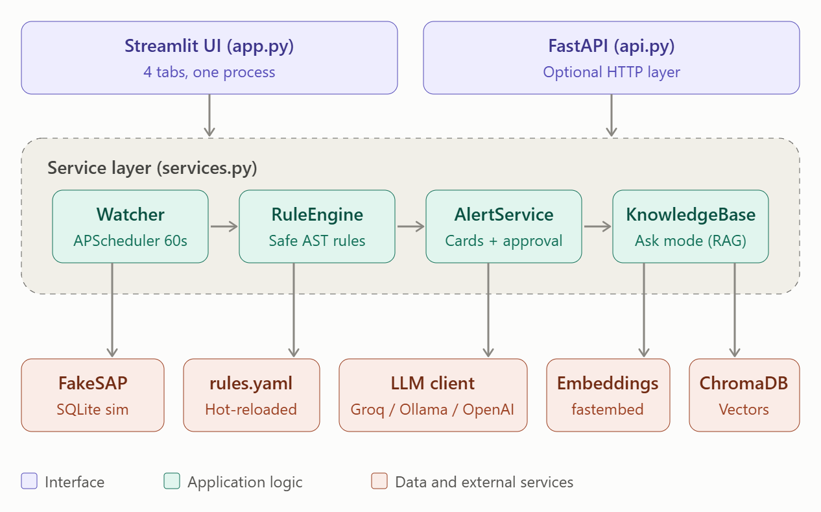
Figure 1: SentrySAP End-to-End System Architecture

6.2 Architectural Layers
- Presentation layer (Streamlit, app.py): four tabs (Ask, Upload Documents, Action Queue, Audit Log) and a sidebar for watch controls. The Action Queue is a fragment that refreshes every ten seconds. An optional FastAPI application (api.py) exposes the same operations over HTTP.
- Service layer (services.py): builds and holds all services once per process and starts the scheduler. The Streamlit application imports it directly, so a single process is sufficient.
- Monitoring and rule layer: the Watcher (APScheduler) triggers cycles; the RuleEngine reads rules.yaml and evaluates "when" expressions using a whitelist-based abstract syntax tree evaluator.
- Alert and approval layer: the AlertService and AlertBuilder create cards, apply de-duplication, enforce the approval gate, call FakeSAP executors and write the audit log.
- Knowledge layer: the KnowledgeBase handles parsing, chunking, embedding, retrieval, grounded answering and the find_playbook() function used by the alert builder.
- Data and external services layer: FakeSAP (SQLite), rules.yaml, the LLM client (OpenAI-compatible, for example Groq or Ollama), local fastembed embeddings and the ChromaDB vector store.

6.3 Data Model
Store | Principal Contents
suppliers | Identifier, name, reliability score, status (ACTIVE or BLOCKED) and creation time.
materials | Material number, name, current stock and reorder point.
purchase_orders | PO number, supplier, material, quantity, current and original delivery dates, and status (OPEN, DELAYED, ESCALATED or DELIVERED).
events | Timestamped simulated SAP events (stock_drop, po_delay, duplicate_supplier) with entity, payload and resolution status.
alerts and audit log | Alert cards with dedupe key, severity, playbook fields and status; audit rows with actor, action and detail.
ChromaDB collection | Embedded document chunks with source name and document type metadata.

7. Implementation

7.1 Technologies Used
Component | Technology | Description
Language | Python 3.x | Application, services, rule engine and seeding scripts
User interface | Streamlit | Four-tab interface, sidebar controls, auto-refreshing action queue
Optional API | FastAPI, Uvicorn | HTTP endpoints over the same service layer
Chat model | OpenAI-compatible client (Groq free tier, Ollama or Gemini) | Grounded answers and alert-card writing
Embeddings | fastembed (all-MiniLM-L6-v2) | Local, free sentence embeddings; optional OpenAI embeddings
Vector store | ChromaDB via LangChain | Cosine-similarity retrieval over document chunks
Text splitting | LangChain text splitters | 800-character chunks with 150-character overlap
Scheduler | APScheduler 3.x | Periodic watch cycles inside the application process
Simulated SAP | SQLite | Materials, suppliers, purchase orders and events
Document parsing | pypdf, reportlab | PDF reading and generation of sample SOP PDFs
Configuration | pydantic-settings, python-dotenv, PyYAML | Environment settings and rule catalogue
Data display | pandas | Event feed and audit-log tables, CSV export

7.2 Frontend Implementation
The interface is implemented entirely in Streamlit. The sidebar shows scheduler status, the last watch-cycle result, a manual cycle trigger, the random event injector and the simulated event feed. The main area has four tabs. A cached resource function builds the services once per server process and starts the scheduler, which prevents multiple schedulers during Streamlit reruns. The Action Queue is declared as a fragment with a ten-second refresh interval so that new alerts appear without a full page reload.
Source code reference: Streamlit interface (app.py) and optional HTTP API (api.py) - see repository: [https://github.com/Passwordon/SentrySAP.git]

7.3 Knowledge Base Module
The knowledge base parses PDF, TXT, MD and ABAP files, detects the document type when it is not specified, and stores chunks with metadata in ChromaDB. The answer function embeds the question, retrieves ranked chunks, applies the relevance threshold and either returns the fixed refusal or calls the model with an instruction to answer only from context. The find_playbook function reuses the same retrieval with a separate threshold and returns the best excerpt, its source and its score, which is the mechanism behind the central feature of the system.

7.4 Rule Engine
Rules are declared in rules.yaml with an identifier, scope, a boolean "when" expression, severity hint, executor, draft label and playbook query. Expressions support the logical operators AND, OR and NOT, comparison and arithmetic operators, the names material, po and supplier, and a limited set of functions (has_open_po, abs, len). The expression is parsed with Python's ast module and evaluated against a whitelist of node types, so the YAML file cannot execute arbitrary code. The three shipped rules are summarised below.
Rule | Condition | Severity | Executor on approval
low_stock_delayed_supplier | Stock below reorder point, open PO exists, and PO delay exceeds 3 days | High | Escalate PO (status becomes ESCALATED)
low_stock_no_open_po | Stock below reorder point and no open PO | Medium | Create replenishment PO
duplicate_supplier_master | Active supplier with duplicates that is the newest duplicate | Medium | Block duplicate supplier

7.5 Alert Builder, Approval Gate and Audit Log
For each finding the alert builder first retrieves the playbook. If retrieval fails or the knowledge base is empty, creation is retried or paused so that an alert is never stored permanently without its playbook. The builder then asks the model to write the card from structured facts and the excerpt; a deterministic fallback card is used if the model fails. A unique de-duplication key per purchase order, material or supplier ensures one alert per situation, and a rejected alert is not raised again. Approval invokes the mapped FakeSAP executor, resolves related events and writes an audit row; rejection records the reason. Escalated purchase orders count as open supply, which prevents a spurious "no open PO" alert after escalation.

7.6 Simulated SAP and Seed Data
The seed script rebuilds the simulated database with 30 materials, 8 suppliers and approximately 20 purchase orders, including deliberate scenarios and decoys. It also generates sample company documents (a Supplier Delay Escalation SOP that mentions the custom transaction ZESCAL01, additional SOPs, a Z-transaction wiki and an ABAP snippet), ingests them, and runs one watch cycle so that alerts with playbooks are ready on first launch.

7.7 Configuration, Security and Resilience
- Secrets are stored in a local .env file created from .env.example; the key is never present in source code, and .gitignore excludes the file from version control.
- Key settings include the LLM key and model, the embedding provider, the watch interval, the relevance threshold for Ask and the playbook threshold for alerts.
- Authentication, rate-limit and network errors from the model provider are translated into friendly messages; the client library retries transient 429 and 5xx responses.
- Rule expressions are evaluated through a whitelist, preventing code execution from configuration.

7.8 Deployment Procedure
- Create and activate a Python virtual environment and install the dependency list.
- Copy .env.example to .env and enter the free chat-model key. Local embeddings need no key but download a small model on first use.
- Run the seed script to build the database, generate and ingest the sample documents and run the first watch cycle.
- Launch the Streamlit application. Optionally launch the FastAPI application for HTTP access.
Complete source code, dependency list and configuration templates are available in the project repository: [INSERT YOUR GITHUB REPOSITORY LINK HERE]

8. User Interface / Application Screenshots

8.1 Ask SentrySAP
The Ask tab provides a chat interface. Each answer is displayed with an expandable list of sources showing document name, type, match percentage and excerpt. Questions outside the documents return the refusal sentence together with a suggestion to upload the relevant document.
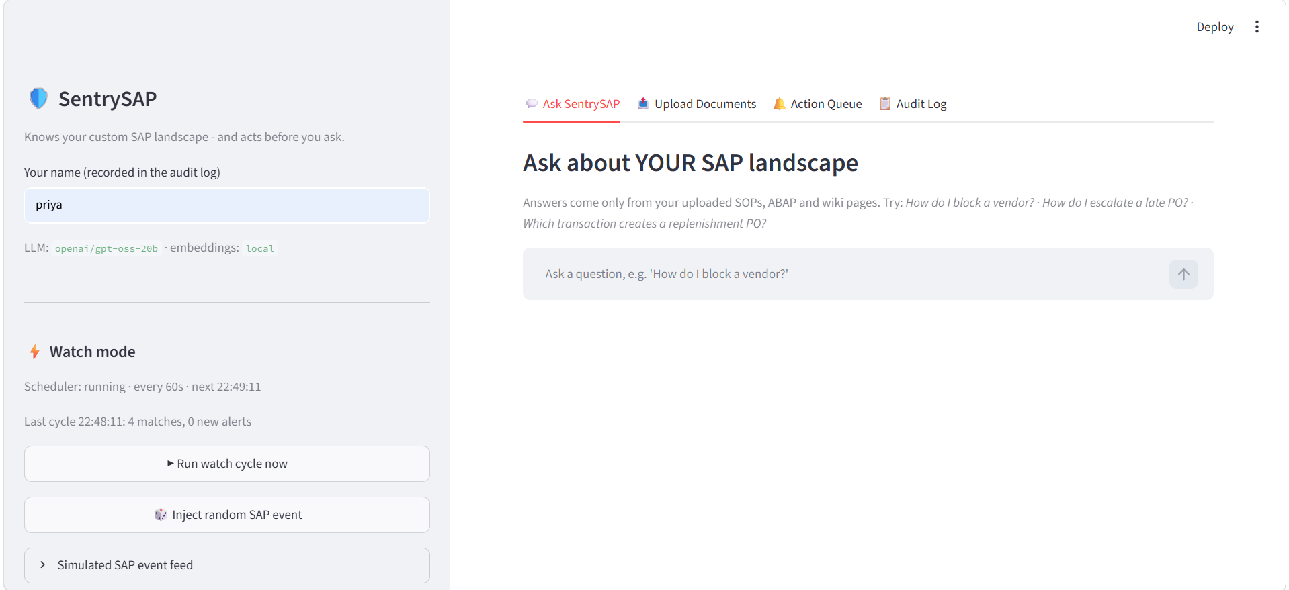
Figure 1: SentrySAP Chat Interface with Sources

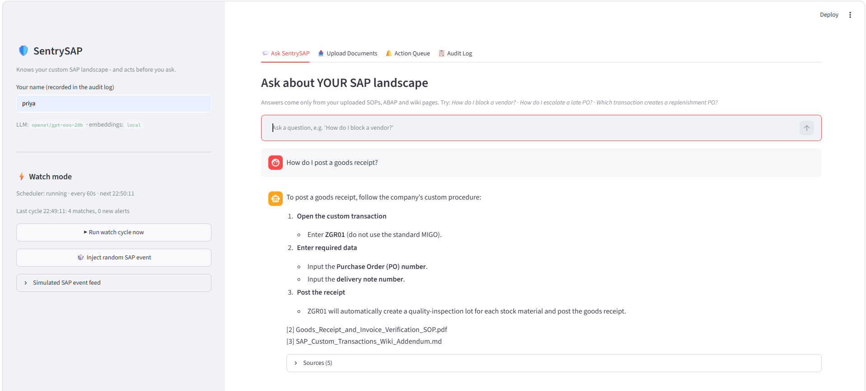

Figure 2: Ask SentrySAP Chat Interface with Sources
UI Component | Operational Purpose
Chat input and history | Accepts questions and preserves the conversation display (answers remain stateless).
Sources expander | Shows document, type, match score and excerpt for transparency.
Refusal message | Prevents unsupported answers when documents lack the information.

8.2 Upload Documents
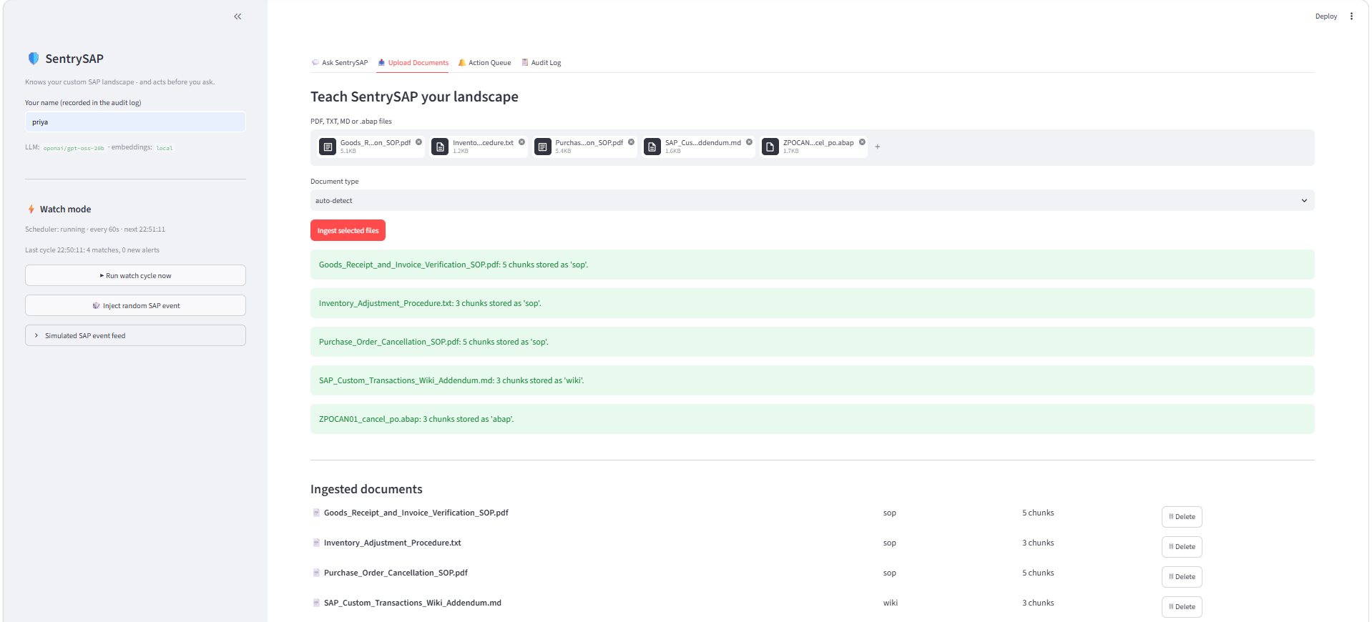
Figure 3: Upload Documents and Ingested Documents List

UI Component | Operational Purpose
File uploader | Accepts PDF, TXT, MD and ABAP files; multiple files per upload.
Document-type selector | Auto-detect or manually label as SOP, ABAP, wiki or other.
Ingested documents list | Shows source, type and chunk count with a delete control.

8.3 Action Queue with Company Playbook
The Action Queue lists pending alerts. Each card shows a severity badge, title, rule identifier, creation time, summary, affected purchase order, suggested action, the playbook excerpt with source and match percentage, the draft message, an optional rejection reason and the Approve & Execute and Reject buttons.
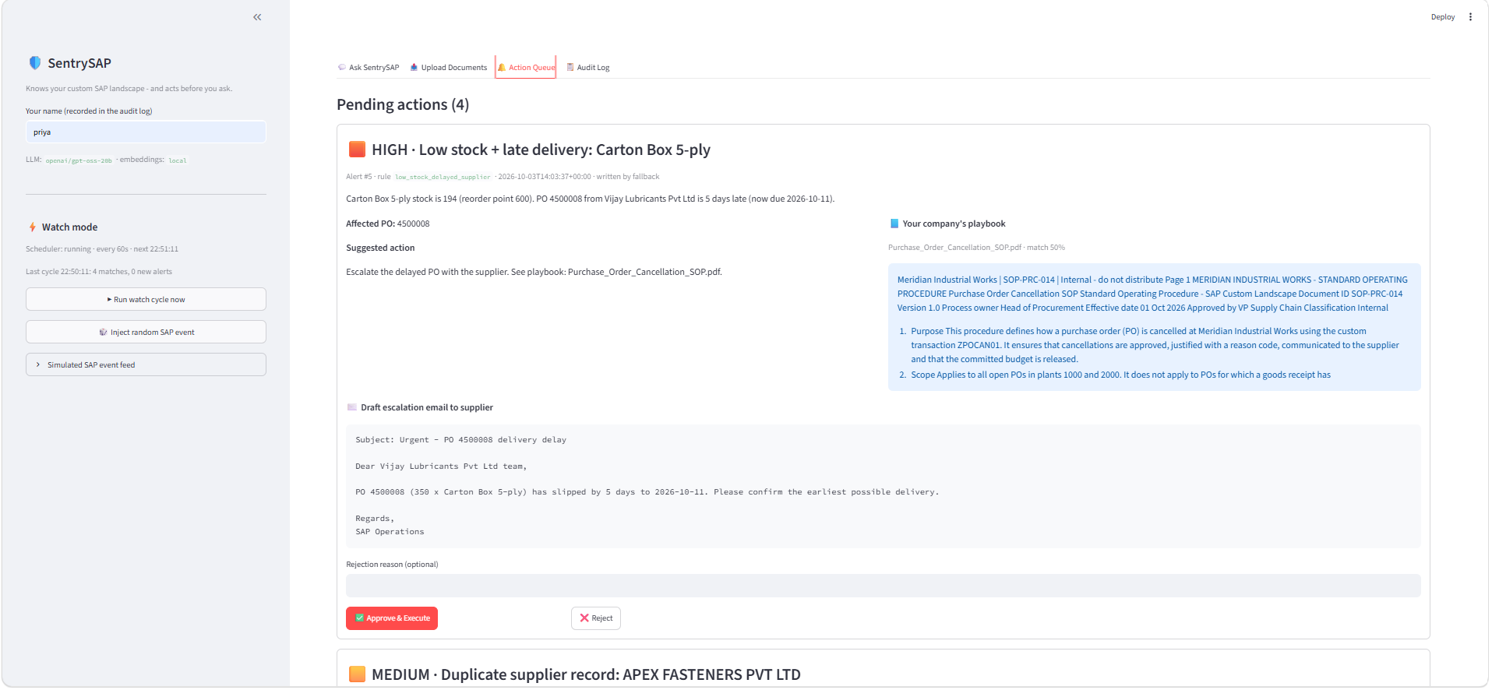
Figure 4: Action Queue Alert Card with Playbook and Draft Message
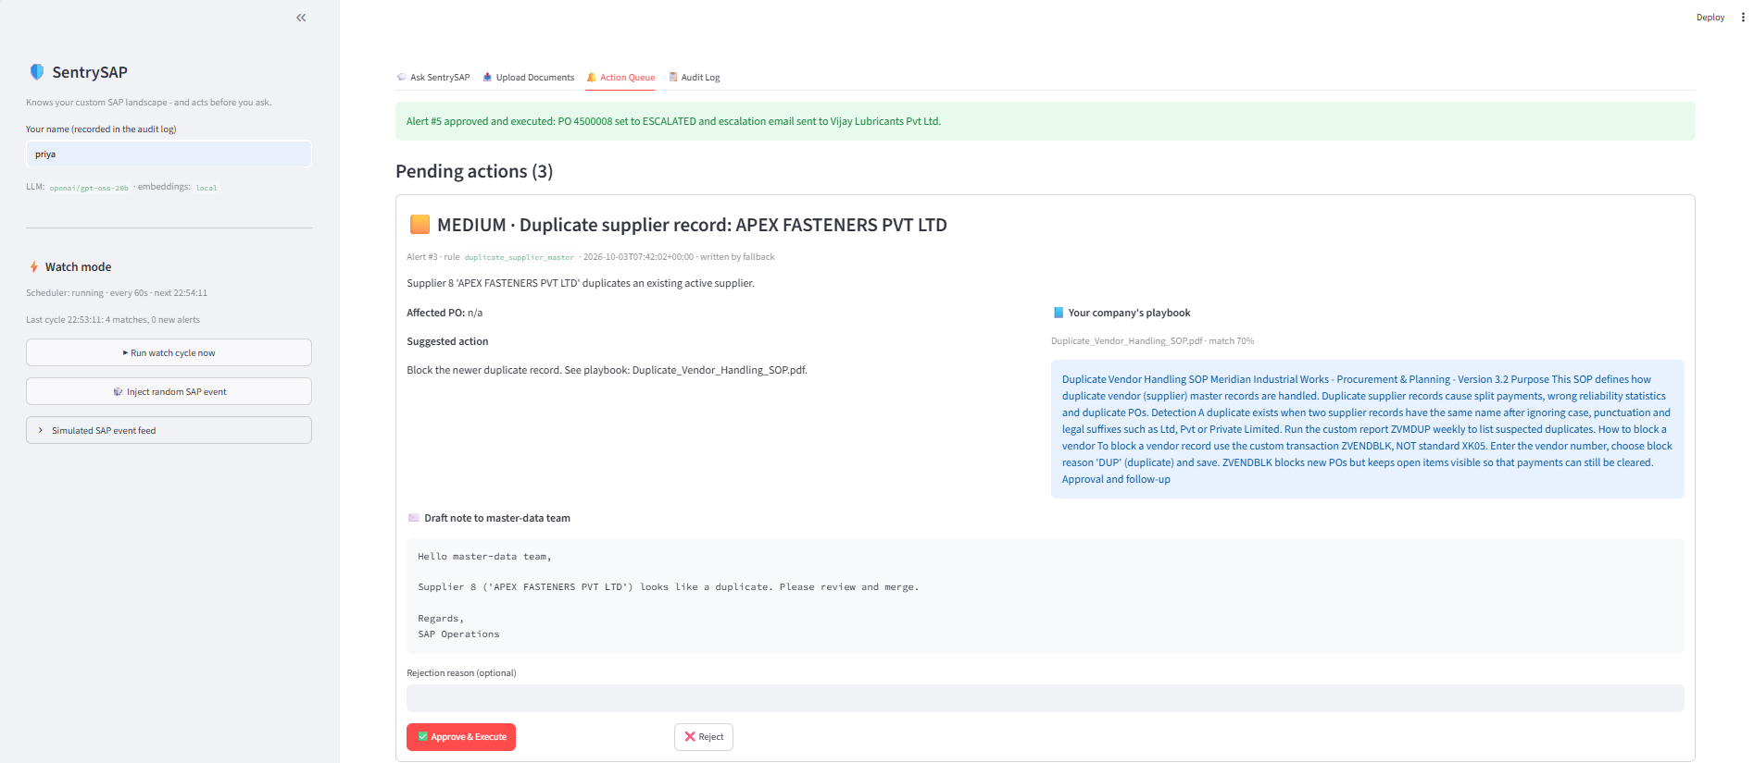
Figure 5: Approve and Reject Workflow Confirmation
UI Component | Operational Purpose
Severity badge and summary | Communicates urgency and the factual situation.
Playbook panel | Displays the organisation's own procedure beside the proposed action.
Draft message | Provides a ready-to-use email, purchase order draft or master-data note.
Approve & Execute / Reject | Human approval gate; execution only after approval.

8.4 Audit Log
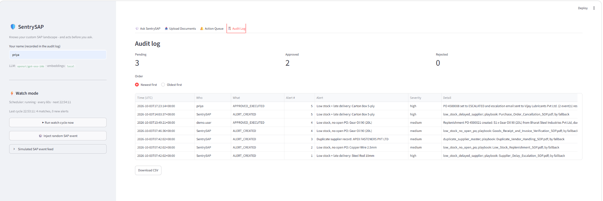
Figure 6: Audit Log with Metrics and CSV Export
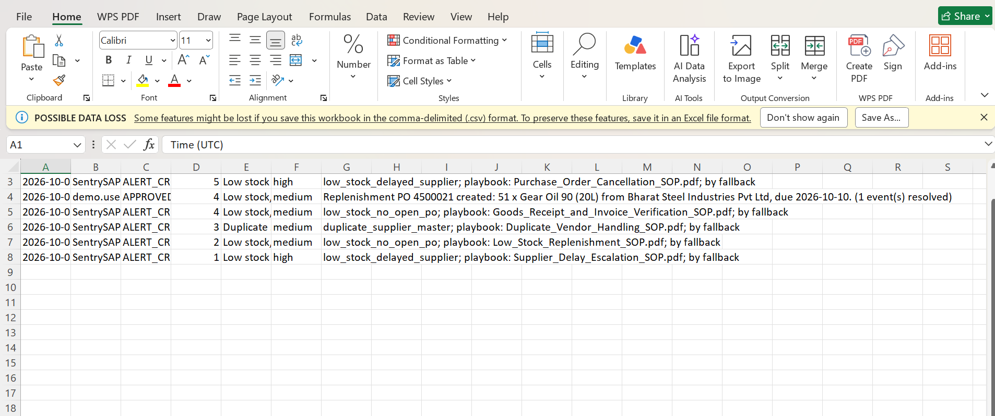
Figure 7: CSV Export in Excel

UI Component | Operational Purpose
Status metrics | Counts of pending, approved and rejected alerts.
Audit table | Time, actor, action, alert, severity and detail, sortable newest or oldest first.
Download CSV | Exports the audit trail for review or compliance.

8.5 Sidebar Watch Controls and Event Feed
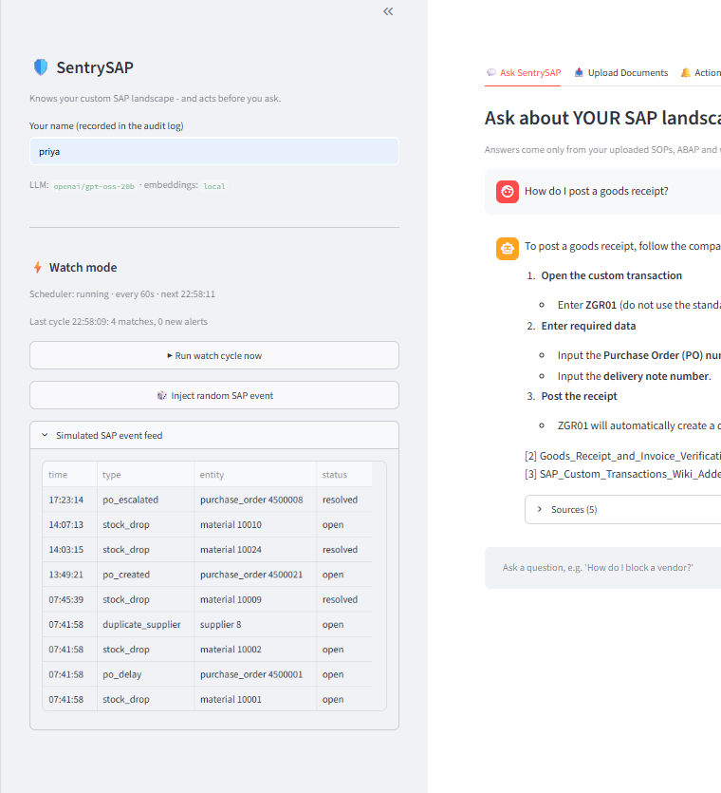
Figure 7: Sidebar Watch Mode Controls and Simulated SAP Event Feed

8.6 Complete End-to-End Workflow
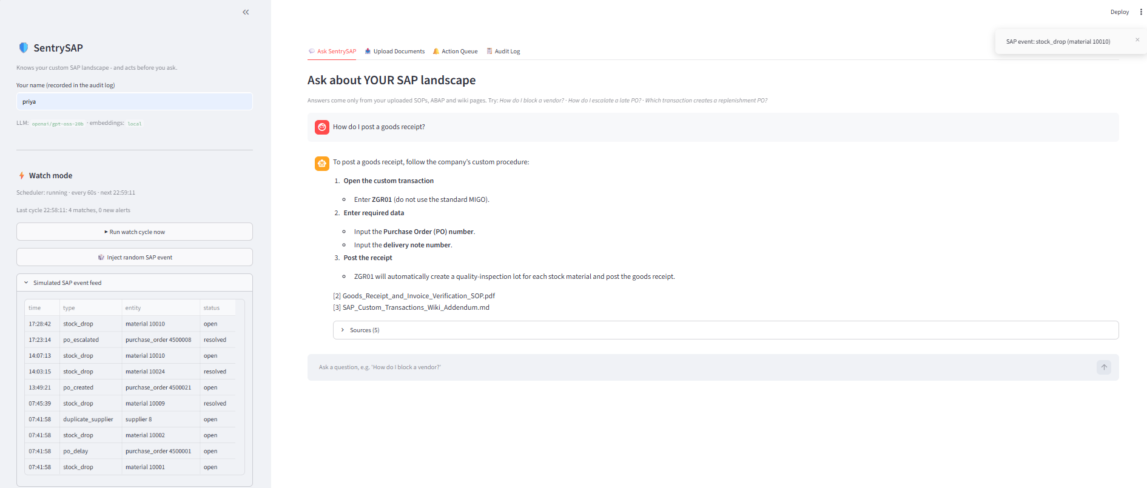Figure 8: Complete End-to-End Workflow from Event to Audit

9. Challenges and Limitations

9.1 Technical and AI Challenges
- Grounding and hallucination control: answers are restricted to retrieved context, a relevance threshold blocks weak matches, and a fixed refusal sentence is enforced in the prompt.
- Threshold calibration across embedding models: cosine scores of a local model differ from those of hosted models, so thresholds (0.25 for Ask, 0.22 for playbooks) are configurable and may need lowering.
- Safe configurable rules: allowing rule edits without code execution risk required a whitelist-based abstract syntax tree evaluator.
- Avoiding alerts without playbooks: alert creation is retried or paused if the playbook lookup fails or the knowledge base is empty.
- Alert duplication and feedback loops: unique de-duplication keys, non-reraising of rejected alerts and treating escalated purchase orders as open supply prevent repeated or bogus alerts.
- LLM failures during card writing: a deterministic fallback card ensures the queue continues to function.
- Streamlit reruns and scheduler lifetime: the services and scheduler are created once through a cached resource.

9.2 Limitations
- Simulated SAP: the connection to real SAP RFC, BAPI, OData or event mesh interfaces is not implemented in this prototype.
- Provider limits: free-tier model limits restrict throughput; one model call is made per alert, so large simultaneous batches are slow.
- Quality depends on documents: missing or outdated SOPs lead to refusals or weaker playbooks.
- No authentication or role model: the approver name is self-declared, and the optional API has no access control.
- Concurrent processes: running the Streamlit application and the FastAPI application against the same database would start two schedulers.
- Limited rule catalogue and language scope: three rules are provided, and documents and prompts are oriented to English.

10. Conclusion

Project Summary
SentrySAP demonstrates how generative AI can be applied responsibly to enterprise operations. The platform ingests an organisation's own SAP knowledge, answers questions strictly from that knowledge, monitors operational events with transparent rules, and presents each alert together with the governing company procedure and a drafted response. Execution is gated by explicit human approval and permanently recorded.

Value of Generative AI
Generative AI converts unstructured documentation into immediately usable guidance and converts structured facts into well-written communications. By placing deterministic detection, approval and execution outside the model, the design captures the benefits of language models while limiting their risks.

Key Learning Outcomes
- Retrieval-augmented generation with chunking, embeddings, vector search and relevance gating.
- Hybrid architecture design that combines deterministic rules with generative components.
- Safe expression evaluation using abstract syntax tree whitelisting.
- Human-in-the-loop workflow design with approval gates, de-duplication and audit trails.
- Provider-independent LLM integration, graceful degradation and configuration management.
- Full-stack Python development with Streamlit, FastAPI, SQLite and APScheduler.

11. Future Scope
- Real SAP integration: replace FakeSAP reads with OData, RFC or IDoc events (for example SAP BTP Event Mesh) and the executors with approved BAPI or OData calls; the rule engine, playbook linker, approval gate and audit log remain unchanged.
- Authentication and role-based approval: integrate single sign-on and require specific roles (for example the Procurement Manager) for particular actions.
- Larger rule catalogue and rule authoring assistant: add rules for goods receipt discrepancies, invoice blocks and credit limits, and let the model draft rule expressions for expert review.
- Notification channels: send alerts to e-mail, Microsoft Teams or Slack with approval links.
- Batched and cached generation: reduce model calls through batching and caching for high-volume scenarios.
- Improved retrieval: add hybrid keyword and semantic search, re-ranking and automatic detection of outdated documents.
- Analytics: dashboards of alert frequency, time to decision, rejection reasons and playbook coverage gaps.
- Multilingual and voice support: answer in multiple languages and accept voice queries.
- Production deployment: containerisation, a production database, centralised logging and a single scheduler process.

12. References
- Lewis, P., Perez, E., Piktus, A., et al. (2020). Retrieval-Augmented Generation for Knowledge-Intensive NLP Tasks. Advances in Neural Information Processing Systems, 33. arXiv:2005.11401.
- Vaswani, A., Shazeer, N., Parmar, N., et al. (2017). Attention Is All You Need. Advances in Neural Information Processing Systems, 30. arXiv:1706.03762.
- Brown, T. B., Mann, B., Ryder, N., et al. (2020). Language Models are Few-Shot Learners. Advances in Neural Information Processing Systems, 33. arXiv:2005.14165.
- Wang, W., Wei, F., Dong, L., Bao, H., Yang, N., and Zhou, M. (2020). MiniLM: Deep Self-Attention Distillation for Task-Agnostic Compression of Pre-Trained Transformers. arXiv:2002.10957.
- Streamlit Documentation. Streamlit: Build and share data apps. https://docs.streamlit.io.
- FastAPI Documentation. FastAPI framework. https://fastapi.tiangolo.com.
- Chroma Documentation. Chroma: the open-source embedding database. https://docs.trychroma.com.
- LangChain Documentation. LangChain Python documentation. https://python.langchain.com.
- Qdrant fastembed Documentation. FastEmbed: fast, lightweight embedding generation. https://github.com/qdrant/fastembed.
- APScheduler Documentation. Advanced Python Scheduler, version 3.x. https://apscheduler.readthedocs.io.
- Groq Documentation. GroqCloud API and supported models. https://console.groq.com/docs.
- Python Software Foundation. ast - Abstract Syntax Trees, Python 3 Documentation. https://docs.python.org/3/library/ast.html.
- SQLite Documentation. SQLite. https://www.sqlite.org/docs.html.
- SAP SE. SAP Help Portal: ABAP platform, BAPI and OData service documentation. https://help.sap.com.
- Project repository: SentrySAP - Source Code & Project Files. [INSERT YOUR GITHUB REPOSITORY LINK HERE]

