1. Start by generating thalweg, left/right inner channel width series (“GVFs” tab in sfe_tbs_M1_25_RB_metrics.xlsx)
2. Calculate
   1. The distance between thalweg and left/right inner channel: this will be the left/right inner channel function (e.g., Left = orange line – blue line, Right = grey line – blue line)
   2. The minimum distance between left and right inner channels: this will be the minimum inner channel width (e.g., minimum of (orange line – grey line))
3. Get Fourier series of thalweg and 2a (the input function files generated for thalweg, left/right widths are: “thal_y.txt”, “W_bf_L.txt”, and “W_bf_R.txt” in sfe_tbs_M1_25, respectively.

Thalweg

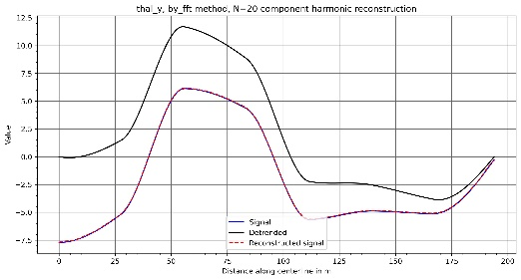

Left/Right distance

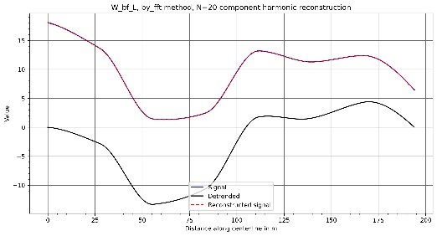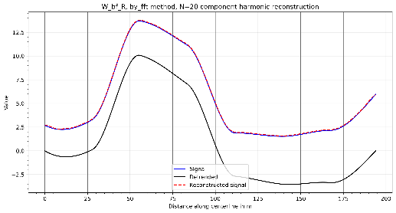

1. Run the main RB input txt file, sfe_tbs_M1_25_vv3.txt. Here, the centerline function is defined as “Meandering Centerline Function=thal_y.txt” in the main RB input txt file.

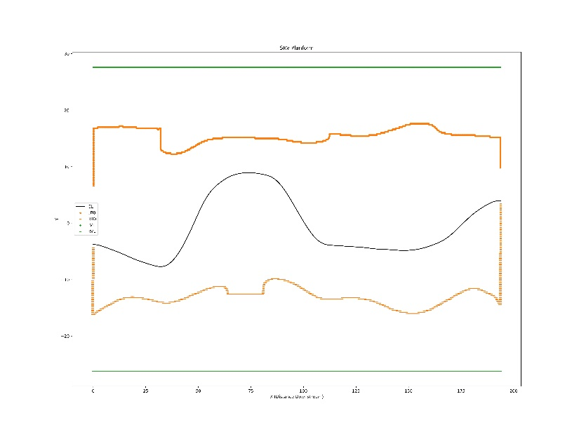

1. Another version without the centerline function (sfe_tbs_M1_25_vv3_CL0). Here, the centerline function not defined in the main RB input txt file. (e.g., “Meandering Centerline Function=thal_y.txt” is commented.)

