Chase Yates
Natalie Stillman-Web
WRTG 4030
February 1, 2023

Learning to Love Yourself

It is no question that many today, especially the youth, face a mental health crisis like no other in history. With little societal answer to the question of meaning, the youth and people of the first world today often seek solace in menial entertainment. From social media to video games to television, the answers seem to be presented on the screens in front of us. This has lead many astray however, and depression, anxiety, and other mental disorders afflict a greater population today than ever before. 2022 Capstone – Animation Short Film (referred to as “Capstone”) seeks not for the solution to this problem, but to provide one step, one hurdle over the emotional barriers we face everyday. The short’s use of color, recognizable symbols, and visual effects, build both relatibility with the main character, ethos with the artist, and powerful driving pathos throughout to push the claim that people struggling need to learn to love and accept themselves to move forward.

The first three images presented in Capstone provide a clear and sudden slingshot of tone, setting the stage for the rest of the short. Immediately we are presented with a warm, orange and yellow color pallette, showing the outside of a home. Birds are singing and butterflies dance on the side of the screen. After the first title card, the image cuts to inside the home, and a sudden blue tone has been established. We see a shaded wall with pictures hung of the main character of the short depicting a happy, young version of our protagonist. The audio has cut to a still white noise. After the next title card, we cut to a disorderly and messy-haired protagonist, sleeping. She is now much older than the previous images we saw of her. These three driving scenes set the tone. The audience now has an understanding that this might not be the happiest of stories. The shift from the bright and warm colors of the outside to the cold, disheveled look of the protagonist’s room shows the viewer that the protagonist likely isn’t what the pictures on the wall depicted her as anymore. She is older, and life has worn her down. This humbling of the protagonist from the audience’s perspective creates an instant connection. Viewers who feel this way will likely have something in common the with character on screen, feeling they might be out of their depth in life, or that they may have stagnated as of recent.

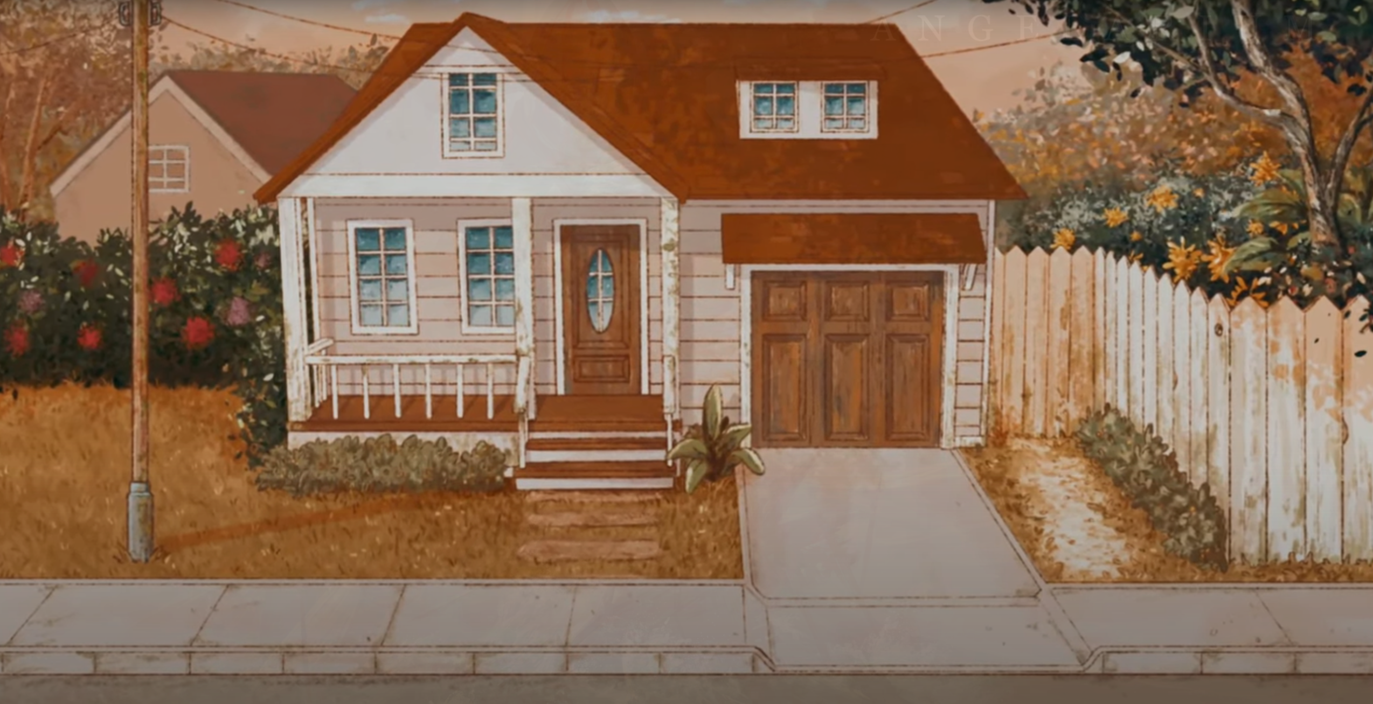
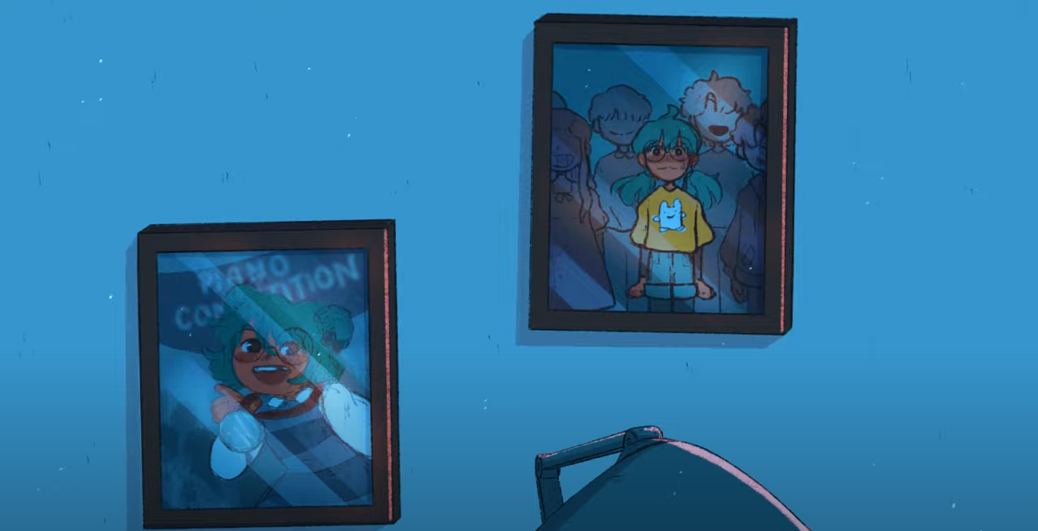
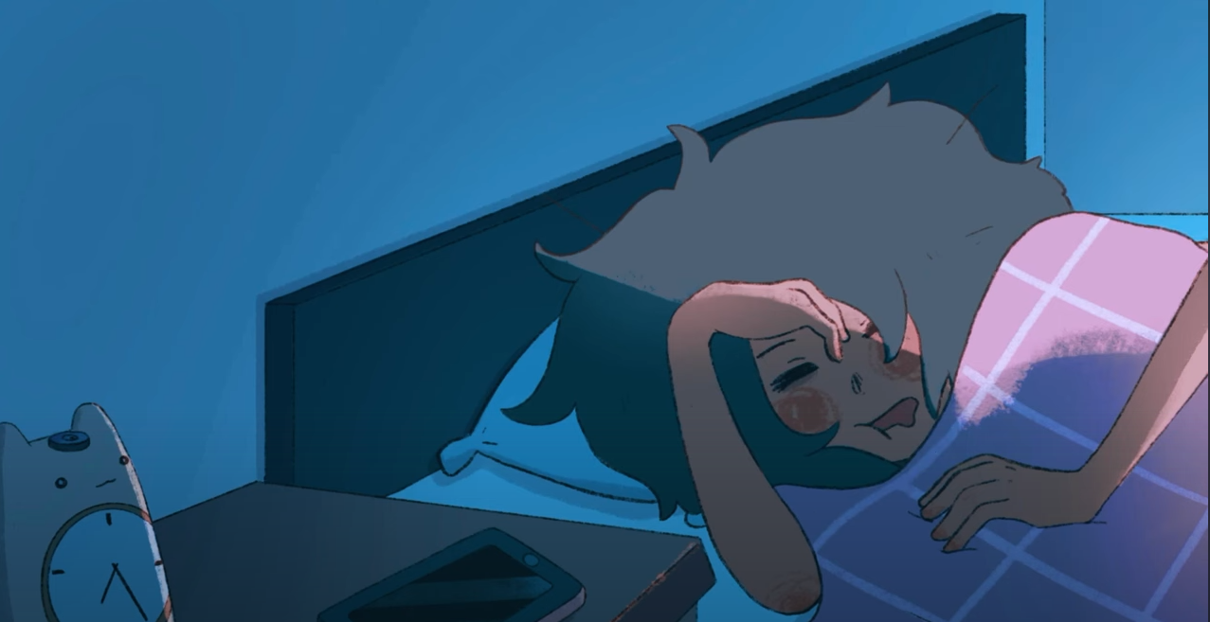

Next, the animation uses various items, details, and recognizable elements to further develop the viewers’ relationship with the character. The first of this is the state of the character’s room as the camera cuts to a wider shot. You can see dirty dishes, trash, clothes on the floor, and drawers not-so-neatly stuffed. More than this, when the protagonist eventually lays down and scrolls on her phone, you can see notifications showing the mindset she is going through: there is an advertisement for a scam, missing assignment alerts, and a poor essay grade. In order to turn off all the noise, the character starts scrolling through social media. In a later scene are graded papers with F- written on them, and a skull in the corner of the protagonist’s closet. These details lend credibility to the artist, showing the effort and thought that went into showing how many little aspects of the main character’s life have been infiltrated by anxiety and/or depression. This further convinces the viewer of the mental state of the protagonist, making the resolution of the short all the more convincing.

There is another character in the short, a small child with a white mask and a green ribbon. This other character is later revealed in the short to be some ‘alternate side’ of the main character, likely the emotional side. It is a part she suppresses in a scene where she sees the character in a closet, goes into visible panic, and slams the closet door shut. This character is hidden throughout the short, and may be found in more places than expected, especially on repeat watches. This further adds detail for viewers to notice, which ties the metaphorical meaning of the character with the different contexts it is seen in.

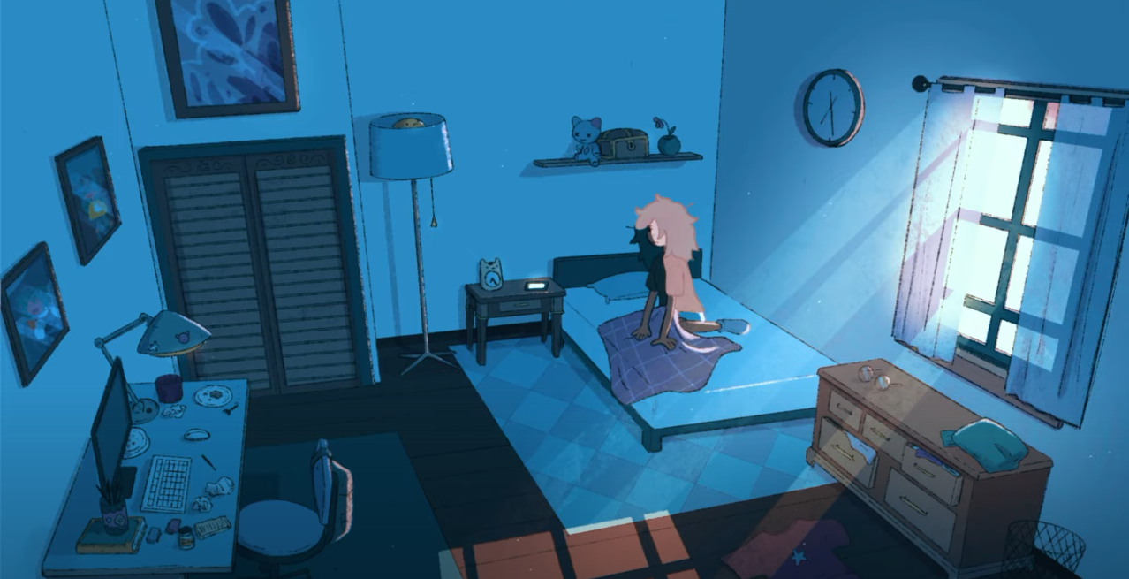
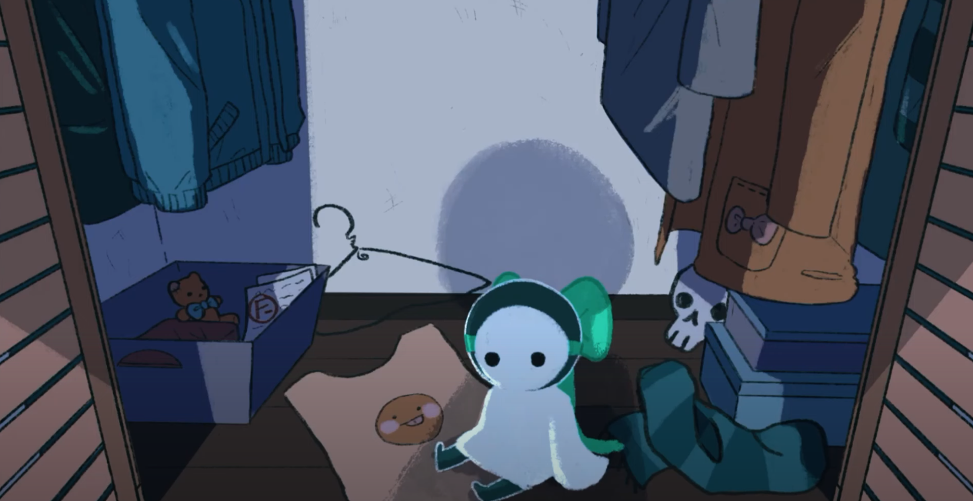
Probably the most important aspect of the short, and the crux of the argument it tries to make, is the emotional effect the viewer, as well as the main character feel throughout. As discussed above, for the majority of the short, the main character is either in a state of apathy, anxiety, or depression. The first example of this is when the protagonist receives messages from a friend, trying to hang out and making sure she is ok. The protagonist simply ignores these messages, with some hesitation. In the closet scene discussed above, our character sees the masked character and goes into visible shock and panic. Her eyes widen and pupils dilate as she briefly stares down the character in the closet. This scene is fairly straightforward, however there is something to be said that the smaller masked character is stuffed in the closet, a metaphor for repression/suppression. This repression is also seen when the character is scrolling through her phone and a couple of ads appear at various times with the masked character on them, recommending therapy. The main character ignores these ads. Probably the second most powerful and emotional scene in the short is the penultimate scene in the bathroom. The masked character sits behind as the main character goes to do her daily routine. As she looks away and back at the mirror, an altered, warped, and glitched version of her is seen with a sickly smile. The protagonist freaks out, and suddenly, a hand comes out of the mirror and pulls her in. She screams as she falls into a near-pitch black dimension. This is the end of the pathos used in the short to show the extent of the main character’s suffering as a result of her mental illnesses. All of these scenes and details occur in quick succession and result in a rapid building of pathos that the viewer may be able to relate with and understand.

Finally, the concluding, and most powerful scene of the short, further uses pathos. However, this time, it is used to show how the main character resolves her situation (or at least starts on the path to resolution). In the black mirror-dimension mentioned above, there is a long green piece of silk that goes off into the distance. The main character picks it up and follows where it goes. As she nears the end of the line of silk, she sees the small masked character, and hears crying. She approaches, and it turns out the long line of silk was connected to the green bow. She hesitates, then pulls on the bow, releasing a flurry of butterflies. This aspect of the scene is hard to decipher, however the untying of the bow could be seen as ‘releasing’ the masked character and the protagonist’s emotions. There is a pause, then the masked character turns around and hugs the protagonist. After a moment, our protagonist reciprocates, and the camera suddenly cuts to the face of the masked character, revealing it was our protagonist all along. With a smile, there is a flash of light, the warm colors return to the image, and the short ends. As the credits roll, the protagonist’s phone can be seen with a notification from her friend saying “great! see you soon”. This whole scene shows how the main character learned to accept her subconscious and the emotional part of her, as she hugs the character representing this. Furthermore, the fact that this other character was depicted as the same as the main character, and the fact that they hug, shows that the main character has learned to love herself again. Finally, the message in the credits shows how our character is putting this lesson into practice, and venturing out into the world again, seeing her friend. There is no doubting the emotional impact of this, the previous scenes, and the pathos that the artist employs in them.

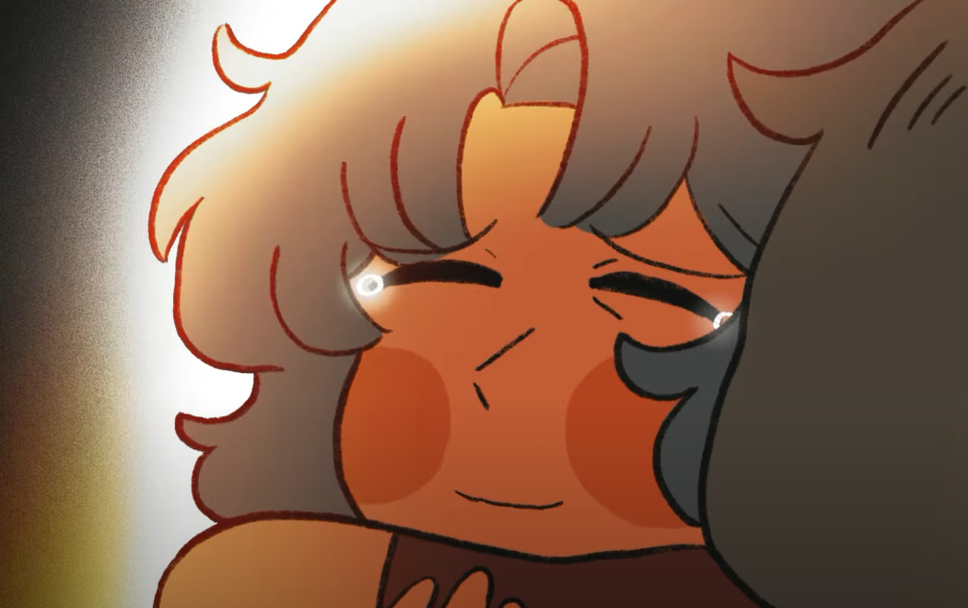

Capstone is a wonderfully powerful and moving piece on the importance of loving oneself. It argues that in order to overcome depression, anxiety and the other emotional plagues we face in modern society, we must learn to live with our emotions and understand them, so that we can learn to love ourselves. It argues this through use of ethos, pathos, and presenting ideas through a fictional character that artist pushes us to relate to. Its warrant is that we want to love ourselves as people, but it doesn’t need to state this, as it is so apparent to us everyday. This short, although it has gone mostly unnoticed, goes to show the power of art in bringing everyday people out of the rut of everyday life.
Works Cited
“2022 CAPSTONE - Animation Short Film” YouTube, uploaded by coffteaa, 1 November 2022, https://www.youtube.com/watch?v=S-h3JaAMAWM.

