

horizontal line

CODE-S Foundation

0553339728 / 0546116102

[Code.s.gh.org@gmail.com](mailto:Code.s.gh.org@gmail.com)

25th July, 2021.

Knutsford University College,

Kumasi,

Ghana.

Dear Sir,

**REQUEST TO RENT CLASSROOMS FOR OUR FREE COMPUTER TRAINING LESSONS.**

I write requesting to rent classrooms for our **free** IT and computer programming classes. CODE-S is a formally registered NGO that organizes free IT and computer programming classes to students with the aim of helping them acquire IT skills.

In 2018 and 2019, we successfully held our training sessions in your noble institution. This year 2021, we wish to hold our training sessions again in your institution from ***the third week of August to the third week of October***, making 2 months in total. We will hold one session per week (on Saturdays) and will require up to four classrooms per session.

We therefore wish to inquire about classrooms availability and associated costs and conditions of rentals. We look forward to hearing from you soon. Thank you.

Yours faithfully,

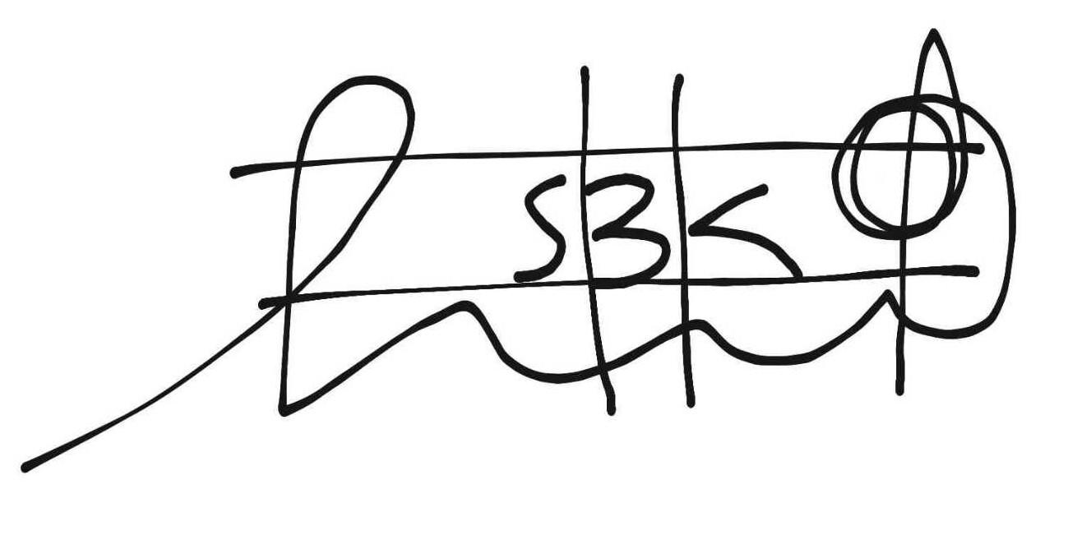

Seth Baah Kusi

(Director)