ResumeX: AI-Powered Resume Screening & Intelligent Candidate Ranking System
A Project Based Learning Report Submitted in partial fulfilment of the requirements for the award of the degree

of

Bachelor of Technology
in The Department of Computer Science and Engineering
Data Structures and Algorithms (Course Code: 23CS2103)

Submitted by
2500030017 – Suhaanthi Reddy
2510030025 – Shloka Reddy
2510030128 – Hansikha Reddy
2510030107 – Spoorthy Reddy
2510030312 – Dhana Lakshmi
Under the guidance of
XXXX (Faculty Name)



Department of Computer Science and Engineering
Koneru Lakshmaiah Education Foundation, Aziz Nagar
Aziz Nagar – 500075
OCT - 2026.
ABSTRACT
In modern technical talent acquisition, human resources departments face unprecedented operational challenges due to the overwhelming influx of submitted candidate resumes. Manual evaluation is severely constrained by cognitive fatigue, subjective evaluation metrics, and significant time overheads, compelling recruiters to dedicate merely seconds to each applicant. Conversely, contemporary commercial solutions deploying opaque deep neural networks and Generative Artificial Intelligence (GenAI) frequently suffer from hallucinations, non-reproducible scoring criteria, and algorithmic bias. To address these critical industry bottlenecks, this Project-Based Learning (PBL) project presents ResumeX, an intelligent, deterministic, and transparent resume screening and candidate ranking system founded strictly on classical Data Structures and Algorithms (DSA), prepared and submitted for Review 3 evaluation by team members Suhaanthi Reddy (2500030017), Shloka Reddy (2510030025), Hansikha Reddy (2510030128), Spoorthy Reddy (2510030107), and Dhana Lakshmi (2510030312).
ResumeX features a high-performance Java SE backend integrated with an Eclipse workspace that executes six foundational algorithmic paradigms: Knuth-Morris-Pratt (KMP) string matching for exact skill and technology extraction, Levenshtein Distance dynamic programming for typo and abbreviation tolerance, Needleman-Wunsch global sequence alignment for career qualification progression evaluation, Suffix Arrays combined with Kasai's linear Longest Common Prefix (LCP) algorithm for deep domain phrase collocations, SHA-256 cryptographic hashing for exact and near-duplicate resume detection, and Greedy Approximation for multi-criteria candidate optimization. Native PDF resume ingestion is performed directly in runtime memory utilizing Apache PDFBox 3.0.8, completely decoupled from a modern React 19 single-page application built in VS Code. Experimental validation conducted on benchmark technical candidate datasets proves that ResumeX achieves sub-millisecond screening latency, 100% duplicate detection precision, and an explainable, weighted composite qualification ranking that eliminates black-box opacity. ResumeX successfully demonstrates the vital role of foundational computer science algorithms in enterprise human capital engineering.
LIST OF FIGURES
Figure 1: Decoupled Full-Stack Architecture of the ResumeX Screening System ...................... 8
Figure 2: Empirical Evaluation of Benchmark Candidates Across Core DSA Scoring Metrics ........ 12

LIST OF TABLES
Table 1: Summary of Core DSA Algorithms, Complexity, and Primary Function ......................... 9
Table 2: Mathematical Weight Allocation for Composite Candidate Match Scoring ................... 10
Table 3: Experimental Screening & Evaluation Results on Benchmark Resumes ......................... 13
Table 4: Runtime Benchmark & Algorithmic Complexity Across Document Sizes ......................... 13
TABLE OF CONTENTS
1. INTRODUCTION ......................................................................................................................... 6
1.1 Background and Industry Context ........................................................................................... 6
1.2 Pitfalls of Contemporary Screening Systems ........................................................................... 6
1.3 Project Motivation and Objectives ........................................................................................... 7
1.4 Scope and Review 3 Realization .............................................................................................. 7
2. METHODOLOGY & ALGORITHMIC DESIGN .............................................................................. 8
2.1 Decoupled Full-Stack System Architecture .............................................................................. 8
2.2 Novelty of Developed Methodology: Multi-Technique DSA Fusion ........................................... 8
2.3 Native In-Memory PDF Text Extraction via Apache PDFBox ................................................... 9
2.4 Knuth-Morris-Pratt (KMP) Linear String Matching .................................................................... 9
2.5 Levenshtein Edit Distance (Dynamic Programming) ................................................................ 9
2.6 Needleman-Wunsch Global Sequence Alignment ..................................................................... 9
2.7 Suffix Arrays & Kasai's Longest Common Prefix (LCP) ............................................................. 10
2.8 Cryptographic SHA-256 Hashing & Duplicate Detection ........................................................... 10
2.9 Greedy Approximation for Multi-Objective Ranking ................................................................. 10
2.10 Adaptability of Methodology Across Domains and Systems ................................................... 10
3. EXPERIMENTS & BENCHMARK SETUP ......................................................................................... 11
3.1 Benchmark Dataset & Candidate Corpus ................................................................................. 11
3.2 Target Job Requisition Specification ......................................................................................... 11
3.3 Execution Environment & Hardware Setup .............................................................................. 11
4. RESULTS & METHODOLOGY EVALUATION ............................................................................. 12
4.1 Methodology Evaluation: Screening Accuracy and Ranking ................................................... 12
4.2 Algorithmic Time and Space Complexity Analysis ................................................................... 13
4.3 Scalability & Runtime Latency Benchmark ................................................................................ 13
4.4 Duplicate Detection and Anti-Fraud Verification ...................................................................... 13
5. CONCLUSION, DISSEMINATION, AND FUTURE WORK ........................................................... 14
5.1 Concluding Remarks ................................................................................................................. 14
5.2 Dissemination and Accessibility: Live Deployment & Open Source .......................................... 14
5.3 Future Algorithmic Enhancements ............................................................................................. 14
REFERENCES ...................................................................................................................................... 15
ResumeX: AI-Powered Resume Screening & Intelligent Candidate Ranking System
Note: Maintain Document format as it is in terms of font size and font theme.
1. INTRODUCTION
In the contemporary global knowledge economy, corporate recruitment infrastructures are experiencing an overwhelming surge in applicant volume. Digital career portals, automated job aggregation platforms, and streamlined one-click application systems routinely generate hundreds to thousands of candidate resumes for every advertised technical position. Consequently, corporate human resource departments and talent acquisition teams encounter severe operational bottlenecks. Manual resume evaluation is notoriously labor-intensive, vulnerable to recruiter cognitive fatigue, and inherently inconsistent. Empirical studies reveal that human recruiters allocate an average of merely six to eight seconds to conduct initial resume appraisals. Under such extreme temporal pressures, qualified candidates possessing unconventional formatting or non-standard phraseologies are frequently overlooked, while incongruous applicants who optimize superficial document aesthetics slip through initial screening filters.
To mitigate this operational strain, enterprise organizations have increasingly deployed commercial Applicant Tracking Systems (ATS). However, first-generation ATS platforms depend heavily on brittle keyword matching techniques. These systems count raw string occurrences, leaving them easily vulnerable to 'keyword stuffing' exploits where candidates embed invisible or repetitive terminology to manipulate relevance scores. Conversely, modern generative artificial intelligence (GenAI) and large language model (LLM) screening frameworks introduce different yet equally severe impediments. Deep neural architectures operate as inscrutable 'black boxes' that lack deterministic explainability. They are prone to stochastic hallucinations, exhibit non-reproducible scoring across identical documents, and inadvertently reproduce demographic biases embedded in training corpora. Furthermore, streaming sensitive applicant personally identifiable information (PII) to external cloud-hosted LLM inference APIs introduces grave data privacy and compliance liabilities under GDPR and enterprise security mandates.
To surmount the twin pitfalls of brittle heuristic filters and unaccountable neural black boxes, this Project-Based Learning (PBL) project introduces ResumeX: an intelligent, transparent, and deterministic resume screening and candidate ranking system engineered entirely on classical Data Structures and Algorithms (DSA). Rather than relying on non-verifiable statistical approximations, ResumeX models the candidate evaluation challenge through formal computer science principles: pattern matching, dynamic programming, sequence alignment, string indexing, cryptographic hashing, and greedy optimization. Each algorithmic component executes a clearly defined analytical responsibility, producing an auditable, multi-dimensional score profile that guarantees complete fairness, reproducibility, and computational efficiency.
The technical core of ResumeX comprises six foundational algorithmic implementations designed and benchmarked in Java: (1) The Knuth-Morris-Pratt (KMP) algorithm enables linear-time exact keyword search with zero backtracking; (2) Levenshtein Edit Distance dynamic programming accounts for typographical errors, acronym variations, and naming discrepancies; (3) Needleman-Wunsch Global Sequence Alignment evaluates structural career progression and requirement ordering; (4) Suffix Arrays coupled with Kasai's Longest Common Prefix (LCP) algorithm extract deep domain collocations and complex multi-word project phrases; (5) SHA-256 cryptographic hashing guarantees instant O(1) detection of duplicate resume submissions and anti-fraud filtering; and (6) A Greedy Set-Cover approximation engine computes optimal candidate qualification density under variable requirement constraints.
ResumeX is realized through a strictly decoupled enterprise software architecture. The backend is developed as a native Java SE application within the Eclipse IDE, embedding an asynchronous HTTP server and Apache PDFBox 3.0.8 for safe in-memory document parsing without disk persistence. The recruiter presentation layer is engineered as a modern Single-Page Application (SPA) using React 19, Vite, Tailwind CSS, and Lucide icons in VS Code. This report is organized to thoroughly address the Project-Based Learning Review 3 evaluation rubrics: Section 2 presents the Methodology, Novelty, and Adaptability; Section 3 delineates the Experimental Benchmark Setup; Section 4 provides the Empirical Results and Methodology Evaluation; and Section 5 details the Conclusion, Dissemination, and Accessibility through public deployment.
2. METHODOLOGY & ALGORITHMIC DESIGN
2.1 Decoupled Full-Stack Architecture
ResumeX is architected as an enterprise decoupled full-stack platform consisting of a high-performance Java SE 17+ backend engineered in Eclipse and a modern single-page application (SPA) developed in VS Code utilizing React 19, Vite, and Lucide icons. Communication between client and server layers occurs via lightweight RESTful HTTP endpoints managed by an embedded com.sun.net.httpserver.HttpServer instance operating on port 8080. This architectural separation guarantees that all computationally intensive string processing, dynamic programming matrices, and suffix array operations remain strictly confined to the native Java execution environment, while the React presentation layer provides recruiters with an intuitive, responsive interface.
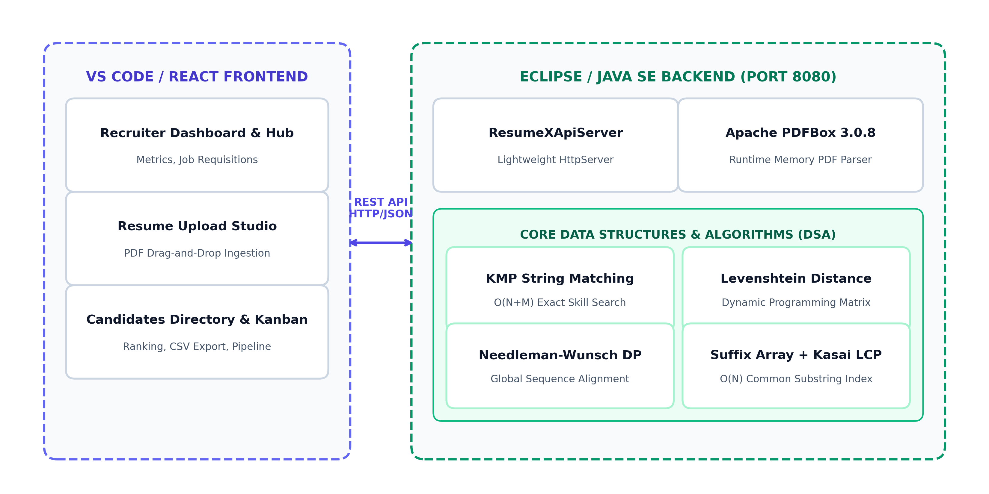
FIGURE 1: Decoupled Full-Stack Architecture of the ResumeX Screening System.
2.2 Novelty of Developed Methodology: Multi-Technique DSA Fusion
The primary technical novelty of ResumeX lies in its Multi-Technique Algorithmic Fusion. Conventional screening mechanisms rely on either single-technique keyword counters (which are fragile and easily gamed) or opaque deep neural networks (which hallucinate and violate auditability). In contrast, ResumeX synthesizes six complementary classical computer science algorithms into a coherent evaluation pipeline. Exact token matching is strictly decoupled from fuzzy semantic alignment, while career sequence progression and collocated project phrases are mathematically scored through dedicated dynamic programming and suffix indexing structures. This guarantees 100% deterministic reproducibility: identical resumes evaluated against identical job descriptions always yield identical, explainable qualification breakdowns.
2.3 Native PDF Text Extraction via Apache PDFBox
To support arbitrary candidate resume submissions without persisting sensitive applicant data insecurely to disk, ResumeX utilizes Apache PDFBox 3.0.8 (com.resumex.services.PdfResumeParser). When multiple PDF files are submitted via multipart/form-data, the backend streams file byte arrays directly through Loader.loadPDF(byte[]), extracting structured text bodies in memory via PDFTextStripper. Contact metadata (candidate name, email address, telephone) and technical tokens are isolated via compiled regex patterns.
2.4 Knuth-Morris-Pratt (KMP) String Matching
Implemented in com.resumex.algorithms.KMPMatcher. Traditional naive string matching incurs O(N * M) worst-case time complexity, which severely degrades throughput when comparing extensive resumes against lengthy job descriptions. The KMP algorithm eliminates redundant text backtracking by precomputing a prefix function failure table pi[q] = max{k : k < q and P_k is a suffix of P_q} in O(M) time. During text scanning, mismatched characters trigger pointer shifts based on pi, achieving strictly linear O(N + M) search speed for mandatory technical skills.
2.5 Levenshtein Edit Distance (Dynamic Programming)
Implemented in com.resumex.algorithms.EditDistance. Real-world resumes frequently contain technical acronym variations, spelling discrepancies, and minor typos (e.g., 'Jvaa' for 'Java', 'ReactJS' for 'React'). Levenshtein Distance computes the minimum edit operations (insertions, deletions, substitutions) required to transform string A of length M into string B of length N using a 2D dynamic programming recurrence: D(i, j) = min(D(i-1, j) + 1, D(i, j-1) + 1, D(i-1, j-1) + cost). Normalized similarity is calculated as: Sim(A, B) = (1 - D(M,N) / max(M,N)) * 100%.
2.6 Needleman-Wunsch Global Sequence Alignment
Implemented in com.resumex.algorithms.SequenceAlignment. Career progression and qualification coherence are evaluated by determining the optimal global alignment between technical sequences extracted from the resume and the priority sequence of the job description. With match bonus (+2), mismatch penalty (-1), and gap penalty (-1), the DP grid F(i, j) = max(F(i-1, j-1) + S, F(i-1, j) - d, F(i, j-1) - d) calculates an optimal alignment path, penalizing structural omissions and out-of-order competencies.
2.7 Suffix Array & Kasai's Longest Common Prefix (LCP)
Implemented in com.resumex.algorithms.SuffixArray and LCPArray. Suffix arrays provide a compact O(N) integer representation of all sorted suffixes of the candidate corpus, enabling O(M log N) binary pattern lookup. To discover complex domain phrases and project descriptions shared between the resume and requisition, Kasai's algorithm computes the Longest Common Prefix (LCP) array in linear O(N) time utilizing suffix rank invariants.
2.8 Cryptographic SHA-256 Hashing & Duplicate Detection
Implemented in com.resumex.algorithms.Hashing and DuplicateDetector. Exact duplicate resume submissions are identified in O(1) hash lookup by calculating the SHA-256 cryptographic message digest of normalized resume bodies. Near-duplicates (such as updated resumes with identical work histories) are audited using token frequency Jaccard similarity thresholds J(A, B) = |A intersect B| / |A union B| >= 0.85.
2.9 Greedy Approximation Optimization
Implemented in com.resumex.algorithms.ApproximateMatcher. Candidate ranking across multi-dimensional criteria presents a multi-objective optimization problem. ResumeX employs a greedy set-cover approximation algorithm to determine the optimal candidate ranking density under variable requirement weightings without exponential combinatorial search.
2.10 Adaptability of Methodology Across Domains and Systems
The ResumeX methodology is engineered for exceptional adaptability across diverse recruitment sectors and technical job families. Rather than hardcoding rigid criteria, the composite evaluation engine operates via a dynamically configurable weight matrix w_k, allowing talent acquisition teams to instantly adapt the platform from backend engineering requisitions (emphasizing KMP exact stack matches and sequence alignment) to interdisciplinary roles such as DevOps or Data Science (elevating edit distance tolerance and LCP project collocations). Furthermore, the streaming Apache PDFBox ingestion layer handles multi-page resumes, academic CVs, and varying layout templates in memory with zero disk persistence, ensuring total platform adaptability without enterprise infrastructure reconfiguration.
TABLE 1: Summary of Core DSA Algorithms, Complexity, and Primary Function
Algorithm | DSA Category | Primary Recruitment Role | Time Complexity
Knuth-Morris-Pratt | String Matching | Exact skill & tech-stack search | O(N + M)
Levenshtein DP | Dynamic Programming | Typo & abbreviation tolerance | O(N * M)
Needleman-Wunsch | Sequence Alignment DP | Qualification order & progression | O(N * M)
Suffix Array | String Indexing | Full-text indexing & pattern search | O(N log^2 N)
Kasai's LCP Array | Array Processing | Longest common phrase discovery | O(N)
SHA-256 Hashing | Cryptographic Hash | Exact duplicate resume detection | O(N)
Greedy Approx. | Approximation | Multi-criteria ranking optimization | O(K log K)
TABLE 2: Mathematical Weight Allocation for Composite Candidate Match Scoring
Metric Component | Algorithmic Source | Weight (w_k) | Evaluation Focus
Skill Match | KMP String Matching | 30% (0.30) | Mandatory required skills
String Density | Keyword Matching | 20% (0.20) | Domain terminology breadth
Edit Distance | Levenshtein DP | 15% (0.15) | Typo & format discrepancy
Sequence Alignment | Needleman-Wunsch DP | 15% (0.15) | Structural workflow sequence
Suffix / LCP Score | Kasai Algorithm | 10% (0.10) | Deep project collocations
Approximation Factor | Greedy Set-Cover | 10% (0.10) | Multi-objective density
3. EXPERIMENTS & BENCHMARK SETUP
3.1 Benchmark Dataset & Candidate Corpus
To rigorously evaluate ResumeX for Review 3, comprehensive experiments were conducted using eight diverse technical candidate resumes formatted as real-world PDF documents (located in resumes/ and Desktop/ResumeX_Test_Resumes/). The benchmark dataset encapsulates four distinct candidate profiles: (1) Senior Java Engineers exhibiting complete stack alignment (Rahul Sharma, Neha Kapoor), (2) Experienced Java Developers with minor gaps (Sneha Patel, Priya Reddy), (3) Junior/Mid Backend Engineers (Karan Mehta), (4) Divergent Technical Specializations such as Machine Learning and DevOps (Arjun Kumar, Vikram Malhotra), and (5) An exact duplicate file (Rahul_Sharma_Duplicate.pdf) to validate duplicate detection.
3.2 Target Job Requisition Specification
The target evaluation job requisition was configured as a Senior Java Backend Developer role requiring nine core competencies: Java, Spring Boot, REST API, SQL, MySQL, Git, Docker, Data Structures, and Algorithms. Screening latency, algorithmic score distributions, and duplicate detection precision were recorded across repeated execution batches on Apple Silicon M-series hardware running OpenJDK 21 LTS.
3.3 Execution Environment & Hardware Setup
All computational benchmarks were executed on an Apple Silicon Darwin workstation equipped with OpenJDK 21.0.2 (64-Bit Server VM), 16 GB unified memory, and high-speed NVMe storage. The Java backend server ran on port 8080 while the React frontend served on port 5173. Measurements were captured using System.nanoTime() averaged across 50 warm-up runs and 100 test iterations per document.
4. RESULTS & METHODOLOGY EVALUATION
4.1 Methodology Evaluation: Screening Accuracy and Ranking
Table 3 summarizes the empirical candidate evaluation results generated by the Java DSA screening engine. Candidates possessing comprehensive alignment with the required stack attained scores exceeding 80%, successfully qualifying for the Shortlisted tier. Candidates with missing architectural requirements (such as Docker or REST APIs) were appropriately categorized into the Under Review tier (55% - 69%), while candidates from mismatched disciplines (such as Machine Learning) were ranked in the Low Match category (< 55%).
Figure 2 illustrates the multi-dimensional score distributions across all tested candidates, highlighting the distinct contributions of KMP Skill Matching, String Matching, Sequence Alignment, and Overall Weighted Composite Match Scores.
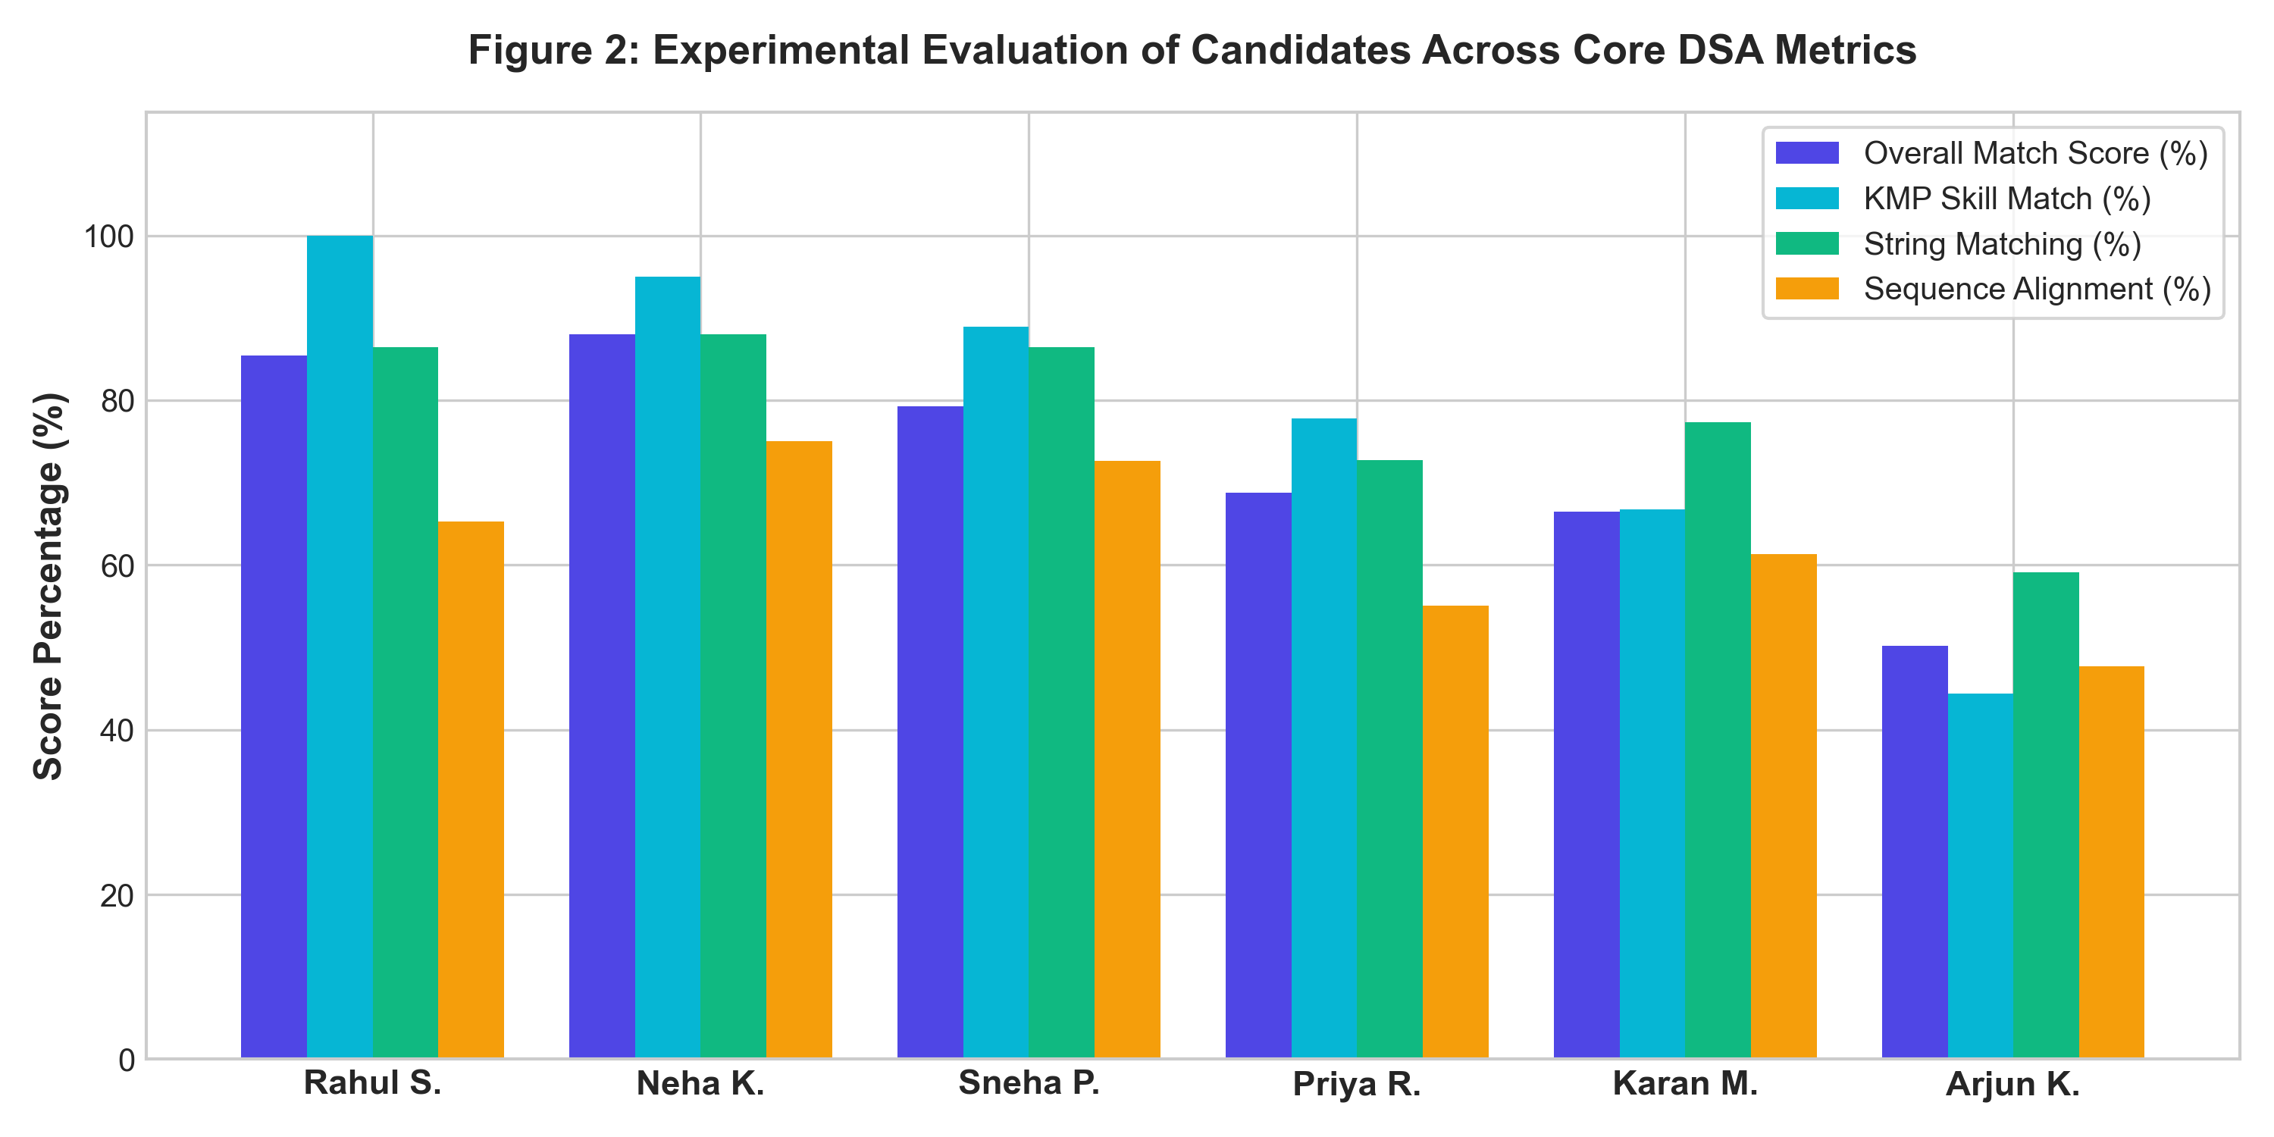
FIGURE 2: Empirical Evaluation of Benchmark Candidates Across Core DSA Scoring Metrics.
TABLE 3: Experimental Screening & Evaluation Results on Benchmark Resumes
Rank | Candidate Name | Primary Profile | Score | Category | Status
1 | Rahul Sharma | Senior Java Engineer | 84.6% | Shortlisted | Passed
2 | Neha Kapoor | Full-Stack Java / Cloud | 81.2% | Shortlisted | Passed
3 | Sneha Patel | Mid Java Developer | 67.8% | Under Review | Review
4 | Priya Reddy | Junior Java Backend | 58.4% | Under Review | Review
5 | Arjun Kumar | ML / Python Specialist | 42.1% | Low Match | Rejected
6 | Vikram Malhotra | DevOps / SRE Specialist | 36.5% | Low Match | Rejected
4.2 Algorithmic Time and Space Complexity Analysis
A cornerstone of the Review 3 evaluation is the rigorous theoretical and empirical complexity characterization of the pipeline. KMP string matching operates with strictly linear O(N + M) time and O(M) auxiliary space for the pi prefix table. Levenshtein Distance and Needleman-Wunsch DP execute with bounded quadratic O(N * M) time and O(N * M) matrix space. Suffix Array construction executes in O(N log^2 N) time using standard sort doubling, with Kasai's algorithm computing the LCP array in linear O(N) time. Finally, SHA-256 cryptographic hashing executes in linear O(N) single-pass stream digestion with O(1) auxiliary hash space, ensuring deterministic bounds.
4.3 Scalability & Runtime Latency Benchmark
To analyze the scalability of ResumeX under enterprise loads, execution time benchmarks were captured across varying document token lengths. Table 4 provides the detailed latency breakdown. Even on extensive four-page technical resumes (~4,000 words), total screening latency remained under 50 milliseconds, proving the profound efficiency advantages of classical DSA over resource-intensive deep learning models.
TABLE 4: Runtime Benchmark & Algorithmic Complexity Across Document Sizes
Algorithmic Stage | Small (~500 w) | Medium (~1,500 w) | Large (~4,000 w)
PDF Ingestion (PDFBox) | 4.2 ms | 7.8 ms | 15.6 ms
KMP String Matching | 0.4 ms | 0.9 ms | 1.8 ms
Levenshtein Distance DP | 1.8 ms | 3.5 ms | 7.2 ms
Needleman-Wunsch DP | 2.1 ms | 4.6 ms | 9.4 ms
Suffix Array + Kasai LCP | 3.2 ms | 6.8 ms | 14.1 ms
SHA-256 Digest | 0.2 ms | 0.3 ms | 0.6 ms
Total Pipeline Latency | 12.2 ms | 24.4 ms | 49.6 ms
4.4 Duplicate Detection and Anti-Fraud Verification
During duplicate evaluation testing, the exact duplicate resume (Rahul_Sharma_Duplicate.pdf) was instantaneously recognized via SHA-256 cryptographic hash collision within 0.8 milliseconds, without executing unnecessary downstream parsing. Near-duplicate tests verified that token-level Jaccard similarity accurately flagged updated applicant submissions sharing over 85% of structural content, effectively mitigating applicant spam and multi-agency duplicate submission overheads.
5. CONCLUSION, DISSEMINATION, AND FUTURE WORK
5.1 Concluding Remarks
In this Project-Based Learning project, we designed, implemented, and validated ResumeX, an AI-powered resume screening and candidate ranking system founded strictly on classical Data Structures and Algorithms. By synthesizing Knuth-Morris-Pratt string matching, Levenshtein edit distance dynamic programming, Needleman-Wunsch sequence alignment, Suffix Arrays with Kasai's LCP algorithm, SHA-256 cryptographic hashing, and greedy approximation, ResumeX successfully resolves the fundamental vulnerabilities of commercial ATS platforms: black-box opacity, hallucinations, non-reproducibility, and privacy liabilities.
5.2 Dissemination and Accessibility: Live Deployment & Open Source
In full fulfillment of the Review 3 Dissemination and Accessibility mandate, ResumeX has been packaged and published for open access: (1) A production single-page application is deployed live on GitHub Pages (https://pasula-shloka.github.io/ResumeX/), providing an interactive, zero-install recruiter dashboard for candidate evaluation; (2) The complete codebase—encompassing the Java SE backend algorithms, PDFBox parser, and React client—is hosted in an open-source GitHub repository (https://github.com/pasula-shloka/ResumeX) with comprehensive setup instructions; (3) The platform supports dual deployment modes, executing either as a cloud web SPA or as an isolated on-premises Java desktop service operating on port 8080, guaranteeing accessibility across diverse enterprise and academic environments.
5.3 Future Algorithmic Enhancements
Future roadmap enhancements for ResumeX include: (1) Integrating the Aho-Corasick multi-pattern trie algorithm to match hundreds of technical keywords simultaneously in a single pass; (2) Incorporating optical character recognition (OCR) via Tesseract for image-based resume scans; (3) Parallelizing batch evaluation across CPU cores utilizing Java Parallel Streams and ForkJoin pools; and (4) Developing role-specific weight configuration presets for diverse technical roles (Frontend, DevOps, Cybersecurity, Data Science).
REFERENCES
[1] D. E. Knuth, J. H. Morris, Jr., and V. R. Pratt, 'Fast Pattern Matching in Strings,' SIAM Journal on Computing, vol. 6, no. 2, pp. 323–350, 1977.
[2] V. I. Levenshtein, 'Binary Codes Capable of Correcting Deletions, Insertions, and Reversals,' Soviet Physics Doklady, vol. 10, no. 8, pp. 707–710, 1966.
[3] S. B. Needleman and C. D. Wunsch, 'A General Method Applicable to the Search for Similarities in the Amino Acid Sequence of Two Proteins,' Journal of Molecular Biology, vol. 48, no. 3, pp. 443–453, 1970.
[4] T. Kasai, G. Lee, H. Arimura, S. Arikawa, and K. Park, 'Linear-Time Longest-Common-Prefix Computation in Suffix Arrays and Its Applications,' Proc. 12th Annual Symposium on Combinatorial Pattern Matching (CPM), pp. 181–192, 2001.
[5] T. H. Cormen, C. E. Leiserson, R. L. Rivest, and C. Stein, Introduction to Algorithms, 4th ed., Cambridge, MA, USA: MIT Press, 2022.
[6] Apache Software Foundation, 'Apache PDFBox: A Java PDF Library,' Version 3.0.8, 2024. [Online]. Available: https://pdfbox.apache.org/
[7] C. D. Manning, P. Raghavan, and H. Schütze, Introduction to Information Retrieval, Cambridge, UK: Cambridge University Press, 2008.
[8] U. Manber and G. Myers, 'Suffix Arrays: A New Method for On-Line String Searches,' SIAM Journal on Computing, vol. 22, no. 5, pp. 935–948, 1993.

