Bluestock Mutual Fund Capstone Project

Final Project Report

Prepared By:
Anusha

Tools Used:
Python
SQL
Power BI
GitHub

Submission Date:
June 2026

EXECUTIVE SUMMARY

The mutual fund industry has become one of the most important investment avenues for both individual and institutional investors. With increasing financial awareness and growing participation in SIPs, the industry has experienced significant growth. This project was developed to analyze mutual fund performance, investor behavior, portfolio concentration, and risk management using data analytics techniques.
The Bluestock Mutual Fund Capstone integrates datasets related to mutual fund schemes, investor transactions, NAV history, portfolio holdings, AUM, and benchmark indices. The objective was to transform raw financial data into meaningful business insights through data cleaning, analysis, and visualization.
The project involved data extraction, preprocessing, handling missing values, removing duplicates, and standardizing records to ensure data quality. Exploratory Data Analysis (EDA) was performed to study AUM growth, SIP trends, investor demographics, state-wise investments, and category inflows.
Performance evaluation was conducted using Alpha, Beta, Sharpe Ratio, Sortino Ratio, Standard Deviation, and Maximum Drawdown. Risk analysis was further enhanced using VaR and CVaR methodologies.
Advanced analytics such as Rolling Sharpe Ratio, Investor Cohort Analysis, SIP Continuity Analysis, Fund Recommendation System, and HHI concentration analysis were implemented to generate deeper insights.
The project concluded with the development of an interactive Power BI dashboard that enables users to explore industry trends, compare fund performance, analyze investor behavior, and assess risk metrics through dynamic visualizations.
Overall, the project demonstrates the practical application of Python, SQL, Power BI, and financial analytics in solving real-world mutual fund investment challenges and supporting data-driven decision-making.

PROJECT OBJECTIVES

The Bluestock Mutual Fund Capstone Project was developed to build a comprehensive analytics solution for the mutual fund industry using Python, SQL, and Power BI. The project focuses on transforming raw financial data into meaningful insights that support better investment decisions.
The primary objective was to establish a robust ETL pipeline capable of extracting, cleaning, transforming, and loading data from multiple sources. This ensured data quality, consistency, and reliability throughout the analysis process.
Another objective was to perform Exploratory Data Analysis (EDA) to identify patterns, trends, and relationships within mutual fund and investor datasets. This included analysing AUM growth, SIP inflows, investor demographics, and investment distributions.
The project also aimed to evaluate mutual fund performance using key financial metrics such as Alpha, Beta, Sharpe Ratio, Sortino Ratio, and Standard Deviation. These measures provide insights into fund returns and associated risks.
Advanced analytics techniques including VaR, CVaR, Rolling Sharpe Ratio, Investor Cohort Analysis, SIP Continuity Analysis, and HHI concentration analysis were implemented to gain deeper insights into investment behavior and portfolio risks.
The project further focused on understanding investor preferences based on age groups, geographic locations, transaction patterns, and investment types. These insights help identify market trends and investor participation levels across different segments.
A recommendation engine was developed to suggest suitable mutual funds based on investor risk appetite. This feature demonstrates how analytics can support personalized investment decision-making.
Special attention was given to risk management and portfolio diversification. By analysing concentration levels and historical performance, the project provides a framework for evaluating investment stability and long-term sustainability.
Finally, the project aimed to develop an interactive Power BI dashboard that enables users to visualize industry trends, compare fund performance, analyse investor behaviour, and make data-driven investment decisions. The dashboard serves as a centralized platform for presenting all analytical findings in an easy-to-understand format.

DATA SOURCES

The Bluestock Mutual Fund Capstone Project utilizes multiple datasets to analyze mutual fund performance, investor behavior, industry growth, and portfolio composition. These datasets were collected, cleaned, and integrated to provide a comprehensive view of the mutual fund ecosystem.
The Fund Master dataset serves as the primary reference table containing details about mutual fund schemes, categories, fund houses, and investment plans. This dataset was used to establish relationships between different data sources.
The AUM (Assets Under Management) dataset provides information regarding the total assets managed by various fund houses and schemes. This data helps in understanding industry growth and fund popularity over time.
The Monthly SIP Inflows dataset contains information about systematic investment plan contributions made by investors. Analysis of this dataset provides insights into investment trends and investor participation.
The NAV History dataset stores historical Net Asset Value information for mutual fund schemes. This dataset was used for return calculations, performance evaluation, and risk analysis.
The Investor Transactions dataset includes transaction details such as investment amount, transaction type, location, and demographic information. It helps in understanding investor behavior and investment patterns.
The Scheme Performance and Portfolio Holdings datasets provide performance metrics, risk measures, and portfolio allocation details that support advanced analytics and concentration analysis throughout the project.

ETL DESIGN

The ETL (Extract, Transform, Load) process played a crucial role in preparing the mutual fund datasets for analysis and visualization. A structured ETL pipeline was developed to ensure data quality, consistency, and reliability throughout the project lifecycle.
The Extract phase involved collecting raw datasets from multiple sources, including fund master data, AUM reports, SIP inflows, NAV history, investor transactions, scheme performance records, and portfolio holdings. These datasets were available in CSV format and contained information related to mutual fund schemes, investors, transactions, and portfolio allocations.
During the Transform phase, extensive data cleaning and preprocessing activities were performed. Missing values were identified and handled appropriately, duplicate records were removed, and incorrect data formats were corrected. Data types such as dates, numerical values, and categorical fields were standardized to maintain consistency across all datasets. Additional validation checks were performed to ensure the accuracy and completeness of the data.
Several transformations were also applied to improve analysis readiness. New calculated fields were created, column names were standardized, and relationships between datasets were established using common identifiers such as AMFI codes and dates. These transformations helped create a unified and structured data model.
The Load phase involved storing the cleaned and processed datasets for further analysis. The transformed datasets were used in Python notebooks for analytics and imported into Power BI for dashboard development. Proper data organization enabled efficient querying, reporting, and visualization.
The ETL pipeline significantly improved data quality and ensured that all subsequent analyses were based on accurate and reliable information. This process formed the foundation for EDA, performance analytics, advanced risk analysis, and dashboard reporting conducted throughout the project.

EXPLORATORY DATA ANALYSIS (EDA) FINDINGS

Exploratory Data Analysis (EDA) was conducted to understand the structure, trends, and patterns present within the mutual fund datasets. The primary objective of EDA was to uncover meaningful insights that could support performance evaluation, investor analysis, and decision-making.
One of the key analyses performed was the study of Assets Under Management (AUM) growth. The results showed a consistent increase in AUM over time, indicating growing investor confidence in mutual fund investments. This trend reflects the expanding reach of financial products and increasing participation in investment markets.
Systematic Investment Plan (SIP) inflows were also analyzed to understand investor contribution patterns. The findings revealed a steady increase in SIP investments, highlighting the growing preference for disciplined and long-term investment strategies among retail investors.
Additional analyses were conducted on investor demographics, transaction behavior, and fund categories. These analyses helped identify variations in investment patterns across different regions, age groups, and investor segments. The results demonstrated that certain demographic groups contributed significantly more to overall investment activity.
Category-wise analysis showed differences in fund popularity and investment inflows. Equity-oriented funds attracted substantial investor interest due to their long-term growth potential, while other categories offered stability and diversification benefits.
Overall, the EDA phase provided valuable insights into industry growth, investor participation, and market trends. These findings established a strong foundation for advanced analytics, performance evaluation, and dashboard development carried out in later stages of the project.

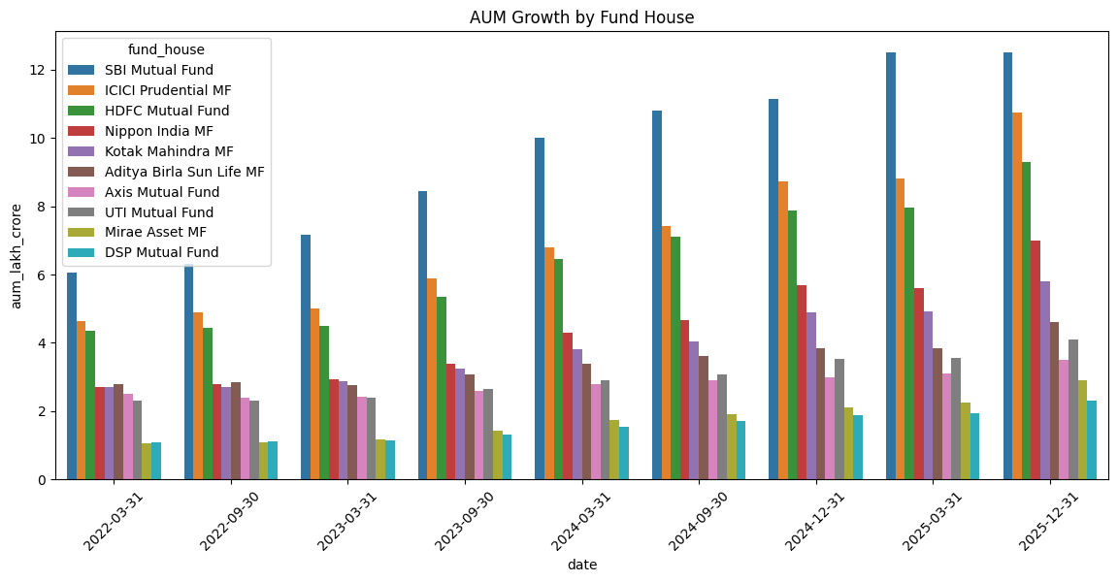

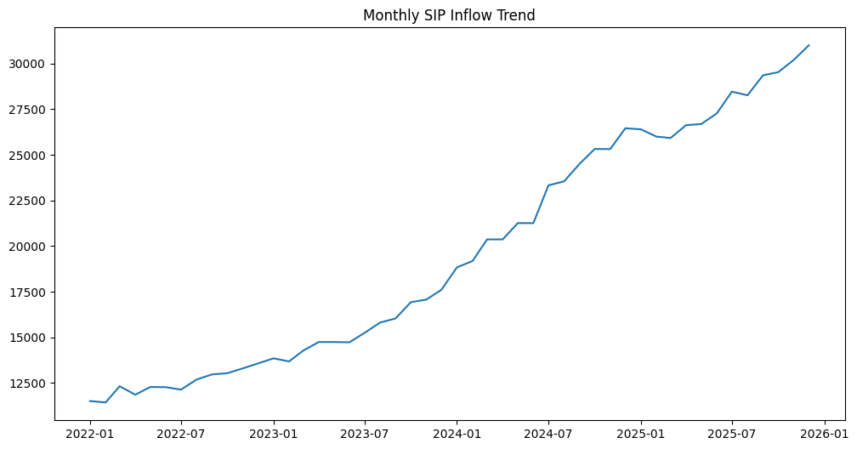

INVESTOR ANALYTICS
Investor Analytics was performed to understand the behavior, preferences, and demographic characteristics of mutual fund investors. By analyzing investor transaction data, valuable insights were obtained regarding investment patterns, regional participation, and demographic trends.
The age group analysis revealed that investors between the ages of 26 and 45 formed the largest segment of mutual fund participants. This age group represents working professionals who actively invest for wealth creation, retirement planning, and financial security. Younger investors also showed increasing participation, indicating growing awareness of investment opportunities.
Gender distribution analysis highlighted the contribution of different investor groups to the mutual fund industry. While male investors represented a significant portion of the investment base, female participation has been steadily increasing, reflecting greater financial inclusion and investment awareness.
State-wise investment analysis was conducted to identify geographic patterns in investor activity. Certain states contributed a larger share of investments due to higher levels of financial literacy, urbanization, and economic development. These regions demonstrated stronger participation in SIPs and long-term investment products.
Transaction analysis further revealed that SIP-based investments accounted for a substantial portion of investor activity. This trend highlights the growing adoption of disciplined investing practices among retail investors. Consistent SIP contributions also indicate increasing confidence in mutual funds as a long-term wealth creation tool.
Overall, investor analytics provided valuable insights into demographic trends, investment behavior, and regional participation. These findings help financial institutions and fund managers better understand investor needs and design products that align with market demand.
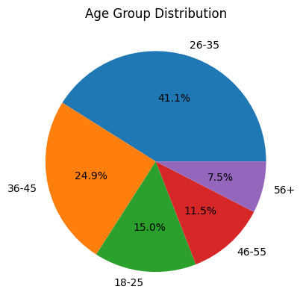
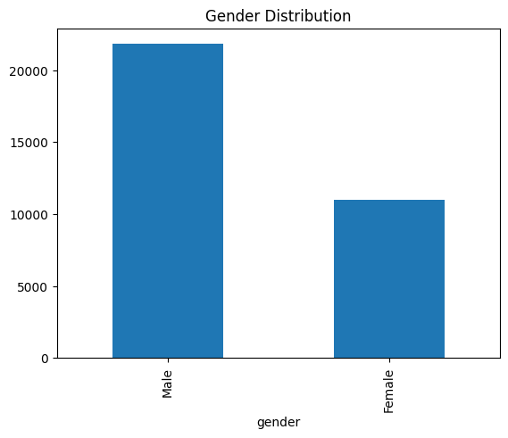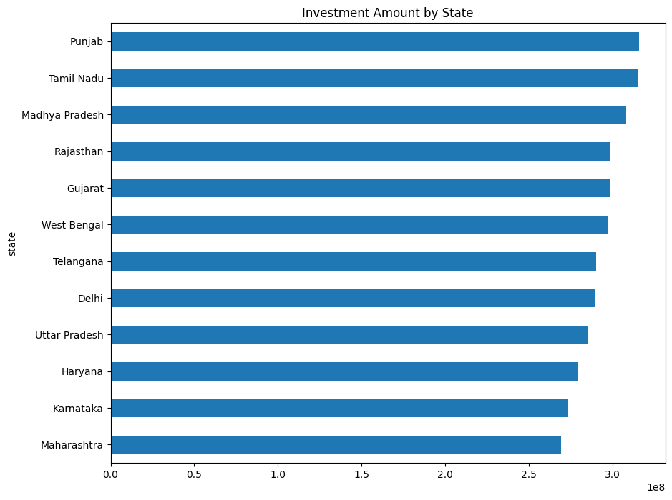
PERFORMANCE ANALYTICS
Performance Analytics was conducted to evaluate the effectiveness and efficiency of mutual fund schemes using key financial performance indicators. These metrics provide valuable insights into fund returns, risk-adjusted performance, and overall investment quality.
Several performance measures were analyzed, including Alpha, Beta, Sharpe Ratio, Sortino Ratio, Standard Deviation, Expense Ratio, and Assets Under Management (AUM). These indicators help investors compare funds and make informed investment decisions based on both returns and risk.
Alpha measures the excess return generated by a fund compared to its benchmark. Funds with positive Alpha values indicate superior performance and effective fund management. Beta measures the sensitivity of a fund's returns relative to market movements. A higher Beta indicates greater volatility, while a lower Beta suggests relatively stable performance.
The Sharpe Ratio was used to evaluate risk-adjusted returns by comparing excess returns against total risk. Funds with higher Sharpe Ratios demonstrated better performance relative to the amount of risk taken. Similarly, the Sortino Ratio focused specifically on downside risk and provided additional insight into fund stability.
Benchmark comparison analysis was performed to determine how various schemes performed against their respective benchmark indices. The results highlighted funds that consistently outperformed market benchmarks and delivered superior long-term returns.
Overall, the performance analytics phase helped identify top-performing schemes, assess risk-return characteristics, and evaluate the effectiveness of fund management strategies. These findings serve as an important foundation for investment evaluation and portfolio selection.
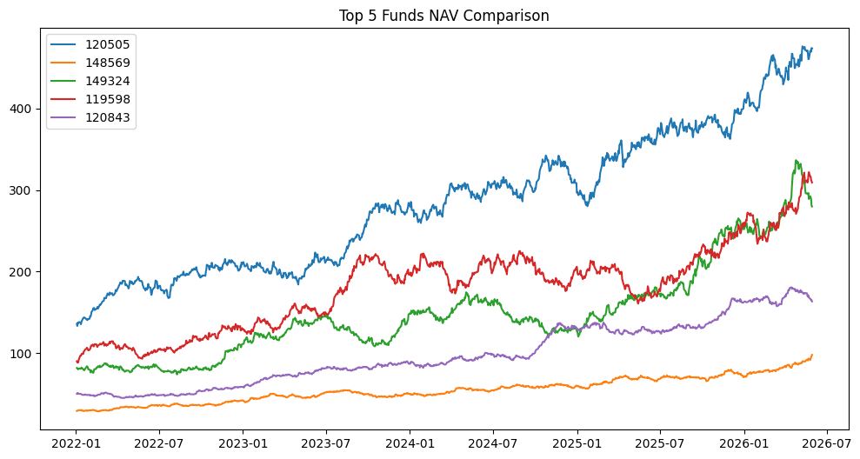
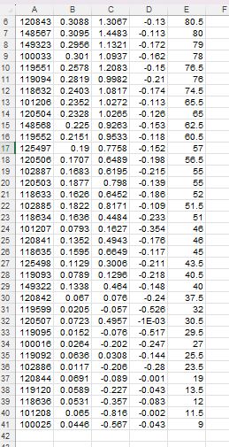
RISK ANALYSIS
Risk Analysis was performed to evaluate the potential uncertainties and volatility associated with mutual fund investments. Understanding risk is essential for investors as it helps them balance expected returns with potential losses and make informed financial decisions.
Several risk-related metrics were analyzed throughout the project, including Risk Grade, Standard Deviation, Maximum Drawdown, Value at Risk (VaR), and Conditional Value at Risk (CVaR). These measures provide insights into the stability and risk profile of mutual fund schemes.
The Risk Grade analysis categorized funds into different risk levels based on their investment characteristics and market exposure. Funds classified under higher risk grades generally offered greater return potential but were also subject to increased market volatility. Conversely, lower-risk funds provided more stable returns with reduced fluctuations.
Return distribution analysis was conducted to understand the spread and variability of fund returns. The results indicated that certain categories of funds exhibited wider return ranges, reflecting higher volatility. Other categories showed relatively consistent performance with lower levels of risk.
Risk assessment also highlighted the importance of diversification in reducing portfolio exposure. Investors who maintain diversified portfolios across multiple sectors and fund categories can potentially reduce overall investment risk while improving long-term stability.
The findings from this analysis provide valuable guidance for investors when selecting funds based on their financial goals, investment horizon, and risk tolerance. Effective risk management remains a critical component of successful portfolio construction and wealth creation.
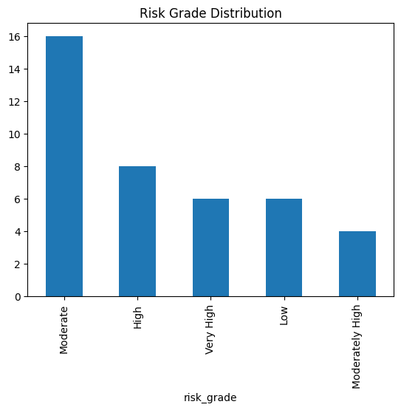
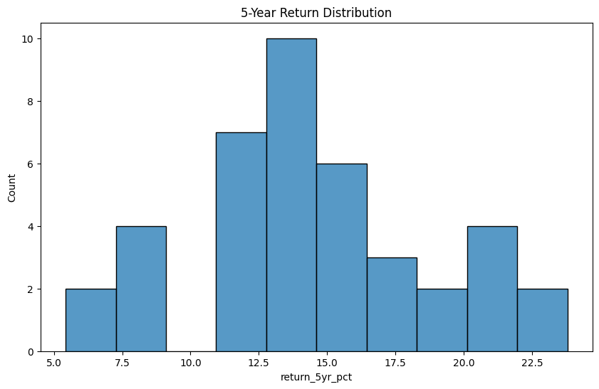

VALUE AT RISK (VaR) AND CONDITIONAL VALUE AT RISK (CVaR)
Value at Risk (VaR) and Conditional Value at Risk (CVaR) were calculated to measure the downside risk associated with mutual fund investments. These metrics are widely used in financial risk management to estimate potential losses under adverse market conditions.
Historical VaR at a 95% confidence level was computed using the daily return distribution of mutual fund schemes. VaR represents the maximum expected loss that may occur over a given period under normal market conditions. A higher VaR value indicates greater exposure to market risk and larger potential losses.
Conditional Value at Risk (CVaR), also known as Expected Shortfall, extends the VaR analysis by measuring the average loss beyond the VaR threshold. While VaR identifies the minimum expected loss level, CVaR provides additional insight into the severity of losses during extreme market events.
The analysis revealed differences in risk exposure across various mutual fund schemes. Funds with higher volatility generally exhibited larger VaR and CVaR values, indicating greater downside risk. Conversely, diversified and lower-risk funds demonstrated relatively stable risk profiles.
These findings help investors understand the potential impact of adverse market movements on their investments. VaR and CVaR serve as important risk management tools that support portfolio construction, fund selection, and long-term investment planning.
Overall, the VaR and CVaR analysis provided a comprehensive assessment of downside risk and highlighted the importance of balancing return expectations with risk tolerance when making investment decisions.
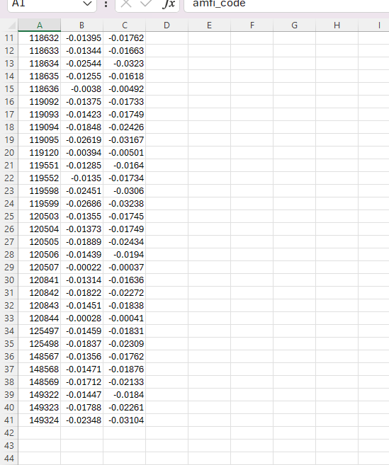
Figure 10: VaR and CVaR Analysis Report

ROLLING SHARPE RATIO ANALYSIS
The Rolling Sharpe Ratio Analysis was conducted to evaluate the consistency of risk-adjusted returns over time. Unlike the traditional Sharpe Ratio, which provides a single performance measure for an entire period, the rolling approach calculates the Sharpe Ratio across a moving time window. This allows investors to observe how fund performance changes under different market conditions.
In this project, a 90-day rolling window was used to calculate the Rolling Sharpe Ratio for selected mutual fund schemes. The ratio was computed using the average daily returns divided by the standard deviation of returns and annualized using the square root of 252 trading days.
The analysis revealed fluctuations in risk-adjusted performance throughout the observation period. Certain funds maintained consistently positive Sharpe Ratios, indicating stable returns relative to the level of risk undertaken. Other funds experienced significant variations due to market volatility and changing economic conditions.
Rolling Sharpe Ratio analysis is particularly useful for identifying periods of strong and weak fund performance. Investors can use this information to evaluate fund stability, compare investment options, and assess the effectiveness of portfolio management strategies.
The results demonstrated that funds with higher and more stable Rolling Sharpe Ratios generally delivered better long-term risk-adjusted performance. These funds may be more suitable for investors seeking consistent returns while managing investment risk.
Overall, the Rolling Sharpe Ratio provides a dynamic view of mutual fund performance and serves as an important tool for monitoring portfolio quality over time. The analysis enhances traditional performance evaluation by incorporating both return generation and risk management perspectives.
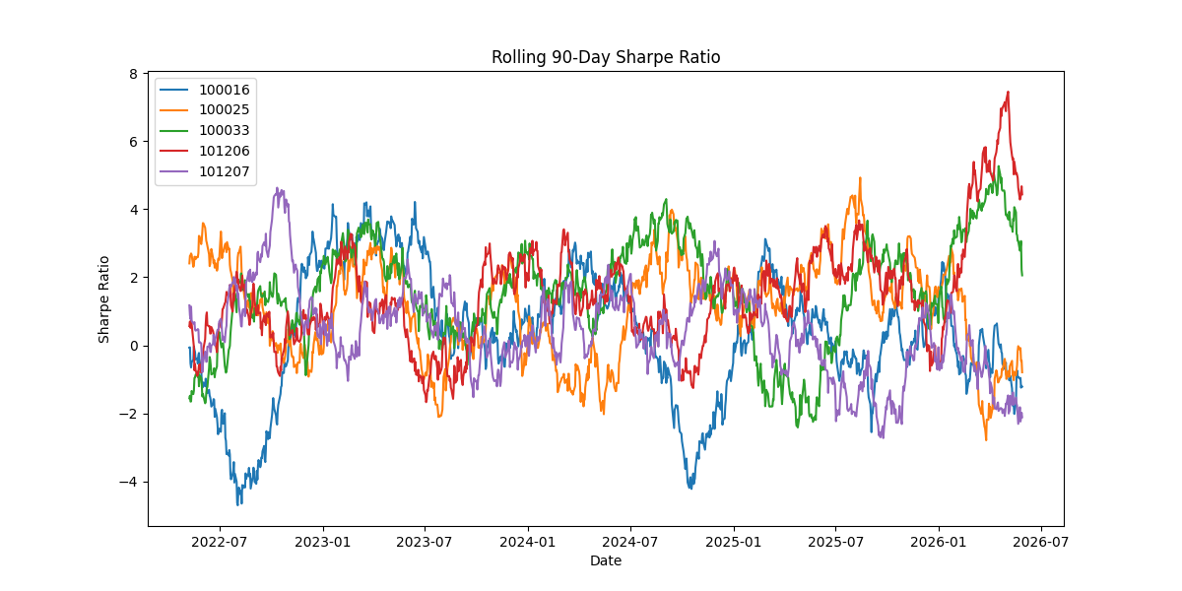
Figure 11: Rolling 90-Day Sharpe Ratio Analysis

FUND RECOMMENDATION SYSTEM
A Fund Recommendation System was developed as part of the advanced analytics phase to assist investors in selecting suitable mutual funds based on their risk appetite. The objective of this system is to simplify investment decision-making by providing personalized fund recommendations using quantitative performance metrics.
The recommendation engine categorizes investors into three primary risk profiles: Low Risk, Moderate Risk, and High Risk. Based on the selected risk category, the system evaluates mutual fund schemes and identifies the top-performing funds using Sharpe Ratio rankings and risk grades.
For low-risk investors, the system prioritizes funds that offer stable returns with lower volatility and reduced exposure to market fluctuations. Moderate-risk investors are recommended balanced funds that provide a combination of growth potential and stability. High-risk investors receive recommendations focused on funds with higher return potential and greater market exposure.
The recommendation process incorporates historical performance data, risk-adjusted return measures, and fund risk classifications. This approach ensures that suggested funds align with the investor's financial goals and risk tolerance.
The system demonstrates how data analytics and financial metrics can be applied to create practical investment tools. By automating fund selection based on objective criteria, the recommendation engine reduces decision complexity and helps investors identify suitable investment opportunities.
Overall, the Fund Recommendation System adds significant value to the project by combining financial analysis with data-driven decision support. It serves as a simple yet effective example of how analytics can be used to improve investment planning and portfolio management.
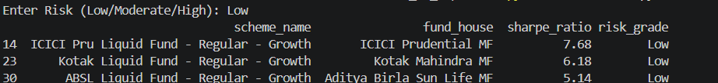
Figure 12: Fund Recommendation System Output
The Fund Recommendation System successfully generated recommendations based on the selected investor risk profile. For the Low Risk category, the system identified liquid funds with high Sharpe Ratios and stable performance characteristics. The recommendations were generated using risk classification and risk-adjusted return metrics. This demonstrates the practical application of analytics in supporting investment decision-making and portfolio selection.

PORTFOLIO CONCENTRATION ANALYSIS (HHI)
Portfolio Concentration Analysis was performed using the Herfindahl-Hirschman Index (HHI) to evaluate the diversification level of mutual fund portfolios. The HHI is a widely used measure of concentration that helps determine whether a portfolio is well diversified or heavily concentrated in a few holdings.
The HHI was calculated by summing the squared portfolio weights of individual holdings within each mutual fund scheme. Lower HHI values indicate a well-diversified portfolio, while higher HHI values suggest concentration in a limited number of stocks or sectors. Diversification is important because it helps reduce portfolio risk and minimize the impact of poor performance from individual holdings.
The analysis revealed significant variation in concentration levels across different mutual fund schemes. Some funds maintained highly diversified portfolios with exposure across multiple sectors and companies, while others exhibited higher concentration levels due to larger allocations in selected holdings.
Sector allocation analysis was also performed to understand the distribution of investments across various industries. The results showed that sectors such as Financial Services, Information Technology, Healthcare, Consumer Goods, and Energy accounted for a substantial portion of portfolio allocations. The level of diversification across sectors played a key role in determining portfolio stability and risk exposure.
Funds with lower concentration levels generally demonstrated better diversification benefits and reduced dependence on the performance of individual stocks. Conversely, highly concentrated portfolios may generate higher returns during favorable market conditions but are also exposed to greater downside risk.
Overall, the HHI analysis provided valuable insights into portfolio construction and diversification quality. The findings highlight the importance of maintaining balanced portfolio allocations to achieve sustainable long-term investment performance while effectively managing risk.
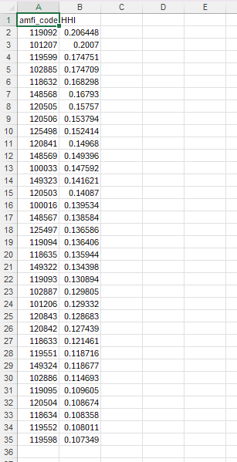
Figure 13: Herfindahl-Hirschman Index (HHI) Report
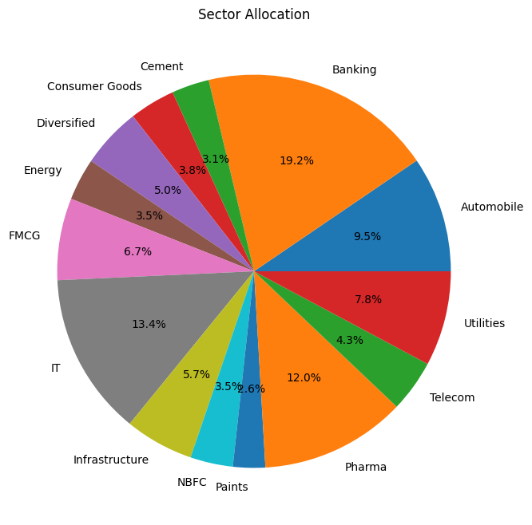
Figure 14: Sector Allocation Analysis

DASHBOARD OVERVIEW
The final phase of the Bluestock Mutual Fund Capstone Project involved the development of an interactive Power BI dashboard designed to present analytical findings in a clear, visual, and user-friendly format. The dashboard serves as a centralized platform that enables users to explore mutual fund performance, investor behavior, industry trends, and risk metrics.
The dashboard was developed using cleaned and transformed datasets generated through the ETL process. Multiple visualizations, including charts, tables, KPIs, slicers, and filters, were incorporated to enhance data exploration and decision-making capabilities. Users can dynamically interact with the dashboard to view specific insights based on categories, risk grades, schemes, and investor segments.
The dashboard is organized into multiple analytical sections, each focusing on a specific business objective. These sections include industry growth analysis, fund performance evaluation, investor analytics, SIP trends, risk assessment, and portfolio concentration analysis. This structure ensures that users can easily navigate between different perspectives of the mutual fund ecosystem.
Interactive filters allow users to customize views and compare different fund categories, performance metrics, and demographic groups. This functionality improves accessibility and enables deeper analytical exploration without requiring technical expertise.
The dashboard successfully transforms complex financial data into meaningful visual insights. It provides investors, analysts, and decision-makers with a comprehensive understanding of market trends, investment performance, and risk exposure.
Overall, the Power BI dashboard represents the culmination of the project by combining data engineering, analytics, and visualization techniques into a single decision-support solution that enhances the interpretation and communication of mutual fund insights.
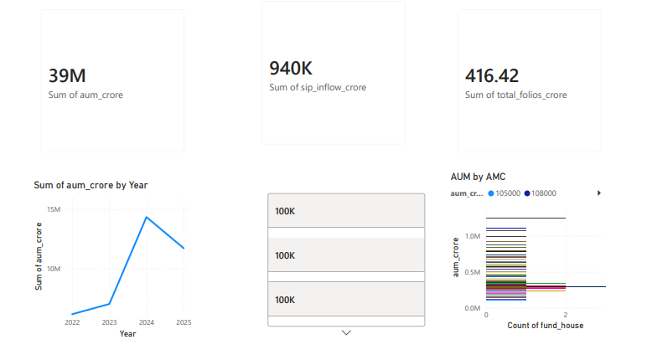
Figure 15: Industry Overview Dashboard
FUND PERFORMANCE DASHBOARD
The Fund Performance Dashboard was developed to provide a detailed view of mutual fund performance across different schemes and categories. The dashboard enables users to compare key financial metrics and identify funds that deliver superior risk-adjusted returns.
Several performance indicators were incorporated into the dashboard, including Alpha, Beta, Sharpe Ratio, Sortino Ratio, Standard Deviation, Expense Ratio, and Assets Under Management (AUM). These metrics allow investors to evaluate both return potential and associated risk levels before making investment decisions.
Interactive charts and tables were used to compare funds against benchmark indices and peer groups. Users can filter data based on fund categories, risk grades, and fund houses to perform customized analysis. This functionality enhances the usability of the dashboard and supports deeper exploration of performance trends.
The dashboard highlights top-performing schemes and identifies funds that consistently outperform their benchmarks. It also enables users to assess the impact of volatility on investment returns and evaluate the effectiveness of fund management strategies.
By presenting performance metrics in a visual and interactive format, the dashboard simplifies complex financial information and improves decision-making. Investors can quickly identify suitable investment opportunities based on their return expectations and risk preferences.
Overall, the Fund Performance Dashboard serves as a valuable analytical tool that supports performance evaluation, fund comparison, and investment planning within the mutual fund industry.
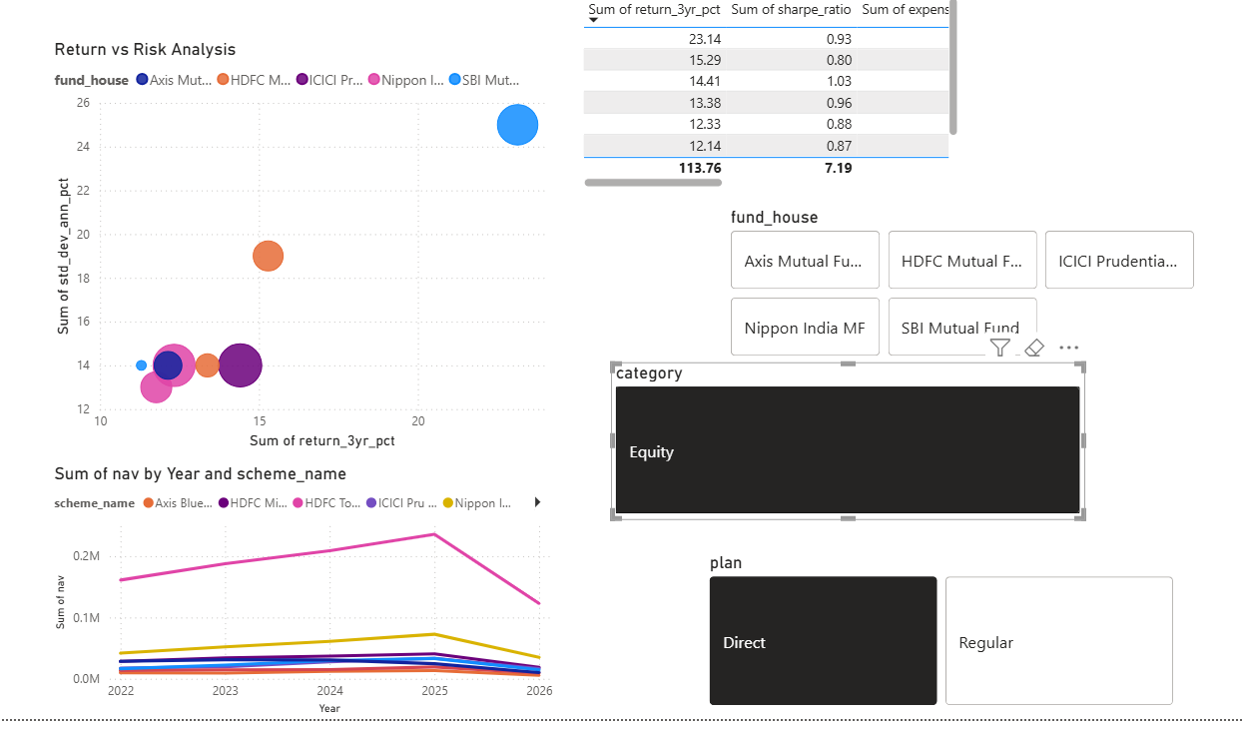
Figure 16: Fund Performance Dashboard

INVESTOR ANALYTICS DASHBOARD
The Investor Analytics Dashboard was designed to provide detailed insights into investor demographics, transaction behavior, and regional investment patterns. The dashboard enables users to analyze investor participation across different age groups, genders, states, and income categories.
Various visualizations were incorporated to highlight investment trends and demographic distributions. These visualizations help identify key investor segments and understand the factors influencing mutual fund participation. The dashboard also provides insights into transaction volumes and investment amounts across different regions.
Age group analysis revealed that working-age individuals contributed the largest share of investments. State-wise investment analysis highlighted the concentration of mutual fund participation in economically developed regions. Gender-based analysis demonstrated increasing participation from diverse investor groups.
Interactive filters allow users to explore investor behavior across multiple dimensions and compare demographic segments. This functionality improves analytical flexibility and supports targeted business insights.
The dashboard plays an important role in understanding customer behavior and identifying opportunities for market expansion. Financial institutions can use these insights to improve investor engagement, product development, and customer acquisition strategies.
Overall, the Investor Analytics Dashboard transforms transaction-level data into meaningful business intelligence and provides valuable support for investment and marketing decisions.
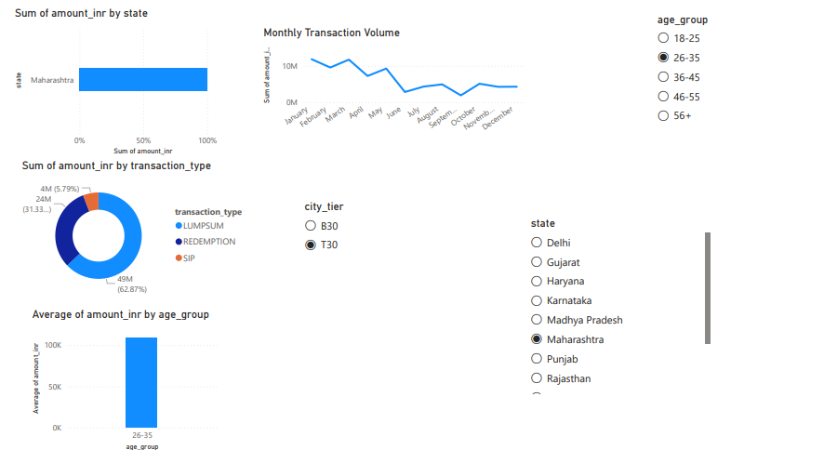
Figure 17: Investor Analytics Dashboard

SIP TRENDS AND INDUSTRY INFLOW DASHBOARD
The SIP Trends Dashboard was developed to analyze systematic investment plan contributions and industry-wide fund inflow patterns. SIPs have become one of the most popular investment methods among retail investors due to their simplicity, affordability, and long-term wealth creation potential.
The dashboard presents yearly SIP inflow trends and category-wise net inflow analysis. The results indicate a steady increase in SIP contributions over the observed period, reflecting growing investor confidence in mutual fund investments. Rising SIP participation demonstrates increased awareness of disciplined investing and long-term financial planning.
Category-wise inflow analysis provides insights into investor preferences across different mutual fund categories. Certain categories consistently attracted higher inflows due to favorable market conditions, strong historical performance, and investor demand. These patterns help identify growth opportunities and changing market dynamics.
Interactive visualizations enable users to monitor investment trends, compare category performance, and assess industry growth. Such insights are valuable for fund managers, analysts, and investors seeking to understand market behavior and future investment opportunities.
Overall, the SIP Trends Dashboard highlights the growing importance of systematic investing and demonstrates the positive growth trajectory of the mutual fund industry.
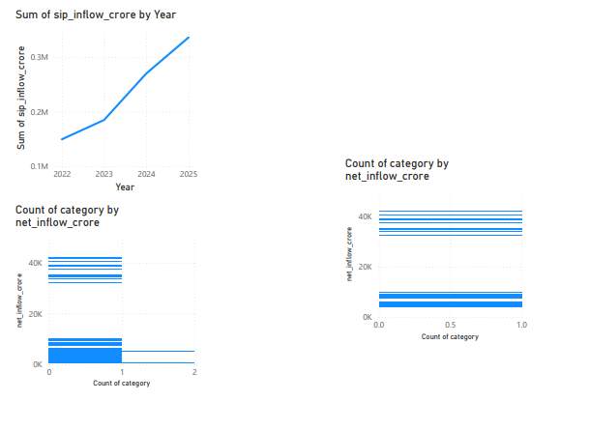
Figure 18: SIP Trends and Industry Inflow Dashboard

KEY FINDINGS
- Assets Under Management (AUM) demonstrated consistent growth, indicating increasing investor participation and confidence in mutual fund investments.
- SIP inflows increased steadily throughout the analysis period, highlighting the growing adoption of systematic investment strategies among retail investors.
- Investors in the 26–45 age group contributed the largest share of investments, making them the most active investor segment.
- Performance analysis revealed significant differences in risk-adjusted returns across mutual fund schemes, with several funds consistently outperforming benchmark indices.
- Risk analysis showed that higher-return funds generally exhibited greater volatility and downside risk, emphasizing the importance of diversification and risk management.
- The Fund Recommendation System successfully identified suitable investment options based on investor risk profiles using Sharpe Ratio and Risk Grade metrics.
- Portfolio concentration analysis revealed varying levels of diversification across funds, with lower HHI values indicating better risk distribution.
- The Power BI dashboards effectively transformed complex financial data into meaningful visual insights, enabling improved decision-making and performance evaluation.

RECOMMENDATIONS
Based on the analytical findings of the project, several recommendations can be made for investors and financial institutions.
Investors should adopt diversified investment strategies to reduce portfolio concentration risk and improve long-term stability. SIP-based investing should be encouraged due to its ability to promote disciplined investing and reduce the impact of market volatility.
Fund selection should consider both return potential and risk-adjusted performance metrics such as Sharpe Ratio, Sortino Ratio, and Maximum Drawdown. Investors should align investment choices with their risk tolerance and financial objectives.
Financial institutions should focus on increasing investor awareness in underrepresented demographic segments and geographic regions. Improved investor education programs can help expand participation and support long-term industry growth.
Future enhancements may include real-time market data integration, predictive analytics, machine learning-based fund recommendation systems, and advanced portfolio optimization models. These improvements would further strengthen decision-support capabilities and analytical accuracy.
CONCLUSION
The Bluestock Mutual Fund Capstone Project successfully demonstrated the application of data analytics, financial analysis, and business intelligence techniques within the mutual fund industry. Through the integration of multiple datasets, the project transformed raw financial data into meaningful insights that support investment decision-making.
The project implemented a complete analytics pipeline including data extraction, cleaning, transformation, exploratory analysis, advanced financial modeling, risk assessment, dashboard development, and reporting. Key analytical techniques such as VaR, CVaR, Rolling Sharpe Ratio, Cohort Analysis, Fund Recommendation Systems, and HHI calculations provided deeper understanding of fund performance and investor behavior.
Interactive Power BI dashboards enhanced data accessibility by presenting analytical findings through intuitive visualizations and filters. These dashboards allow users to evaluate performance, analyze trends, and explore investment opportunities efficiently.
Overall, the project achieved its objectives and delivered a scalable framework for mutual fund analytics. The insights generated through this work can support investors, analysts, and financial institutions in making more informed investment decisions while effectively managing risk and maximizing long-term value.

