This instruction is about how to use “SynapseCounter”, a Fiji (a new version of ImageJ ) plugin, to quantify synaptic puncta density in cortical neuron culture. Specific antibodies are immunostained against presynaptic protein Synapsin I and postsynaptic protein PSD95 to label synaptic puncta. An antibody against GFP is also applied to label GFP expressing neurons. The goal of this plugin is to automate the quantification of synaptic puncta. The whole procedure includes four steps: image file preparation, threshold scoring, plugin running and data collection.

*Step 1 – Image file preparation*

After confocal images are collected, we first need to convert all image files to TIFF type. Usually the software of the confocal microscope provides the function of image format converting. Fiji (ImageJ) also provides format converter for most popular confocal file types. After this step, all three channels should be separated and each is a single image. All the images to be analyzed should be put in the same folder. There should not be any other files in the folder except the image files to be analyzed. The naming of the files should be like this: sample_1_channel_1.tiff, sample_1_channel_2.tiff, sample_1_channel_3.tiff, sample_2_channel_1.tiff, sample_2_channel_2.tiff, sample_2_channel_3.tiff... etc. so that the three images from the same sample are placed together in the folder. This is very important because later the program is going to take each three images and analyze them as a group. If the order is messed up, then the analysis will be wrong. In this step, I also shuffle and rename the samples (groups of three images) to randomize the samples and eliminate subjective bias. I am happy to write a script for you if you want this feature.

*Step 2 – Threshold scoring*

In this step, we need to score the threshold for each channel manually. I usually score ten randomly chosen images for each channel and take the average value. The procedure is like this: first run Fiji program; then click “File->Open” to load an image; then click “Image->Adjust->Threshold” to open the threshold window; next, move the horizontal bars to adjust the threshold for the image, and write down the threshold. Repeat the actions for 10 images for each channel and calculate the mean value as the threshold for each channel.

*Step 3 – Plugin running*

Now it’s the exciting part. Click “Plugins -> SynapseCounter FW” to run the plugin and there will be a popup window like Figure 1. Enter the thresholds into the corresponding cells. The minimal and maximal particle size is to exclude particles that are too large or too small to be a synapse. If you are using 63x oil with 1.5x zoom, then you can use the default value. For other setting, you might need to determine the best range yourself. The unit for the particle size is square micron. After entering all the values, then click OK. There will be a popup window for you to choose the folder containing the images, as shown in Figure 2. Choose the window and click Select. Then the automatic analysis will start to run. During the run, there will be windows flying back and forth, which is totally normal. In very rare case, there might be error message popping up when there is zero synaptic punctum in the current sample, you can just press OK and let the program keep running.

Figure 1.

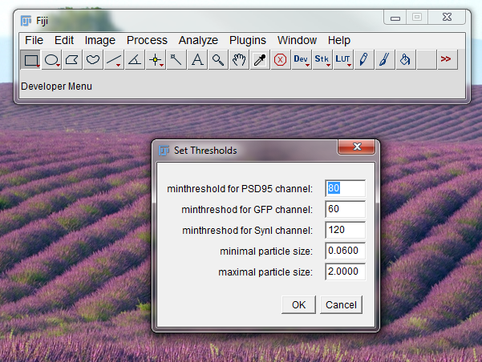

Figure 2

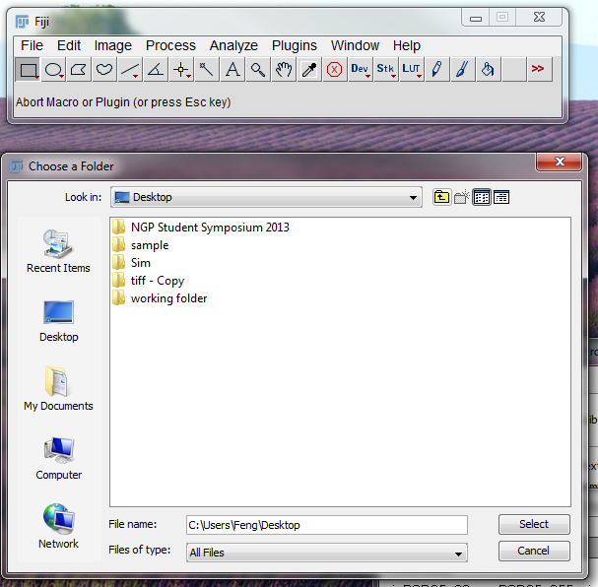

*Step 4 – Data collection*

After the program finishes running, there will be a log file. Save this file. This file contains the summarized data from the analysis. The log file content is explained as below in Figure 3. The R&G&B channel value is the total number of synaptic puncta in the imaged segment of GFP positive dendrites. You can copy the values to an xls file and conduct whatever statistical analysis you like. For each sample, two other files are generated and store in the same directory. One is a txt file containing the detail information on each punctum. The other is a zip archive file, which contains roi files. It can be opened by “Analyze->Tools->ROI Manager”. This zip file can be used to validate the automated selection is correct. First, load the image into the Fiji program. Then open the ROI Manager as mentioned earlier. In ROI Manager, click “More -> Open” to load the zip file corresponding to the image sample. Then you will see the roi files shown up in the window of the ROI Manager. Click “Show All”, you will see that the puncta are now highlighted in the image. Then you can decide whether the selected puncta are the correct ones.

This is it! Feel free to contact me if you have any questions.

Figure 3.

