Appendix 2: Extra inning rule / Tiebreak
Scoring symbol TIE
If the game remains tied after the completion of nine (9) innings, the following procedures will be implemented during extra innings:
Each team will begin the 10th inning (and any subsequent necessary extra innings) with a player on first and second, no outs.
To begin the 10th inning, representatives from each team will meet a home plate and will indicate (at the same time) to the home plate umpire where the team wishes to begin the batting order. That is, the teams have the option of beginning the 10th inning anywhere in the existing batting order that was in effect when the 9th inning ended. Note that this is not a new line-up (just potentially a different order), and it may very well be the same line-up that ended the 9th inning. The rationale for doing so is to ensure that both teams have an equal chance at having what they consider to be their best hitters and base runners in a position to score in the 10thinning.
For example: if the team decides to have the #5 hitter inthe line-up hit first, then the #3 hitter will be placed at 2B andthe #4 hitter will be placed at 1B. Furthermore, if the teamdecides to have the #2 hitter in the line-up hit first, then the #9 hitter would be at 2B and the #1 hitter would be at 1B.
WBSC |  | Traduction dans l’outil de scorage |  | Outil
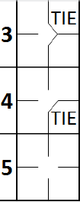 |  | inning visitor number 1 {  action { batter -> KS }  action { batter -> KS }  action { batter -> 1B7 }  action { batter -> KL}  }  /* Inning 1 : hometeam */  inning hometeam number 1 {  …  }  inning visitor number 2 {  specialSituation {  tieBreak  }  } |  | 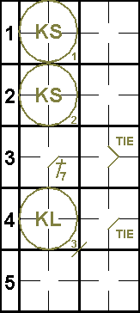

Once those players/runners are determined for the10th inning, the order of any subsequent innings will be determined by how the previous inning ended. That is, if the 10th inning ends with the #5 hitter having the last plate appearance (PA), then the 11th inning begins the #6hitter at bat, and the #4 hitter at 2B and the #5 hitter at first base.
WBSC |  | Traduction dans l’outil de scorage |  | Outil
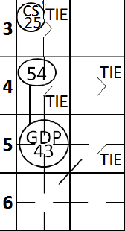 |  | /* Inning 2 : visitor */  inning visitor number 2 {  specialSituation {  tieBreak  }  action { runner2 -> CS25 }  action { batter -> GDP43 , runner1 -> 54 }  } |  | 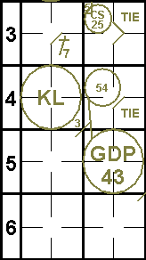

No player re-entry is permitted during extra innings.
The traditional system of the visiting team hitting in the top of the inning and the home team hitting in the bottom of the inning (if needed) will remain in effect until a winner is determined.
Any runner that starts on 2B or on 1B in the Tie-Breaker will not be credited with a Plate Appearance (PA) or times at bat (AB).
A run scored by the players starting as runners at first and second base shall be charged to the defensive team and not the pitcher and can therefore never be earned runs. Whether a run scored by any other player shall be charged to the pitcher, is up to the judgment of the official scorer.
WBSC |  | Traduction dans l’outil de scorage |  | Outil
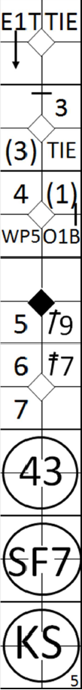 |  | /* Inning 2 : visitor */  inning visitor number 2 {  specialSituation {  tieBreak  }  action { batter -> O1b (3), runner1 -> + (3)+, runner2 -> E1T+}  action { batter -> 1B9, runner2 -> +}  action { runner3 -> WP}  action { batter -> 2B7, runner1 -> +++ earned}  action { batter -> 43, runner2 -> + }  action { batter -> SF7, runner3 -> +}  action { batter -> KS }  } |  | 

If action by a subsequent batter, such as a fielder’s choice, causes the lead-off runner to be put out, the first run scored that inning may be charged to the team. (Example: If a runner reaches first base safely on a fielder’s choice as a result of a first-to-third putout, this new runner still is charged to the team.)
If the lead-off runner at second is put out without action by the batter (caught stealing, picked off or leaving the base early), then, no run is charged to the team.
WBSC |  | Traduction dans l’outil de scorage |  | Outil
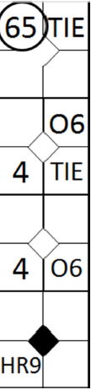 |  | action { batter -> O6, runner1 -> O6, runner2 -> 64}  action { batter -> HR9 earned, runner1 -> +++,runner2 -> ++ } |  | 

In case of a pitcher change at the beginning of the extra inning, it is very important to mark this change above the two players starting as runners on base. The extra inning is supposed to lead to a game-winning run which determines the statistics to be awarded to the pitchers. A run scored by one of the players that started as runners in this extra inning, should be charged to the relief pitcher.
WBSC |  | Traduction dans l’outil de scorage |  | Outil
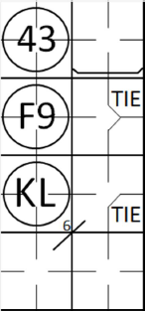 |  | specialSituation {  tieBreak  }  substitution hometeam {  player 1 replaceBy "NEW pitcher" shirtNumber=43  } |  | 