Assists
An assist is a statistic credited to a fielder whose action contributes to a batter-runner or runner being put out [OBR 9.10].
An assist shall be credited to each fielder who:
- Throws or deflects a batted or thrown ball in such a way that a putout results, or would have resulted except for a subsequent error by any fielder. Only one assist and no more shall be credited to each fielder who throws or deflects the ball in a run-down play that results in a putout, or would have resulted in a putout, except for a sub sequent error [OBR 9.10(a)(1)];
Comment: Mere ineffective contact with the ball shall not be considered an assist. ‘Deflect’ shall mean to slow down or change the direction of the ball and thereby effectively assist in putting out a batter or runner. If a putout results from an appeal play within the natural course of play, the official scorer shall give assists to each fielder, except the fielder making the putout, whose action led to the putout. If a putout results from an appeal play initiated by the pitcher throwing to a fielder after the previous play has ended, the official scorer shall credit the pitcher, and only the pitcher, with an assist [OBR9.10(a)(1) Comment].
- Throws or deflects the ball during a play that results in a runner being called out for interference, or for running out of line [OBR 9.10(a)(2)];
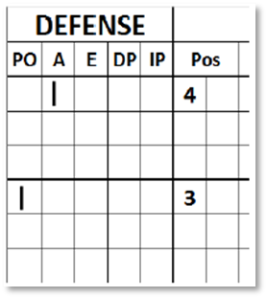 | The assist should be recorded with a vertical stroke in column ‘A’ of the defense, in correspondence with the position in defense of the respective fielder.
The same fielder may nevertheless be credited with an assist and a putout, or an assist and an error.
Do not credit an assist to [OBR 9.10(b)(1), (2), (3)]:
- The pitcher on a strikeout, unless the pitcher fields an uncaught third strike and makes a throw that results in a putout;
- The pitcher, when, as the result of a legal pitch received by the catcher, a runner is put out, as when the catcher picks a runner off base, throws out a runner trying to steal, or tags a runner trying to score; or
- A fielder whose wild throw permits a runner to advance, even though the runner subsequently is put out as a result of continuous play.
- A play that follows a misplay (whether or not the misplay is an error) is a new play, and the fielder making any misplay shall not be credited with an assist unless such fielder takes part in the new play.
Example 33: With a runner on first base the batter hits a ground ball to the third baseman, who deflects the ball towards the shortstop, who catches it and throws to second in time to put out the runner.
Credit assists to both the third baseman and the shortstop, and a putout to the second baseman.
WBSC |  | Traduction dans l’outil de scorage |  | Outil
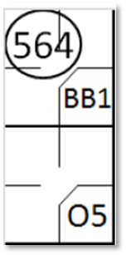 |  | /* Le premier batteur atteint la première base sur un 'Base on Ball' */  action { batter -> BB }  /* Le second batteur atteint la première base sur un choix défensif du défenseur de la cinquième base. Le défenseur de la cinquième base relais au à l'arrêt court qui relaie au défenseur de la deuxième base pour retirer le coureur arrivant de la première base */  action { batter -> O5 , runner1 -> 564} |  | 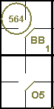

Example 34: With a runner on first base, the batter hits a ground ball to the second baseman, who throws to the shortstop too late to put out the runner.
The shortstop throws to the first baseman who puts out the batter-runner.
Credit assists to both the second baseman and the shortstop and a putout to the first baseman.
WBSC |  | Traduction dans l’outil de scorage |  | Outil
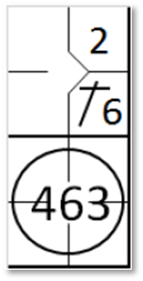 |  | /* Le premier batteur frappe un hit sur l'arrêt court */  action { batter -> 1B6 }  /* Le second frappeur frappe une balle au sol qui est rattrapé par le défenseur de la deuxième base. Il relaie la balle à l'arrêt court pour tenté de retiré le coureur sans succès. L'arrêt court relai alors la balle au défenseur de la première base pour retirer le batteur coureur */  action { batter -> 463 , runner1 -> + } |  | 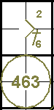

Example 35: With a runner on second base the batter hits a ground ball to the third baseman, who catches the ball and throws it to second, catching the runner off base.
This leads to a rundown play.
The ball is passed from one fielder to another (third baseman, second baseman, catcher, shortstop, third baseman, second baseman, catcher) until the shortstop makes a putout. Write the complete rundown on the score-sheet but credit only one assist to the third baseman, the second baseman, the shortstop and the catcher and a putout to the shortstop.
WBSC |  | Traduction dans l’outil de scorage |  | Outil
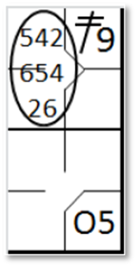 |  | /* Le premier batteur frappe un double dans le champ droit */  action { batter -> 2B9 }  /* Le deuxième batteur frappe une balle au sol sur la troisième base, il arrive sur base sur un choix défensif. Le coureur venant de la deuxième base est pris en souricière */  action { batter -> O5 , runner2 -> 54265426 } |  | 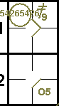

Example 36: The batter hits a ground ball to the third baseman, who catches it in time to put him out at first base, but throws wild to the first base.
The batter-runner advances towards second base but is put out by the shortstop assisted by the right fielder, who caught the ball thrown by the third baseman. Charge an error to the third baseman, an assist to the right fielder and a putout to the shortstop.
WBSC |  | Traduction dans l’outil de scorage |  | Outil
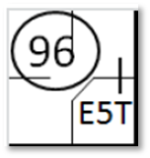 |  | /* Le batteur frappe une balle vers le défenseur de la troisième base qui fait une erreur  de relaie vers la première base. Le batteur coureur en profite pour tenter de gagner la deuxième. La balle est récupérée par le défenseur du champ droit qui relaie à l'arrêt court pour retirer le batteur coureur */  action { batter -> E5T 96 } |  | 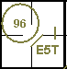

Example 37: The batter hits a slow ground ball towards the third baseman, who catches it too late to put him out at first base, but throws in any case, muffing the throw.
The batter-runner continues towards second base but is put out by the shortstop, assisted by a throw from the right fielder, who caught the ball thrown by the third baseman. Credit an assist to the right fielder and a putout to the shortstop.
WBSC |  | Traduction dans l’outil de scorage |  | Outil
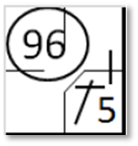 |  | /* Le batteur frappe une hit vers le défenseur de la troisième base qui fait une erreur de relaie vers la première base. Le batteur coureur en profite pour tenter de gagner la deuxième base. La balle est récupérée par le défenseur du champ droit qui relaie à l'arrêt court pour retirer le batteur coureur */  action { batter -> 1B5 96 } |  | 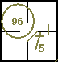

Example 38: The batter is struck out but on the third strike the catcher fails to catch the ball, which bounces against the protective barriers behind him and back onto the field.
The pitcher catches the ball and assists the first baseman in aputout. Credit an assist to the pitcher and a putout to the first baseman.
WBSC |  | Traduction dans l’outil de scorage |  | Outil
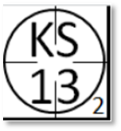 |  | /* Troisième strike relaché, le lanceur récupère la balle a le renvoie au défenseur de la première base pour retirer le batteur-coureur */  action { batter -> KS13 } |  | 

Example 39: The batter hits a difficult high ball between second base and the right fielder. The second baseman runs back and, jumping to make the putout, deflects the ball with his glove but fails to catch it. Before the ball lands the right fielder catches it and makes the putout. Credit an assist to the second baseman and a putout to the right fielder. Or
WBSC |  | Traduction dans l’outil de scorage |  | Outil
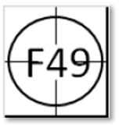 |  | /* Le batteur frappe en balle en l'air. le défenseur de la deuxième base touche la balle sans la rattrapée et le défenseur du champ droit la rattrape avant qu'elle ne touche le sol */  action { batter -> F49 } |  | 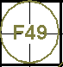

Example 40: The batter hits an easy high ball between second base and the right fielder. The second baseman tries to make the putout but merely deflects the ball with his glove. Before the ball lands the right fielder catches it and makes the putout.Credit an assist to second base and a putout to the right fielder. The action of the second baseman should be considered a misplay but not charged as an error, as the out is made.
WBSC |  | Traduction dans l’outil de scorage |  | Outil
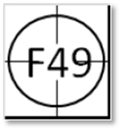 |  | /* Le batteur frappe en balle en l'air. le défenseur de la deuxième base touche la balle sans la rattrapée et le défenseur du champ droit la rattrape avant qu'elle ne touche le sol */  action { batter -> F49 } |  | 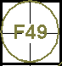

Example 41: The batter hits an easy ground ball towards third base, who deflects the ball but fails to catch it. It is caught bythe short stop who throws to first base in time to make the putout. Credit an assist to the short stop and a putout to the first baseman. No assist is credited to the third baseman.
WBSC |  | Traduction dans l’outil de scorage |  | Outil
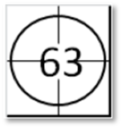 |  | /* retrait du batteur coureur sur une frappe sur l'arrêt court qui relai vers le défenseur de la troisième base */  action { batter -> 63 } |  | 