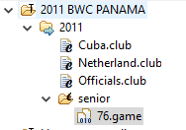
tournament = "2011 BWC PANAMA";

