**LAB REPORT**

|  |  |
| --- | --- |
| Modul | **Deep Learning (TSM_DeLearn)** |
| Title | **Perceptron Learning Algorithm** |
| Date | 02.03.2021 |
| Objective | * Implement the perceptron learning algorithm. * Test the implementation using:   + Dummy dataset which is generated on the fly.   + Lightweight MNIST dataset. |
| Lecturer | * Prof. Dr. Jean Hennebert * Prof. Dr. Martin Melchior |
| Student | Group 11:   * Florian Merz (florian.merz@ost.ch) * Patrick Koller (patrick.koller@ost.ch) * Yohanes Sugiarto (yohanes.sugiarto@ost.ch) |

**Results step 1 – linearly separable dataset:**

A linearly separable 2D dataset, consisting of label 0 (blue crosses) and label 1 (red crosses) is created on the fly. The green, dashed line represents the optimal separation line between the two classes with the maximal margin to each class. Applying the perceptron-learning-algorithm to this dataset results in the magenta colored line, which separates the classes perfectly, but not optimally in a sense to maximize the margin to both classes.

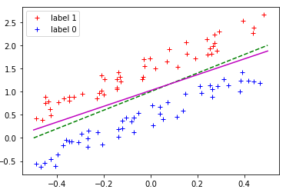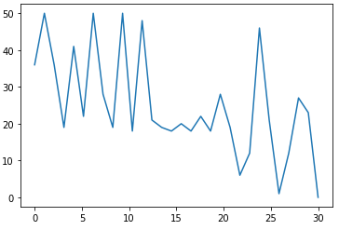

* Linearly separable dataset
  + Optimal parameters (Green dashed line) are w1 = -2.0, w2 = 1.0, and bias = -1
  + Training converged in 29 iterations
  + Resulting parameters are w1 = -4.990, w2 = 2.929 and bias = -3
  + The perceptron-learning-algorithm separates the dataset nicely into the two desired classes

**Results step 1 – non-linear separable dataset: (Optional)**

A quadratic separable 2D dataset, consisting of label 0 (blue crosses) and label 1 (red crosses) is created on the fly. Applying the perceptron-learning-algorithm to this quadratic dataset results in the linear magenta colored line, which fails to separate the dataset in a meaningful way.

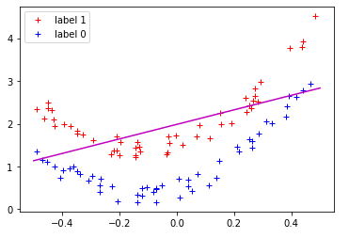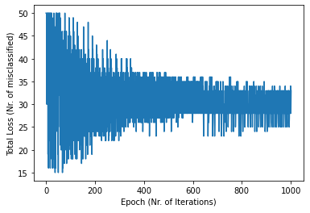

* Quadratic separable dataset
  + The perceptron-learning-algorithm fails to separate the dataset as desired
  + Optimal solution would need to be a quadratic function

**Results step 2 – MNIST dataset:**

The lightweight MNIST dataset (which consists of 8×8-pixel images of handwritten digits) is widely used for training and testing in the field of machine learning and deep learning. Applying the perceptron-learning-algorithm to differentiate between the numbers 0 and 1 converges after only 11 iterations and gives perfect results in terms of accuraccy.

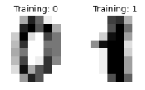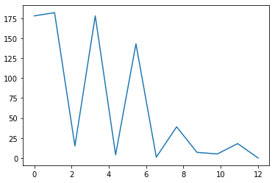

* MNIST dataset
  + The perceptron-learning-algorithm is able to create a nice decision boundary to separate the numbers 0 and 1 successfully
  + Comparing all other pairs of numbers is much more difficult. Our implementation is not able to differentiate clearly better than random between all other pairs of numbers.