**mDPI ‘Benchtop’ Organism Swimming Behavior Macro Tutorial**

Guide to using ImageJ/FIJI MTrackJ plugin to quantify organism motion-behavior from recorded videos

June 2023, Patrick Duffy

Source Code: https://github.com/imagescience/MTrackJ/

Plugin Manual and .jar download: https://imagescience.org/meijering/software/mtrackj/

Citation for using MTrackJ in research:

E. Meijering, O. Dzyubachyk, I. Smal

Methods for Cell and Particle Tracking

*Methods in Enzymology*, vol. 504, February 2012, pp. 183-200

MTrackJ is an ImageJ/FIJI plugin to facilitate tracking of moving objects in image sequences, and calculate measurements using track statistics. The plugin is capable of tracking objects in max 5D space-time of any type supported by ImageJ’s stacks. Tracks can also be saved to be edited in the future; track-files are essentially x,y,z,t pathing points that are overlays so they don’t occupy significant disk space (unlike videos or image stacks!).

**Installation (ImageJ):**

1. Download both .jar files from link above (MTrackJ_.jar and imagescience.jar)
2. Manually move both .jar files to the plugins folder of your ImageJ location (/ImageJ/plugins/)
3. That’s it. Load up ImageJ and the MTrackJ plugin should be available in the drop-down Plugins menu

**Procedure to Create a Track:**

1. Open ImageJ, locate a desired video-file with organism behavior you wish to measure, drag the image file into ImageJ
   1. **Un-check** the box that says ‘Use Virtual Stack’
2. Input Image-Properties constants. In the ImageJ menu, go to Image🡪Properties
   1. Conversion from pixels (benchtop) is 1pix = 68 um
      1. Change Pixel width (it will change height and depth automatically) to 68; change the unit to ‘um’
   2. Change the Frame Interval to 0.04 sec
   3. Check the ‘Global’ box if you are intending on processing more than one image-sequence this session. You will have to re-do these constant each time you open a new image stack, or a new ImageJ session.
3. 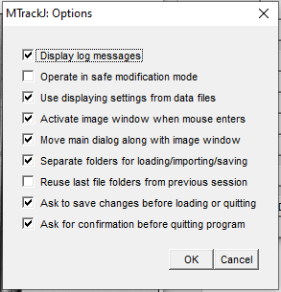Open MTrackJ’s GUI from the Plugins drop-down menu. Open MTrackJ’s Options menu from the lower-left of the GUI. Verify settings are saved and match Figure 1

**Figure 1 MTrackJ Options**

1. Open MTrackJ’s Tracking-Options from the Tracking menu item. **This is the really cool part of MTrackJ, it has built-in calculations to ‘normalize’ the center-point location of an organism!** The ‘dark centroid’ option is the most similar to how we flat-field and identify ROI (Regions of Interest) in shadowgraph plankton images; in practice, it is identifying the centroid of the ‘darks’ grey value in a specified region. ‘Dark pixel values’ in plankton images (especially gelatinous) are essentially the center of body-mass.
   1. Check the box to move-forward with each click, increase time step size to 5 (0.04 x 5 = 0.20 sec per time step/click)
   2. Check the box to finish a track after adding point at last time step available
   3. Check the box to apply local cursor snapping during tracking. This will create a box-overlay during manual track creation to show what regions are included in the calculation
      1. Snap Feature 🡪 Dark Centroid
      2. Snap range 🡪 Max (51 x 51 pixels)
2. **Add a track:** click the ‘Add’ MTrackJ menu and it should turn red to signal you are now in track-editing mode on the Image-stacks.
   1. In external spreadsheet (excel csv; SwimmingBehaviorMetaData.csv for example) record the video file name, organism-ID (species), and track #. **Organism diameter (length) cannot be measured while MTrackJ’s GUI is open. Do not forget to measure organisms after you create tracks for an image and save/export the results.**
   2. Click over desired organism to create track point. Clicking faster than twice in 200 ms (0.2 sec) will terminate a track and begin the next sequential #. Do not worry if this occurs, tracks can be merged afterwards.
   3. 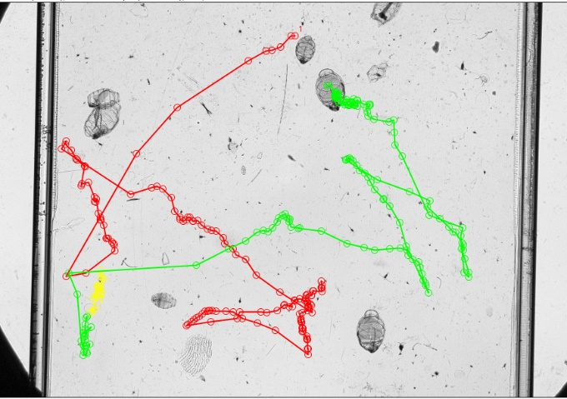With each time-step, try to cover the same regions of large organisms with the 51x51 pixel region. If tracking smaller organisms, you may want to decrease the dark-centroid region
   4. To finish a track early if the organism moves off-screen, click the ‘Add’ menu option.
3. **Merge a track:** Oh no! You clicked too quickly and need to merge together a track like **Figure 2**. Select the ‘Merge’ MTrackJ menu option; it will turn red.

**Figure 2:** Track that requires Merging

* 1. Whichever track is clicked first is the # which will be kept

1. **Save Tracks**: First save the track-overlays by clicking the ‘Save’ option in the top-right of the ImageJ GUI. Navigate to the desired folder to save processed data. **The file-name of the saved file will not need to be edited; it take the name of the video-file loaded (xxxx.avi) and automatically add an additional extension to save as xxxx.avi.mdf**
2. **Export Measurements**: To save a .csv of the track statistics, click ‘Measure’ which will calculate measurements for all tracks in a loaded stack. A new menu that is a data-table will appear, in that new data-table select File🡪SaveAs and navigate to your desired folder to save processed data. You will need to manually input the file-name as the name of the video file you were processing .csv (xxxx.csv) without the .avi extension included. The name of this .csv should match text you input into the file-name column of the SwimmingBehaviorMetaData.csv external spreadsheet you are recording so you know what track-#’s belong to which organisms in which specific video-file.
3. **Measure Organisms: Don’t forget to record organism lengths. MTrackJ must be closed for this step.**
   1. 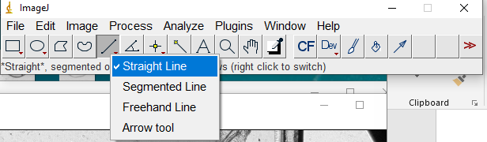Select the Straight-line tool (**Figure 3**) by right-clicking the icon pictured

Figure 3 Straight line tool for organism measurement

* 1. Identify a frame where the organism appears to be fully pictured. Click once to begin measurement then drag cross-hair cursor to the opposite end of the organism. Before releasing the cursor, look at and record the length of the segment displayed in the ImageJ menu (**Figure 4**)
  2. 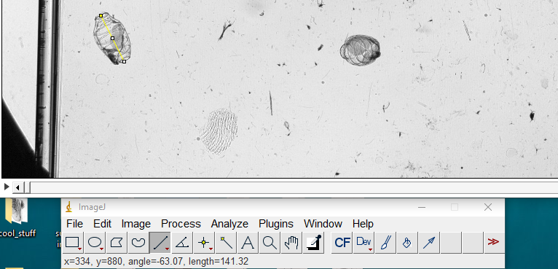

Figure 4 Length of a doliolid using straight lines