Long Set 1 Answers
Andrew Mount
Pat Dyer
Econ 385
Professor MJ

Question 1
Question 1: Linear Combinations of Random Variables
Given:
E(X) = 24
E(Y) = 4
Var(X) = 36
Var(Y) = 25
Cov(X,Y) = 6

1. Deriving the variance formula
Var(aX + bY) = E[(aX + bY - E(aX + bY))^2]

Since:
E(aX + bY) = aE(X) + bE(Y)

Var(aX + bY)
= E[(a(X - E(X)) + b(Y - E(Y)))^2]

Expanding:
= E[a^2(X - E(X))^2 + 2ab(X - E(X))(Y - E(Y)) + b^2(Y - E(Y))^2]

Therefore:
Var(aX + bY)
= a^2Var(X) + b^2Var(Y) + 2abCov(X,Y)

2. C = 2X + Y and D = X - Y
For C:
E(C) = 2E(X) + E(Y)
= 2(24) + 4,
= 52 minutes

Var(C) = 2^2(36) + 1^2(25) + 2(2)(1)(6)
= 144 + 25 + 24
= 193 minutes^2

SD(C) = sqrt(193)
= 13.89 minutes

For D:
E(D) = E(X) - E(Y)
= 24 - 4
= 20 minutes

Var(D) = 1^2(36) + (-1)^2(25) + 2(1)(-1)(6)
= 36 + 25 - 12
= 49 minutes^2

SD(D) = sqrt(49)
= 7 minutes

3. Variances if X and Y are independent
If X and Y are independent, Cov(X,Y) = 0.

For C:
Var(C) = 4(36) + 25
= 169 minutes^2

For D:
Var(D) = 36 + 25
= 61 minutes^2

4.

Question 5
Question 5: Becoming Familiar with the Data
Handling of ties and missing data: there are no missing values in any variable. For every win percentage we drop ties (result1 = 0.5) and use only decisive games, then report the tie rate separately. Mean scores and score margins use all games, including ties.

1. Overview
Number of games: 5,075
Seasons: 2002 through 2020 (19 seasons). The last game is the Super Bowl on 2021-02-07, which is part of the 2020 season.
Variable types:
date: Date (read in as text, then converted with as.Date)
team1, team2: character
season, neutral, playoff, score1, score2: integer
elo1, elo2, elo_prob1, result1: numeric

2. New variables and game counts
score_margin = score1 - score2: how many points Team 1 won by (negative if Team 1 lost)
total_points = score1 + score2: combined points scored by both teams
elo_difference = elo1 - elo2: Team 1's pregame rating advantage (positive means Team 1 was rated stronger)

Game type | Number of games
Regular season | 4,864
Playoff | 211
Neutral site | 56 (37 regular season + 19 playoff)
Ties | 11

3. Extreme games
Most total points: 2004-11-28 (2004 season), CIN 58, CLE 48 (106 total points)
Largest absolute score margin: 2009-10-18 (2009 season), NE 59, TEN 0 (59-point margin)

Question 6
Question 6: Is There a Home-Field Advantage?
Sample: non-neutral regular-season games (4,827 games, of which 10 were ties and 4,817 were decisive).

1. Overall statistics
Statistic | Value
Home win % (decisive games) | 56.82%
Tie % | 0.21%
Mean home score | 23.34 points
Mean away score | 21.05 points
Mean home score margin | +2.28 points

Yes, the sample shows descriptive evidence of a home-field advantage. Home teams win about 57% of decisive games, well above 50%, and outscore visiting teams by about 2.3 points per game on average.

2. By season
Season | Home win % | Mean home margin
2002 | 58.04% | 2.25
2003 | 61.57% | 3.63
2004 | 56.64% | 2.51
2005 | 59.52% | 3.74
2006 | 53.12% | 0.85
2007 | 57.65% | 2.89
2008 | 57.09% | 2.55
2009 | 57.25% | 2.33
2010 | 55.91% | 1.95
2011 | 56.86% | 3.30
2012 | 57.48% | 2.59
2013 | 60.08% | 3.23
2014 | 57.54% | 2.67
2015 | 53.75% | 1.48
2016 | 57.77% | 2.60
2017 | 56.97% | 2.50
2018 | 60.56% | 2.34
2019 | 52.00% | -0.05
2020 | 49.80% | 0.05

Using home win %: the home advantage was largest in 2003 (61.57%) and smallest in 2020 (49.80%).
Using mean home score margin: it was largest in 2005 (+3.74 points) and smallest in 2019 (-0.05 points).
The two statistics disagree because win % only counts whether the home team won, while the margin also depends on how big the wins and losses were.

3. 2020 vs 2002-2019
 | Home win % | Mean home margin
2002-2019 | 57.21% | +2.41 points
2020 | 49.80% | +0.05 points
Difference (2020 - earlier) | -7.41 percentage points | -2.36 points

Yes, 2020 was noticeably different. The home win percentage fell by about 7.4 percentage points, to below 50%, and the average home margin dropped by about 2.4 points to essentially zero. The home-field advantage basically disappeared in 2020.

4. Why this doesn't prove attendance caused the change
This is a before-and-after comparison, not a controlled experiment. Crowds weren't the only thing that was different in 2020, so we can't separate the effect of attendance from other factors, such as:
Random variation: 2020 is only one season of 256 games, and home advantage bounces around from year to year. 2019 had a -0.05 margin with full crowds.
Other COVID changes: no preseason, player opt-outs, COVID-list absences, and changes to practices and travel routines affected both teams.
Officiating and rule changes: referees may call games differently without crowd pressure, and penalty rules change over time.
Team quality: which teams were strong and who they played at home differs every season, and Q7 shows team strength has a big effect on results.
A longer-run trend: home advantage may have already been shrinking before 2020 (see 2019).

Question 7
Question 7: Do Better-Rated Teams Win by More?
Sample: non-neutral regular-season games (4,827 games).

1. Scatterplot
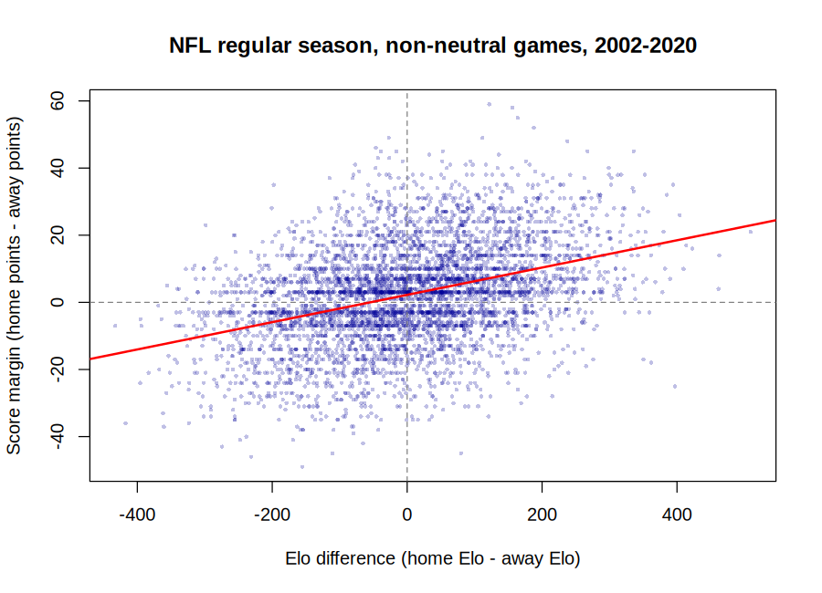

There is a clear positive relationship. The better the home team is rated compared to the away team, the more it tends to win by. The relationship is noisy, though (correlation = 0.38). The fitted line (red) is score_margin = 2.24 + 0.041(elo_difference), so every 100 extra Elo points is associated with about 4 more points of margin. The intercept of about 2.2 points means the home team is still favored when the two teams are rated evenly.

2. Home team stronger vs weaker
(No games had exactly equal Elo ratings.)
Group | Games | Home win % | Mean home margin
Home team had higher Elo | 2,407 | 69.86% | +6.72 points
Home team had lower Elo | 2,420 | 43.85% | -2.13 points

The results depend heavily on which team was stronger. When the home team was rated higher, it won about 70% of the time by almost 7 points on average. When the home team was rated lower, it only won about 44% of the time and lost by about 2 points on average. So team strength matters more than location.
However, home-field advantage still shows up in both groups. The average Elo gap is about the same size in both groups (+111 vs -108). If location didn't matter, a stronger home team and a stronger away team would win by about the same amount. Instead, stronger home teams win by 6.72 points but stronger away teams only win by 2.13. Splitting the difference, (6.72 - 2.13)/2 ≈ 2.3 points, which matches the overall home advantage from Question 6.

Question 8
Question 8: Our NFL Finding
Empirical question: Are Elo's pregame win probabilities accurate? When Elo says Team 1 has a certain chance of winning, does Team 1 actually win about that often?

Subsample: all decisive games (5,064 games, dropping the 11 ties), grouped into 10-percentage-point bins of the pregame probability elo_prob1.

Elo win probability | Games | Average predicted | Actual win rate
0.1 - 0.2 | 55 | 0.172 | 0.200
0.2 - 0.3 | 244 | 0.256 | 0.270
0.3 - 0.4 | 502 | 0.353 | 0.337
0.4 - 0.5 | 761 | 0.453 | 0.461
0.5 - 0.6 | 1,046 | 0.552 | 0.545
0.6 - 0.7 | 1,089 | 0.652 | 0.615
0.7 - 0.8 | 862 | 0.748 | 0.724
0.8 - 0.9 | 453 | 0.841 | 0.843
0.9 - 1.0 | 52 | 0.919 | 0.885

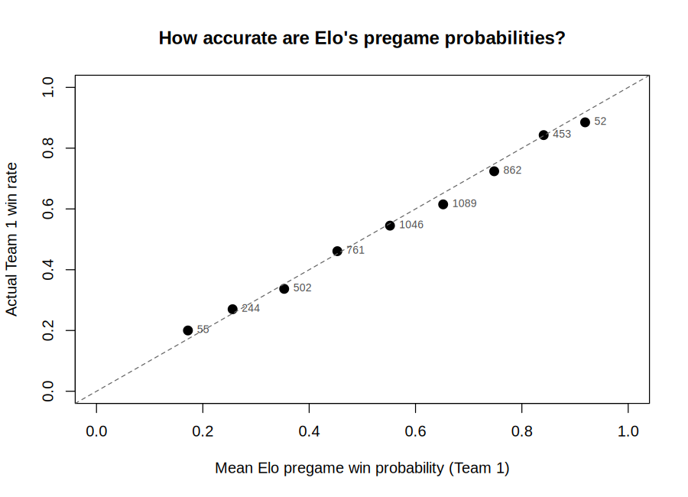

Finding: Elo's probabilities are very accurate. In every bin, the actual win rate is within about 4 percentage points of what Elo predicted, and the points lie almost exactly on the 45-degree line. Overall, the Elo favorite won 64.3% of games, so about 1 in 3 games is an upset, which is what the probabilities themselves predict. The one small pattern is that moderate favorites (60-80%) win a little less often than predicted.

