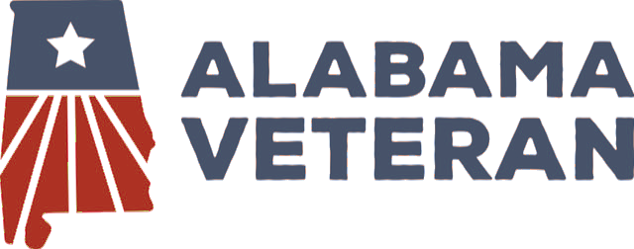
FREE TOPGOLF FOR VETERANS
ALABAMA VETERAN INITIATIVE

Program Operations Procedure · Version 1.0 — Draft | Approved By: Alabama Veteran Board | 2026

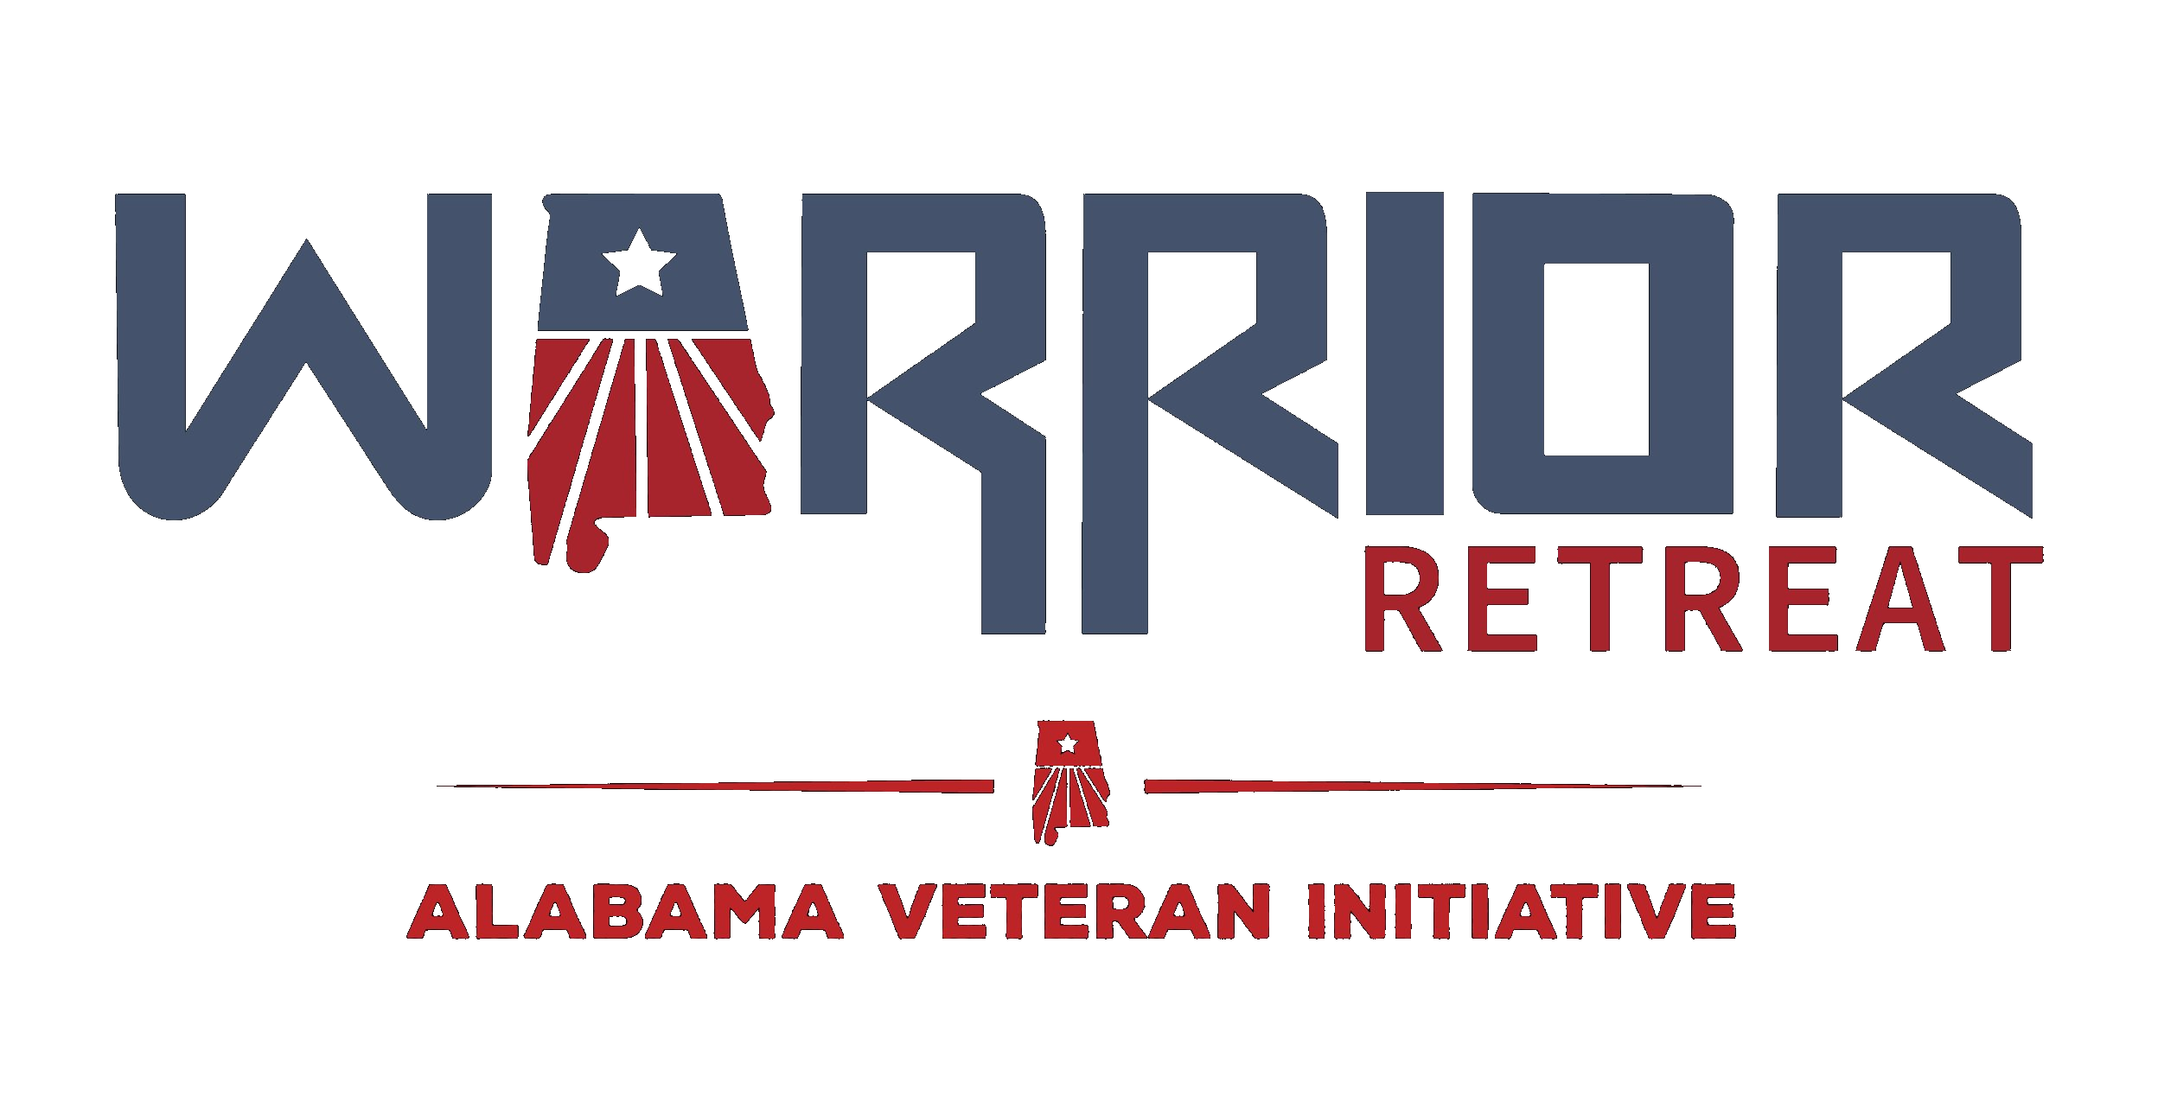 | 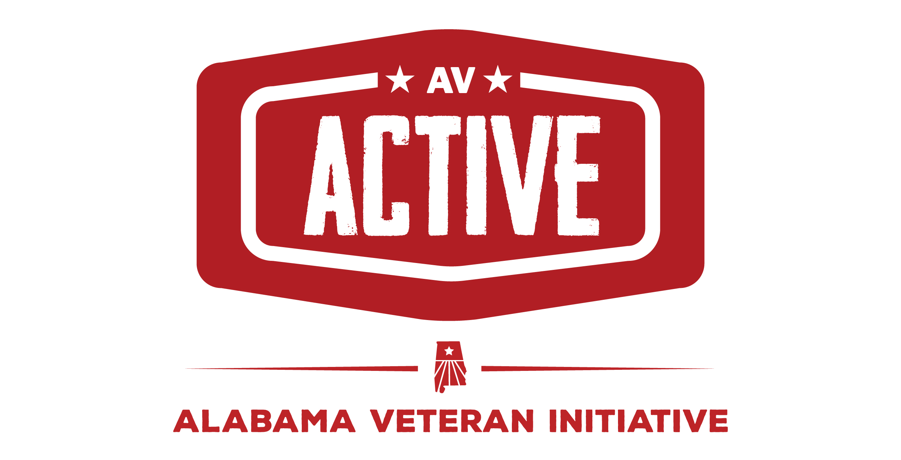

SECTION 1 — PURPOSE

This document outlines the complete step-by-step procedure for managing the Alabama Veterans Free Topgolf Program. It is intended to ensure that all team members, volunteers, and board members operate from a consistent, standardized process — from initial promotion through post-visit follow-up and donor engagement.

SECTION 2 — PROGRAM OVERVIEW

- Veterans may book two-hour blocks during platinum membership hours at Topgolf.
- Bookings are managed through an online calendar hosted on the organization’s website and Facebook group.
- All communications and automations are managed through the GoHighLevel (GHL) system.
- Program contact information is provided early in the booking process so veterans know who to reach for support.

SECTION 3 — PROGRAM SPIN-UP PROCESS

During the initial 30–45 days while the GoHighLevel automation is being finalized, the following interim process will be used:

- Veterans who wish to book will email the program group email at topgolf@alabamaveteran.org.
- Team members enrolled in the group email will monitor requests and assist with scheduling.
- Bookings will be made manually through the Topgolf App until full automation is live.
- Initially, the program will operate at the Birmingham (BHM) Topgolf location only.
- Huntsville and Mobile locations may be added as demand grows and the program scales.

SECTION 4 — PROGRAM CONTACTS

The following contacts are available to assist veterans at any point in the process. Contact details must be included in the first one to two automated messages sent after booking.

Role | Name | Phone / Email
Program Coordinator | [Name] | [Phone / Email]
Booking Support | [Name] | [Phone / Email]
Day-Of Contact | [Name] | [Phone / Email]

SECTION 5 — PROGRAM PROCEDURE

Phase 1: Promotion & Booking

Step 1 — Promote the Program
- Post available time slots on the organization’s website calendar.
- Promote availability in the organization’s Facebook group.
- Clearly communicate that veterans may schedule two-hour blocks during platinum hours on the Topgolf membership.
- Include program contact information in all promotional posts.

Step 2 — Veteran Books a Time Slot
- Veteran visits the website or Facebook group and accesses the booking calendar.
- Veteran selects an available two-hour platinum-hours block.
- Veteran completes the booking form with their name, contact number, email, and number of guests.
- Program contact information is included in the booking flow in case the veteran needs assistance.

Phase 2: Group Forms & Booking Confirmation

Step 3 — Group Booking Link Sent to Veteran
- Upon initial booking submission, an automated link is sent to the veteran via email and SMS.
- The veteran must share this link with every person in their group who will be playing.
- Each group member must complete the following through the link:
- Personal contact and demographic information (required for grant reporting)
- Required waivers and disclosures (must be signed digitally before the booking is confirmed)

NOTE: The booking is NOT fully confirmed until all group members have completed and signed the required forms. A reminder will be sent to the veteran if any group member has not completed their forms within the designated deadline.

- The deadline to complete all group forms will be communicated clearly and set far enough in advance to allow processing time before the scheduled visit.

Step 4 — Email & SMS Confirmation Sent
- Once all group forms are completed, the GHL system sends an automated email confirmation to the veteran.
- The email includes booking details (date, time, location) and program instructions.
- An SMS text confirmation is also sent confirming the appointment is fully scheduled.
- Program contact information is included in both messages.

Step 5 — Cancellation Policy & Reminder Notifications
- The cancellation deadline is clearly communicated in the confirmation messages.
- Veterans must cancel before the designated cutoff time to avoid last-minute no-shows.
- A reminder SMS and/or email is sent the day before the scheduled appointment.
- An additional reminder is sent the morning of the appointment.
- All reminders include the date, time, location, and program contact information.

NOTE: Define the specific cancellation deadline (e.g., 24 or 48 hours prior) and ensure it is consistently enforced. This should be finalized by the board and inserted here.

Phase 3: Day-Of Check-In

Step 6 — Arrival & Check-In at the Topgolf Desk
- Veteran arrives at Topgolf and approaches the check-in desk.
- Veteran states they have a reservation under the Alabama Veterans program.
- Veteran provides their own mobile number as an alternate number to the desk staff.
- Topgolf will use this alternate number to send the bay confirmation code directly to the veteran.
- This keeps the automation flow clean and avoids the organization receiving individual bay codes.
- This step is completed by every veteran upon each check-in visit.

Step 7 — SMS: Arrival Instructions
- Upon check-in, the GHL system sends an automated SMS to the veteran with step-by-step on-site instructions.
- This may include directions inside the facility, who to speak with on-site, and what to expect at the bay.

Step 8 — SMS: Bay Directions
- Topgolf sends the bay confirmation code via SMS to the alternate number the veteran provided at the desk.
- The GHL system sends an additional automated SMS to the veteran with directions to their specific bay.

Phase 4: Post-Visit Engagement

Step 9 — Thank You Text & Post-Visit Form
- A thank you SMS is sent to the veteran while they are at their bay, encouraging them to enjoy their time.
- The message includes a link to a short form containing:
- Grant Demographic Information — REQUIRED: name, service branch, dates of service, group size, zip code, and other fields needed for grant reporting.
- Photo Release — OPTIONAL: Veteran and/or family/friends may submit a photo taken during the visit for use on social media or the website.
- Testimonial — OPTIONAL: A short written testimonial about their experience that may be shared publicly with their consent.

NOTE: Demographic data collection is required for grant compliance. Photos and testimonials are optional. Veteran consent must be clearly indicated before any content is published publicly.

Step 10 — Follow-Up SMS (2–4 Hours After Visit)
- A follow-up SMS is sent a few hours after the scheduled end time.
- The message thanks the veteran again and asks if they enjoyed their experience.
- The veteran is invited to schedule a future visit and asked if there is anything else the organization can do for them.
- This contact is entered into the GHL marketing automation pipeline for future outreach including:
- Donation campaigns
- Upcoming events and programs
- Volunteer or ambassador opportunities

SECTION 6 — GOHIGHLEVEL AUTOMATION SUMMARY

The following automated touchpoints must be configured and tested in GoHighLevel before the program goes live:

- Trigger: Booking submitted → Send group booking link via email + SMS (Step 3)
- Trigger: Group forms incomplete past deadline → Send reminder to veteran (Step 3)
- Trigger: All group forms completed → Send email confirmation + SMS confirmation (Step 4)
- Trigger: 24–48 hours before appointment → Send reminder email + SMS (Step 5)
- Trigger: Day of appointment → Send morning reminder SMS (Step 5)
- Trigger: Check-in confirmed → Send arrival instructions SMS (Step 7)
- Trigger: Bay assigned → Send bay directions SMS (Step 8)
- Trigger: Bay check-in confirmed → Send thank you + feedback form SMS (Step 9)
- Trigger: 2–4 hours post-visit → Send follow-up SMS (Step 10)
- Trigger: Form submitted → Add contact to donor/events marketing pipeline

SECTION 7 — PROCESS SUMMARY

Step | Action | Who | Communication Sent
1 | Promote the Program | Organization | Website + Facebook post
2 | Veteran Books Slot | Veteran | None
3 | Group Forms Sent | GHL Automation | Email + SMS with group link
4 | Booking Confirmed | GHL Automation | Email confirmation + SMS
5 | Reminders & Cancellation | GHL Automation | SMS + Email (day before & day of)
6 | Check-In at Topgolf Desk | Veteran + Staff | Alternate number provided on-site
7 | Arrival Instructions | GHL Automation | SMS with on-site instructions
8 | Bay Directions | GHL + Topgolf | SMS with bay location/directions
9 | Thank You + Form | GHL Automation | SMS with form link
10 | Follow-Up | GHL Automation | SMS 2–4 hrs later; enters marketing pipeline

Alabama Veteran Initiative · alabamaveteran.org · c.montz@alabamaveteran.org · 205-531-8189
Internal Working Document — Not for Public Release

