PeerAssessment

First load the data and change the date into the correct format

activity = read.csv("activity.csv")  
activity$date = as.Date(activity$date, format = "%m/%d/%Y")

Calculate the total number of steps taken per day

total = aggregate(activity$steps ~ as.factor(activity$date), FUN=sum)  
colnames(total) = c("date", "totalSteps")  
hist(total$totalSteps, breaks = 15, col = "lightblue", xlab = "Total steps per day", main = "Histogram of total steps per day")

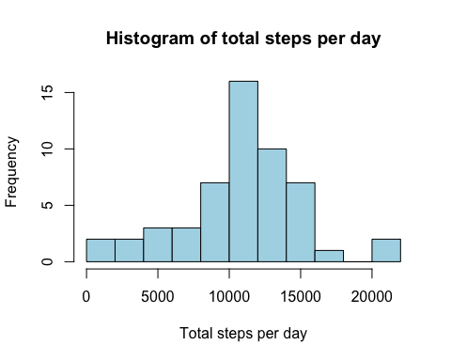

The mean total number of steps taken is

mean(total$totalSteps)

## [1] 10766.19

The median total number of steps taken is

median(total$totalSteps)

## [1] 10765

Time series plot of 5-min interval and the average number of steps taken

yvals = aggregate(activity$steps ~ activity$interval, FUN=mean)  
colnames(yvals) = c("interval", "totalSteps")  
  
plot(yvals$interval, yvals$totalSteps, type="l", xlab = "Interval", ylab = "Average total steps per day", main = "Average steps per interval")

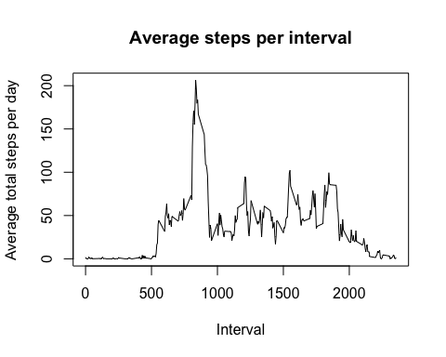

5-minute interval with maximum number of steps

yvals$interval[which(yvals$totalSteps == max(yvals$totalSteps))]

## [1] 835

Finding total number of NAs in the data set

sum(is.na(activity$steps))

## [1] 2304

Replace NAs with mean in each interval

New Factor variable with weekday/weekend

weekends = as.factor(weekdays(activity$date) %in% c('Sunday', 'Saturday'))  
activity$weekends = weekends   
par(mfrow=c(2,1))  
week = activity[which(activity$weekends==F),]  
weekdays.val = aggregate(week$steps ~ week$interval, FUN=mean)  
colnames(weekdays.val) = c("interval", "steps")  
end = activity[which(activity$weekends==T),]  
weekends.val = aggregate(end$steps ~ end$interval, FUN = mean)  
colnames(weekends.val) = c("interval", "steps")

Plotting Weekend vs weekday steps

plot(weekdays.val$steps ~ weekdays.val$interval, type = "l", xlab="Interval", main = "Weekdays", ylab = "Steps")

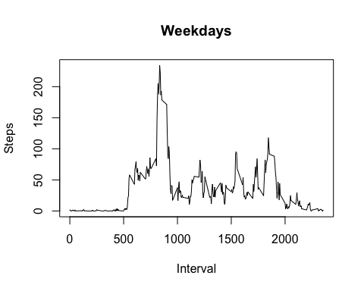

plot(weekends.val$steps ~ weekends.val$interval, type = "l", xlab="Interval", main = "Weekends", ylab = "Steps")

