CRIMP

# CoNVERT and Resize Images ProCESSOR

Version 1.0.0 ©2025 Pat Dooley

# Overview

Project background and description

CRIMP is a Windows program for photographers who want to resize and change the file format of images stored in folders on their local storage devices. Here are some use cases where CRIMP could be utilized.

1. You have shot an event and you have a large number of photographs to post on social media or your personal web site and you are limited in the size of images you can submit.
2. You want to add the photograph file name to those photographs so that someone wanting a full-size copy can tell you which photograph(s) they want.
3. You have a large number of JPG, PNG or TIFF images that are taking up too much space and you want to convert them to a space saving format, such as WEBP, without losing quality.
4. You have your photos in WEBP format but you want to upload to a web-site, such as Instagram or SmugMug, that doesn’t (yet) accept WEBP images.
5. You want to create a contact sheet, a collection of thumbnail images from a photo shoot, so you can select the best ones for further editing.

In this document, the terms “image”, “photograph” and “file” are interchangeable. The usage depends on the context.

# History

CRIMP follows an earlier program that was designed to resize images to address the first two use cases.  
  
In the process converting web applications to use the WEBP format for images it was observed that WEBP images with a medium quality setting were a half to a third of the size of equivalent JPG images with no apparent loss of quality. Photographers with large repositories of JPG images could save a substantial amount of local storage space if they could convert their images to the more modern WEBP format. The problem is that using the Google [cwebp](https://developers.google.com/speed/webp/docs/cwebp) utility one file at a time would take a long time. The same problem likely arises using image processing programs, such as Photoshop or Paint.Net, that can save files in WEBP format.  
  
CRIMP extends the capabilities of its predecessor to the conversion of files from and to the most common formats used by photographers. It can convert BMP, GIF, TIFF, JPG. and WEBP files and resize them at the same time. It works on sets of folders rather than individual files.  
  
CRIMP also lets the users add the file name and/or a copyright notice to each image it converts or resizes

# Installing Crimp

CRIMP only runs on 64-bit Windows desktops and laptops.

# Using Crimp

The first step is to decide what you want to accomplish. Do you want to make images smaller for posting to social media? Do you need to convert files to a different file type to make them acceptable to another user or application? Do you need to add a copyright notice and/or the file name? Do you want to delete the files you converted?

Once you have decided on a plan of action, you can launch CRIMP and enter your choices.

## Resizing Options

This panel gives you resizing options.

* None: CRIMP will not change the width and height of the image.
* Percentage: CRIMP will change the width and height by the given amount.
* Width: CRIMP will change the width of the image to the given amount and change the height according to the aspect ratio of the image.
* Height: CRIMP will change the height of the image to the given amount and change the width according to the aspect ratio of the image.

You could use the Percentage option to make images larger. This is not recommended since it results in a loss of resolution. As always, test on a small sample to see if the results are acceptable.

## Input File Options

This panel lets you choose the input file type. You can then select a radio button to choose whether to “Keep” the input files after they have been processed or “Delete [them] after copying”. Typically, you would keep the input files if you are resizing them to a smaller size and delete them if you are changing the type from JPG to WEBP, say.   
  
Sometimes, you want to defer deletion until you’ve checked that the conversion worked perfectly or fixed any issues such as a failed conversion or a corrupt file. The third radio button labelled “Delete without copying” can be used to do the deletion phase separately from the conversion/resizing phase.

## Image Text Options

This panel gives you the option to tag the output image with a copyright notice and/or the file name of the image to the output file.   
  
The Copyright Notice entry area lets you add a copyright notice to your output images. CRIMP puts the copyright symbol in there for you because it is tricky to enter. Unless you add some text after the copyright symbol, CRIMP will not add a copyright notice.

The Checkbox labeled “Add filename to image” lets you add the file name to the image.  
  
The “Font name” drop down lets you choose which font to use. It will reflect your current choice and font size.

  
  
The Size field lets you set the Font Size. Be aware that the size you want will depend on the height of the image and you should test on a sample image before processing a large number of files. The Italic and Bold options are not currently available. The underlying software component, [Magick.Net](https://github.com/dlemstra/Magick.NET), does not yet support bold and italic font styles.

## Output File Options

This panel lets you choose the output file type and the quality. The quality is limited to the range 50 to 100 and is only applied to JPG and WEBP files. A value of 100 means that the conversion will maintain the original quality. Lower values means that the conversion will compress the photograph to make the file size smaller but this means there will be some loss of quality.   
  
Before committing to converting a large number of photographs, you should do a little experimenting to see just how much quality is lost by choosing different quality settings. You may be surprised at how little detail is at low quality settings.

If you choose WEBP, then you can select between “Fast” and “Slow”. If you choose the former, then CRIMP will convert files to WEBP format 3 to 4 times faster than slow mode at the cost of some loss of quality. In our experience, the results are virtually identical.



You can choose to put the output in a different folder from the folder containing the input files. If you check “Save Elsewhere” then you will need to click the **Output Folder**  button to select the output folder. If it does not exist, then you can create it inside the Windows dialog that is used to pick a folder. Basically, you navigate to the parent folder, right-mouse-click, choose “New” and enter the name of the new folder. You can clear the output folder by clicking the red “X”.

Note that you can select a hierarchy of input files. This hierarchy is preserved inside the Output folder.  
  
If we choose an output folder called “Favorite Parks” and we copy every folder across, then the resulting folder structure would look the same. Note that you can pick and choose which folders to copy. Maybe, you just want a few favorite visits rather than all the parks and every year.

## Input Folder Selection

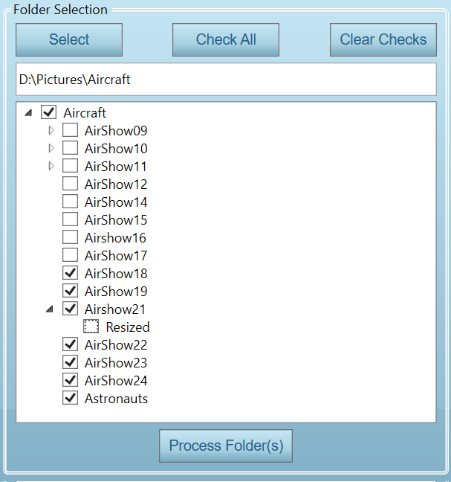The right hand side panel is used to select the set of folders you want to process. When you click the **Select** button, you are shown a dialog that lets you select the parent folder. It might be D:\Pictures\Aircraft..

You will then be shown a hierarchy of check boxes showing “Aircraft” and all the folders inside that folder. You can use the **Check All** button to check all the folders and then uncheck the folders you want to skip, or simply check just the folders you want to process.

If you check or uncheck a folder, then all the folders under it will also be checked or unchecked. In the example below, the entries under Airshow21 has been manually unchecked after Airshow21 was checked.

**Important**  
CRIMP does not process unchecked folders, even if the parent is checked.

Once you are satisfied with your input folder selections, you can click the **OK** button. CRIMP will check to ensure your choices make sense. If it finds no issues, it will then start processing the folders you select. The progress bar shows the progress within each folder. While CRIMP is processing files, you won’t be able to make any further changes.

When the process is finished, you can see the statistics for the processing run on the right side of the screen.

You can see any errors that were encountered during the run. By switching to the **Error Log** tab. Typical causes for errors are files that are too large or files that do not match their extension.

Clicking the  **Open button** will show the errors in more detail.

## Processing

Once you have set all your options and chosen the folders you wish to process then you can click the **Process Folder(s)** button to initiate processing.

The “Processing..” label at the bottom of the screen will show you the folder currently being processed and the Progress Bar next to it will show you the progress for the current folder. You will not be able to change anything while folders are being processed.



Sometimes, error messages will popup because CRIMP encounters problems reading or converting s file. Typical causes are corrupt images, images that have the wrong extension, or images that are extremely large. These errors are logged and you can view them by clicking on the error log tab (see above).

When processing is complete, a little dialog will pop-up telling you "Conversion/Resizing phase complete!". If you have selected to delete the input files that have been processed, you will be given a final chance to save them. The dialog will prompt you with the message “Final chance to keep the input files. Keep them after all?”. Answering “Yes” keeps them while “No” lets CRIMP delete them. When all the files in the selected folders have been deleted, another dialog will pop-up that says "Deletion phase complete!". This phase is very fast.

**Important**  
CRIMP does not delete folders.

Sometimes, error messages will pop-up saying files can’t be deleted. This is usually no cause for alarm and you should allow processing to continue rather than stopping it.

## Viewing Results

When processing is complete, CRIMP shows the results in a table on the right side of the screen. The table shows aggregate information about each folder processed. There are buttons under the table that let you save the results as a CSV (comma separated variable) file, an HTML file, or both, or on the Windows clipboard.

CSV files can be loaded into Excel, for example. HTML files can be viewed using your browser. Results saved to the clipboard can be pasted into Excel.



## Technical Information

CRIMP is a WPF (Windows Presentation Foundation) application developed using Microsoft Visual Studio 2022. It uses [Magick.Net](https://github.com/dlemstra/Magick.NET) to read, convert, resize and save individual files. The source code is available on GitHub.