

Spatiotemporal Mapping with ST Suite

Tutorial

2017

Pat Janssen
School of Food and Nutrition
email: P.Janssen@Massey.ac.nz

1 Introduction 3
1.1 About ST Suite 3
1.2 Image Sequences 3
2 Diameter, Radius and Longitudinal Maps 5
2.1 Background 5
2.2 D map Example 5
2.3 L map Example 6
2.4 R map Example 7
2.5 ST_Viewer Features 7
3 Intensity and SR Maps for LOIs 9
3.1 Background 9
3.2 Example 9
3.3 Tuning Cross-Correlation Settings 9
4 SR Maps for Arc-Shaped ROIs 10
4.1 Background 10
4.2 Tubiform Example 10
4.3 Sacculate Example 11
5 Areal SR Maps for Rectangular ROIs 12
5.1 Background 12
5.2 Areal SR Example 12
5.3 Areal SR Map 13
5.4 Synchronised Pressure Trace 13
5.5 Areal SR Movie 13
References 15
Appendix A. Extracting Images From Videos 16

Introduction

About ST Suite
Over recent years we have used spatiotemporal (ST) mapping to further our understanding of the motility of organs within the gastrointestinal tract. To foster progress in this field, the collection of computer programs (ST suite) used in our work is being made available under the terms of the GNU General Public License (v3).
The ST suite was developed under Lazarus, which is an open source development environment for Free Pascal. In principle, this can be used to cross-compile for Linux or Mac OS X operating systems but only a Windows version has been used up until now. While the source code is available, the casual user only requires the executable files in the bin directory. This contains the following programs:

Name | Function
ST_Generator | Generate diameter (Dmap) or radius (Rmap) maps from image sequence.  Generate displacement data either along a line of interest (LOI) or within a region of interest (ROI).
ST_Viewer | Display and compare Dmaps and Rmaps.  Generate longitudinal (Lmap) or strain rate (SRmap) maps from displacement data along an LOI.
Calc2Dstrain | Calculate strain rates within a rectangular ROI from displacement data.
View2Dstrain | View areal strain rates superimposed on an image sequence
VideoSplitCrop | Utility to split and crop a video file into its component images

This short tutorial is based around a set of image data located in the examples directory that has been included with the suite. Any questions, suggestions for improvements or bugs to report can be sent to my email on the title page.

Image Sequences
The input to ST suite is an image sequence, i.e. a set of sequentially numbered images. The numbers should begin at zero and can be either fixed or variable length, e.g. Filename0..Filename19567 or Filename00000..Filename19567. The images can be either in png, tif or bmp format but grayscale png is preferred as this incorporates lossless compression to keep the file size down and avoids the overhead associated with colour-to-grayscale conversions. A text header file incorporating a brief description of the sequence is assumed to accompany the images and this is searched for when opening a sequence.
While the image quality requirement for ST algorithms based on edge detection is not high, cross-correlation algorithms require sharp images with minimal compression. The IC Capture program supplied with cameras from The Imaging Source can generate an uncompressed Y800 image stream within an AVI video file that meets this requirement. The included utility VideoSplitCrop can break these particular video files up into a sequence of the component images. The above utility has shortcomings when extracting images from other video file types. The procedure described in Appendix A may be more helpful for such files.
It should be noted that the cross-correlation algorithm has difficulty dealing with saturated regions in an image, i.e. pixels having a greyscale value of 255. These regions are usually associated with light reflecting off the organ surface and can often be eliminated by using more diffuse lighting. Similarly, the algorithm has difficulty with excessive pixel noise, which is usually due to the camera using too high a gain due to insufficient light making it through to the sensor.

Diameter, Radius and Longitudinal Maps

Background
These techniques can be used to analyse the motility of tubiform organs in both the radial and axial dimensions while mounted in a bath. The diameter and radius maps are calculated by detecting the edge of the organ assuming it is lighter in colour than the background. The longitudinal map is calculated using the cross-correlation technique for points along the organ located radially midway between the top and bottom edges (Janssen et al., 2009). The latter technique determines the local strain rate in the axial direction, i.e. the rate at which the organ is lengthening (+ve strain rate) or shortening (-ve).

D map Example
Throughout this suite of programs the ST analysis of an image sequence can be regarded as a two stage process, namely, the image analysis to extract motility data followed by the manipulation and display of that data. The following procedure will process an image sequence to generate a raw D map file in which the intensity of each pixel corresponds to the diameter of the organ measured in pixels.

- Run ST_Generator program
- Select File>Open Sequence menu option
  - Navigate to the Examples\Ileum directory and select Ileum.txt, the header file for the image sequence. Hit OK to continue.
- Optionally, select File>Add Mask menu option
  - Select Mask.png to mask out bath hardware etc.
- Select Generate 1D>Diameter Map menu option
- Select File>Save Maps menu option
  - Select file name for raw D map file (tif)

Any pure black areas in optional mask file (a grayscale png image) are erased from each image in the sequence. In this case, the mask was generated by editing one of the files in the sequence using a paint program to black out the tank outlet. An alternative approach is to use the cropping feature (shown as a yellow rectangle) to remove unwanted areas of the images. The raw D map file created is a conventional tif format file that can be viewed by many programs, e.g. Paint.Net or IrfanView. However, there are advantages in using the viewer that comes with this suite and is described below.

- Run ST_Viewer program
- Select File Open button on the main tool bar
  - Navigate to saved files and select the raw D map file (tif)
  - Use the scroll bars, and the zoom and brightness buttons to explore
- Optionally, select Publish Map button (an open book) on the map tool bar
  - Enter the appropriate scale, 5.9 pixels/mm in this case. Hit OK to continue.
  - Select Save Map button on the map tool bar and save it
  - Select Save Key button on the key tool bar and save it

The last optional step above saves a scaled copy of the map and its corresponding key for inclusion in reports or publications. When doing this, make sure a 1:1 size ratio is maintained between the map and its key.

L map Example
This example generates a raw D map file as in the previous example but also uses a cross-correlation technique to determine the displacement of points along the organ. The displacements are shown with red indicating a movement to the right and green to the left.

- Run ST_Generator program
- Select File>Open Sequence menu option
  - Navigate to the Examples\Ileum directory and select Ileum.txt, the header file for the image sequence. Hit OK to continue.
- Optionally, select File>Add Mask menu option
  - Select Mask.png to mask out bath hardware etc.
- Select Generate 1D> Dmap and Floating Longitudinal SRmap menu option
- Select File>Save Maps menu option
  - Select file name for raw D map (tif) and displacement (ccd) maps

The displacements file (ccd) is a plain text file and can be opened with a simple text editor, i.e. NotePad. It is not uncommon to see noise or speckles on the displacement map. This noise can be removed by a median filter before differentiating the data with respect to position to obtain a longitudinal strain rate map (L map).

- Run ST_Viewer program
- Select File Open button on the main tool bar
  - Navigate to and select the cross-correlation displacement file (ccd)
- Select Filter/Smooth Map button (funnel) on the map tool bar
- Select Calculate New Map button (calculator) on the map tool bar

The calculation generates a strain rate map in which yellow is used to represent shortening and blue lengthening. For inclusion in reports or publications, a scaled copy of this map and its corresponding key can be generated in same manner as for the D map in the previous section.

R map Example
In the triply haustrated colon of the rabbit, circular contractions in the strips of tissue linking the haustra are not always in phase. One way of dealing with this is to rotate the organ so that the widest haustrum is facing upwards and the contractions in two of the strips are visible. A straight line is drawn along the axis of the organ, and then, upper and lower raw R map files can be generated in which the intensity of each pixel corresponds to the distance measured in pixels from the straight to the upper or lower organ boundary.
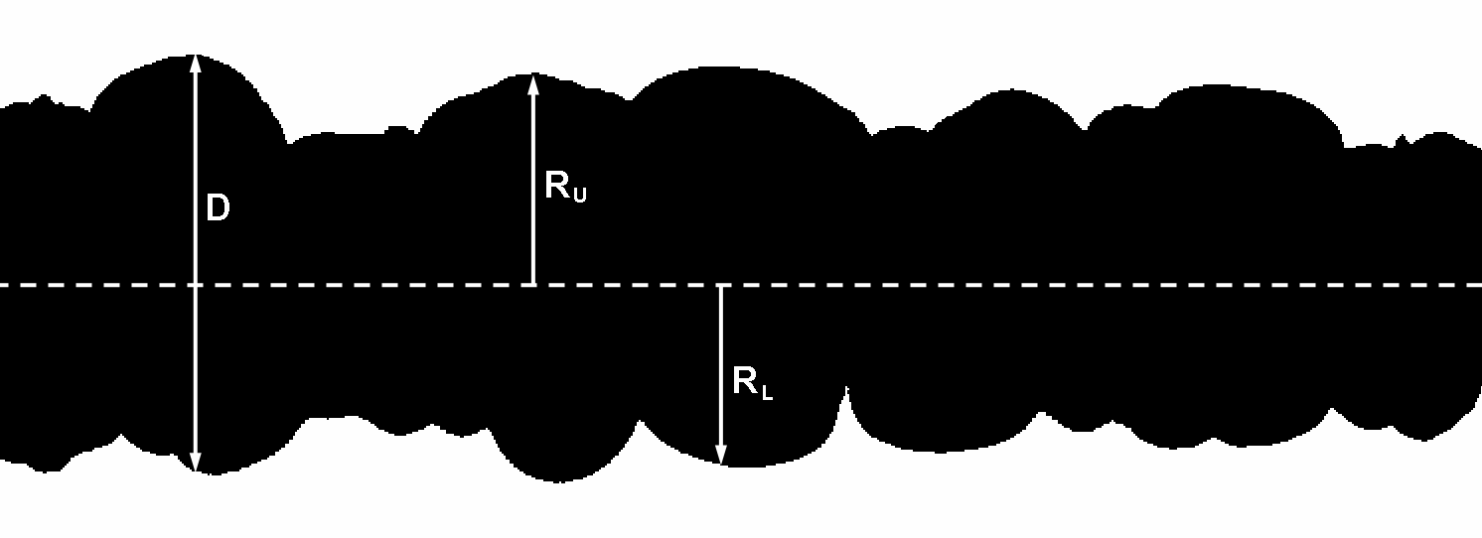
- Run ST_Generator program
- Select File>Open Sequence menu option
  - Navigate to the Examples\Colon directory and select Colon.txt.
- Select Generate 1D>Upper Radial Map menu option
- Select File>Save Maps menu option
  - Select file name for raw R map file (tif)

The radial maps can be viewed in a similar manner to D maps, as described in Sec 2.2. If the axis of the organ does not correspond to the dark blue straight line, the latter can be shifted using the User Input> Set 2 End Anchor Points menu option. This straight line is also used to position the reference points used by the cross-correlation technique when selecting the Generate 1D>Dmap and Fixed Longitudinal SRmap menu option.

ST_Viewer Features
It is often desired to compare several simultaneous maps; a task for which the viewer is well suited.

- Run ST_Viewer program
- Open the D, R or L maps in separate windows
- Select Lock Window Scroll (padlock) button on the main tool bar
- Move cursor to a feature, right click and select Mark Point

The value of each map at the same point will appear in the status bar of the window. If you wish to extract the propagation speed of a feature, follow the procedure below. The speed will be given in scientific units if the map has been published; otherwise it is given in terms of pixels moved in the time interval (delT) between successive images.

- Move cursor to start of feature, right click and select Mark Point
- Move cursor to end of feature, right click and select Mark Line

Finally, in some situations a conventional graph can be easier to interpret than a map. To generate a graph along a transept on a map, right click on the position of the desired transept and select to copy either a row or column profile to the system clipboard. The latter can now be pasted into MS Excel or a graphics program. To copy the profile along a user specified LOI:

- Move cursor to start of LOI, right click and select Mark Point
- Move cursor to end of LOI, right click and select Copy LOI Profile

Intensity and SR Maps for LOIs

Background
The techniques described in the previous chapter work well with mounted tubiform organs. In the latter, the directions of the longitudinal and circular muscles correspond roughly with the X and Y dimensions of the captured images, and it is straightforward to insert a black card in or behind the organ bath so that the organ boundary is clearly visible. The techniques described in this chapter allow more complex structures can be explored by mapping either strain rate or simply image pixel intensity along a user-specified line of interest (LOI).

Example
This example examines the low-amplitude high-frequency contractions of the circular muscles of a rat stomach. The strain rate measured is that in the direction of the LOI, and hence, the LOI is orientated in the direction of the circular muscles.

- Run ST_Generator program
- Select File>Open Sequence menu option
  - Navigate to the Examples\Stomach directory and select Stomach.txt
- Select User Input>Import Points and select RawLOI.ccd
- Select Generate 1D> Line Intensity Map and SRmap menu option
- Select File>Save Maps menu option and select the intensity map and cross-correlation displacement file (tif & ccd)

The example above imports the LOI position from another file but the position can be shifted either by selecting the User Input>Set 2 Arc Anchor Points menu option and using the mouse to set the location, or by selecting the User Input>Manual Input menu option and entering the coordinates directly, i.e. the left and right anchor points.
The maps can be viewed with ST_Viewer as before but it may be advantageous to reduce the number of fitted spline nodes (M) as the LOI is comparatively short. To check this, right click a line in the strain rate map and select View Spline Fit on the popup menu. The graphs that appear show both the original displacement data (green and red line) and the differential of the penalized spline (yellow and blue). An excessive number of nodes will result in small waves on the spline.

Tuning Cross-Correlation Settings
There are two settings for the cross-correlation technique that can be fine-tuned; the window size about the reference point and the maximum displacement distance searched. These settings can be accessed using User Input>Correlation Settings. To test the settings, open a sequence, select Help>Single Point Test and click on a point of interest. The square window should follow the point of interest.

SR Maps for Arc-Shaped ROIs

Background
The approach used in Sec 2 has a number of shortcomings. D and R maps based on detecting organ boundaries can be thought of as representing strain whereas L maps represent strain rate. Thus to compare the two directly one has to integrate the strain rate values with respect to time. Secondly, in some situations it is difficult to get reliable edge detection to locate the organ boundaries.

Tubiform Example
Generate displacement data for reference points located on an arc-shaped ROI (Janssen et al., 2014).

- Run ST_Generator program
- Select File>Open Sequence menu option
  - Navigate to the Examples\InVivo directory and select PigIleum.txt.
- Set the bounds of the arc-shaped ROI, either
  - Select User Input>Import Points and select RawArcROI.arc, or
  - Select User Input>Set 3 Arc Anchor Points and use the mouse to set
- Select Generate 2D>Arc ROI Map menu option
- Select File>Save Maps menu option
  - Select file name for raw displacement data file (arc)

The viewer can now be used to process the displacement data into strain rate maps for both the longitudinal and radial directions.

- Run ST_Viewer program
- Select File Open button on the main tool bar
  - Navigate to and select the raw displacement data file (arc)
  - Choose Longitudinal as the strain rate direction
- Select Filter/Smooth Map button (funnel) on the map tool bar
- Select Calculate New Map button (calculator) on the map tool bar
  - Accept the default penalised spline settings
- Select File Open button on the main tool bar
  - Navigate to and select the raw displacement data file (arc)
  - Choose Radial as the strain rate direction
- Select Filter/Smooth Map button (funnel) on the map tool bar
- Select Lock Window Scroll (padlock) button on the main tool bar

Each strain rate map can be individually published and saved to disk. The appropriate scale in this case was 8.3 pixels/mm.

Sacculate Example
The utility of the arc-shaped ROI technique is not limited to tubiform organs but can also be used to explore the disposition of contractions about the surface of a sacculate structure as shown by this example.

- Run ST_Generator program
- Select File>Open Sequence menu option
  - Navigate to the Examples\Stomach directory and select Stomach.txt
- Select User Input>Import Points and select RawStomach.arc
- Select Generate 2D>Arc ROI Map menu option
- Select File>Save Maps menu option and select file name (arc)

The strain rate maps can be viewed in a similar manner to that described in Sec 4.2. It is important to hit the Increase Contrast button a few times to make the low amplitude contractions visible. The appropriate scale in this case was 16.9 pixels/mm.

Areal SR Maps for Rectangular ROIs

Background
For complex sacculate structures, a good way of evaluating contraction appears to be the areal strain rate, which is the local rate of change of surface area. This is determined by combining the local linear strain rates in the X and Y directions.

Areal SR Example
Use the same cross-correlation technique to generate displacement data for reference points located on a rectangular ROI.

- Run ST_Generator program
- Select File>Open Sequence menu option
  - Navigate to the Examples\Bladder directory and select PigBladder.txt
- Set the bounds of the rectangular ROI, either
  - Select User Input>Import Points and select RawBladder.rct, or
  - Select User Input>Set Crop Limits>All and use the mouse to set the ROI bounds
- Select Generate 2D>Rect ROI Map menu option
- Go and have a cup of coffee
- Select File>Save Maps menu option and select the displacement file name (rct)

As the calculation load is excessive, the conversion of displacement data to 2D strain rate data is undertaken as a separate operation rather than being incorporated in the ST_Viewer as for the 1D case.

- Run Calc2Dstrain program
- Select Calculate 2D Strain Rates button (calculator) on the main tool bar
  - Navigate to and select the displacement data file (rct)
- Wait for the conversion complete message

The 2D strain rate file will have the same file name and location as the displacement data file but a different extension (sr2). It is now possible to superimpose the areal strain rates over the original image sequence.

- Run View2Dstrain program
- Select File>Open Sequence menu option
  - Navigate to the Examples\Bladder directory and select PigBladder.txt
- Select File>Open Strain Rate File menu option
  - Select RawBladder.sr2
- Select Mask>Set Elliptical Mask Limits>All and use the mouse to set the bounds of the elliptical mask in from the edge of the organ
- Use the video player control buttons to view the sequence

Areal SR Map
The obvious difficulty with attempting to generate a ST map for a 2D surface is that there are too many dimensions to visualise easily. A simple workaround is to map the areal SR along a user specified LOI. Follow the instructions in Sec 5.2 and then:

- Specify the LOI by
  - Right click on the start of the LOI and select Anchor 1
  - Right click on the end and select Anchor
- Select SR Display>Map Along Anchors menu option
- Optionally, select SR Display>Apply Smoothing menu option
  - Note that this may slow down the update rate
- Use the video player control buttons to view the portion of the sequence to be mapped
- Select Save Map button on the captured map tool bar

Synchronised Pressure Trace
There is a fairly rudimentary capability for adding a pressure trace to the right of the images. Currently, the program assumes that the pressure measurements have been exported by the ADInstruments LabChart program in a specific format; namely, as two columns of data (time and pressure) at a frequency of 10Hz and including comments. One of the comments can be used to synchronise the pressure trace with the image sequence. Follow the instructions in Sec 5.2 and then:

- Select File>Open Pressure File menu option
  - Select Pressures.txt
- Select File>Synchronise Pressures to Images
  - In this case, set line number to 50 and image number to 15

Areal SR Movie
A movie file can be made for publication or distribution. The process involves catching the appropriate part of the screen to a new series of image files and binding these into a single video file. Firstly, follow the instructions in Sec 5.2 and optionally Sec 5.4, then:

- Select File>Export Screen Dumps menu option
  - Select destination directory and base file name
  - Set starting and ending image numbers
  - Toggle switch on
- Go to starting image number
- Play all the images you want captured

There are many video editing programs that will bind the images into a movie. One suggestion is:

- Run Virtualdub program and open the first image file by using File>Open video file
  - The program should pick up all the image files. If it doesn’t, try temporarily renaming/removing FFMpeg Input Plugin and try again.
- Select Video>Frame Rate and set to 5 frames/second.
- Select File>Save as AVI. Enter video filename and continue.

The resultant avi file will be massive as it is uncompressed. It is suggested to use WinFF or FFmpeg to convert it to an mp4 file, which will then be compressed.

References

Janssen PWM, Lentle RG, Chambers P, Reynolds GW, De Loubens C & Hulls CM. (2014). Spatiotemporal organization of standing postprandial contractions in the distal ileum of the anesthetized pig. Neurogastroenterology & Motility 26, 1651-1662.

Janssen PWM, Lentle RG, Hulls C, Ravindran V & Amerah AM. (2009). Spatiotemporal mapping of the motility of the isolated chicken caecum. Journal of Comparative Physiology B 179, 593-604.

Appendix A. Extracting Images From Videos
VirtualDub is a freeware video processing tool that seems to be reasonably effective at extracting images out of a wide range of video formats. A minor issue is the need to install the FFMpeg plugin pack to support a broader range of video files, e.g. mkv, mp4 and mov.

Installing VirtualDub
- Download VirtualDub and also the VirtualDub FFMpeg Input Plugin from the Sourceforge website. The 32-bit versions seem fine.
- Extract both zip archives.
- Navigate to the VirtualdubFFMpegPlugin\Plugins32 folder, and copy both the FFInputDriver.vdplugin file and the ffdlls folder into the VirtualDub\Plugins32 folder (see below).

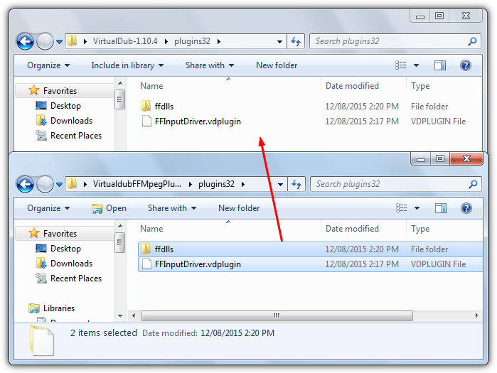

Extracting Images
- Run Virtualdub program and open the video file by using File>Open.
- Optionally, select Video>Frame rate. The Decimate field allows you to downsample; we find that 5 frames/second is adequate for most situations.
- Select File menu>Export>Image sequence. Enter the filename to save as and the folder to save into. Use a common lossless output format, i.e. bmp or png. Then click OK and VirtualDub will begin to extract the images.
- To reduce the disk space occupied and processing overheads, the image files can be cropped and converted to grayscale png files using File>Batch Conversion/Rename command in the IrfanView program.
- A header file (txt) needs to be created or edited for the new image sequence using a text editor. The file name should be the same as the image files in the sequence excluding the file number. The text file has the following five lines:
  - Description of experiment or image sequence
  - Date of image capture
  - Time of capture
  - Number of the final file in the image sequence (essential!)
  - Image capture rate, typically 5 fps

