Feb 27th 2016

Sean had asked that I tell him how much oil is left in the tanks. I had an initial goal of being able to measure the oil level with the monitoring Arduino that I did last year to measure temperature and humidity in the basement.

I did a little Googling while I was up in Jewett and I found this article
http://alaskanshade.blogspot.ch/2013/12/home-heating-hacking-part-1-or-how-to.html

http://hackaday.com/2013/12/04/using-ultrasonic-sensors-to-measure-and-log-oil-tank-levels/

What they are doing is using an ultrasonic sensor which can detect range and determine how low down the oil is in the tank. As luck would have it, I have one of these sensor. With the help of the new libraries for ranging. I was able to set the ranging sensor up pretty quickly.

There are several items that I need to sort out.

- How to mount this on top of the oil tank. There is a 2 1/4” plug on the top of the tank. I should be able to unplug this put the sensor on the top of the tank.
- Now I have to kind of calibrate this with the oil tank
- I need to figure out how to get this information over to the Arduino with the Ethernet adapter so that it can be transmitted back to the web server in East Islip.
a) Step 1 is to find the code that I currently have in the Arduino downstairs.

I can work on item1 now and try and get a preliminary reading on the oil tank. The wiring is as per the diagram below:
Vcc - Red
Trig-Orange
Echo-Yellow
Gnd-Brown
Vcc
Pin 12
Pin 11
Gnd
HC-SR04
Arduino

I went to the hardware store in Windham after church this morning and got a 2” male fitting. There is a screw plug at the top of the oil tank that I can take off and try this experiment.

And I set it up. Kinda proud of myself getting this gerry-rigged so quickly but of course it does not work.
From the side. | From the bottom. That is the sensor
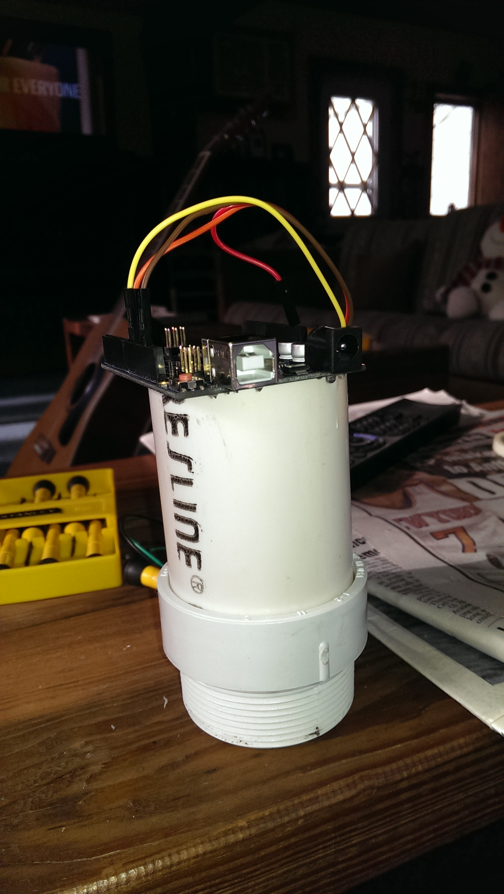 | 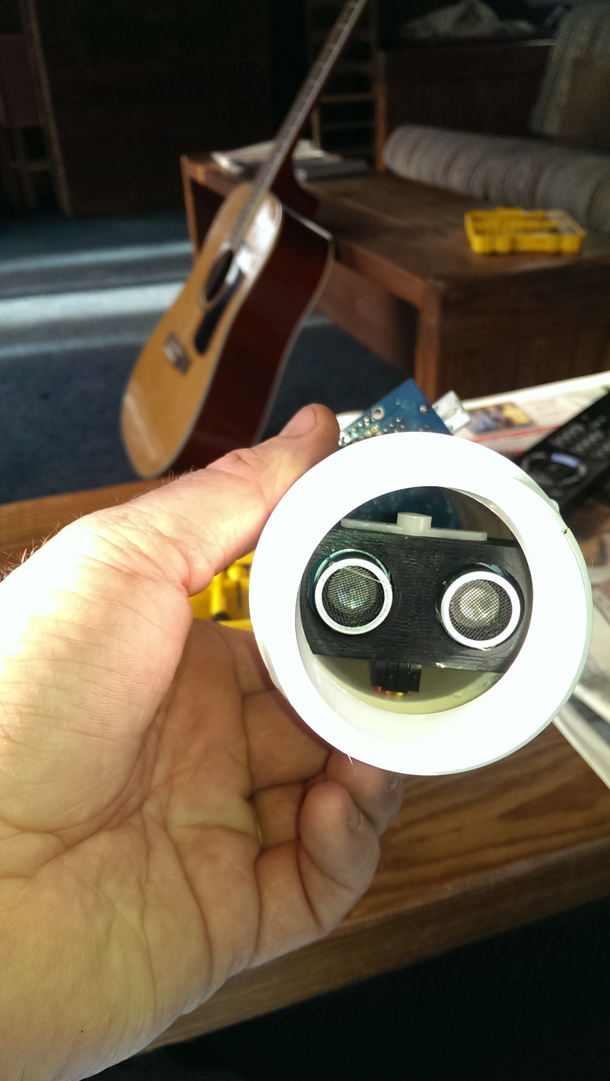

If I have the threaded portion on the bottom, the sensor seems to get screwed up and won't register a distance of more than 3 cm. I am going to try and cut the threads back to that there are only three lines. I would say that the threads total about 1 1/4” inchs. Going to try and get it down to about ½ “.

Which I did and it still is not working. I have to lower the sensor lower into the nipple. I will hot glue gun it and see how that works

Alright, once I got the sensor dead level with the bottom of the nipple it seems to be working well. I need to make some measurements with it and compare it to a ruler and see how it works.

Distance with Ruler (cm) | Distance with sensor(cm) | Material
13.5 | 13 | Wood table
42 | 43 | Carpet
91.5 | 92 | Wood floor
26 | 26 | Bottom of kitchen sink

So the idea is to measure a liquid so I started filling up the kitchen sink with water and it seems to be working pretty well. I started the sink empty and it went from 26 cm to 25, 24. I am letting it fill up a bit and then measure again. Yep, I measured a little more than 20 cm and it got it!!!
OK. Item 1 is pretty good. Onto item 2.

Trying to characterize the oil tank:

I don't think that we are splitting atoms here. The tank is 66 cm (26 inches) wide and 107 (42 inches) cm tall and 152 cm (60 inches) long and holds 275 gallons.

107cm
64cm

1 gallon = 3785.41 cubic cm

At the top and bottom of the tank, when it gets to the rounded part, 1 cm of depth is going to represent a much smaller volume than when we are in the middle of the tank.

When we get to the middle of the tank it is simple geometry
64cm * 152 cm *1 cm = 9728cc /3785.41cc/gal = 2.57 gallons/cm.

Width | 64
Height | 107
Length | 152
Middle Tank cc | 9728
Cc/gallon | 3785
Middle Tank gallons/cc | 2.57
Radius of top circle | 32
Volume of top and b

When we get to the bottom of the tank, it is similar to the top but in reverse.

When you measure the tank, I think that it will be pretty close if we estimate the top and bottom of the tank as circle with a radius of 32cm. If we try and figure out how many gallons of fuel are stored in the top and bottom of the tank with this estimate.

Volume of a cylinder = PI r^2*h

so the volume of the top and bottom will be:
3.14159*32^2*160 = 514,718 cc/3785.41 = 136 gallons. This kinda seems to high to me.

OK so if that is true, I should have about another 139 gallons in the rest of the tank (275-136)
The tank is 110 cm and the radius of the circle was 32 cm. So I need to subtract 64cm from that
110-64 = 46cm and I calculated 2.7 gallons/cm so I have 124 gallons in middle. That gets me to about 263 gallons, so I am pretty close.

I am doing all these calculations so that I can come up with an estimate as to how deep the tank should be based on the gauge. It is getting a bit late, so while I would like to calculate a number, I think I need to just make the measurement.

I went downstairs to the basement and screwed it into the top of the oil tank. Well, it did not work. The depth of the threads for the oil tank is about 1/2” thick and that seems to screw it up . No problem, I know what the issue is, I just need to move it down more onto the bottom of the nipple.

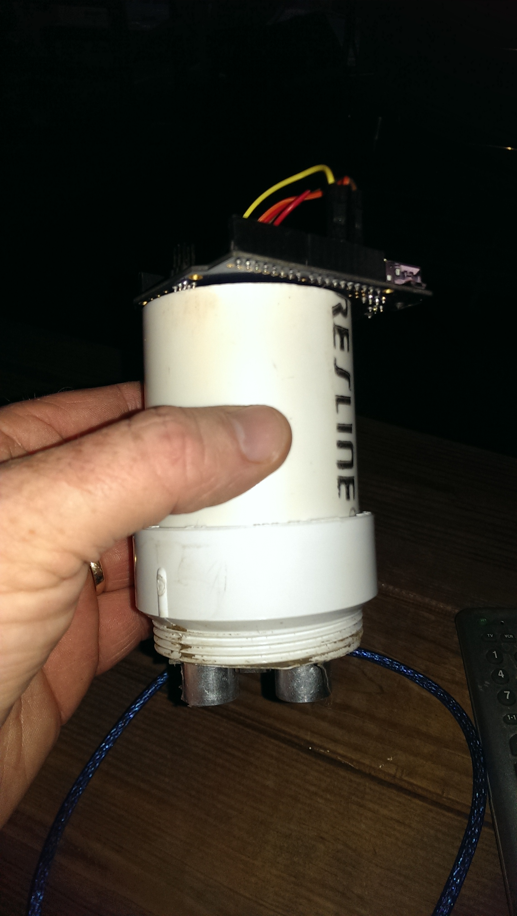

When I did that it seems to work. The measurement was 83cm. Now I have to figure out if that makes sense.

Feb 29th 2016

Still in Jewett on Monday (which is real nice) and I figured I would work on this a little more. At some point this needs to change from a chronology to a document but I can do that later.

OK Back to capacity calculations.

is the formula for the partial cylinder volume. I am going to set this up in a spreadsheet to make it easier but there are several notes to make here.
Stole this from Wolfram (http://mathworld.wolfram.com/HorizontalCylindricalSegment.html)

