**Manual for Geometry and Landmark Processing**

*01.06.2023*

Participants were asked to draw a cognitive map of the environment, including the maze geometry, landmark recall and landmark positioning.

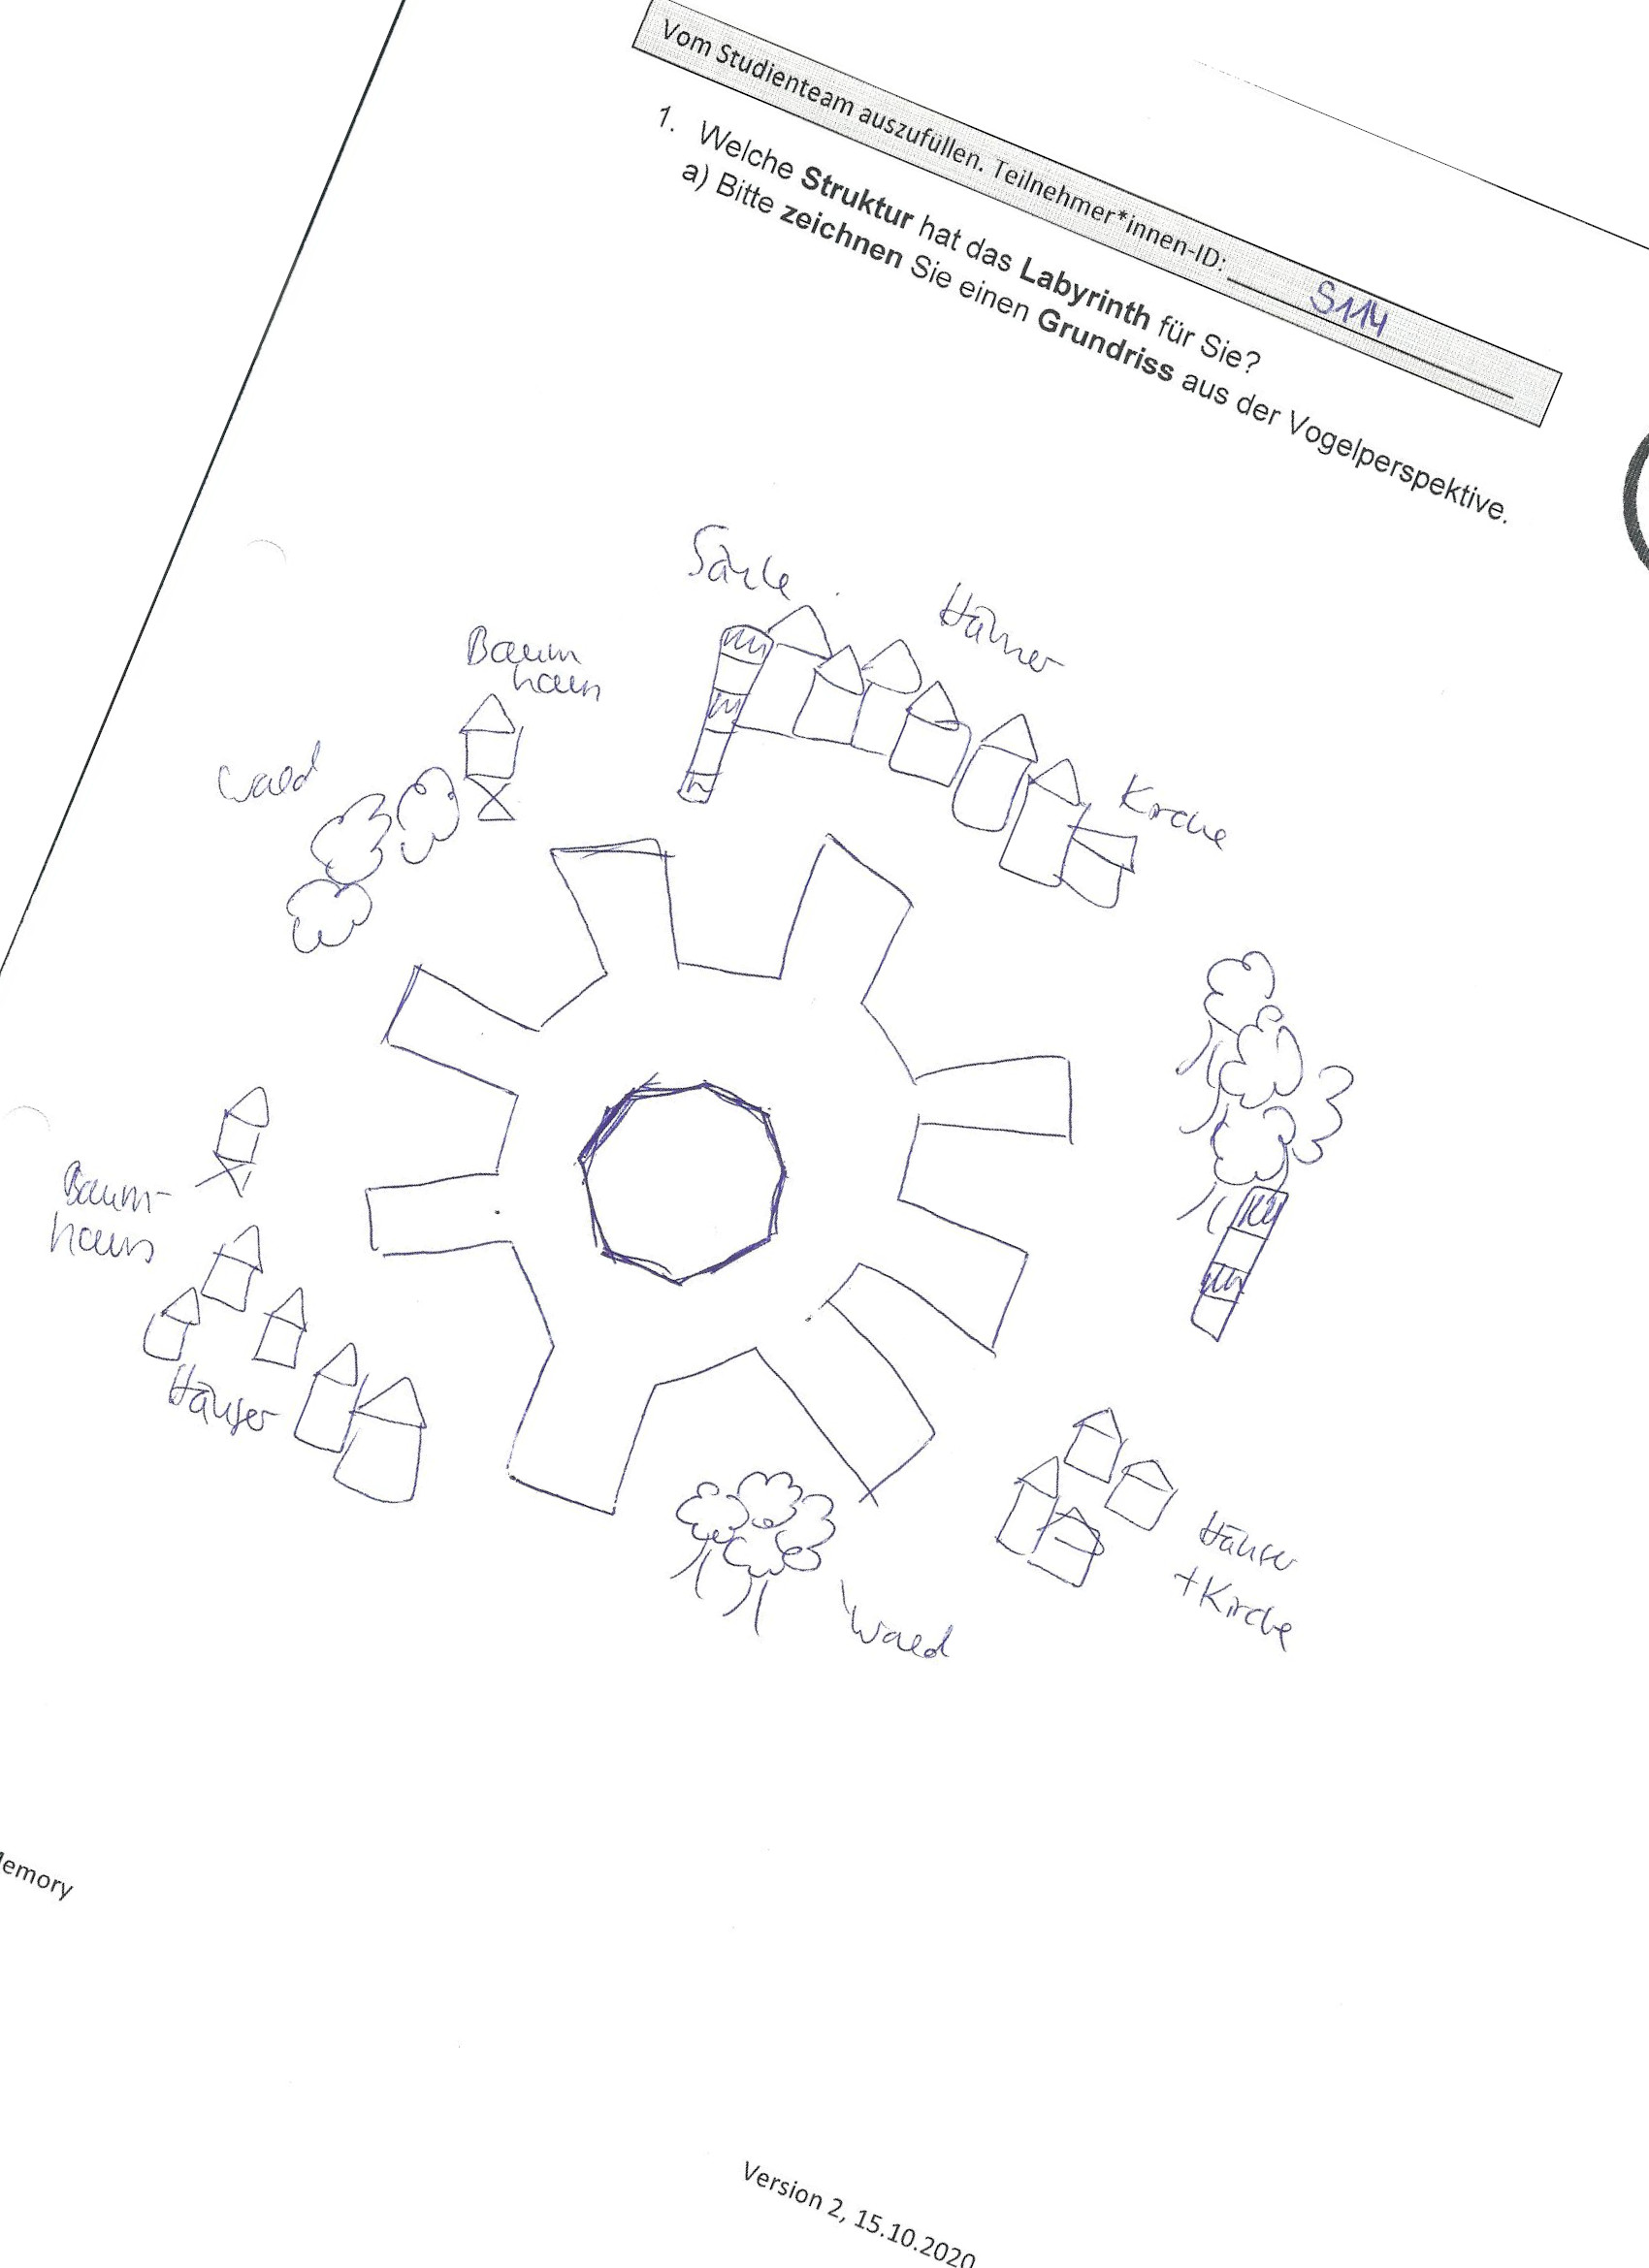

**Evaluation of maze geometry**

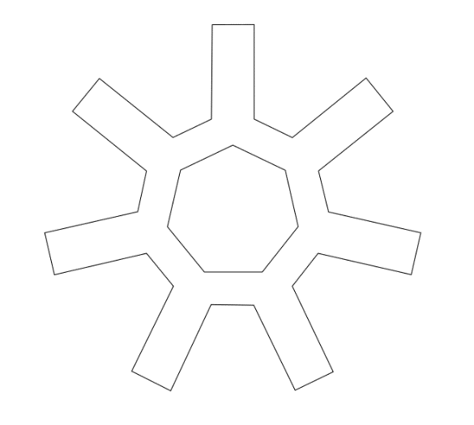

2

1

1

2

1

1

1. Digitalization of maze geometry as a Bézier path in Inkscape

* Open original image in Inkscape and scale to full page size
* Use Bézier curve tool to mark the path
  + Start with the outer shape: First point at an outer right corner in top middle (1), then down (2), and then continue in clockwise direction. If the outer shape has more than one element use Path 🡪 Combine to combine into one single outer shape.
  + Now the inner shape: Start with an inner corner near the first outer corner (1) then continue in clockwise direction. If the inner shape has more than one element use Path 🡪 Combine to combine into one single inner shape.
  + Check if number order is correct: Extensions 🡪 Visualize Path 🡪 Node numbers (Preview)
  + You can adjust line angles by pulling the lines and add points by double-clicking. Please use as few points as possible because additional points influence the interpolation in Matlab and the comparison to template with the Prokrustes method.
* Group the outer and inner shapes as one object and make sure that inner element is first (if available), outer element is last. Make the original image invisible and save as .svg file

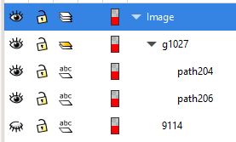

inner shape

outer shape

* There is no need to translate, scale, and rotate for an ideal match with the template when using this method (tested with modified template and example images).

1. Comparison of maze geometry with template geometry in Matlab

* Load the Bézier points with loadsvg function by Tomihiro Ikegami from the Matlab file exchange (<https://de.mathworks.com/matlabcentral/fileexchange/72225-load-svg-into-your-matlab-code>)
* Normalization of points (removes scale and translation)
* DTW interpolation for an equal number of query points
* Prokrustes analysis to compare maze geometry with template geometry
  + Procrustes distance, a measure of dissimilarity between two shapes, returned as a numeric scalar in the range [0,1]. procrustes computes the distance using the sum of squared differences between the corresponding points in X and Z. The function then standardizes the Procrustes distance by the scale of X.
* Save Prokrustes distance for each subject as .txt file

**Evaluation of landmark recall and positioning**

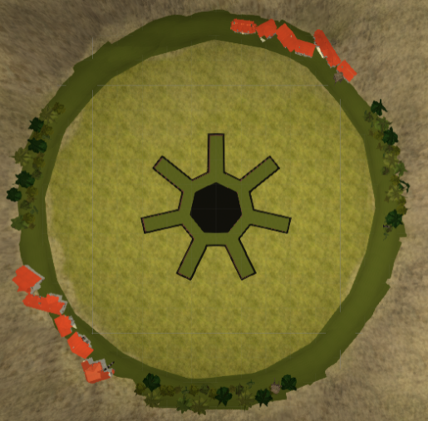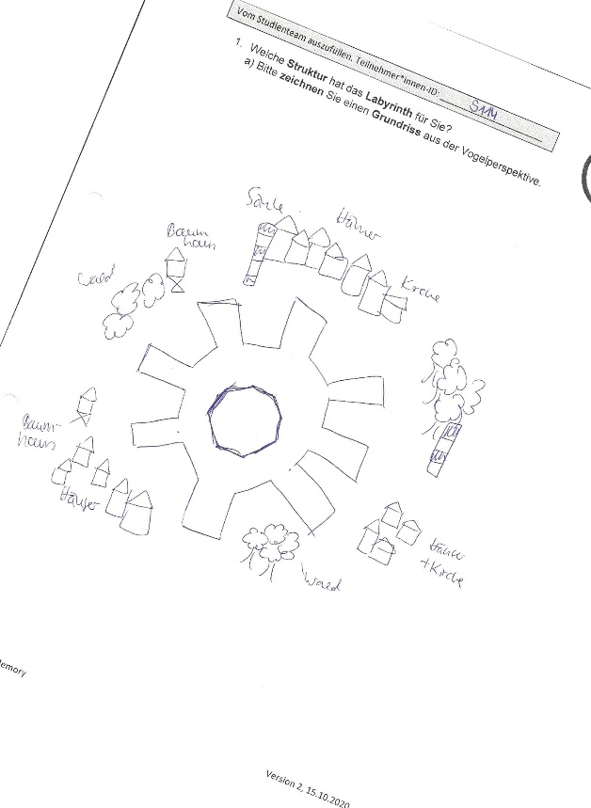

Landmark recall and positioning is evaluated with the Gardony Map Drawing Analyzer software

* Gardony AL, Taylor HA, Brunyé TT. Gardony Map Drawing Analyzer: Software for quantitative analysis of sketch maps. Behav Res Methods. 2016 Mar;48(1):151-77. doi: 10.3758/s13428-014-0556-x.
* Friedman, A., & Kohler, B. (2003). Bidimensional regression: assessing the configural similarity and accuracy of cognitive maps and other two-dimensional data sets. Psychological Methods, 8, 468–491. doi: 10.1037/1082-989X.8.4.468

1. Scoring in GMDA

* 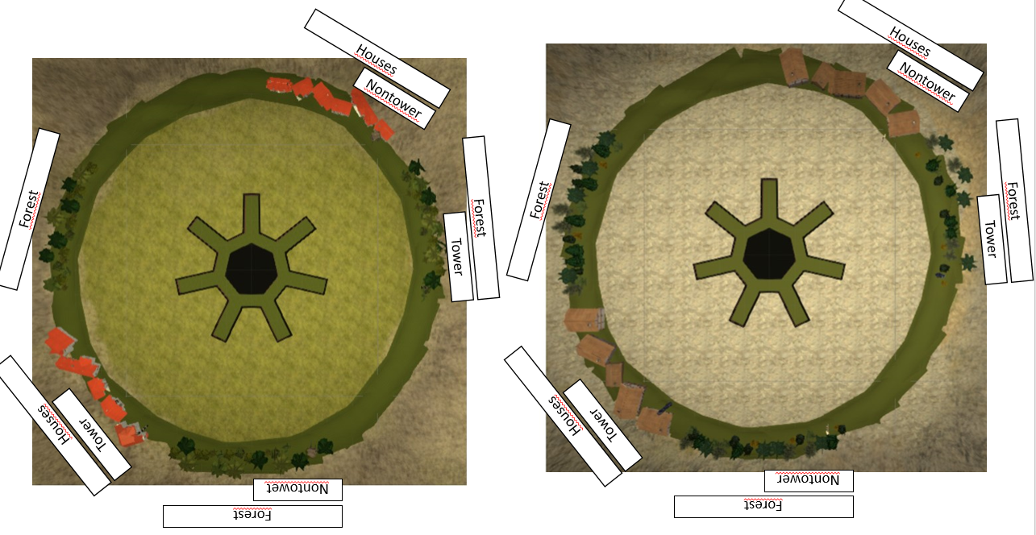Define nine landmarks for template image in *xycoords_map_WP1_template_9.csv*

|  |  |  |  |
| --- | --- | --- | --- |
| **landmarkName** | **landmarkNum** | **X** | **Y** |
| Houses-next to nontower | 1 | 101 | 231 |
| Nontower-next to houses | 2 | 152 | 172 |
| Forest-next to tower | 3 | 233 | 65 |
| Tower-next to forest | 4 | 218 | -7 |
| Forest-next to nontower | 5 | -5 | -243 |
| Nontower-next to forest | 6 | 66 | -218 |
| Houses-next to tower | 7 | -207 | -155 |
| Tower-next to houses | 8 | -145 | -190 |
| Forest-solo | 9 | -258 | 73 |

* Start *GMDA.exe*
* Select *xycoords_map_WP1_template_9.csv* as protocol and open map image
* Move landmark markers to corresponding positions on map image
  + If landmarks do not exist, remove them by double-clicking.
  + If there are duplicate landmarks (e.g. three towers instead of two), do not score the ambiguous, duplicate landmark at all but remove them by double-clicking.
* Click on *Preview*
  + The image rotation strongly influences GMDA measures! In GMDA one can rotate in 90° steps. Gardony et al. (2016) recommend to select the rotation with a *minimal theta* value. If the 90° rotation does not result in a sufficient theta value (ideally theta < +/- 10), one can rotate the image in GIMP in 45° and 22.5° steps and save it as a new image and try again.
  + Select the rotation with minimal theta (ideally < +/- 10).
* Click on *Calculate* and enter ID
  + Stores a Configuration file (for reproducing the arrangement) and two Data files (sum scores and raw data) in csv format.
  + On German PCs GMDA can result in a software bug (delimiter error), where the comma is used as delimiter and decimal symbol at the same time. The R script *Script_01_GMDA_to_txt.R* corrects for this error and extracts the relevant scores.

1. Information on GMDA Scores (Gardony et al. 2016)

* Number of landmarks recalled
  + Duplicate landmarks were not scored and thus result in a deduction of points.
* SQRT(CanOrg) (= canonical measure)
  + Canonical measures compare each landmark’s position relative to all other landmarks using canonical directions (NSEW). To calculate canonical organization (CanOrg), the software iterates through pairwise comparisons and determines if the canonical relationships for each comparison in the sketch map match the target environment (each time 0 or 1 points).
  + Comparisons to missing landmarks are automatically scored as zero (penalized). We recommend interpreting CanOrg contextualized with the number of correctly drawn landmarks.
  + The score ranges from 0 to 1 with higher scores indicating better configural accuracy and landmark recall.
  + The distribution of CanOrg is often nonnormal and positively skewed. To correct this, GMDA provides a square-root-corrected measure SQRT(CanOrg).
* CanAcc (= canonical measure)
  + Consider a sketch map that omits several landmarks but accurately represents the landmarks depicted. This sketch map would receive a low CanOrg score, which would mask the configural accuracy of the depicted landmarks. Canonical accuracy (CanAcc) accounts for this possibility. CanAcc is calculated identically to CanOrg except CanAcc only considers drawn landmarks.
  + The score ranges from 0 to 1 with higher scores indicating better configural accuracy for depicted landmarks.
* DistanceAcc (= metrical measure)
  + Metrical measures offer more fine-grained resolution than canonical comparisons.
  + Distance accuracy measures the accuracy of scaling of inter-landmark distances on the sketch map and calculates distance ratio difference scores between the sketch maps and target environment.
  + It considers the absolute magnitude of inter-landmark distance error, not direction (expanded, shrunk).
  + The score ranges from 0 to 1 with larger scores indicating more accurate representation of inter-landmark distances.
* AngleAcc (= metrical measure)
  + Angle accuracy measures the accuracy of inter-landmark angles on the sketch map and calculates angular difference scores between the sketch maps and target environment.
  + It considers the absolute magnitude of inter-landmark angular error rather, not direction (clockwise, counterclockwise).
  + The score ranges from 0 to 1 with larger scores indicating more accurate inter-landmark angle representation.
* Others:
  + CanOrg is the uncorrected version of SQRT(CanOrg) 🡪 not suitable
  + Distance bias and Angle bias consider direction of scaling/rotation instead of magnitude and are heavily influenced by size and rotation of the sketch map input 🡪 not suitable
* r: bidimensional regression parameter from Friedman & Kohler (2003)
  + Measures the degree of resemblance between sets of point configurations, ranges from 0 to 1. Values closer to 1 represent a better fit.
  + It is insensitive to scaling, translation, and rotation of the sketch map relative to the target environment as well as missing landmarks 🡪 not suitable

Which scores are recommended for this project? Only canonical scores!

* Option 1: Number of landmarks and CanAcc
* Option 2: SQRT(CanOrg)