1. Sources:

* <https://refactoring.guru/pl/design-patterns/>

1. General notes

* Gamma categorization of design patterns:
  + Creational patterns
    - Deal with the creation (construction) of objects
    - Explicit (constructor) vs implicit (DI, reflection etc.)
    - Wholesale (singe statement) vs piecewise (step by step)
  + Structural patterns
    - Concerned with the structure (e.g., class members)
    - Many patterns are wrappers that mimic the underlying class interface
    - Stress the importance of good API design
  + Behavioral patterns
    - They are all different, no central theme

1. SOLID

* Single responsibility principle
  + Class should have only 1 reason to change
  + Different tasks handle different independent tasks, problems
  + Example is having a journal with title and add_entry() method. Bad idea is to add new functionality to this class for saving journal to file. In case we have a lot of classes operating on strings, it would lead us to copying this functionality to other classes. It is better to create separate class for new concern (interfacing with files).
* Open – close principle
  + Classes should be open for extensions (by inheriting for example) but closed for modifications
  + It is better to not come back to same class as it is already tested and also client maybe would have to recompile client program to use new library
* Liskov substitution principle
  + You should be able to substitute a base type with a inherit class
  + If we have class square and rectangle, it’s better to make those 2 classes inherit from shape instead of square inherit from rectangle (square only 1 member, rectangle 2)
* Interface segregation
  + Don’t put to much into 1 interface, split into separate interfaces
  + Example with IMachine witch were able to print(), scan() and fax(). Every class inheriting from this interface has to implement all of these function even if it is only printer
* Dependency inversion principle
  + High level modules should not depend on low level ones, use abstractions

1. Builder (Creational)

* Instead of creating a component in user code, you create specialized class/structure to create (build) this component (encapsulate this component) and work with whis component
* If you want to force user to not use component, you can make ctrors private and add friend class builder into component
* You can either give builder a constructor and initialize components members in it, or you can return builder via static function (components member)
* Use it to avoid million parameters in constructor

1. Factory (Creational)

* Used when creation logic is too complicated and/or constructors would be not descriptive (constructors has the same name as component, you cannot overload them with same args with diffrent names, can turn into ‘std::optional hell’)
* Object creation (non-piecewise, unlike Builder) can be outsourced to:
  + Separate function (Factory method)
  + Separate class (Factory)
  + Hierarchy of factories (Abstract Factory)

1. Prototype (Creational)

* Interface needs to implement prototype in means partially create object and store it somewhere to copy
* User has to copy prototype (already created object – then he can customize fields of this object in his favour, but for all other fields will be already filled with some values)
* To make copy possible, interface has to implement copy constructor or implement serialization methods
* Is better then just copying obj because by copying obj user cannot copy private members, also the object that you are copying to, don’t have to be the same type (it is enough that it inherits from common interface)

1. Singleton (Creational)

* Only one component in the system (e.g. database or object factory)
* E.g. when constructor is very expensive
* Can be implemented with hiding ctrs (copy as well) in private part. Then providing member of class Singleton* singleton and static method if (singleton == nullptr) -> singleton = make_unique<Singleton>() and return singleton beside if. This way every caller of this static method will get same instance of Singleton (first will allocate memory for it).
* Monolit design pattern is type of Singleton where we have static data member (is one and common for all class instances)

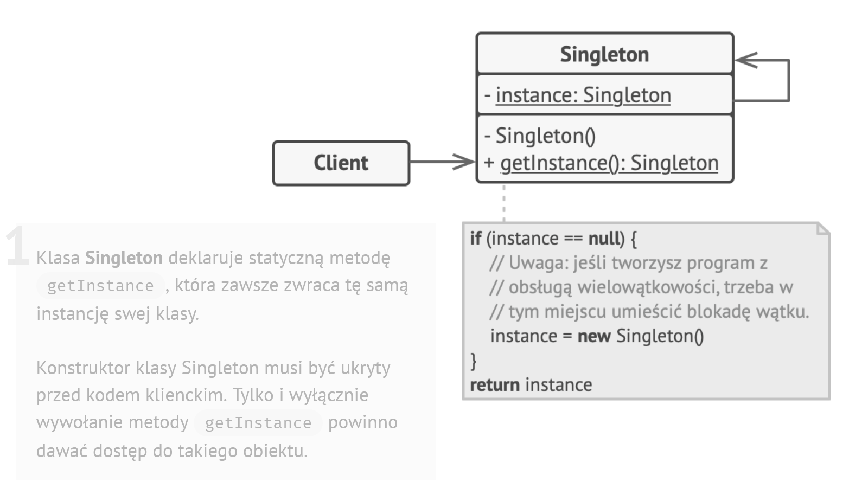

1. Adapter (Structural)

* Allows objects with incompatible interface to collaborate.
* Example: You created stock market monitoring app which displays charts and diagrams in XML. Then you decide to improve app by integrating 3rd-party library. But the library works only with JSON format.
* Adapter is a special object that converts the interface of one object that another can understand it.
* The adapter gets an interface, compatible with one of the existing objects.
* Using this interface, the existing object can safely call the adapter’s methods.
* Upon receiving a call, the adapter passes the request to the second object, but in a format and order that the second object expects.
* Sometimes it’s even possible to create a two-way adapter that can convert the calls in both directions.
* 2 implementations, object adapter (composition) and class adapter (inheritance)

