CUSTOMER JOURNEY MAP – BANKING SYSTEM

1. INTRODUCTION
A Customer Journey Map (CJM) is a visual representation of every experience a customer has while interacting with a product or service. It illustrates the complete story of a customer’s interaction, starting from the initial point of contact, through engagement, and extending into a long-term relationship.
In the highly competitive banking sector, services are often commoditized, meaning that most banks offer similar financial products. As a result, the primary differentiator between Bank A and Bank B is the Customer Experience (CX). This experiment focuses on mapping the end-to-end journey of a student customer interacting with a Retail Banking System, analyzing both digital touchpoints (Mobile Banking Application) and physical touchpoints (Bank Branch).

2. AIM & OBJECTIVES
Aim
To visualize and analyze the complete journey of a customer interacting with a Banking System.
Specific Objectives
- To visualize the user flow from initial brand awareness to post-service support.
- To identify critical pain points such as hidden charges, onboarding delays, and technical glitches.
- To optimize the customer experience by proposing actionable improvements such as Digital KYC and AI-based customer support systems.

3. SOFTWARE & TOOLS USED
The following tools were used to design and analyze the customer journey:
Tool Name | Purpose
Figma | High-fidelity interface and journey mapping
Canva | Layout design and report presentation
draw.io | Process flow and journey diagrams

4. USER PERSONA
To ensure the journey map is realistic and empathetic, a representative user persona was created based on the target demographic.
Table 1: User Persona Profile
Parameter | Description
Name | Utsav Gupta
Age | 19 Years
Occupation | Engineering Student
Primary Goal | Easy money management and fast transactions for college expenses
Key Frustrations | Long queues, frequent app crashes, slow customer support

5. THE CUSTOMER JOURNEY MAP (DATA MATRIX)
The following matrix summarizes the customer experience across five key journey stages.
Table 2: Customer Journey Map Matrix
Stage | User Actions | User Emotions | Pain Points | Opportunities
Awareness | Searches for bank information; sees advertisements | Neutral | Too many options; unclear benefits | Student-focused banking plans
Consideration | Compares charges; reads reviews | Confused | Hidden charges; complex terms | Transparent pricing charts
Onboarding | Submits KYC documents | Frustrated | Verification delays | Faster Digital / Video KYC
Usage | Transfers funds; pays bills | Satisfied or Frustrated | App crashes; failed transactions | Improved app stability
Support | Contacts helpline; raises complaint | Angry | Long waiting times | AI-based customer support

6. DETAILED STAGE ANALYSIS (TABLE FORMAT)
Table 4: Detailed Customer Journey Stage Analysis
Stage | Description | User Actions | Touchpoints | User Emotions | Pain Points | Opportunities / Improvements
Stage 1: Awareness & Discovery | This stage begins when the user realizes the need for a bank account and starts exploring available options. | Searches online for banking options; notices advertisements and peer recommendations. | Social media ads, bank websites, branch posters. | Curious, Neutral | Too many similar banking options; lack of clear differentiation between banks. | Introduce student-focused accounts; use simple, jargon-free communication highlighting clear benefits.
Stage 2: Consideration | The user evaluates shortlisted banks before making a decision. | Compares charges, minimum balance requirements, and reads online reviews; contacts customer care. | Bank websites, customer care helpline, branch inquiry desk. | Confused, Cautious | Hidden charges; complex terms and conditions. | Provide transparent pricing, easy-to-read fee charts, and comparison tables.
Stage 3: Account Opening (Onboarding) | The user proceeds to open an account with the selected bank. | Submits KYC documents and personal details through the app or branch. | Mobile banking app, branch counter, SMS/Email notifications. | Hopeful, Slightly Frustrated | Delays in KYC verification and account activation. | Implement Digital / Video KYC; show real-time application status tracking.
Stage 4: Usage & Experience | The user starts using banking services regularly. | Performs balance checks, fund transfers, and bill payments. | Mobile banking app, ATM services. | Satisfied or Frustrated (depends on system performance) | App crashes; failed or delayed transactions. | Improve app stability; ensure instant transaction reversal and system reliability.
Stage 5: Post-Use / Support | The user seeks help when an issue occurs. | Calls customer care, uses chatbot, or visits branch for complaint resolution. | Helpline (IVR), AI chatbot, branch support desk. | Angry, Relieved | Long waiting times; slow complaint resolution. | Deploy AI chatbots for routine issues; introduce instant callback and faster grievance handling.

7. VISUAL REPRESENTATION (PROCESS FLOW)
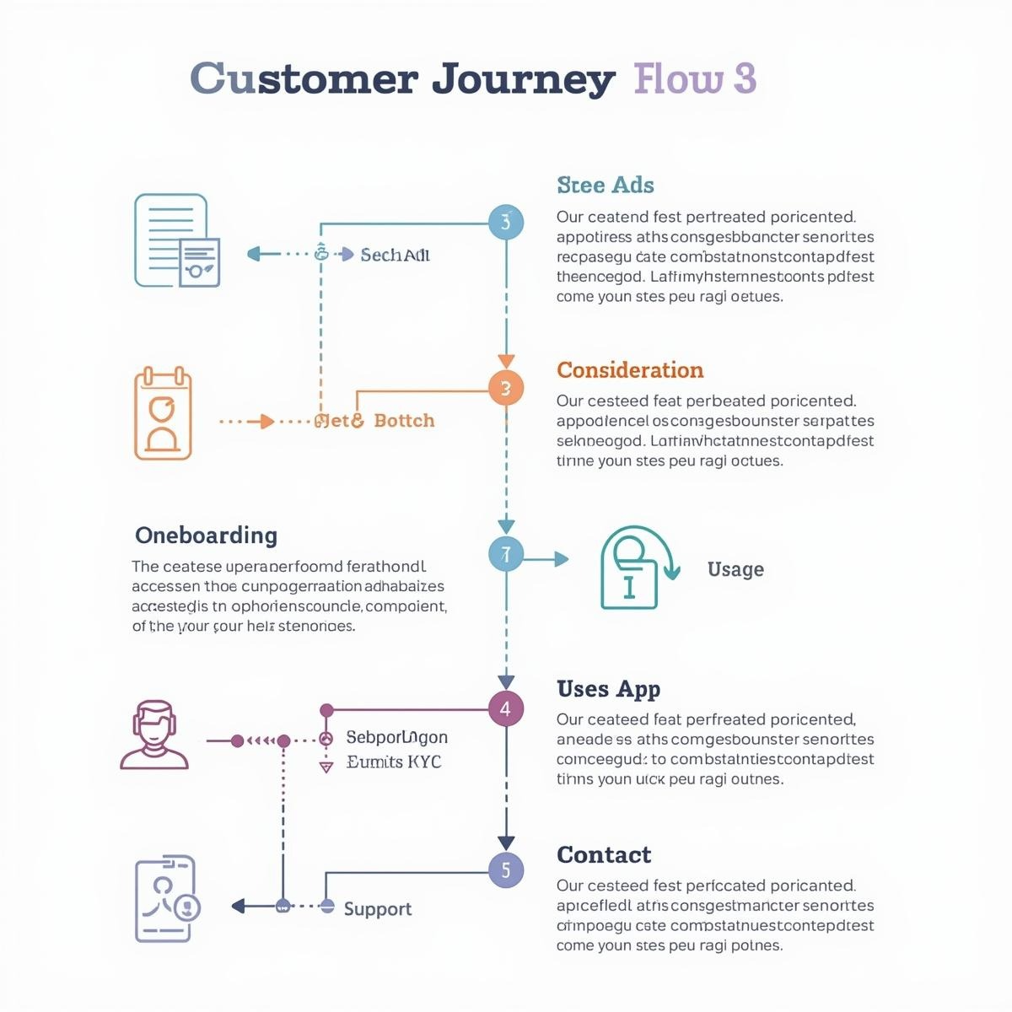

8. CRITICAL GAP ANALYSIS
Based on the journey analysis, two major service gaps were identified.
Table 3: Gap Analysis & Recommendations
Gap Area | Problem Identified | Proposed Solution
Onboarding Gap | Manual verification causes 3–4 day delays, risking user drop-off | Implement Digital KYC with OCR and Video Verification
Support Gap | High call volumes result in long waiting times | Deploy AI chatbots and instant callback features

9. CONCLUSION
This experiment successfully mapped the end-to-end journey of a student customer interacting with a Retail Banking System. While the core banking services function adequately, the service delivery layer shows significant weaknesses. Onboarding delays and inefficient customer support are the primary causes of dissatisfaction.
By implementing Digital KYC, improving mobile application stability, and integrating AI-driven customer support, banks can significantly enhance customer trust, satisfaction, and long-term retention.

