Python project_Solar cell uniformity

A little background: A full size solar cell is a 156 x 156 mm2 square with rounded corners. For uniformity improvement purposes, each full size solar cell is divided into 184, 1 cm2 small cells that are characterized separately (see picture below).

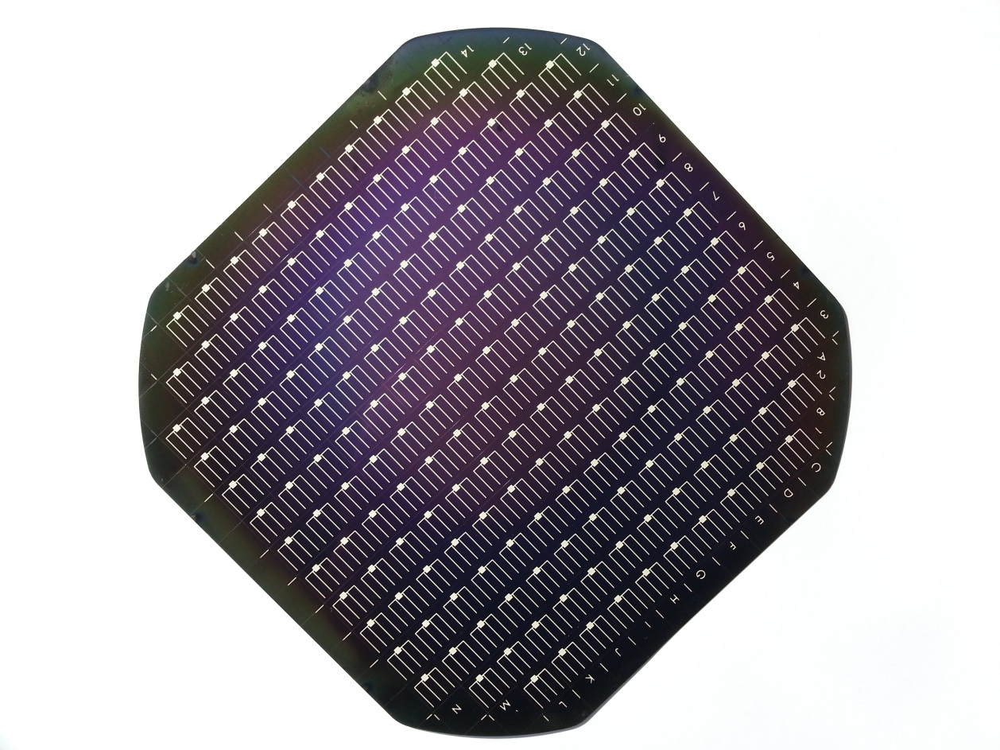

Figure A full size solar cell divided into 184 small cells

Important solar cell parameters are “short circuit current” (Isc), “open circuit voltage”(Voc), “fill factor” (FF) and “Efficiency”(Eta).

Field of operation : Data processing and graphing project

Name: solar_cell_ uniformiPy

This project is going to display solar cell parameters in a color-coded 2D plot .The inputs are current-voltage measurements for each small solar cell on a full size device. The outputs are the graphs of the solar cell parameters depending on the location on the full size device.

Class 1 : Solar_cell_small

An instance of an object solar cell is created from a txt file containing current-voltage data. In the init method the data is extracted.

Attributes:

position (extracted from the file name)

voltage (list or table extracted from file)

current (list or table extracted from file)

power (list or table_calculated from Voltage and Current)

pmax (int representing the maximum power_calculated from power)

vp_max(int representing the voltage at pmax_calculated from voltage)

ip_max(int representing the current at pmax_calculated from voltage)

isc (int representing the short circuit current_calculated from voltage and current )

voc (int representing the open circuit voltage_calculated from voltage and current)

ff (int representing the fill factor_calculated from isc, voc , vp_max and ip_max)

eta (int representing the efficiency of the solar cell_calculated from pmax)

Class 2 : Solar_cell_full _size

Attributes:

Small_cells (list of all the small cells in a full size solar cell)

Method:

voc_colorplot(On a graph representing the full size solar cell, it will plot a square for each individual small cell. The color of the square is representative of the voc of the small cell.)

similar methods will be created for isc, ff, eta.