**Horizon-Base Indirect Lighting**

## The ideal companion for your far-field indirect lighting solution.

February 2018 – Benoît “Patapom” Mayaux  
b.mayaux@gmail.com

In the following document, vectors will be written in boldface characters (e.g. **,** ) and scalar values will use regular characters (e.g. , ).  
The spherical coordinates used throughout the paper have an elevation angle aligned with the vertical **Z** axis, and an azimuthal angle lying in the tangent plane measured from axis **X**:

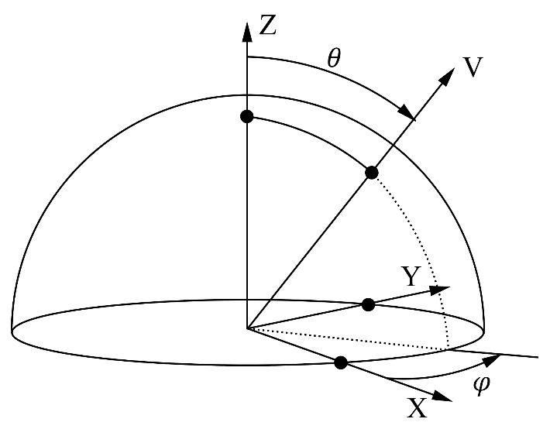

**Fig. 1.** The frame for spherical coordinates used in this paper.

1. Introduction

The Horizon-Based Ambient Occlusion (HBAO) technique introduced by Bavoil et al. [1] proposed to improve the computation of the Ambient Occlusion integral by skipping all the rays that we know for sure would intersect the heightfield/depth buffer and thus wouldn’t contribute to the visibility term:

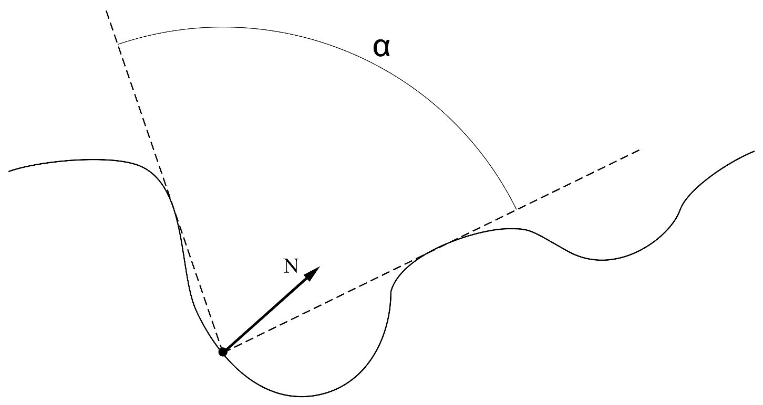

**Fig. 2.** The HBAO algorithm is exploiting the full visibility of the horizon cone of angle 𝛼:  
 we know all the rays inside the cone escape the surface of the heightfield and are the only ones actually contributing to the visibility term.

The ambient occlusion term is then simplified into:

Where:

* is the location of the pixel for which we are calculating the AO
* is the incoming ray direction
* is the upper hemisphere of directions whose solid angle is 2π
* is the portion of solid angle covered by the vector
* is the visibility term returning 1 if the ray escapes to infinity, 0 if the ray intersects the heightfield
* is the horizon angle in azimuthal direction

This technique allows us to avoid tracing rays for the entire hemisphere, instead we simply need to determine the horizon angle for a particular azimuthal angle by sampling the height field in screen space:

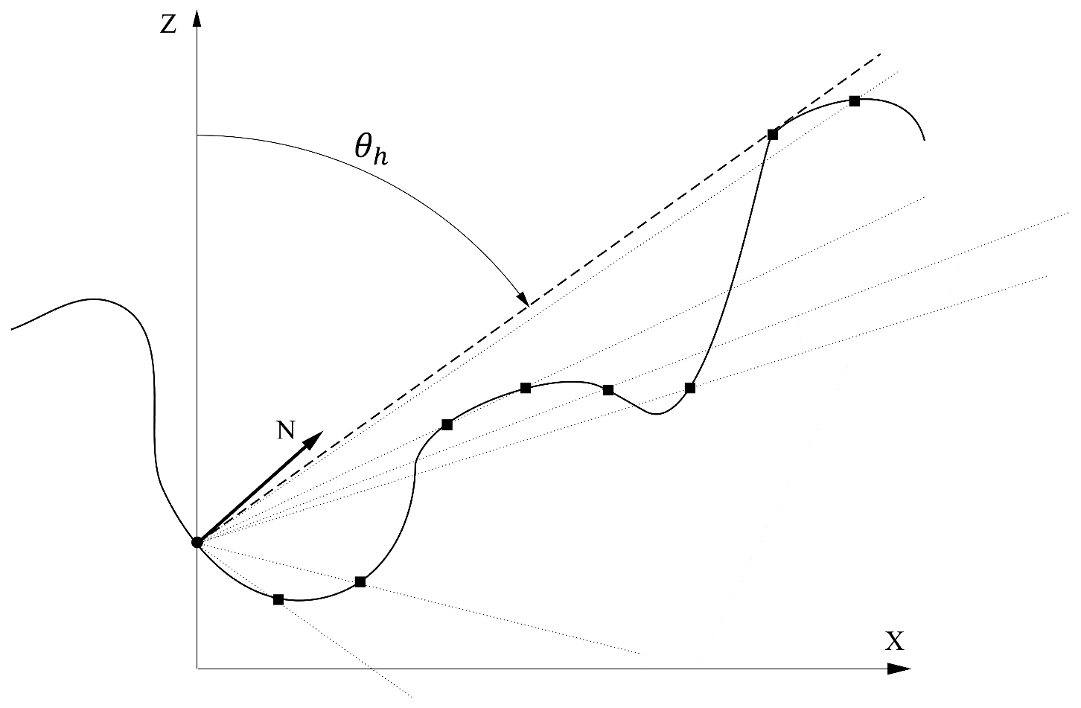

**Fig. 3.** The heightfield is sampled along the X direction and the horizon is updated along the way by reducing the horizon angle each time.

The portion of AO computed by the inner integral is:

And so, the final expression for the AO becomes:

# Back & Front Sampling

In this paper, to avoid doing the same work twice, we will assume that we always trace the front and back parts of the slices of the tangent-space disk at the same time:

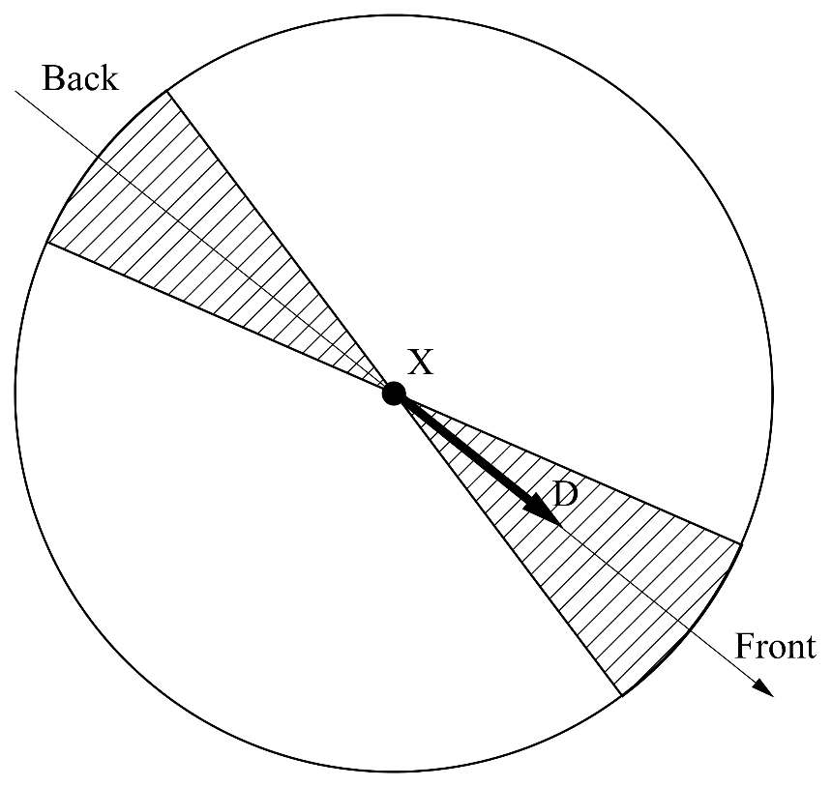

**Fig. 4.** The tangent-Space disk is sampled both in the forward and backward direction

Estimating the AO in such a simultaneous back & front manner simply becomes:

# Local Camera Space

In order to avoid getting a camera-space normal with a negative z component, we must construct a “local” camera space specifically for our sampling location :

Where:

* is the normalized view vector pointing from our world-space location toward the camera
* is the world-space camera position
* is the world-space camera up vector

From which we obtain:

* the new local camera-space “right” vector
* the new local camera-space “up” vector

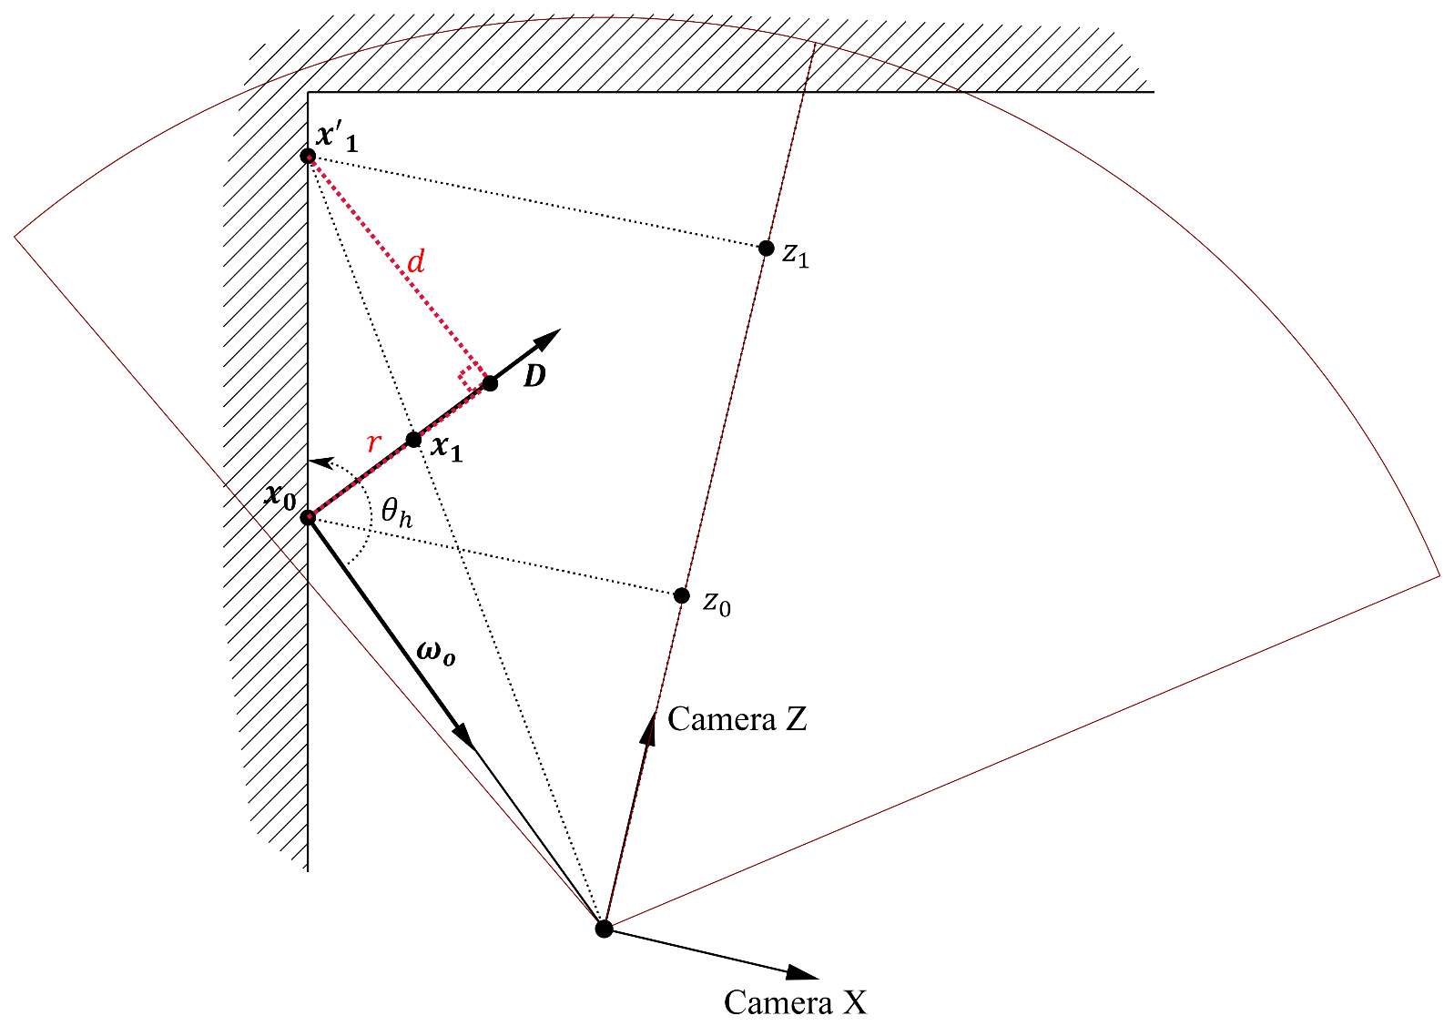

**Fig. 5.** The important difference between the “global” camera space and the “Local” camera space reconstructed from point and camera view vector .  
Moving to a neighbor location implies some reprojection steps to obtain , and used to compute the new horizon angle . These steps are described in section 2.1.2.

This new local camera space will be used to express the normal, the horizon angles and later, the bent cones.

1. Improvements over HBAO

In this paper, we will propose several techniques to make the most out of the information gathered while performing the HBAO algorithm:

* The first section will discuss how to use the camera-space normal, if it’s available, to make the result more robust.
* The second section will discuss how to obtain the bent-cone from our samples  
  The generated bent-cone buffer will then replace the normal buffer and become a very efficient tool to compute a better scene lighting.
* Finally, the third section will explain how to eventually re-use the indirect diffuse lighting from the previously rendered frame to compute a very important near-field indirect lighting term to improve the scene lighting.

# Using the Normal

We can first improve a little upon the quality of the HBAO algorithm by using the normal to initialize the horizon angles.  
The camera-space normal vector is often available from the G-Buffer produced by most deferred renderers.

The gray areas of the tangent-space disk from figure 4 are approximated by a “slice” rotating about the axis of the local camera-space described earlier:

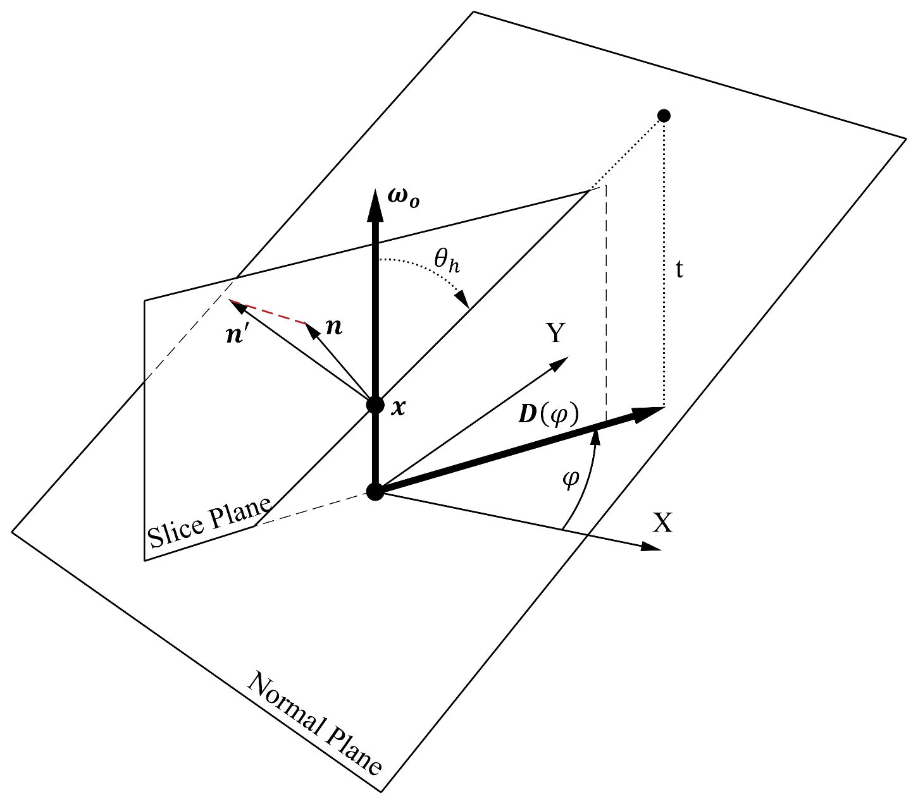

**Fig. 6.** a camera-space slice rotating by an angle about the axis pointing toward the camera. Is the tangent direction of the slice in world-space**.**  
We point out the important fact that the camera-space normal is not necessarily lying in the plane of the slice and will need to be projected onto the slice, yielding the  vector.

## Initial Horizon Angles

As represented in figure 6, we initialize the horizon angles for the slice by computing the projection of the vector onto the normal plane by following the axis to find the length :

Where:

* is the slice’s azimuthal direction expressed in local camera-space
* is some azimuthal angle in the tangent plane of the local camera-space
* is the view direction expressed in local camera-space
* is the normal expressed in camera-space
* is the intersection distance with the normal plane
* and are respectively the initial front and back horizon angles

**TODO: Show ON/OFF image**

## Updating the Horizon Angles

In figure 5 we saw that when we move from our central location to the neighbor location by following the world-space vector for a small distance we get**:**

If we sample the depth-buffer at the screen-space location corresponding to this new location , it will give us depth from which we obtain the new world-space location that we can finally express back into the local camera space:

From which we can finally obtain the cosine of the horizon angles that we will use all along this paper:

Where:

* is the measured elevation angle for the neighbor sample at
* is the horizon angle that can only decrease as we move along

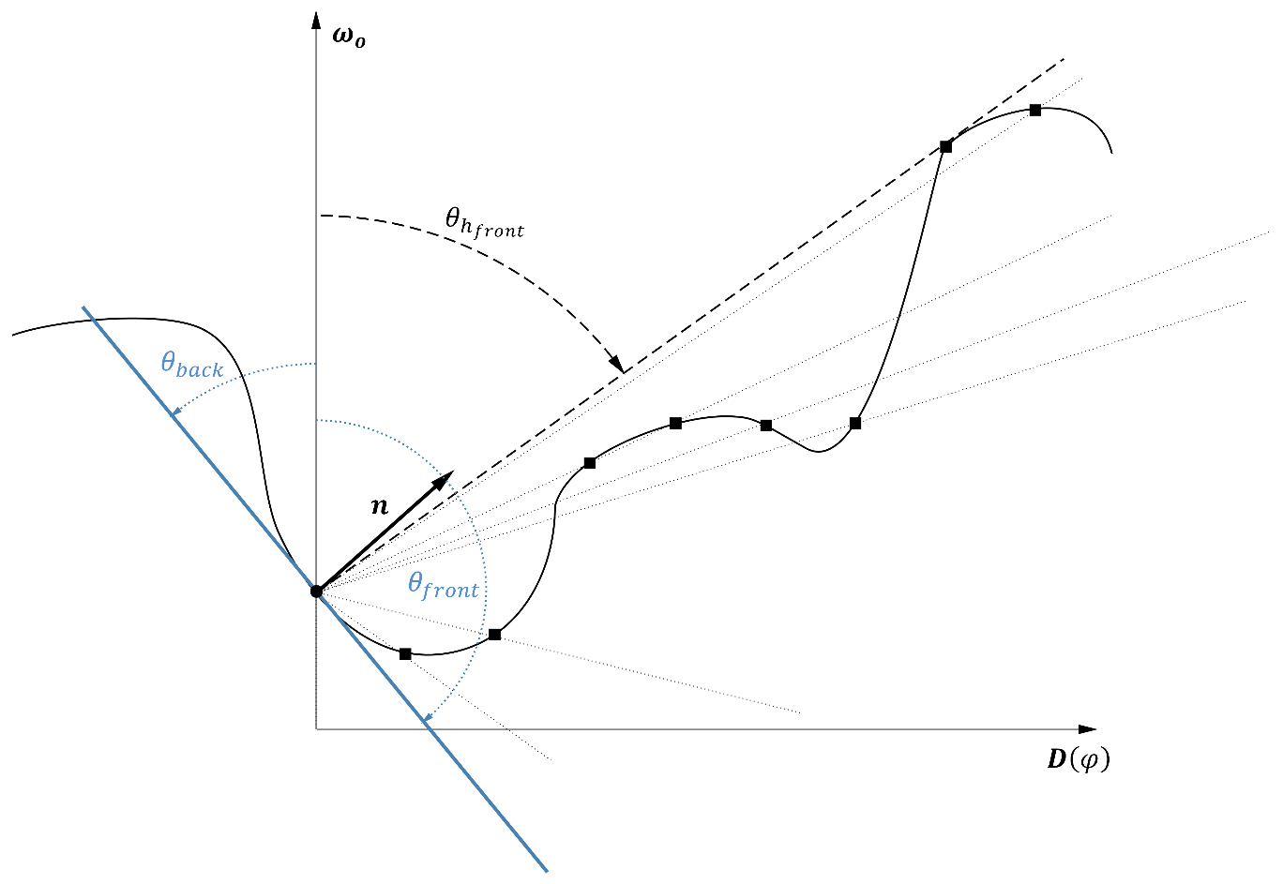

**Fig. 7.** Using the normal to determine and as our initial horizon values for each slice of the camera-space sampling disk, then updating our horizon angle as we march along the slice’s tangent direction .

# Bent Cones

We follow the methodology of the GTAO computation described by Jimenez et al. [3] to compute the ambient occlusion but we are also interested in computing what I call a “bent cone”, which is a combination of a bent normal used as the central axis of a cone whose aperture depends on the ambient occlusion:

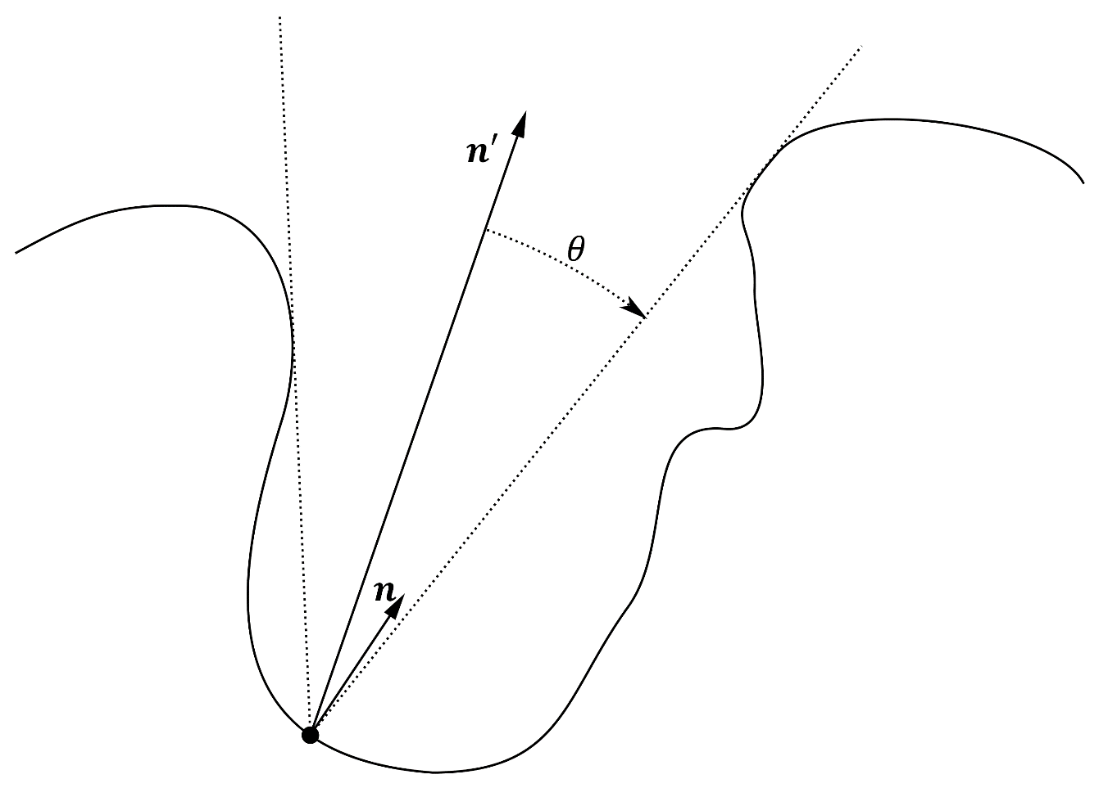

**Fig. 8.** The “Bent-Cone”, a bent normal with an angle.

## Bent Normal

In order to first get the bent normal , we need to compute the average direction of a vector unoccluded by the environment:

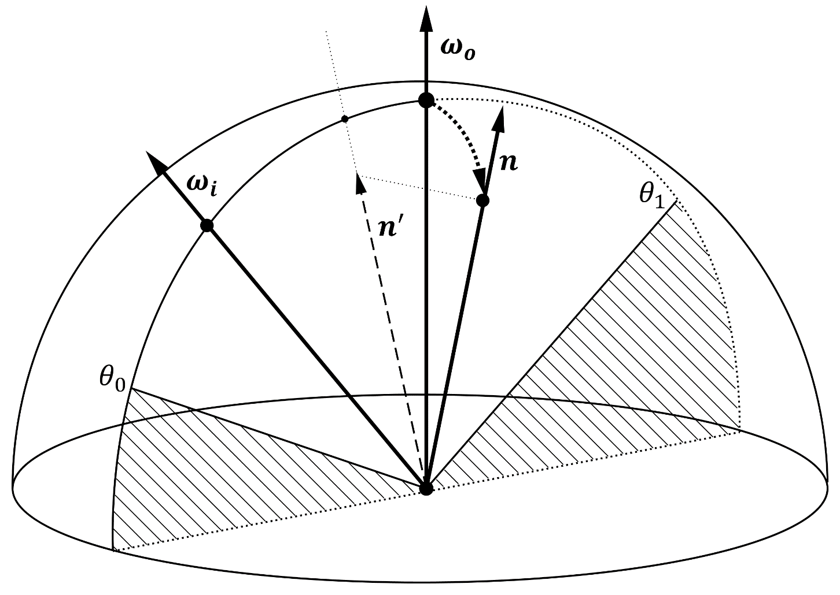

**Fig. 9.** Integration of the vector between angles and , restricted to a single slice. Notice that the normal vector is not necessarily lying in the slice’s plane.

We can get an approximation of the integral for equation 4 by computing a series of integrals restricted to 2D slices rotating about our view axis as shown in the figure above:

Where:

* S is the amount of slices
* is the “back” horizon angle for the slice.
* is the “front” horizon angle for the slice.
* is a vector direction restricted to the slice, with the angle .

Focusing on the inner integral, we rewrite its expression in slice-space as:

Where:

* is the camera-space vector expressed in slice-space
* is the resulting normal vector for the slice

And we get:

From which can finally rebuild a unit camera-space normal:

Where:

* and are the and values for the slice
* and are the camera-space slice vectors described by equations group (1)

**TODO: Show world space result bent-normal**

**TODO: Show ON/OFF image**

## Cone Aperture and Ambient Occlusion

We need the solid angle covered by the cone to be significant when we will use it to sample the distant environment, or use it for direct lighting.

Sampling the distant (*i.e.* far-field) environment is given by:

Where:

* is the irradiance at for surface normal from the far-field environment
* is the incoming radiance at from direction
* is the set of all directions covering the upper hemisphere
* is the solid angle covered by the surface perceived along direction
* is the visibility term we saw in section 1

I wrote in [4] that equation 7 is often simplified into:

Where is the unoccluded irradiance from a diffuse cube map, or some SH representation.

We see from equation 8 that we need to compute the AO term:

From figure 9 we see it is easy to integrate the visibility of a single slice using our 2 horizon angles:

And finally, AO is given by:

Where is the slice index and the amount of slices.

To finalize our bent-cone, we are interested in another formulation for the AO, which would be the solid angle covered by the cone with aperture angle :

The true integral of the visibility term in equation 8 actually yields exactly this solid angle:

From this we can deduce that:

And finally, the aperture angle of our bent-cone is given by:

We can also conclude that the cosine of the aperture angle of our bent-cone is the *geometric equivalent* of the classical AO formulation, but we will prefer it to the AO term since it lends itself very well to a comparison to the dot product generally found in lighting equations.

The effect of accounting for the cone aperture angle is most important, as can be seen in the image below:

**TODO: Show cone aperture/AO result**

**TODO: Show ON/OFF image**

## AO Variance

In order to add a little more variation to our AO values, we can also compute the variance for each slice.  
We assume that each slice provides its own little AO value:

We use the running variance algorithm described in [6] to accumulate variance as we go along with each new slice:

Where:

* is the average of the AO value for slice
* is the variance of the AO value for slice
* is the total amount of computed slices
* is the resulting variance and the standard deviation

We saw from equation 10 that AO and cone aperture were equivalent notions so we could very well assume the standard deviation in AO is also giving use a standard deviation in cone angle:

Where is a custom bias that can be applied to increase or decrease the variation of the cone angle.

The resulting angles could be used as a classical “hotspot” and “falloff” angle of regular spot lights at the cost of one more storage slot in the resulting bent-cone buffer:

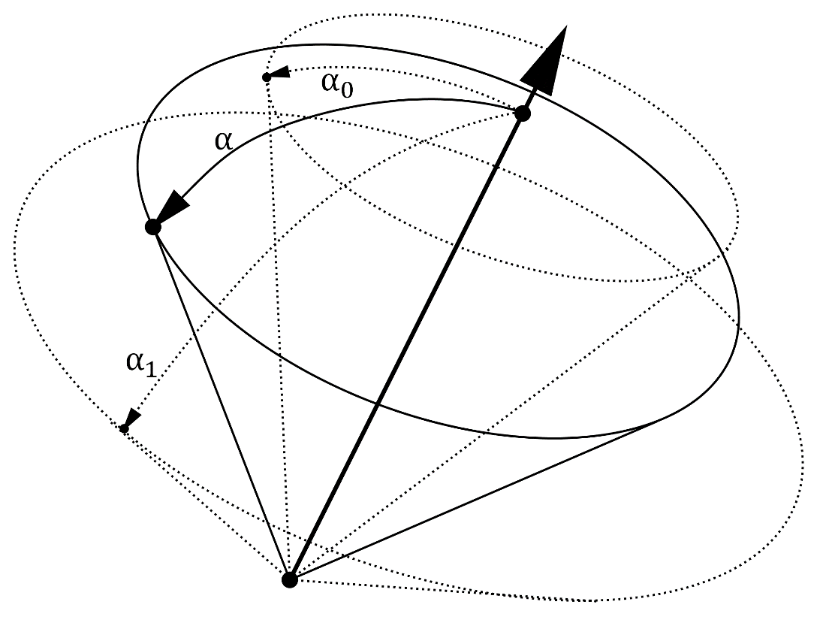

**Fig. 10.** using the standard deviation of AO to compute “hotspot” and “falloff” angles.

**TODO: Show image with representation of variance**

## Using the bent-cone for far-field indirect illumination (Cube Map)

In [4] we noted that the simplification induced by equation 8 suffers from a loss in energy that should be compensated by applying a factor given by so that:

With:

Here, is sampled from a pre-convolved diffuse cube map, or obtained from any other way where the angular aperture is predefined to be 90° and cannot be changed.

**TODO: Show image**

## Using the bent-cone for far-field indirect illumination (Spherical Harmonics)

If the distant environment is available as spherical harmonics (SH) instead, then we should use the modified irradiance estimate from [5] that allows to reduce the aperture angle used in Ramamoorthi’s calculations [7] using the simple free parameter as replacement for the upper bound to the integral (16) instead of the default value:

I will only give the procedure for an order 2 SH representation (i.e. 9 coefficients), details can be found on my wiki page for a possible extension to higher orders:

Then the resulting irradiance estimate for a cone of aperture is given by:

The represent the encoded SH terms for the distant environment’s radiance.

***Note:*** It is also totally possible to estimate the irradiance by simply using the classical hemisphere SH estimate from [7] and multiply the result by as seen in section 2.2.4. but I find the results more accurate using the reduced-cone formulation.

**TODO: Show image**

## Using the bent-cone for direct illumination

The attenuation factor for direct lights is often written:

Where:

* is the location of the light source
* is the direction of the light source (if not a point source)
* is a custom function that returns a [0,1] attenuation value depending on the angle between light and target. For a point source, returns always 1. Often a smoothstep function between a hotspot and a falloff angle.

Using the bent-cone data, we could augment with a new attenuation term depending on whether the light direction is perceived by the surface or not:

Where are the hotspot/falloff angles computed earlier in section 2.2.3., and is a custom attenuation function, like maybe another classical smoothstep.

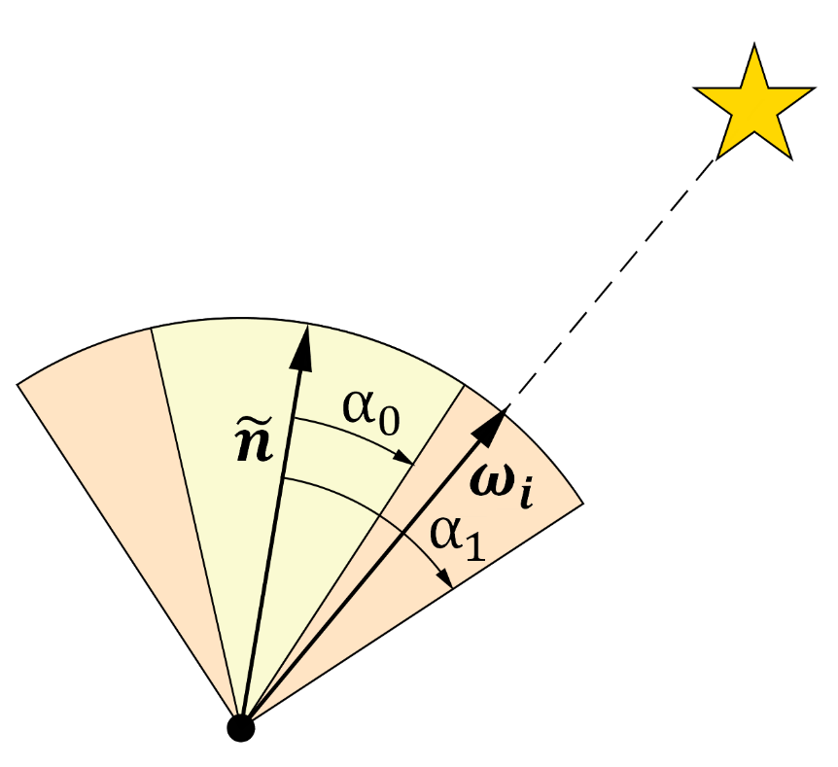

**Fig. 11.** using the freshly computed bent-cone angles to attenuate the directly perceived irradiance.

**TODO: Show ON/OFF image**

## Using the bent-cone with area lights

TODO! Intersect bent cone with area light’s surface? 🡪 Intersection of a disc with a parallelogram?

## Specular Occlusion

TODO! Quote Jimenez’s GTSO, cone intersections, blah

# Indirect Lighting

The classical lighting equation to compute the outgoing radiance from a pixel at in viewing direction is essentially given by:

Where:

* is the incoming radiance at from direction
* is the surface’s BRDF
* is the surface normal
* is the set of all directions covering the upper hemisphere
* is the solid angle covered by the surface perceived along direction

Focusing only on diffuse Lambertian reflection, we can rewrite equation 13 as:

Where:

* is the irradiance collected at surface location and normal .
* represents the diffuse BRDF for a surface with albedo .   
  The division by is here to guarantee energy conservation since .  
  NOTE: although a RGB quantity will be noted simply in the rest of the document

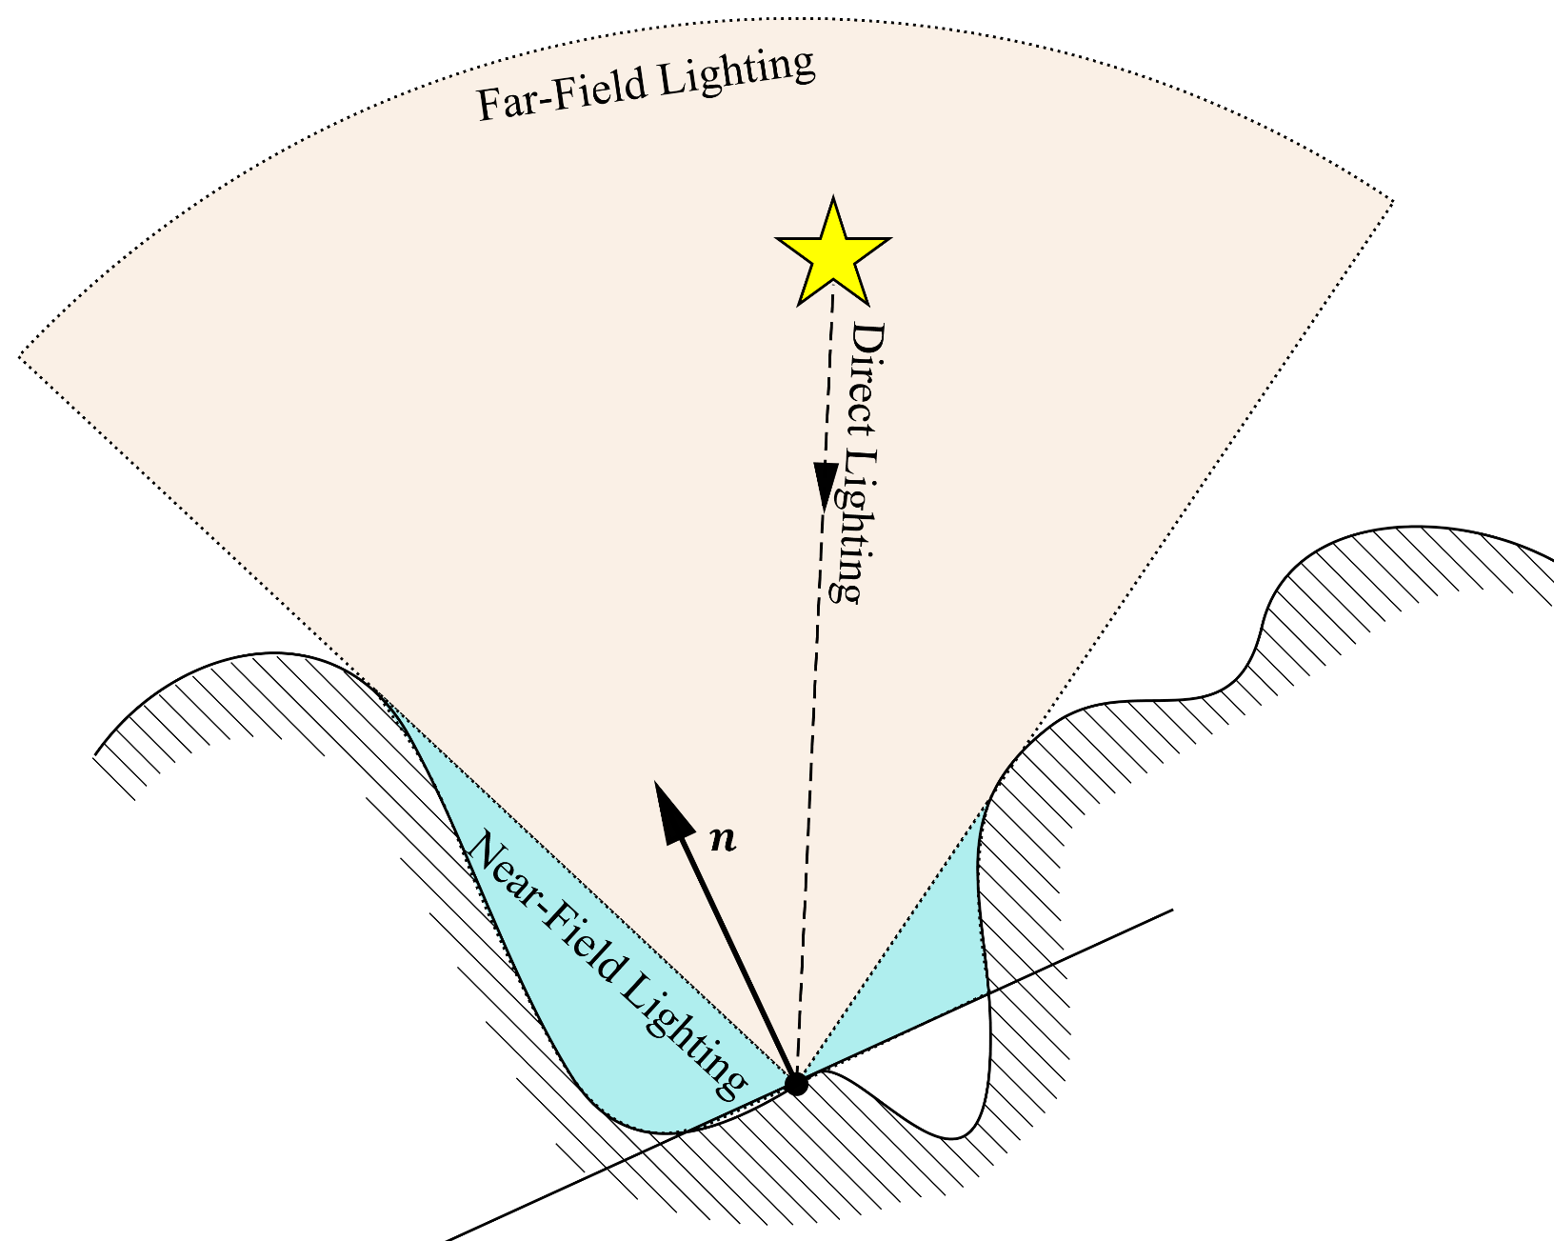

**Fig. 12.** Representation of the 3 sources of irradiance: Direct lighting, Far-field lighting from the unoccluded environment and Near-Field Lighting which represents the irradiance that bounced off the neighbor environment. We notice that the Near-Field only accounts for the occluded environment above the normal plane and is the exact complement of the far-field.

We saw in equation 7 how to sample the far-field environment but as shown in figure 12, the full computation for the irradiance is given by:

Where:

* is the direct diffuse lighting irradiance computed using all the light sources of the scene
* is the far-field distant environment term that can be computed using the bent-cone as show in sections 2.2.4. and 2.2.5.
* represents the missing near-field environment term, the part of the energy that bounced off the close environment and perceived indirectly by our sampling point.  
  This part is most often ignored in most real-time renderers as it is tricky and expensive to compute.

can be written as:

We notice this term is using the opposite of the visibility function and is thus the exact complement of the far-field environment term since it only gathers radiance that bounced off of the *occluded* environment

Contrary to [4] where the near-field bounces were approximated via manually fitted ad-hoc terms, in this paper we will see how to compute the actual near-field term.

## Recursive Irradiance Bounces

We begin by noticing that the incoming radiance term from equation 15 must be a diffuse reflection of the light on the neighbor environment and does not involve the normal at :

Where and are the location and normal of the neighbor environment perceived in direction which is simplified by using , the reflected radiance sampled at location .

***Note:*** Becausewe are going to sample a buffer where we stored the diffuse *radiance* , the and are already combined together so we cannot make the same assumption as in [3] that the neighbor reflectance is the same as our current reflectance **.**The equivalent optimization trick in our case would be to avoid sampling the neighbor radiance altogether and only use our central radiance for all neighbor samples instead, but the quality would suffer.

We can then rewrite equation 15 as:

And interestingly, we notice that estimating the near-field irradiance simply involves sampling the radiance from neighbor surfaces.

Assuming the diffuse radiance values computed during the *last frame N-1* are available then we could solve the lighting diffuse equation 14 by computing:

With:

* the radiance computed at frame N that will be stored in the diffuse radiance buffer that will, in turn, be re-used at frame N+1
* the direct lighting irradiance computed at frame N
* the far-field radiance computed at frame N
* the radiance computed at frame N-1 and stored at neighbor location

Computing radiance in this fashion would theoretically give us an “infinite amount of light bounces” since we keep the light bouncing one frame after another.

The details on how to reproject radiance from frame N-1 are given later in section 3.1.

## Solving the indirect lighting integral

All we are left to solve is equation 16. Coming back to the context of our integration slice where we are slowly computing the horizon angles for our front and back directions:

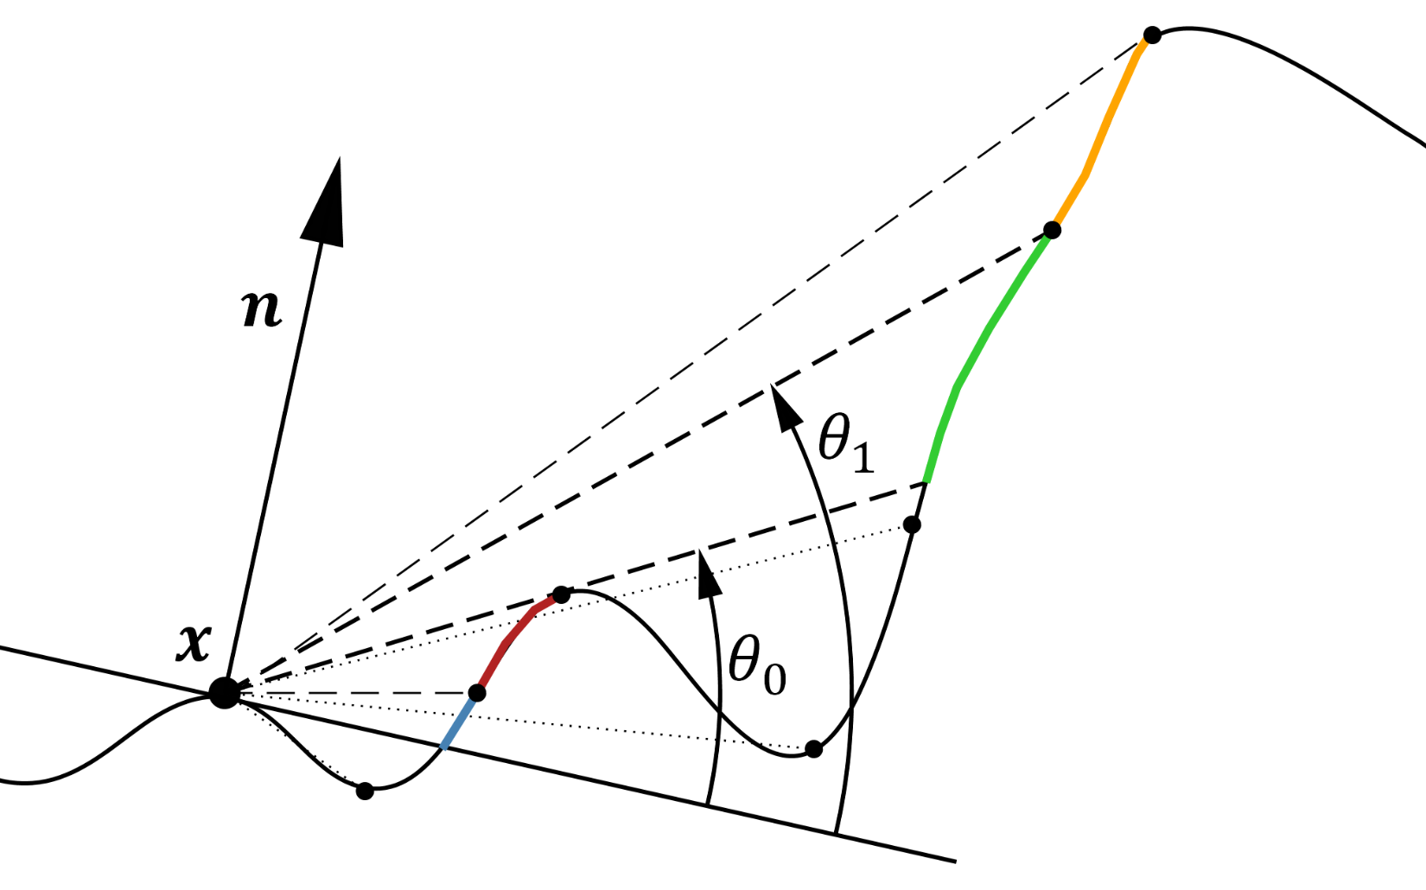

**Fig. 13.** Sampling the gathered irradiance when the horizon is rising from to : we simply need to sample the neighbor radiance (shown in green) and compute its perceived influence on our central location .

In this figure, we can easily see that the only irradiance we perceive from is the one from when the horizon jumps up a little: only the area represented in green contributes to the perceived irradiance when we rise from to .

So, for a small jump of the horizon angle from to , we have the following integral to solve:

Assuming is constant for the entire interval [] then becomes:

With:

* our rotating incoming vector for the current slice
* the slice’s direction vector from equation 2
* is the normal vector projected onto the slice
* is the previous (i.e. lower) horizon angle
* is the new (i.e. raised) horizon angle
* is the neighbor radiance sampled at the neighbor location where we are currently updating the horizon

Solving the integral yields:

## Accounting for the Fresnel Term

*Tagada!*

**TODO: Integrate F0!!!!**

**TODO: Integrate with linear interpolation of Li ?**

**TODO: Show ON/OFF image**

# Conclusion

We got the most bang for our bucks by exploiting all possible information during our sampling phase!

1. Integration with the lighting pipeline

**Notes:**

* Speak about the bent cones replacing the normal in lighting
* Speak about the need to have a buffer only for diffuse lighting! (separate from the full lighting buffer)

# Reprojecting Last Frame Radiance

Focusing only on diffuse Lambertian reflection, we can rewrite eq. (1) as:

## Depth Filtering

**#TODO:** Not sure I have a definite algorithm for that, keep that for later…

**TODO: Show filtering result**

**TODO: Show ON/OFF image**

# Putting it all together

Focusing only on diffuse Lambertian reflection, we can rewrite eq. (1) as:

Focusing only on diffuse Lambertian reflection, we can rewrite eq. (1) as:

**TODO: Integrate F0!!!!**

**TODO: Show ON/OFF image**

1. Performance

Focusing only on diffuse Lambertian reflection, we can rewrite eq. (1) as:

**TODO: Optimize! Ca rame à mort! ☹**

1. Acknowledgments

Special thanks to Eric Arnebäck for proof reading this paper, Benjamin Lalisse for his clever remarks and general support, Martin Gérard for his precious help with my math, [Geoffrey Rosin](https://www.artstation.com/kikette) for his amazing textures, and Sandra for moral support 😊.

1. References

*[1] Bavoil, L. and Sainz M. 2008. “Image-Space Horizon-Based Ambient Occlusion”*

*[2] Bavoil, L. and Jansen, J. 2013. “Particle Shadows & Cache-Efficient Post-Processing”*

*[3] Jimenez, J. Wu, X-C. Pesce, A. and Jarabo, A. 2016. “Practical Realtime Strategies for Accurate Indirect Occlusion”*

*[4] Mayaux, B. 2018, “*[*Improved Ambient Occlusion*](https://drive.google.com/file/d/1SyagcEVplIm2KkRD3WQYSO9O0Iyi1hfy)*”*

*[5] Mayaux, B. “*[*Spherical Harmonics Irradiance Estimate for a Cone*](http://wiki.nuaj.net/index.php?title=SphericalHarmonicsPorta)*” (personal wiki) (broken at this time)*

*[6] Cook, J. D. “*[*Accurately computing running variance*](https://www.johndcook.com/blog/standard_deviation/)*”*

*[**7] Ramamoorthi, R. 2001,* [*“On the Relationship between Radiance and Irradiance: Determining the illumination from images of a convex Lambertian object*](https://graphics.stanford.edu/papers/invlamb/josa.pdf)*”*