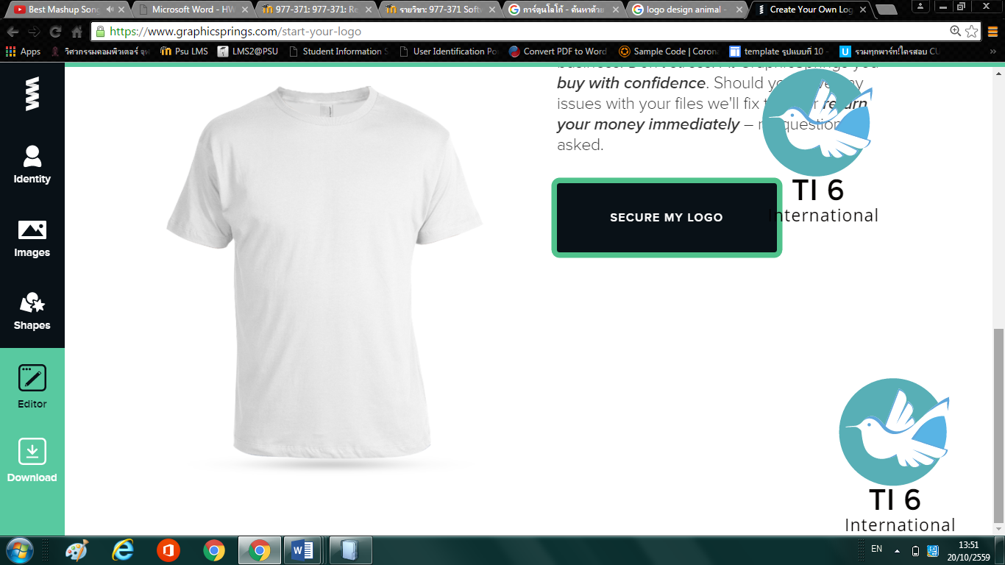

**Analysis Document**

**Student Association Management System**

**Version 1.0**

**Prepare by**

5630213048 MR. PATAVEE TEPSONG (PM)

5630213024 MR. THIRAWAT SAE-SIEW

5630213035 MR. KITTIPAT TEEHOR

5630213040 MR. THONGCHAI RAWANGKHAEM

5730213059 MISS PIRATCHANA MAKSUB

5730213098 MISS JIDAPA CHINTAWAN

20/10/2556