Skill-2

--------------------

Git Basic Commands:

echo "sample-repo" >> README.md

git init

git add README.md

git commit -m "first commit"

git branch -M main

git remote add origin https://github.com/sueethabulla/my-first-repo.git

git push -u origin main

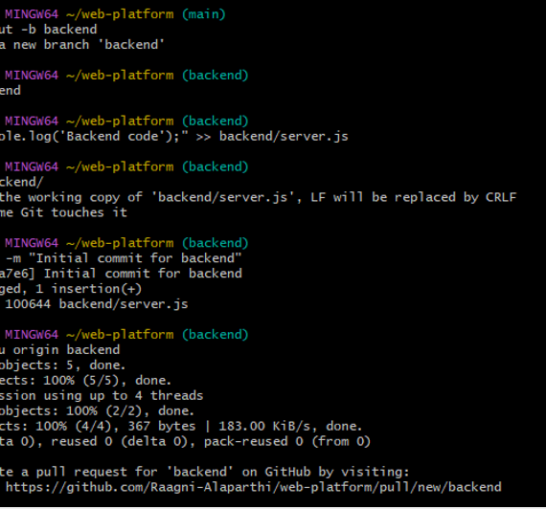

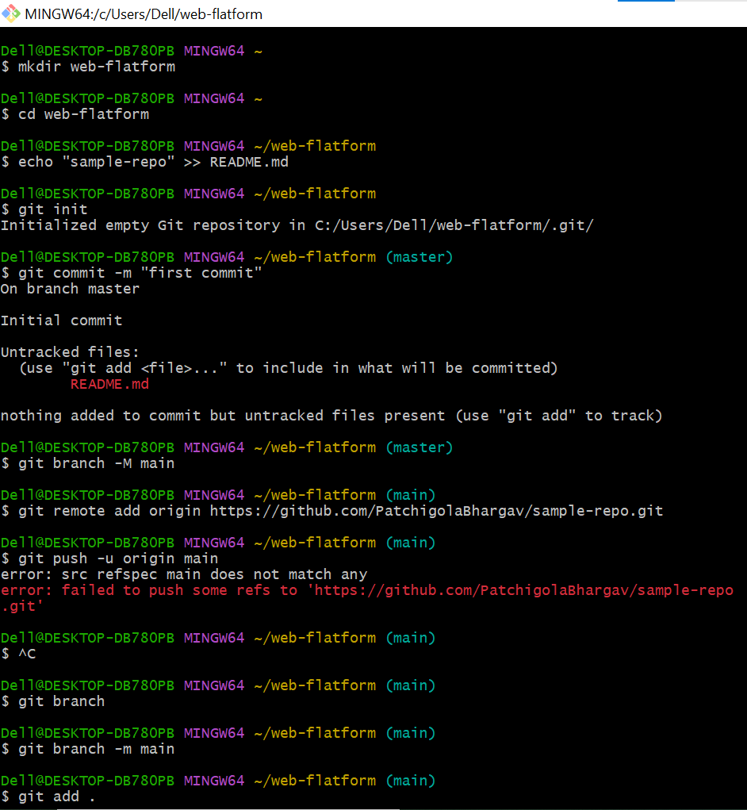

Git Branch:

git branch branch-name -> Create a new branch

git checkout branch-name -> Switch to an existing branch

git checkout -b branch-name -> Create and switch to new branch

git branch -> List all local branches

git branch -r -> List remote branches

git branch -a -> List all branches (local + remote)

git branch -m new-name -> Rename current branch

git branch -m old-name new-name -> Rename a specific branch

git merge branch-name -> Merge a branch into current branch

git rebase branch-name -> Rebase current branch onto another

git branch -d branch-name -> Delete a local branch (safe)

git branch -D branch-name -> Force delete a local branch

git push origin --delete branch-name -> Delete a remote branch

git push origin branch-name -> Push a local branch to remote



Git merge:

git checkout main

git merge feature1 -m "Merge frontend branch"

git merge feature2 -m "Merge backend branch"

git push origin main