# 实验8 综合组网实验

1. 根据组网图，配置生成树协议和链路聚合。并写出相关命令：

**[S1和S2:]**

**生成树协议：**

**stp enable**

**链路聚合：**

**interface bridge-aggregation 1**

**link-aggregation mode dynamic**

**inter e 1/0/1**

**port link-aggregation group 1**

**inter e 1/0/3**

**port link-aggregation group 1**

**inter bridge-aggregation 1**

**port link-type trunk**

**port trunk permit vlan all**

**因为本实验组网图实际上如下所示：**

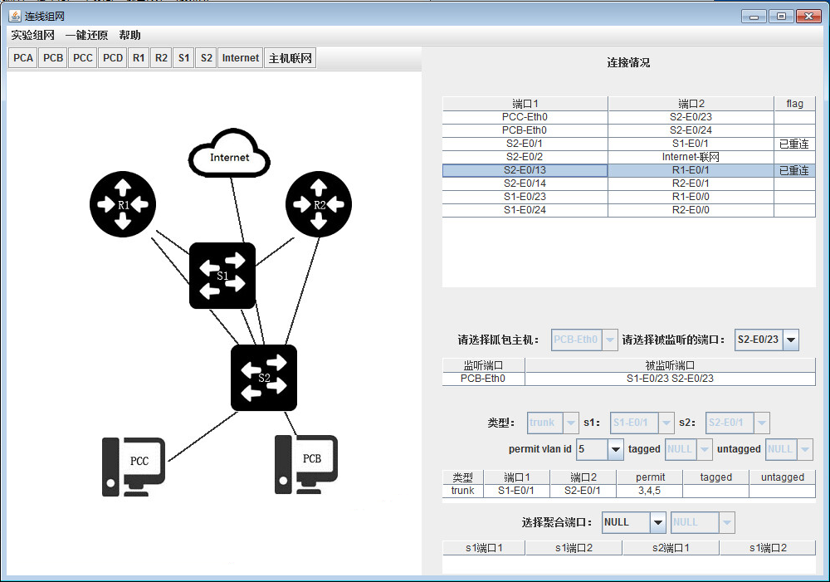

**所示本实验只需要配置**

**生成树协议：**

**stp enable**

**链路聚合：**

**inter e 1/0/1**

**port link-type trunk**

**port trunk permit vlan all（或者port trunk permit vlan 3 4 5）**

1. 请写出核心路由器和核心交换机中的指定路由器和备份指定路由器，并说明为什么？

**指定路由器是R1，指定的备份路由器是R2，配置命令如下：**

**[R1]:**

**ip route-static 0.0.0.0 0.0.0.0 192.168.5.1**

**inter e0/0**

**ip addr 192.168.100.3 24**

**vrrp vrid 11 virtual-ip 192.168.100.2**

**vrrp vrid 11 priority 100**

**ospf**

**default-route-advertise cost 100**

**[R2]:**

**ip route-static 0.0.0.0 0.0.0.0 192.168.5.1**

**inter e0/0**

**ip addr 192.168.100.4 24**

**vrrp vrid 11 virtual-ip 192.168.100.2**

**vrrp vrid 11 priority 80**

**ospf**

**default-route-advertise cost 200**

**[S1]:**

**ip route-static 0.0.0.0 192.168.100.2 preference 60**

**ip route-static 0.0.0.0 192.168.100.3 preference 80**

**ip route-static 0.0.0.0 192.168.100.4 preference 100**

**原因说明：**

**首先因为在S1上面配置了路由备份的三条默认路由，而第一条preference最低为60优先下一跳去往192.168.100.2，路由表查找去往192.168.100.2的下一跳是哪里，发现R1和R2的virtual-ip都是192.168.100.2，因此选择priority为100优先级更高的R1进行转发。所以R1是主路由器，R2是备份路由器。**

**（实验过程中核心交换机S1和汇聚交换机S2的不单独配置前往外网的默认路由，只需要在出口路由器R1和R2上，将默认路由引入至OSPF，并通过OSPF传播给S1和S2）而当S1路由备份失效时候，即静态路由失效时，由于R1和R2都启用了OSPF协议，并且R1的cost值比较小，优先选择R1，当R1失效时候才会选择R2路由器，因此R1是主出口路由器，R2是备份路由器。**

1. 写出访问控制列表的相关命令：

**PCA的ip地址：10.3.1.2/24 网关：10.3.1.1**

**PCB的ip地址：10.3.2.2/24 网关：10.3.2.1**

**[R1]:**

**acl number 2001**

**rule 0 permit source 10.3.2.0 0.0.0.255**

**rule 1 permit source 10.3.1.0 0.0.0.255**

**rule 2 deny**

**[R2]:**

**acl number 2001**

**rule 0 deny source 10.3.2.0 0.0.0.255**

**rule 1 permit source 10.3.1.0 0.0.0.255**

**rule 2 deny**

**当R1路由器正常时，PCA和PCB能够正常访问互联网，并且网路中的路由器和交换机是无法ping到外网的。**

**当关闭R1->S2->Internet这条路线的R1上端口e0/1时候，由于路由器R2的规则阻止，10.3.2.0网段访问互联网，即PCA可以访问换联网，而PCB无法访问。**

1. 将路由器R1的E1接口断掉，截获并分析Trap报文，写出报文的字段名和字段值，然后重新连接，通过网络管理服务器查看路由器状态。

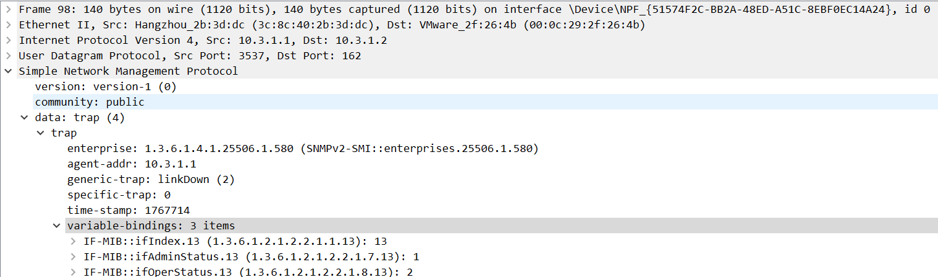

|  |  |  |  |
| --- | --- | --- | --- |
| 字段名 | | 字段长度 | 字段表达信息 |
| enterprise | | 10 | 企业： SNMPv2-SMI::enterprise.25506.1.580 |
| agent_addr | | 4 | 代理的IP地址： 10.3.1.1 |
| generic_trap | | 1 | Trap类型： linkDown(2) |
| specific_trap | | 1 | 特定代码： 0(不是代理自定义的事件) |
| time_stamp | | 3 | 时间戳： 1767714 |
| Variable_bindings | | 51 | 变量绑定 |
| VarBind1 | Name | 10 | 1.3.6.1.2.1.2.2.1.1.13 |
| Value | 1 | 13 |
| VarBind2 | Name | 10 | 1.3.6.1.2.1.2.2.1.7.13 |
| Value | 1 | 1 |
| VarBind3 | Name | 10 | 1.3.6.1.2.1.2.2.1.8.13 |
| Value | 1 | 2 |

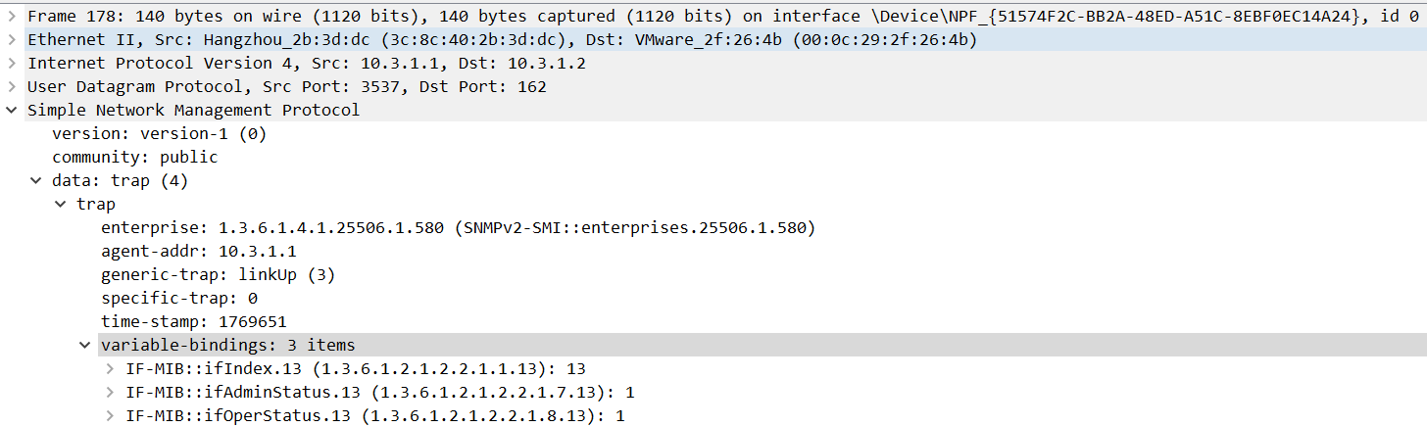

|  |  |  |  |
| --- | --- | --- | --- |
| 字段名 | | 字段长度 | 字段表达信息 |
| enterprise | | 10 | 企业： SNMPv2-SMI::enterprise.25506.1.580 |
| agent_addr | | 4 | 代理的IP地址： 10.3.1.1 |
| generic_trap | | 1 | Trap类型： linkUp(3) |
| specific_trap | | 1 | 特定代码： 0(不是代理自定义的事件) |
| time_stamp | | 3 | 时间戳： 1769651 |
| Variable_bindings | | 51 | 变量绑定 |
| VarBind1 | Name | 10 | 1.3.6.1.2.1.2.2.1.1.13 |
| Value | 1 | 13 |
| VarBind2 | Name | 10 | 1.3.6.1.2.1.2.2.1.7.13 |
| Value | 1 | 1 |
| VarBind3 | Name | 10 | 1.3.6.1.2.1.2.2.1.8.13 |
| Value | 1 | 1 |

1. 每台设备上配置专用的网络管理地址有什么好处？

**答：**

**因为网管软件需要按照ip地址添加设备，因此每台设备都配置专用网络管理地址可以方便的被网络管理工具实时监控和管理。方便网络管理工具对设备进行故障管理，配置管理，计费管理，性能管理，安全管理。**

1. 请附上全部网络设备的最终配置

PS：假如主机ping不通192.168.5.1 ，而主机能ping通R1的接口地址，R1能ping通192.168.5.1

删掉vlan1的DHCP即可：

inter vlan 1

undo ip addr dhcp-alloc

S1 S2都要undo不然会在网关卡主

[S1]dis cur

#

version 5.20, Release 2108P01

#

sysname S1

#

irf mac-address persistent timer

irf auto-update enable

undo irf link-delay

#

domain default enable system

#

ip ttl-expires enable

ip unreachables enable

#

undo ip http enable

#

multicast routing-enable

#

password-recovery enable

#

vlan 1

#

vlan 3

#

vlan 5

#

vlan 30

#

vlan 100

#

domain system

access-limit disable

state active

idle-cut disable

self-service-url disable

#

user-group system

group-attribute allow-guest

#

interface NULL0

#

interface Vlan-interface1

#

interface Vlan-interface3

#

interface Vlan-interface5

ip address 192.168.3.1 255.255.255.0

pim dm

#

interface Vlan-interface100

ip address 192.168.100.1 255.255.255.0

pim dm

#

interface Ethernet1/0/1

port link-mode bridge

port link-type trunk

port trunk permit vlan 1 3 to 5

#

interface Ethernet1/0/2

port link-mode bridge

#

interface Ethernet1/0/3

port link-mode bridge

#

interface Ethernet1/0/4

port link-mode bridge

#

interface Ethernet1/0/5

port link-mode bridge

#

interface Ethernet1/0/6

port link-mode bridge

#

interface Ethernet1/0/7

port link-mode bridge

#

interface Ethernet1/0/8

port link-mode bridge

#

interface Ethernet1/0/9

port link-mode bridge

#

interface Ethernet1/0/10

port link-mode bridge

#

interface Ethernet1/0/11

port link-mode bridge

#

interface Ethernet1/0/12

port link-mode bridge

#

interface Ethernet1/0/13

port link-mode bridge

#

interface Ethernet1/0/14

port link-mode bridge

#

interface Ethernet1/0/15

port link-mode bridge

#

interface Ethernet1/0/16

port link-mode bridge

#

interface Ethernet1/0/17

port link-mode bridge

#

interface Ethernet1/0/18

port link-mode bridge

#

interface Ethernet1/0/19

port link-mode bridge

#

interface Ethernet1/0/20

port link-mode bridge

#

interface Ethernet1/0/21

port link-mode bridge

#

interface Ethernet1/0/22

port link-mode bridge

#

interface Ethernet1/0/23

port link-mode bridge

port access vlan 100

#

interface Ethernet1/0/24

port link-mode bridge

port access vlan 100

#

interface GigabitEthernet1/0/25

port link-mode bridge

#

interface GigabitEthernet1/0/26

port link-mode bridge

#

interface GigabitEthernet1/0/27

port link-mode bridge

#

interface GigabitEthernet1/0/28

port link-mode bridge

#

ospf 1

area 0.0.0.0

network 192.168.100.0 0.0.0.255

network 192.168.3.0 0.0.0.255

#

ip route-static 0.0.0.0 0.0.0.0 192.168.100.2

ip route-static 0.0.0.0 0.0.0.0 192.168.100.3 preference 80

ip route-static 0.0.0.0 0.0.0.0 192.168.100.4 preference 100

#

snmp-agent

snmp-agent local-engineid 800063A2033C8C402A76CD

snmp-agent community write p

snmp-agent community read public

snmp-agent community write private

snmp-agent sys-info version all

snmp-agent target-host trap address udp-domain 10.3.1.2 params securityname public

snmp-agent trap enable default-route

#

load xml-configuration

#

load tr069-configuration

#

user-interface aux 0

user-interface vty 0 15

#

return

/*************************S1*************************/

/*************************S2*************************/

[S2]dis cur

#

version 5.20, Release 2108P01

#

sysname S2

#

irf mac-address persistent timer

irf auto-update enable

undo irf link-delay

#

domain default enable system

#

ip ttl-expires enable

ip unreachables enable

#

undo ip http enable

#

multicast routing-ena

#

password-recovery enable

#

vlan 1

#

vlan 3 to 5

#

vlan 30

#

domain system

access-limit disable

state active

idle-cut disable

self-service-url disable

#

user-group system

group-attribute allow-guest

#

interface NULL0

#

interface Vlan-interface1

#

interface Vlan-interface3

ip address 10.3.1.1 255.255.255.0

igmp enable

pim dm

#

interface Vlan-interface4

ip address 10.3.2.1 255.255.255.0

igmp enable

pim dm

#

interface Vlan-interface5

ip address 192.168.3.2 255.255.255.0

pim dm

#

interface Ethernet1/0/1

port link-mode bridge

port link-type trunk

port trunk permit vlan 1 3 to 5

#

interface Ethernet1/0/2

port link-mode bridge

#

interface Ethernet1/0/3

port link-mode bridge

#

interface Ethernet1/0/4

port link-mode bridge

#

interface Ethernet1/0/5

port link-mode bridge

#

interface Ethernet1/0/6

port link-mode bridge

#

interface Ethernet1/0/7

port link-mode bridge

#

interface Ethernet1/0/8

port link-mode bridge

#

interface Ethernet1/0/9

port link-mode bridge

#

interface Ethernet1/0/10

port link-mode bridge

#

interface Ethernet1/0/11

port link-mode bridge

#

interface Ethernet1/0/12

port link-mode bridge

#

interface Ethernet1/0/13

port link-mode bridge

#

interface Ethernet1/0/14

port link-mode bridge

#

interface Ethernet1/0/15

port link-mode bridge

#

interface Ethernet1/0/16

port link-mode bridge

#

interface Ethernet1/0/17

port link-mode bridge

#

interface Ethernet1/0/18

port link-mode bridge

#

interface Ethernet1/0/19

port link-mode bridge

#

interface Ethernet1/0/20

port link-mode bridge

#

interface Ethernet1/0/21

port link-mode bridge

#

interface Ethernet1/0/22

port link-mode bridge

#

interface Ethernet1/0/23

port link-mode bridge

port access vlan 3

#

interface Ethernet1/0/24

port link-mode bridge

port access vlan 4

#

interface GigabitEthernet1/0/25

port link-mode bridge

#

interface GigabitEthernet1/0/26

port link-mode bridge

#

interface GigabitEthernet1/0/27

port link-mode bridge

#

interface GigabitEthernet1/0/28

port link-mode bridge

#

ospf 1

area 0.0.0.0

network 10.3.1.0 0.0.0.255

network 10.3.2.0 0.0.0.255

network 192.168.3.0 0.0.0.255

#

snmp-agent

snmp-agent local-engineid 800063A2033C8C402B3DF9

snmp-agent community read public

snmp-agent community write private

snmp-agent sys-info version all

snmp-agent target-host trap address udp-domain 10.3.1.2 params securityname pub

lic

snmp-agent trap enable default-route

#

load xml-configuration

#

load tr069-configuration

#

user-interface aux 0

user-interface vty 0 15

#

Return

/*************************S2*************************/

/*************************R1*************************/

[R1]dis cur

#

version 5.20, Release 2513P27

#

sysname R1

#

nat address-group 1

address 192.168.5.110 192.168.5.112

#

domain default enable system

#

ip ttl-expires enable

ip unreachables enable

#

dar p2p signature-file flash:/p2p_default.mtd

#

port-security enable

#

undo ip http enable

#

multicast routing-enable

#

password-recovery enable

#

acl number 2001

rule 0 permit source 10.3.2.0 0.0.0.255

rule 1 permit source 10.3.1.0 0.0.0.255

rule 2 deny

#

vlan 1

#

domain system

access-limit disable

state active

idle-cut disable

self-service-url disable

#

user-group system

group-attribute allow-guest

#

local-user admin

password cipher $c$3$40gC1cxf/wIJNa1ufFPJsjKAof+QP5aV

authorization-attribute level 3

service-type telnet

#

stp enable

#

cwmp

undo cwmp enable

#

interface Aux0

async mode flow

link-protocol ppp

#

interface Cellular0/0

async mode protocol

link-protocol ppp

#

interface Ethernet0/0

port link-mode route

shutdown

ip address 192.168.100.3 255.255.255.0

vrrp vrid 11 virtual-ip 192.168.100.2

vrrp vrid 11 priority 100

pim dm

#

interface Ethernet0/1

port link-mode route

nat outbound 2001 address-group 1

ip address 192.168.5.110 255.255.255.0

#

interface Serial1/0

link-protocol ppp

#

interface Serial2/0

link-protocol ppp

#

interface NULL0

#

interface Ethernet0/2

port link-mode bridge

#

interface Ethernet0/3

port link-mode bridge

#

interface Ethernet0/4

port link-mode bridge

#

interface Ethernet0/5

port link-mode bridge

#

interface Ethernet0/6

port link-mode bridge

#

interface Ethernet0/7

port link-mode bridge

#

interface Ethernet0/8

port link-mode bridge

#

interface Ethernet0/9

port link-mode bridge

#

interface Ethernet0/10

port link-mode bridge

#

interface Ethernet0/11

port link-mode bridge

#

interface Ethernet0/12

port link-mode bridge

#

interface Ethernet0/13

port link-mode bridge

#

interface Ethernet0/14

port link-mode bridge

#

interface Ethernet0/15

port link-mode bridge

#

interface Ethernet0/16

port link-mode bridge

#

interface Ethernet0/17

port link-mode bridge

#

interface Ethernet0/18

port link-mode bridge

#

interface Ethernet0/19

port link-mode bridge

#

interface Ethernet0/20

port link-mode bridge

#

interface Ethernet0/21

port link-mode bridge

#

interface Ethernet0/22

port link-mode bridge

#

interface Ethernet0/23

port link-mode bridge

#

interface Ethernet0/24

port link-mode bridge

#

interface Ethernet0/25

port link-mode bridge

#

interface Ethernet0/26

port link-mode bridge

#

interface Ethernet0/27

port link-mode bridge

#

interface Ethernet0/28

port link-mode bridge

#

interface Ethernet0/29

port link-mode bridge

#

interface Ethernet0/30

port link-mode bridge

#

interface Ethernet0/31

port link-mode bridge

#

interface Ethernet0/32

port link-mode bridge

#

interface Ethernet0/33

port link-mode bridge

#

interface Ethernet0/34

port link-mode bridge

#

interface Ethernet0/35

port link-mode bridge

#

interface Ethernet0/36

port link-mode bridge

#

interface Ethernet0/37

port link-mode bridge

#

interface Ethernet0/38

port link-mode bridge

#

interface Ethernet0/39

port link-mode bridge

#

interface Ethernet0/40

port link-mode bridge

#

interface Ethernet0/41

port link-mode bridge

#

interface Ethernet0/42

port link-mode bridge

#

interface Ethernet0/43

port link-mode bridge

#

interface Ethernet0/44

port link-mode bridge

#

interface Ethernet0/45

port link-mode bridge

#

interface Ethernet0/46

port link-mode bridge

#

interface Ethernet0/47

port link-mode bridge

#

interface Ethernet0/48

port link-mode bridge

#

interface Ethernet0/49

port link-mode bridge

#

ospf 1

default-route-advertise cost 100

import-route static

area 0.0.0.0

network 192.168.100.0 0.0.0.255

#

ip route-static 0.0.0.0 0.0.0.0 192.168.5.1

#

snmp-agent

snmp-agent local-engineid 800063A203586AB1F3D7F2

snmp-agent community read public

snmp-agent community write private

snmp-agent sys-info version all

snmp-agent target-host trap address udp-domain 10.3.1.2 params securityname public

snmp-agent trap enable default-route

#

load xml-configuration

#

load tr069-configuration

#

user-interface tty 12

user-interface aux 0

user-interface vty 0 4

authentication-mode scheme

#

return

/*************************R1*************************/

/*************************R2*************************/

[R2]dis cur

#

version 5.20, Release 2513P27

#

sysname R2

#

nat address-group 1 192.168.5.113 192.168.5.114

#

domain default enable system

#

ip ttl-expires enable

ip unreachables enable

#

dar p2p signature-file flash:/p2p_default.mtd

#

port-security enable

#

undo ip http enable

#

multicast routing-enable

#

password-recovery enable

#

acl number 2001

rule 0 deny source 10.3.2.0 0.0.0.255

rule 1 permit source 10.3.1.0 0.0.0.255

rule 2 deny

#

vlan 1

#

domain system

access-limit disable

state active

idle-cut disable

self-service-url disable

#

user-group system

group-attribute allow-guest

#

local-user admin

password cipher $c$3$40gC1cxf/wIJNa1ufFPJsjKAof+QP5aV

authorization-attribute level 3

service-type telnet

#

stp enable

#

cwmp

undo cwmp enable

#

interface Aux0

async mode flow

link-protocol ppp

#

interface Cellular0/0

async mode protocol

link-protocol ppp

#

interface Ethernet0/0

port link-mode route

ip address 192.168.100.4 255.255.255.0

vrrp vrid 11 virtual-ip 192.168.100.2

vrrp vrid 11 priority 80

pim dm

#

interface Ethernet0/1

port link-mode route

nat outbound 2001 address-group 1

ip address 192.168.5.113 255.255.255.0

pim dm

#

interface Serial1/0

link-protocol ppp

#

interface Serial2/0

link-protocol ppp

#

interface NULL0

#

interface Ethernet0/2

port link-mode bridge

#

interface Ethernet0/3

port link-mode bridge

#

interface Ethernet0/4

port link-mode bridge

#

interface Ethernet0/5

port link-mode bridge

#

interface Ethernet0/6

port link-mode bridge

#

interface Ethernet0/7

port link-mode bridge

#

interface Ethernet0/8

port link-mode bridge

#

interface Ethernet0/9

port link-mode bridge

#

interface Ethernet0/10

port link-mode bridge

#

interface Ethernet0/11

port link-mode bridge

#

interface Ethernet0/12

port link-mode bridge

#

interface Ethernet0/13

port link-mode bridge

#

interface Ethernet0/14

port link-mode bridge

#

interface Ethernet0/15

port link-mode bridge

#

interface Ethernet0/16

port link-mode bridge

#

interface Ethernet0/17

port link-mode bridge

#

interface Ethernet0/18

port link-mode bridge

#

interface Ethernet0/19

port link-mode bridge

#

interface Ethernet0/20

port link-mode bridge

#

interface Ethernet0/21

port link-mode bridge

#

interface Ethernet0/22

port link-mode bridge

#

interface Ethernet0/23

port link-mode bridge

#

interface Ethernet0/24

port link-mode bridge

#

interface Ethernet0/25

port link-mode bridge

#

interface Ethernet0/26

port link-mode bridge

#

interface Ethernet0/27

port link-mode bridge

#

interface Ethernet0/28

port link-mode bridge

#

interface Ethernet0/29

port link-mode bridge

#

interface Ethernet0/30

port link-mode bridge

#

interface Ethernet0/31

port link-mode bridge

#

interface Ethernet0/32

port link-mode bridge

#

interface Ethernet0/33

port link-mode bridge

#

interface Ethernet0/34

port link-mode bridge

#

interface Ethernet0/35

port link-mode bridge

#

interface Ethernet0/36

port link-mode bridge

#

interface Ethernet0/37

port link-mode bridge

#

interface Ethernet0/38

port link-mode bridge

#

interface Ethernet0/39

port link-mode bridge

#

interface Ethernet0/40

port link-mode bridge

#

interface Ethernet0/41

port link-mode bridge

#

interface Ethernet0/42

port link-mode bridge

#

interface Ethernet0/43

port link-mode bridge

#

interface Ethernet0/44

port link-mode bridge

#

interface Ethernet0/45

port link-mode bridge

#

interface Ethernet0/46

port link-mode bridge

#

interface Ethernet0/47

port link-mode bridge

#

interface Ethernet0/48

port link-mode bridge

#

interface Ethernet0/49

port link-mode bridge

#

ospf 1

default-route-advertise cost 200

import-route static

area 0.0.0.0

network 192.168.100.0 0.0.0.255

#

ip route-static 0.0.0.0 0.0.0.0 192.168.5.1

#

snmp-agent

snmp-agent local-engineid 800063A203586AB1F3D8D9

snmp-agent community read public

snmp-agent community write private

snmp-agent sys-info version all

snmp-agent target-host trap address udp-domain 10.3.1.2 params securityname public

snmp-agent trap enable default-route

#

load xml-configuration

#

load tr069-configuration

#

user-interface tty 12

user-interface aux 0

user-interface vty 0 4

authentication-mode scheme

#

return