# 实验8 综合组网实验

1. 根据组网图，配置生成树协议和链路聚合。并写出相关命令：

答：

[S1&S2]：

生成树协议：

stp enable

链路聚合：

interface bridge-aggregation 1

link-aggregation mode dynamic

interface e 1/0/1

port link-aggregation group 1

interface e 1/0/3

port link-aggregation group 1

interface bridge-aggregation 1

port link-type trunk

port trunk permit vlan all

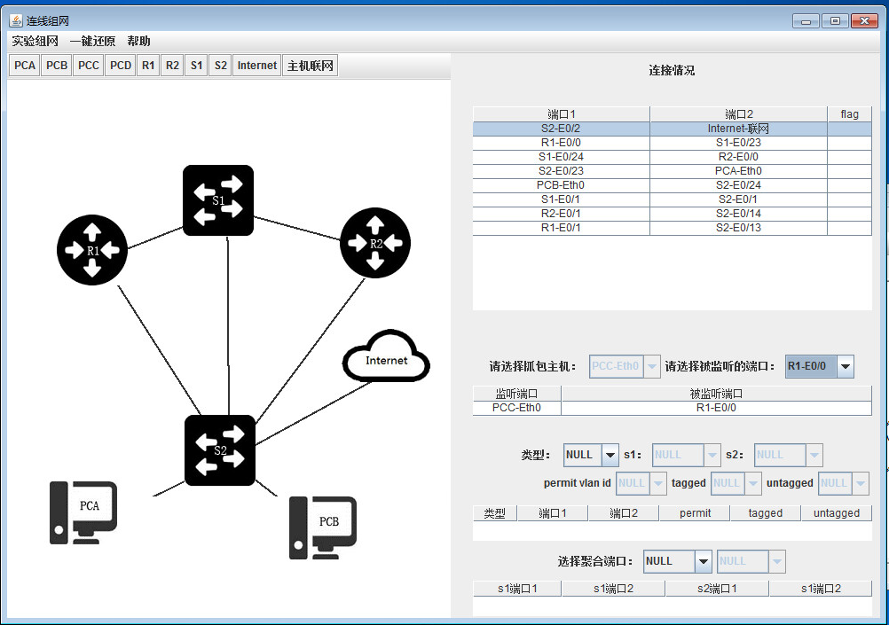

1. 请写出核心路由器和核心交换机中的指定路由器和备份指定路由器，并说明为什么？

答：

[R1]：

ip route-static 0.0.0.0 0 192.168.5.1

interface e0/0

vrrp vrid 11 virtual-ip 192.168.100.2

vrrp vrid 11 priority 100

ospf

default-route-advertise cost 100

[R2]：

ip route-static 0.0.0.0 0 192.168.5.1

interface e0/0

vrrp vrid 11 virtual-ip 192.168.100.2

vrrp vrid 11 priority 80

ospf

default-route-advertise cost 200

[S1]：

ip route-static 0.0.0.0 0 192.168.100.2 preference 60

ip route-static 0.0.0.0 0 192.168.100.3 preference 80

ip route-static 0.0.0.0 0 192.168.100.4 preference 100

原因：

因为在S1上设置了默认路由，因此去往优先级为60的192.168.100.2，而因为R1上的vrrp优先级为100大于R2的优先级80，因此R1为主路由器，R2为备份路由器；

当虚拟路由器失效时，会去往优先级为80的192.168.100.3，然后再考虑去往优先级为100的192.168.100.4；

当静态路由失效时，因为R1和R2在ospf引入了默认路由并设置了cost，因此会优先选择cost为100的R1，再考虑cost为200的R2。

R1的vrrp：

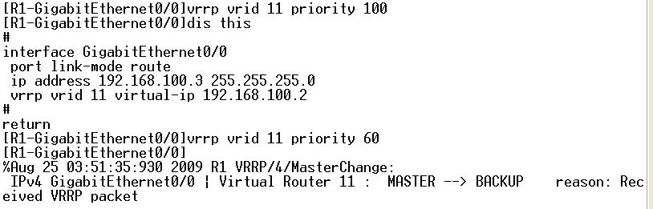

默认情况：

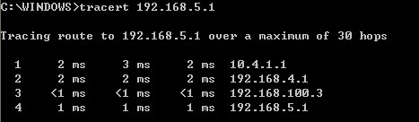

R1的e0/0端口shutdown后：

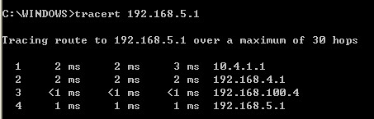

1. 写出访问控制列表的相关命令：

答：

[R1&R2]：

acl number 2001

rule 0 permit source 10.4.1.0 0.0.0.255

rule 2 deny source any

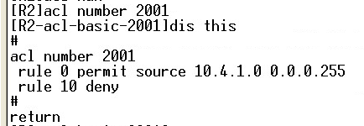

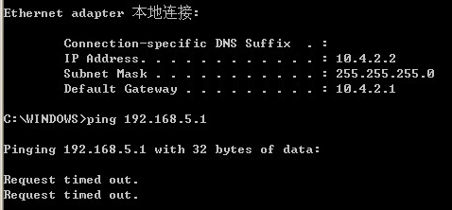

这样PCA(10.4.1.2)能上网，PCB(10.4.2.2)不能上网。

1. 将路由器R1的E1接口断掉，截获并分析Trap报文，写出报文的字段名和字段值，然后重新连接，通过网络管理服务器查看路由器状态。

答：

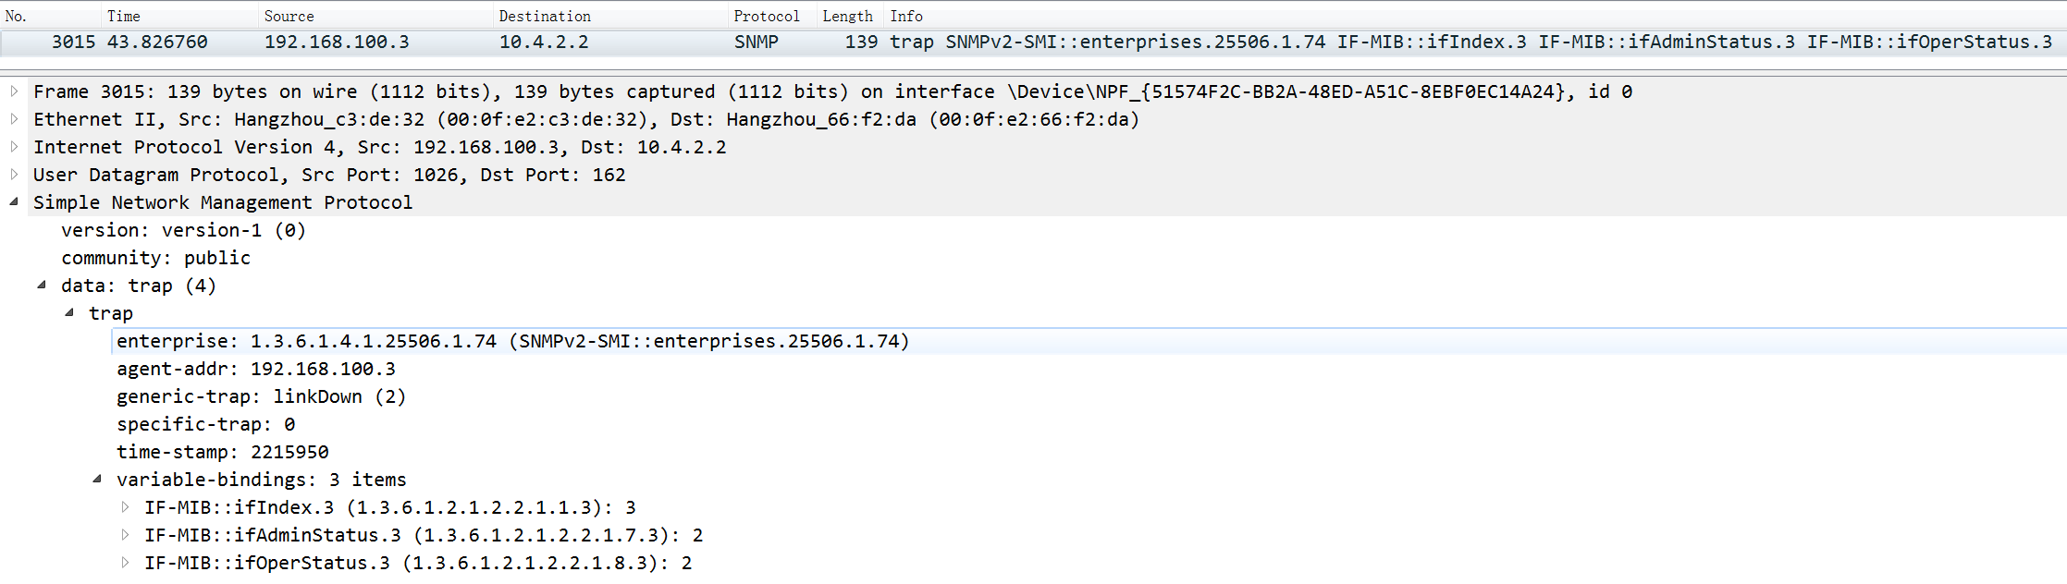

|  |  |  |  |
| --- | --- | --- | --- |
| 字段名 | | 字段长度 | 字段表达信息 |
| enterprise | | 10 | 企业： SNMPv2-SMI::enterprise.25506.1.74 |
| agent_addr | | 4 | 代理的IP地址： 192.168.100.3 |
| generic_trap | | 1 | Trap类型： linkDown(2) |
| specific_trap | | 1 | 特定代码： 0(不是代理自定义的事件) |
| time_stamp | | 3 | 时间戳： 2215950 |
| Variable_bindings | | 51 | 变量绑定 |
| VarBind1 | Name | 10 | 1.3.6.1.2.1.2.2.1.1.3 |
| Value | 1 | 3 |
| VarBind2 | Name | 10 | 1.3.6.1.2.1.2.2.1.7.3 |
| Value | 1 | 2 |
| VarBind3 | Name | 10 | 1.3.6.1.2.1.2.2.1.8.3 |
| Value | 1 | 2 |

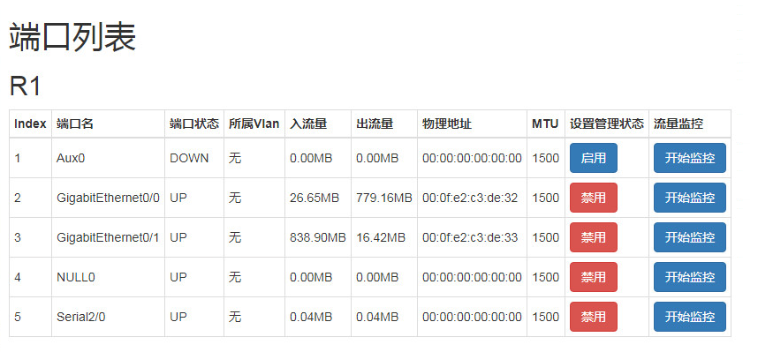

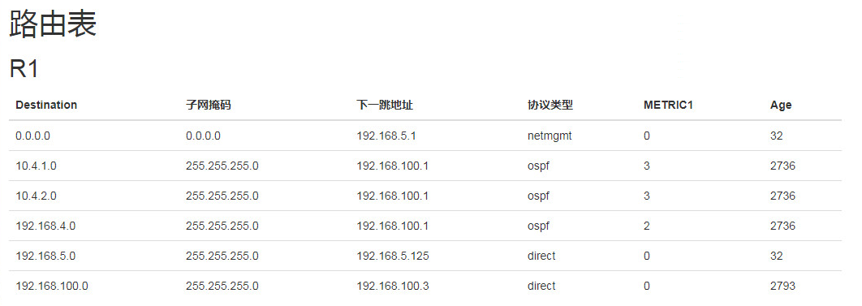

组播实验：

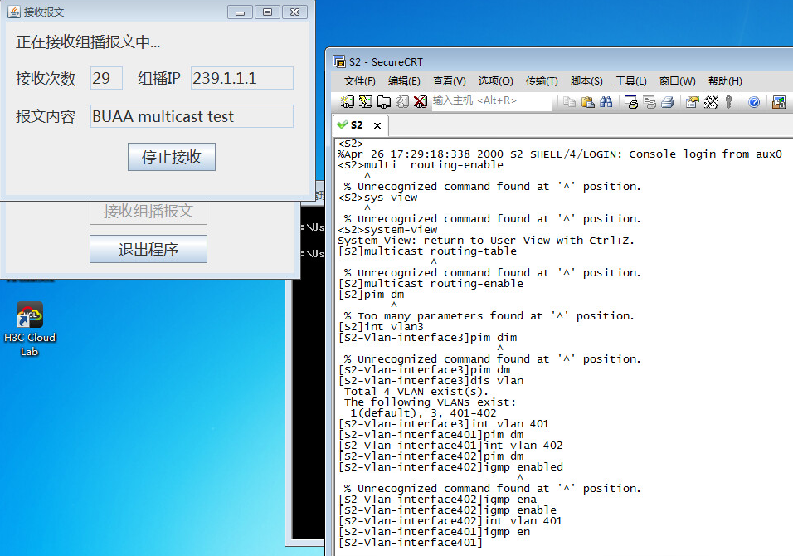

1. 每台设备上配置专用的网络管理地址有什么好处？

答：

因为网管软件需要按照ip地址添加设备，因此每台设备都配置专用网络管理地址可以方便的被网络管理工具实时监控和管理。方便网络管理工具对设备进行故障管理，配置管理，计费管理，性能管理，安全管理。

1. 请附上全部网络设备的最终配置

答：

[S1]dis cur

#

version 5.20, Release 5301

#

sysname S1

#

domain default enable system

#

multicast routing-enable

#

vlan 1

#

vlan 40

#

vlan 100

#

domain system

access-limit disable

state active

idle-cut disable

self-service-url disable

#

stp enable

#

interface NULL0

#

interface Vlan-interface40

ip address 192.168.4.1 255.255.255.0

pim dm

#

interface Vlan-interface100

ip address 192.168.100.1 255.255.255.0

#

interface Ethernet1/0/1

port access vlan 40

#

interface Ethernet1/0/2

#

interface Ethernet1/0/3

#

interface Ethernet1/0/4

#

interface Ethernet1/0/5

#

interface Ethernet1/0/6

#

interface Ethernet1/0/7

#

interface Ethernet1/0/8

#

interface Ethernet1/0/9

#

interface Ethernet1/0/10

#

interface Ethernet1/0/11

#

interface Ethernet1/0/12

#

interface Ethernet1/0/13

#

interface Ethernet1/0/14

#

interface Ethernet1/0/15

#

interface Ethernet1/0/16

#

interface Ethernet1/0/17

#

interface Ethernet1/0/18

#

interface Ethernet1/0/19

#

interface Ethernet1/0/20

#

interface Ethernet1/0/21

#

interface Ethernet1/0/22

#

interface Ethernet1/0/23

port access vlan 100

#

interface Ethernet1/0/24

port access vlan 100

#

interface GigabitEthernet1/1/1

#

interface GigabitEthernet1/1/2

#

interface GigabitEthernet1/1/3

#

interface GigabitEthernet1/1/4

#

ospf 1

area 0.0.0.0

network 192.168.100.0 0.0.0.255

network 192.168.4.0 0.0.0.255

#

ip route-static 0.0.0.0 0.0.0.0 192.168.100.2

ip route-static 0.0.0.0 0.0.0.0 192.168.100.3 preference 80

ip route-static 0.0.0.0 0.0.0.0 192.168.100.4 preference 100

#

user-interface aux 0

user-interface vty 0 4

#

Return

// ------------------------------分割线------------------------------

[S2]dis cur

#

version 5.20, Release 5301

#

sysname S2

#

domain default enable system

#

multicast routing-enable

#

vlan 1

#

vlan 40

#

vlan 401 to 402

#

domain system

access-limit disable

state active

idle-cut disable

self-service-url disable

#

interface NULL0

#

interface Vlan-interface40

ip address 192.168.4.2 255.255.255.0

pim dm

#

interface Vlan-interface401

ip address 10.4.1.1 255.255.255.0

igmp enable

pim dm

#

interface Vlan-interface402

ip address 10.4.2.1 255.255.255.0

igmp enable

pim dm

#

interface Ethernet1/0/1

port access vlan 40

#

interface Ethernet1/0/2

#

interface Ethernet1/0/3

#

interface Ethernet1/0/4

#

interface Ethernet1/0/5

#

interface Ethernet1/0/6

#

interface Ethernet1/0/7

#

interface Ethernet1/0/8

#

interface Ethernet1/0/9

#

interface Ethernet1/0/10

#

interface Ethernet1/0/11

#

interface Ethernet1/0/12

#

interface Ethernet1/0/13

#

interface Ethernet1/0/14

#

interface Ethernet1/0/15

#

interface Ethernet1/0/16

#

interface Ethernet1/0/17

#

interface Ethernet1/0/18

#

interface Ethernet1/0/19

#

interface Ethernet1/0/20

#

interface Ethernet1/0/21

#

interface Ethernet1/0/22

#

interface Ethernet1/0/23

port access vlan 401

#

interface Ethernet1/0/24

port access vlan 402

#

interface GigabitEthernet1/1/1

#

interface GigabitEthernet1/1/2

#

interface GigabitEthernet1/1/3

#

interface GigabitEthernet1/1/4

#

ospf 1

area 0.0.0.0

network 192.168.4.0 0.0.0.255

network 10.4.1.0 0.0.0.255

network 10.4.2.0 0.0.0.255

#

user-interface aux 0

user-interface vty 0 4

#

return

// ------------------------------分割线------------------------------

[R1]dis cur

#

version 5.20, Release 1618P10, Basic

#

sysname R1

#

ipsec cpu-backup enable

#

undo cryptoengine enable

#

nat address-group 1 192.168.5.125 192.168.5.127

#

domain default enable system

#

ip unreachables enable

#

acl number 2001

rule 0 permit source 10.4.1.0 0.0.0.255

rule 2 deny

#

vlan 1

#

domain system

access-limit disable

state active

idle-cut disable

self-service-url disable

#

local-user admin

password cipher .]@USE=B,53Q=^Q`MAF4<1!!

service-type telnet

level 3

#

stp enable

#

interface Aux0

async mode flow

link-protocol ppp

#

interface Serial2/0

link-protocol ppp

#

interface NULL0

#

interface GigabitEthernet0/0

port link-mode route

ip address 192.168.100.3 255.255.255.0

vrrp vrid 11 virtual-ip 192.168.100.2

vrrp vrid 11 priority 110

#

interface GigabitEthernet0/1

port link-mode route

nat outbound 2001 address-group 1

ip address 192.168.5.125 255.255.255.0

#

ospf 1

default-route-advertise cost 100

area 0.0.0.0

network 192.168.100.0 0.0.0.255

#

ip route-static 0.0.0.0 0.0.0.0 192.168.5.1

#

snmp-agent

snmp-agent local-engineid 800063A203000FE2C3DE32

snmp-agent community read public

snmp-agent community write private

snmp-agent sys-info version all

snmp-agent target-host trap address udp-domain 10.4.2.2 params securityname public

#

user-interface con 0

user-interface aux 0

user-interface vty 0 4

#

return

// ------------------------------分割线------------------------------

[R2]dis cur

#

version 5.20, Release 1618P10, Basic

#

sysname R2

#

ipsec cpu-backup enable

#

undo cryptoengine enable

#

nat address-group 1 192.168.5.128 192.168.5.129

#

domain default enable system

#

ip unreachables enable

#

acl number 2001

rule 0 permit source 10.4.1.0 0.0.0.255

rule 2 deny

#

vlan 1

#

vlan 100

#

domain system

access-limit disable

state active

idle-cut disable

self-service-url disable

#

local-user admin

password cipher .]@USE=B,53Q=^Q`MAF4<1!!

service-type telnet

level 3

#

stp enable

#

interface Aux0

async mode flow

link-protocol ppp

#

interface Serial2/0

link-protocol ppp

#

interface NULL0

#

interface Vlan-interface100

#

interface GigabitEthernet0/0

port link-mode route

ip address 192.168.100.4 255.255.255.0

vrrp vrid 11 virtual-ip 192.168.100.2

vrrp vrid 11 priority 80

#

interface GigabitEthernet0/1

port link-mode route

nat outbound 2001 address-group 1

ip address 192.168.5.128 255.255.255.0

#

ospf 1

default-route-advertise cost 200

area 0.0.0.0

network 192.168.100.0 0.0.0.255

#

ip route-static 0.0.0.0 0.0.0.0 192.168.5.1

#

user-interface con 0

user-interface aux 0

user-interface vty 0 4

#

return