Lec02作业

1. 根据P49-P50中BNF所描述的“program”文法，针对上述每个产生式，给出一组满足规则的语言实例，要求覆盖基本分支。既一个产生式至少给出一个满足该文法的字符串。

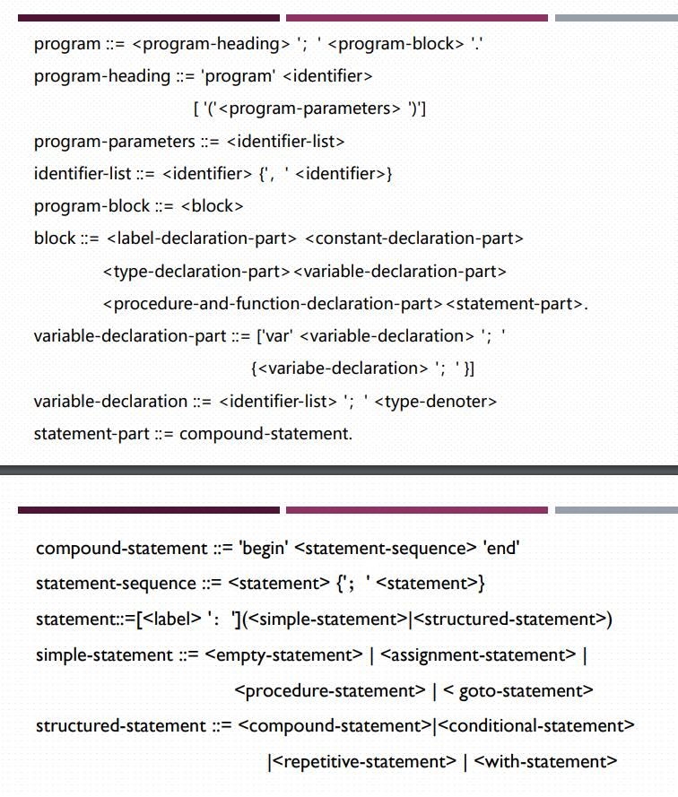

program ::= program id0 (id1, id2); label-declaration-part constant-declaration-part type-declaration-part var id1, id2; td1; id3, id4; td2; paf-declaration-part begin label: empty; assignment; procedure; goto end.

program-heading ::= program id0 (id1, id2)

program-parameters ::= id1, id2

identifier-list ::= id1, id2

program-block ::= label-declaration-part constant-declaration-part type-declaration-part var id1, id2; td1; id3, id4; td2; paf-declaration-part begin label: empty; assignment; procedure; goto end.

block ::= label-declaration-part constant-declaration-part type-declaration-part var id1, id2; td1; id3, id4; td2; paf-declaration-part begin label: empty; assignment; procedure; goto end.

variable-declaration-part ::= var id1, id2; td1; id3, id4; td2;

variable-declaration ::= id1, id2; td1

statement-part::= begin label: empty; assignment; procedure; goto end.

compound-statement ::= begin empty; assignment; procedure; goto end

statement-sequence ::= empty; assignment; procedure; goto

statement ::= label: empty

simple-statement ::= goto

structured-statement ::= begin label: empty; assignment; procedure; goto end

1. 将以下BNF表示的Algol60部分产生式画成语法图

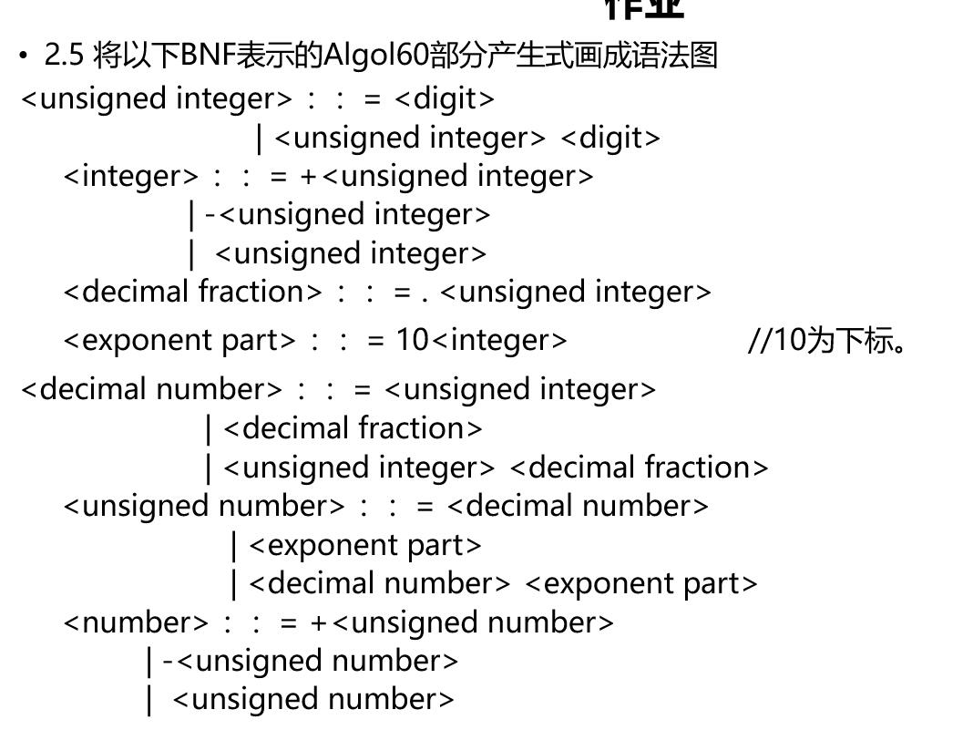

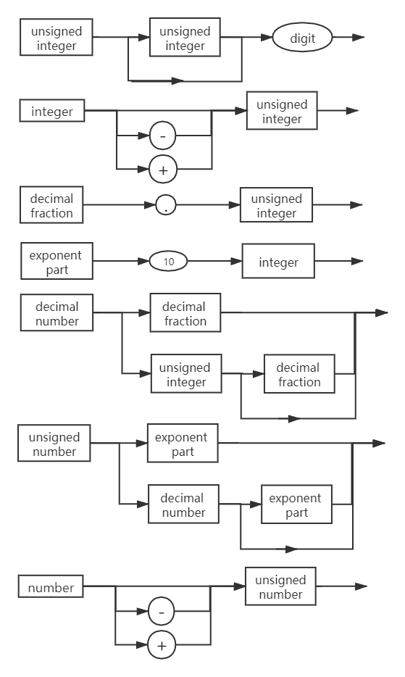

1. 将下面的EBNF转换为BNF：

S -> A { b A }

A -> a [ b ] A

解：< S > ::= < A > {‘ b ’ < A > }

< A > ::= ‘a’ [‘b’ ] < A >

1. 考虑下列文法：

< S > -> < A > a < B > b

< A > -> < A > b | b

< B > -> a < B > | a

下面的哪些句子属于这些文法所产生的语言？

baab

bbbab

bbaaaaa

bbaab

解：A -> { b }

B -> { a }

S -> { b } a { a } b

∴ baab、bbaab是该文法所产生的语言