CREATE VIEW Cars_Maintenance_View AS

SELECT

c.Make,

c.Model,

c.Year,

cm.Description,

cm.Maintenance_Date,

cm.Maintenance_Cost

FROM

CARS c

JOIN

CAR_MAINTENANCE cm ON c.CAR_ID = cm.CAR_ID

ORDER BY

cm.Maintenance_Date DESC;

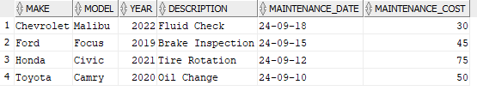

CREATE VIEW Customer_Rental_Summary AS

SELECT

c.First_Name,

c.Last_Name,

COUNT(r.Rental_ID) AS Total_Rentals,

MIN(r.Rental_Start_Date) AS First_Rental,

MAX(r.Rental_Start_Date) AS Last_Rental

FROM

CUSTOMERS c

LEFT JOIN

RENTAL_TRANSACTIONS r ON c.CUSTOMER_ID = r.CUSTOMER_ID

GROUP BY

c.First_Name, c.Last_Name

ORDER BY

Total_Rentals DESC;

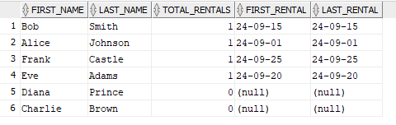

SELECT

c.Make,

c.Model,

COUNT(r.Rental_ID) AS Total_Rentals,

MIN(r.Rental_Start_Date) AS First_Rental,

MAX(r.Rental_End_Date) AS Last_Rental

FROM

CARS c

LEFT JOIN

RENTAL_TRANSACTIONS r ON c.CAR_ID = r.CAR_ID

GROUP BY

c.Make, c.Model

ORDER BY

Total_Rentals DESC;

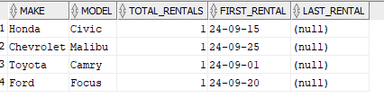

SELECT

c.First_Name AS "First Name",

c.Last_Name AS "Last Name",

COUNT(r.Rental_ID) AS "Total Rentals"

FROM

CUSTOMERS c

JOIN

RENTAL_TRANSACTIONS r ON c.CUSTOMER_ID = r.CUSTOMER_ID

GROUP BY

c.First_Name, c.Last_Name

ORDER BY

"Total Rentals" DESC

FETCH FIRST 5 ROWS ONLY;

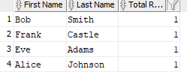

SELECT

c.Make AS "Car Make",

c.Model AS "Car Model",

SUM(cm.Maintenance_Cost) AS "Total Maintenance Cost"

FROM

CARS c

JOIN

CAR_MAINTENANCE cm ON c.CAR_ID = cm.CAR_ID

GROUP BY

c.Make, c.Model

ORDER BY

"Total Maintenance Cost" DESC;

