Federated Multimodal Graph Learning Framework
Mortality & Sepsis Prediction using the eICU Dataset

Progress Report — Steps 1 through 4

Date: October 7, 2026
Dataset: eICU Collaborative Research Database

Table of Contents
1. Executive Summary
2. Dataset Overview
3. Step 1 — Data Preparation
4. Step 2 — Modality-Specific Feature Learning
4.1 Tabular Encoder (MLP)
4.2 Time-Series Encoder (LSTM)
4.3 Text Encoder (MiniBERT)
4.4 Federated Pre-training
5. Step 3 — Multimodal Fusion
6. Step 4 — Intra-Hospital Patient Graph Construction
7. Interactive Visualization Playground
8. Codebase Structure
9. Summary & Next Steps

1. Executive Summary
This report documents the implementation progress of the first four steps of our Federated Multimodal Graph Learning Framework for predicting in-hospital mortality and sepsis. The framework treats each hospital as an independent federated learning client, ensuring that raw patient data never leaves the hospital boundary.
We have successfully completed:
- Step 1 — Data Preparation (partitioning the eICU dataset by hospital)
- Step 2 — Modality-Specific Feature Learning (Tabular MLP, Time-Series LSTM, and Text MiniBERT encoders)
- Step 3 — Multimodal Fusion (concatenation + projection network)
- Step 4 — Intra-Hospital Patient Graph Construction (k-NN and threshold-based graphs)
Additionally, a federated pre-training script for the Tabular Autoencoder using FedAvg has been implemented and executed, and a React-based interactive visualization playground has been built to inspect the patient graphs.

2. Dataset Overview
Metric | Value
Source | eICU Collaborative Research Database
Total Hospitals | 208
Total Patients | 200,859
Tabular Features per Patient | 72 (demographics, vitals, diagnoses, medications)
Time-Series Features per Timestep | 51 (labs, infusions, treatments)
Time-Series Resolution | Hourly bins (padded/truncated to 48 hours)
Text Features | Lab notes, infusion names, medication names
Prediction Targets | Hospital mortality, ICU mortality

Data is partitioned by hospitalid so that each hospital directory contains independent tabular and timeseries parquet files. Each hospital performs all preprocessing locally, ensuring no cross-hospital data sharing occurs at the data level.

3. Step 1 — Data Preparation
Module: src/datasets.py
Classes: EICUTabularDataset, EICUTimeSeriesDataset

What It Does
- Loads the .parquet files for a single hospital.
- Separates input features from target labels (mortality flags).
- Applies z-score normalization using globally computed statistics.
- Pads/truncates time-series sequences to a fixed window of 48 hours.
- Extracts unstructured text from free-text columns (lab_other_names, infusion_other_names, med_other_names).

Sample Output (Hospital 102)
Property | Value
Patients | 31
Tabular input dimension | 67 features
Time-series input dimension | 46 features × 48 timesteps
Mortality cases | 3 out of 31 (9.7%)

4. Step 2 — Modality-Specific Feature Learning
Three separate neural network encoders process each modality independently, each producing a 64-dimensional patient embedding.

4.1 Tabular Encoder (MLP)
Property | Value
Architecture | 3-layer MLP (input → 128 → 64 → 64)
Normalization | BatchNorm after each hidden layer
Activation | ReLU
Regularization | Dropout (p=0.3)
Input | 67 static clinical features
Output | 64D embedding per patient

4.2 Time-Series Encoder (LSTM)
Property | Value
Architecture | 2-layer Stacked LSTM + Linear Projection
Hidden dimension | 64
Sequence handling | pack_padded_sequence for variable-length inputs
Output extraction | Last valid hidden state
Input | (48, 46) — 48 hours × 46 features
Output | 64D embedding per patient

4.3 Text Encoder (MiniBERT)
Property | Value
Base model | prajjwal1/bert-mini (HuggingFace)
Parameters | ~11.3M (pre-trained)
Tokenizer | BertTokenizer
Max sequence length | 512 tokens
Projection | Linear(256→128) → BN → ReLU → Linear(128→64)
Input | Concatenated clinical text strings
Output | 64D embedding per patient

Smoke Test Results (Hospital 102)
[PASS] All smoke tests passed!
Tabular : (67,) → (64,)
LSTM : (48, 46) → (64,)
Text : (variable length str) → (64,)

4.4 Federated Pre-training (Tabular Autoencoder)
Parameter | Value
Communication rounds | 15
Local epochs per round | 3
Client fraction per round | 15% (~31 hospitals)
Batch size | 32
Learning rate | 1e-3
Aggregation strategy | FedAvg (weighted by patient count)

The resulting pre-trained weights are saved at pretrained_weights/global_tabular_ae.pth.

5. Step 3 — Multimodal Fusion
Module: src/fusion.py
Class: MultimodalFusion
The three 64D modality embeddings are concatenated to form a 192D vector, which is then projected through a smoothing MLP:
Tabular Emb (64) ─┐
├─ Concat (192) → Linear → BN → ReLU → Dropout
TimeSeries Emb(64)─┤ → Linear(192→128) → BN → ReLU
Text Emb (64) ─────┘
Output: Unified Patient Embedding (128D)
Property | Value
Input | 3 × 64D = 192D concatenated embedding
Hidden layer | 192 → 192 (with BatchNorm, ReLU, Dropout)
Output | 128D unified patient embedding

6. Step 4 — Intra-Hospital Patient Graph Construction
Module: src/graph_builder.py
Functions: build_knn_graph, build_threshold_graph

6.1 k-Nearest Neighbors (k-NN) Graph
- Computes pairwise cosine similarity between all patient embeddings.
- Connects each patient to their top-k most similar neighbors.
- Produces directed edges (source → target) with similarity scores as edge weights.

6.2 Threshold-Based Graph
- Computes pairwise cosine similarity.
- Creates an edge between patients whose similarity exceeds a threshold (e.g., 0.75).
- Produces undirected edges with similarity scores as weights.

Privacy Enforcement
Since each batch only contains patients from one hospital (by construction of the federated data partitioning), cross-hospital edges are mathematically impossible. No additional filtering is required.

Graph Output (Hospital 102, k=3 KNN)
Property | Value
Nodes (patients) | 31
Edges | 49
Edge format | PyTorch Geometric edge_index (2 × E)
Edge weights | Cosine similarity scores
Survived nodes | 28 (green)
High-risk nodes | 3 (red)

7. Interactive Visualization Playground
To facilitate inspection and demonstration, we built a React + Vite frontend that renders the patient graph as an interactive force-directed layout.
- Force-directed graph with physics simulation (nodes repel, edges attract)
- Color-coded nodes — Green (Stable/Survived), Red (High Risk/Expired)
- Click-to-inspect — Selecting a patient reveals clinical text and neighbor count
- Real data — Generated from actual hospital_102 patient data through the full pipeline

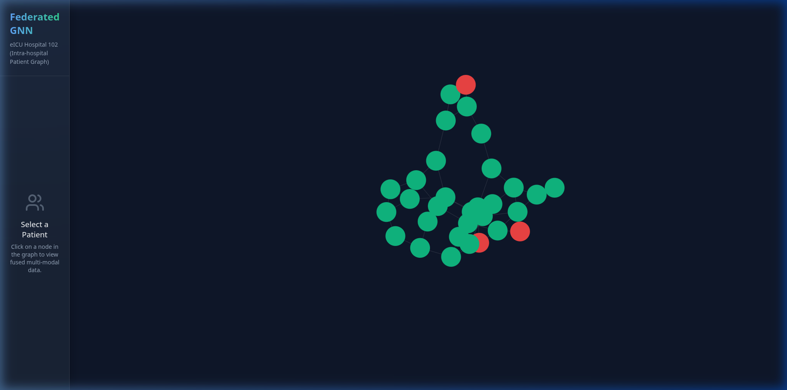
Figure 1: Patient Graph Overview — Hospital 102

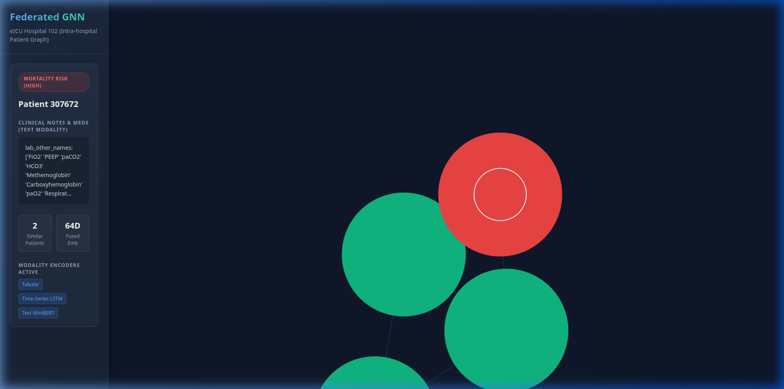
Figure 2: Selected Patient Details — Clinical Text and Modality Tags

8. Codebase Structure
project-root/
├── processed/ # Raw data (208 hospitals)
│ ├── hospitals/hospital_*/
│ ├── feature_schema.json
│ └── timeseries_stats.json
├── src/ # Core modules
│ ├── datasets.py # Step 1
│ ├── encoders.py # Step 2
│ ├── fusion.py # Step 3
│ └── graph_builder.py # Step 4
├── scripts/ # Executable scripts
├── tests/ # Smoke tests
├── pretrained_weights/ # Saved model weights
└── frontend-playground/ # React visualization

9. Summary & Next Steps

Completed (Steps 1–4)
Step | Component | Status
1 | Data Preparation | ✅ Complete
2 | Tabular Encoder (MLP) | ✅ Complete
2 | Time-Series Encoder (LSTM) | ✅ Complete
2 | Text Encoder (MiniBERT) | ✅ Complete
2 | Federated Pre-training (AE + FedAvg) | ✅ Complete
3 | Multimodal Fusion | ✅ Complete
4 | Patient Graph Construction | ✅ Complete

Remaining (Steps 5–8)
Step | Component | Status
5 | Graph Neural Network (GraphSAGE / GAT) | ⬜ Not started
6 | Multi-task Prediction Heads | ⬜ Not started
7 | Federated Client Training Loop | ⬜ Not started
8 | Central Server Aggregation (FedAvg) | ⬜ Not started

Planned Next Actions
- Implement a Graph Neural Network module (GraphSAGE or GAT) for graph-enhanced patient embeddings.
- Add dual prediction heads for mortality and sepsis classification with a multi-task loss function.
- Build the full federated training loop coordinating all 208 hospital clients.
- Evaluate using AUROC, AUPRC, Accuracy, Precision, Recall, and F1-score.

