**Assignment-2**

**EE2003: Computer Organization**

**Name**: Aayush Patel

**Roll No.**: EE21B003

**Question (P15)**

*Design a 8-bit carry select adder module in Verilog.*

*The module should have two 8-bit inputs (A and B) and a 1-bit input Cin. It should output an 8-bit sum Sum and a 1-bit carry-out Cout.*

*Use two 4-bit ripple carry adders and a multiplexer to implement the carry select adder.*

**Carry Select Adder**

I will be using four 4bit-ripple carry adders and 4 multiplexers. The design we will follow is provided below.

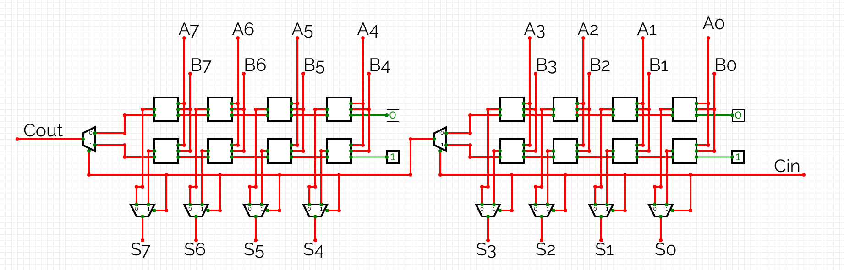

(In the image I have shown different muxes for each bit, but in Verilog I made the mux for 4-bits.)

**Source Code**

`timescale 1ns / 1ps

//MULTIPLEXER

module mux2to1 (

input [3:0]A,

input [3:0]B,

input Sel,

output [3:0]Y

);

assign Y = (Sel) ? B : A;

endmodule

//RIPPLE CARRY ADDER

module ripple_carry_adder (

input [3:0] A,

input [3:0] B,

input Cin,

output [3:0] Sum,

output Cout

);

wire [3:0] rippleSum;

wire C0, C1, C2, C3;

// Calculate the Sum and Carry-out for each bit

assign rippleSum[0] = A[0] ^ B[0] ^ Cin;

assign C0 = (A[0] & B[0]) | (Cin & (A[0] ^ B[0]));

assign rippleSum[1] = A[1] ^ B[1] ^ C0;

assign C1 = (A[1] & B[1]) | (C0 & (A[1] ^ B[1]));

assign rippleSum[2] = A[2] ^ B[2] ^ C1;

assign C2 = (A[2] & B[2]) | (C1 & (A[2] ^ B[2]));

assign rippleSum[3] = A[3] ^ B[3] ^ C2;

assign C3 = (A[3] & B[3]) | (C2 & (A[3] ^ B[3]));

// Output Sum and final Carry-out

assign Sum = rippleSum;

assign Cout = C3;

endmodule

//CARRY SELECT ADDER

module carry_select_adder (

input [7:0] A,

input [7:0] B,

input Sel,

output [7:0] Sum,

output Cout

);

wire [3:0] A0, B0, A1, B1;

wire [3:0] Sum00, Sum01, Sum10, Sum11;

wire Cout00, Cout01, Cout10, Cout11, Cout0, Cout1; // Carry-out from the 4-bit adders and select signal

// Split input A and B into two 4-bit parts each

assign {A1, A0} = A;

assign {B1, B0} = B;

// Four 4-bit ripple carry adders

ripple_carry_adder rca0 (

.A(A0),

.B(B0),

.Cin(1'b0), // Carry-in is 0 for the first adder

.Sum(Sum00),

.Cout(Cout00)

);

ripple_carry_adder rca1 (

.A(A0),

.B(B0),

.Cin(1'b1), // Carry-in is 1 for the second adder

.Sum(Sum01),

.Cout(Cout01)

);

ripple_carry_adder rca2 (

.A(A1),

.B(B1),

.Cin(1'b0), // Carry-in is 0 for the first adder

.Sum(Sum10),

.Cout(Cout10)

);

ripple_carry_adder rca3 (

.A(A1),

.B(B1),

.Cin(1'b1), // Carry-in is 1 for the second adder

.Sum(Sum11),

.Cout(Cout11)

);

// Create multiplexers to select the appropriate Sum and Cout

mux2to1 mux_sum0 (

.A(Sum00),

.B(Sum01),

.Sel(Sel),

.Y(Sum[3:0])

);

mux2to1 mux_sum1 (

.A(Sum10),

.B(Sum11),

.Sel(Cout0),

.Y(Sum[7:4])

);

mux2to1 mux_cout0 (

.A(Cout00),

.B(Cout01),

.Sel(Sel),

.Y(Cout0)

);

mux2to1 mux_cout1 (

.A(Cout10),

.B(Cout11),

.Sel(Cout0),

.Y(Cout1)

);

Endmodule

**Testbench**

`timescale 1ns / 1ps

module testbench;

reg [7:0] A, B;

reg Cin;

wire [7:0] Sum;

wire Cout;

carry_select_adder uut (

.A(A),

.B(B),

.Sel(Cin),

.Sum(Sum),

.Cout(Cout)

);

initial begin

$dumpfile("carry_select_adder.vcd");

$dumpvars(0, testbench);

// Test case 1: A = 4, B = 5, Cin = 0

A = 4;

B = 5;

Cin = 0;

#1 $display("Test Case 1: A = %d, B = %d, Cin = %d, Sum = %d, Cout = %d", A, B, Cin, Sum, Cout);

// Test case 2: A = 153, B = 43, Cin = 1

A = 153;

B = 43;

Cin = 1;

#1 $display("Test Case 2: A = %d, B = %d, Cin = %d, Sum = %d, Cout = %d", A, B, Cin, Sum, Cout);

$finish;

end

endmodule

**Waveform – Output**

I have used “EDA playground” to generate the simulations/waveforms.

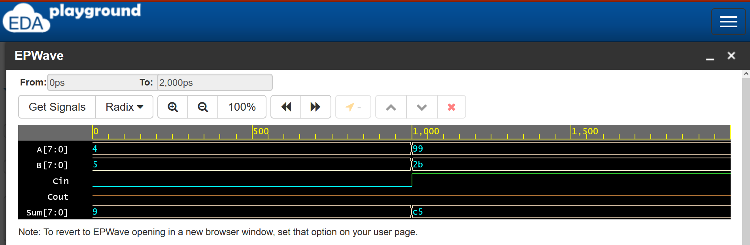

(4+5+0=9)

And

(153+43+1=197 i.e 99+2b+1=c5)