**Computer Organization Assignment-4**

**Name: Aayush Patel**

**Roll: EE21B003**

**PART – A**

**Modulo Operation**

Computing : a0 % a1

Program (for **Flushing Enabled**) :

addi a0, x0, 39

addi a1, x0, 7

bge a1, a0, skip

loop:

sub a0, a0, a1

bge a0, a1, loop

skip:

**Data Hazard**: Read After Write (RAW)

The 3rd instruction reads value of a1, after writing in 2nd instruction. So the pipeline needs to stall.

**Branch Hazard** : For both the branching instructions. Resolved by flushing.

Forwarding Enabled (with Flushing)

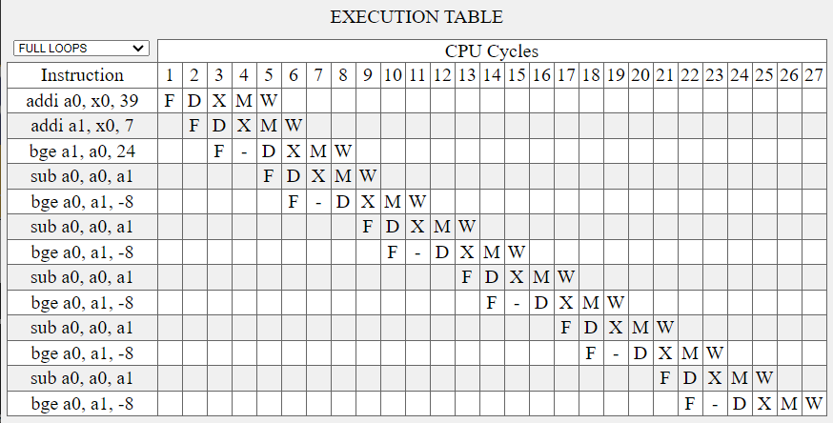

Throughput = 13/27 = 0.48148

(27 Clock Cycles)

Forwarding Disabled (with Flushing)

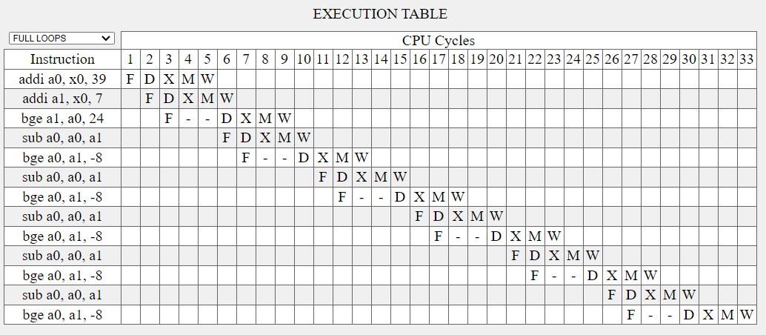

Throughput = 13/33 = 0.393939

(33 Clock Cycles)

Program (for **Delay Slot**):

addi a0, x0, 39

addi a1, x0, 7

bge a1, a0, skip

nop

loop:

sub a0, a0, a1

bge a0, a1, loop

skip:

**Data Hazard**: Read After Write (RAW)

The 3rd instruction reads value of a1, after writing in 2nd instruction. So the pipeline needs to stall.

**Branch Hazard** : For both the branching instructions, but the second one does not have any instruction after it so it won’t initiate it. Resolved by using no operation (nop).

**Note**: We might get wrong/ unexpected results in case of Delay Slot Branch Hazard Handling as it does not flush the previous instructions which were not meant to take place. So I used nop here to avoid getting wrong results.

Forwarding Enabled (with Delay Slot)

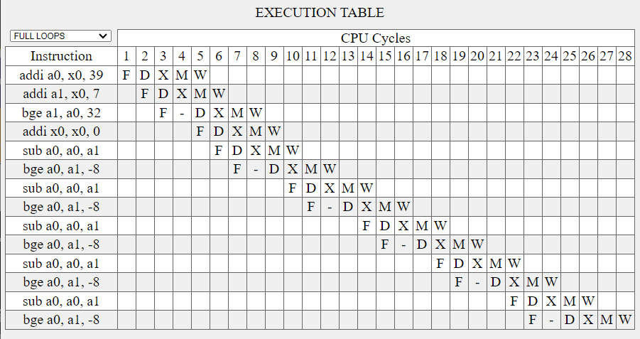

Throughput = 13/28 = 0.464285

(28 Clock Cycles)

Forwarding Disabled (with Delay Slot)

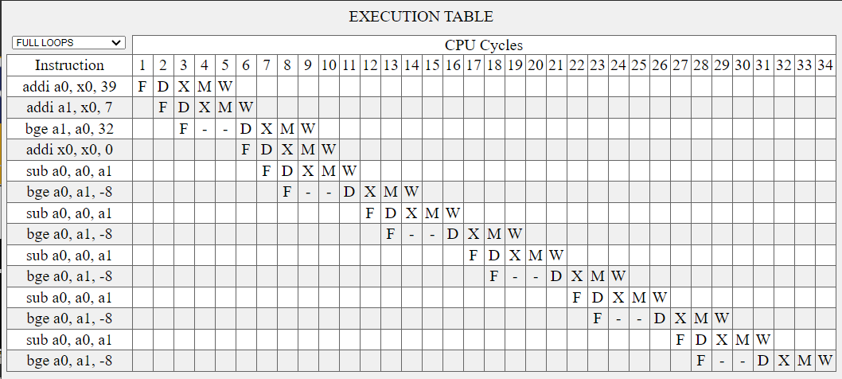

Throughput = 13/34 = 0.382352

(34 Clock Cycles)

**PART – B**

After running the given file (helloworld.riscv) on the RISC-V Simulator I got the following Results.

Performance Table:

|  |  |  |  |  |
| --- | --- | --- | --- | --- |
| **Performance Parameter** | **AT** | **NT** | **BTFNT** | **BPB** |
| No. of Instructions | 152 | 140 | 152 | 152 |
| No. of Cycles | 262 | 228 | 250 | 262 |
| Average Cycle/Instruction | 1.7237 | 1.6286 | 1.6447 | 1.7237 |
| Accuracy | 0.4706 | 0.5833 | 0.7059 | 0.4706 |
| No. of Control Hazard | 26 | 23 | 22 | 26 |
| No. of Data Hazard | 76 | 73 | 77 | 76 |
| No. of Memory Hazard | 1 | 1 | 1 | 1 |