39%7=4

addi a0, x0, 39

addi a1, x0, 7

bge a1, a0, skip

loop:

sub a0, a0, a1

bge a0, a1, loop

skip:

Flushsing, fwding

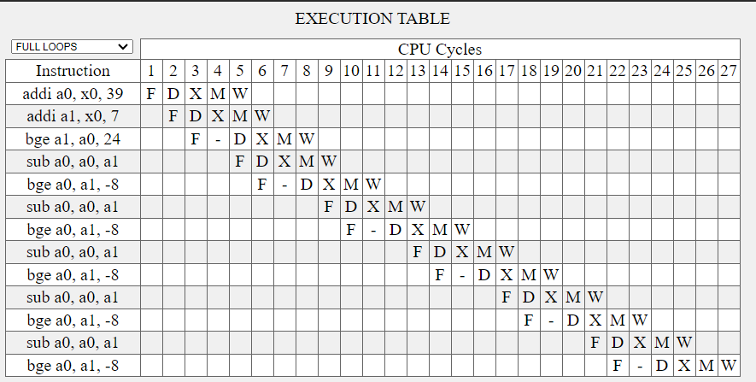

Flushing , not fwding

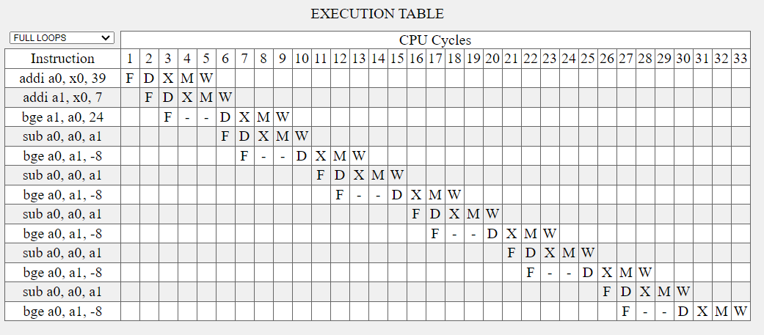

Delay slot, fwding

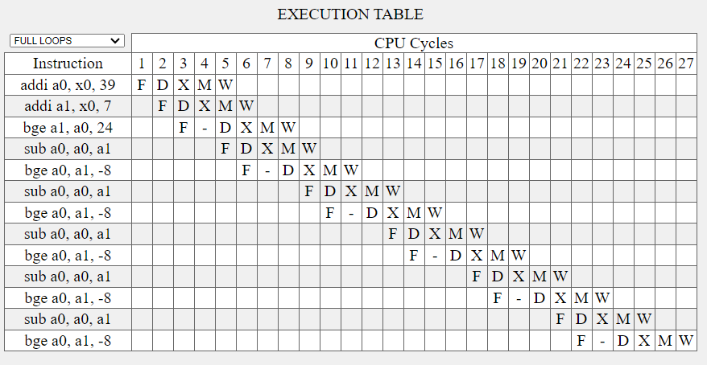

Delay slot, not fwding

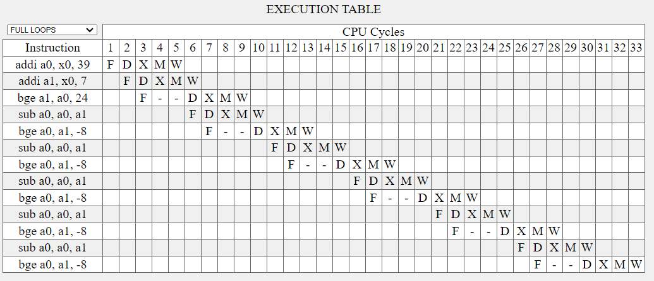

Flushing , fwding

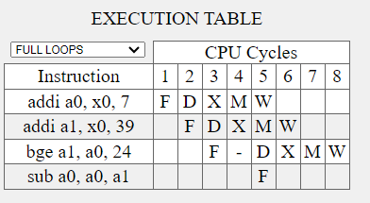

Delay Slot, fwding

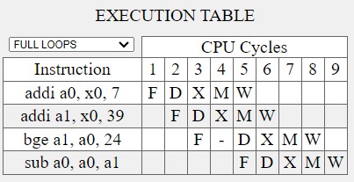

Flushing, not fwding

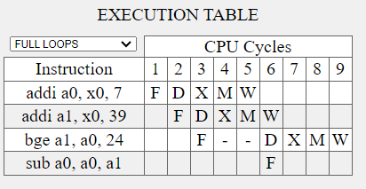

Delay slot, not fwding

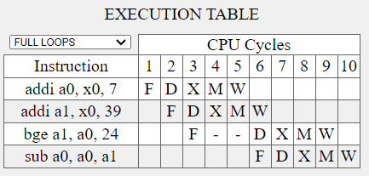

addi a0, x0, 39

addi a1, x0, 7

loop:

bge a1, a0, skip

sub a0, a0, a1

beq x0, x0, loop

skip: