Hospital Patient Analytics
Data Visualization with R Project Report
Project Number | 9
Project Title | Hospital Patient Analytics
Batch Number
Section | C7
Member 1 Name Roll No. | Keshavpatel Enjapuri & 24011CSEAI0064
Member 2 Name Roll No. | Balina Sathwika & 24011CSEAI0058
Member 3 Name Roll No. | Mashetti Manideep & 24011CSEAI0135
Dataset Name and Source | Simulated hospital patient records created for academic analysis
Analysis Tool | R with tidyverse ggplot2 and broom

1. Introduction
This project explores hospital patient records to describe patterns in patient characteristics, department, admission type, treatment duration, cost and discharge status. The analysis is descriptive and exploratory and does not make clinical or causal claims.

2. Objectives
- Prepare and clean patient-level data.
- Compare patient patterns across departments.
- Examine duration cost and discharge status.
- Create at least five meaningful ggplot2 visualizations.
- Use exploratory logistic regression for recovery status.

3. Dataset Description
The project uses 400 simulated patient records created for this academic assignment. The raw CSV has 9 variables: patient ID, age, gender, department, diagnosis, treatment duration, admission type, treatment cost and discharge status. It covers six departments and three admission types.

4. Data Preparation
The R program checks duplicate IDs and missing values. Missing age and cost values are replaced by medians; missing gender and diagnosis values are labelled Not recorded. Department admission type and discharge status are converted to categorical variables.

5. Exploratory Data Analysis EDA
The cleaned dataset contains 400 records. Mean age is 42.8 years. 81.2% of records have discharge status Recovered. Costs tend to rise with treatment duration.

6. Visualizations

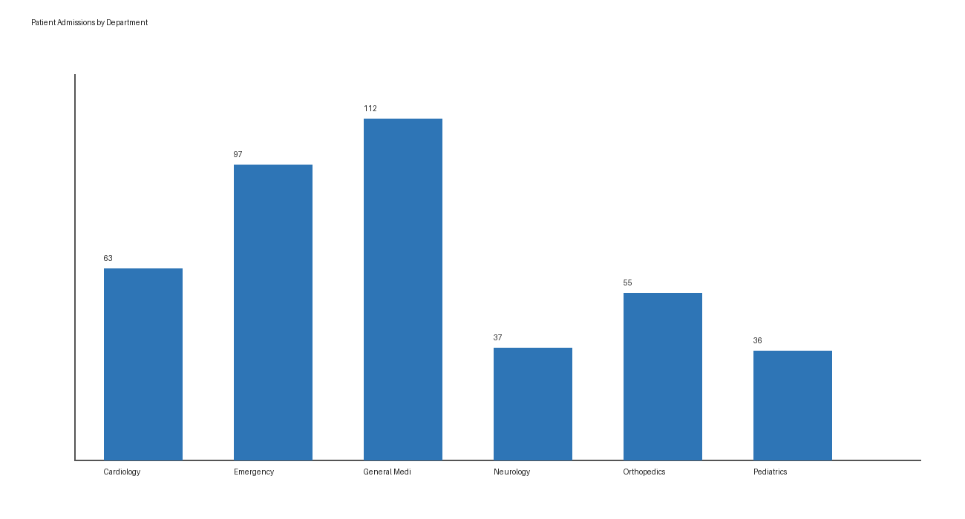
Figure 1. Patient admissions by department.

Observation: General Medicine and Emergency contribute the largest patient counts.
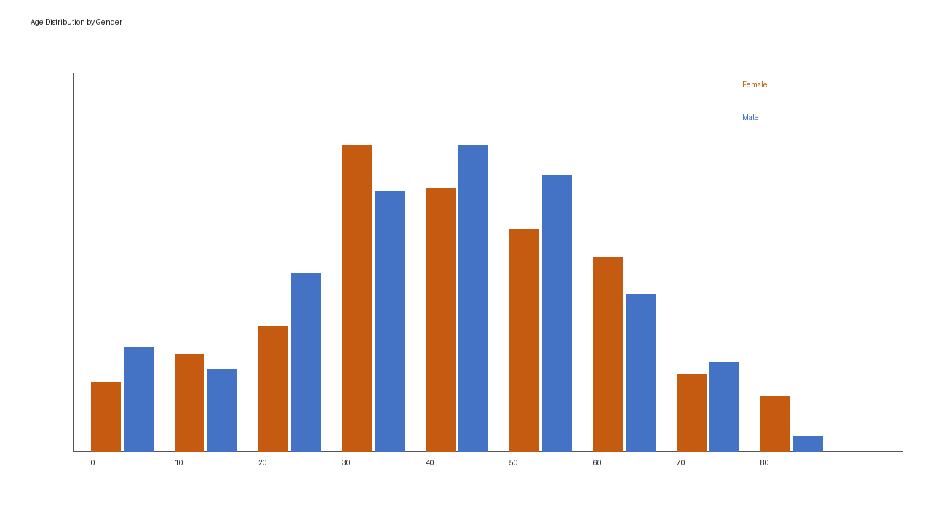
Figure 2. Age distribution by gender.

Observation: The distributions overlap across gender groups.
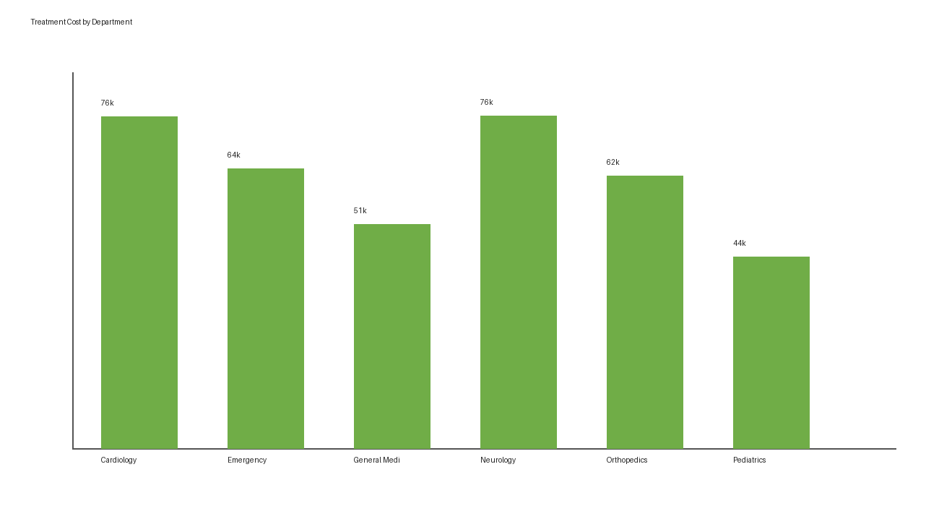
Figure 3. Treatment cost by department.

Observation: Cost distributions differ by department.
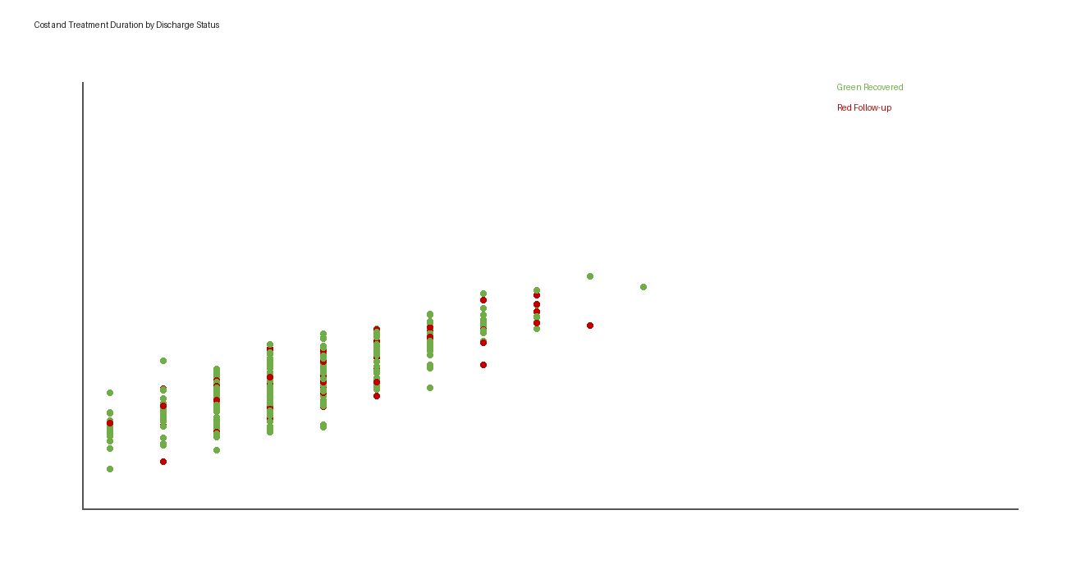
Figure 4. Cost and treatment duration.

Observation: Cost generally rises as treatment duration increases.
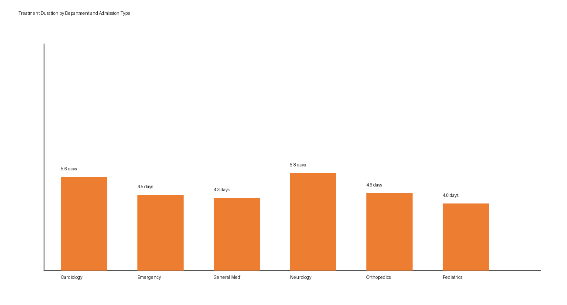
Figure 5. Treatment duration facets.

Observation: Emergency admissions tend to have longer recorded durations.

7. Statistical Analysis Model
The R program fits a binary logistic regression with Recovered as the response and age, duration, cost, department, admission type and gender as predictors. It is exploratory and not a medical decision model.

8. Major Findings
- Patient volume differs across departments.
- Treatment cost has a positive relationship with treatment duration.
- Department and admission type add context to cost and duration patterns.
- 81.2% of records are coded as Recovered.
- Results describe only the simulated dataset.

9. Conclusion
This project demonstrates a complete R workflow from raw records through cleaning, EDA, visualizations and an exploratory model. The main limitation is that the data are simulated and do not include clinical severity or follow-up information.

10. Individual Contributions
Member | Work Completed
Member 1 | To be filled by the group
Member 2 | To be filled by the group
Member 3 | To be filled by the group

11. References
- Project dataset: hospital_patients_raw.csv, simulated patient records created for this academic project.
- Wickham H et al. tidyverse package.
- Wickham H. ggplot2: Elegant Graphics for Data Analysis.
- R Core Team. R: A Language and Environment for Statistical Computing.

