Assignment 2

|  |
| --- |
| **Class: BankAccount** |
| - balance : double  - num_Of_Deposit : int  - num_Of_Withdrawals : int  - annual_Int_Rate : double  - monthly_Ser_Charge : double |
| + BankAccount()  + BankAccount(balance : double, annual_Int_Rate : double, monthly_Ser_Charge : double)  + getBalance : double  + getNum_Of_Deposit : int  + getNum_Of_Withdrawals : int  + getAnnual_Int_Rate : double  + getMonthly_Ser_Charge : double  + setBalance(double balance) : void  + setNum_Of_Deposit(int num_Of_Deposit) : void  + setNum_Of_Withdrawals(int num_Of_Withdrawals) : void  + setAnnual_Int_Rate(double annual_Int_Rate) : void  + setMonthly_Ser_Charge(double monthly_Ser_Charge) : void  + deposit(double amount_Of_Deposit) : void  + withdraw(double amount_Of_Withdraw) : void  + calcInterest() : double  + monthlyProcess() : void |

|  |
| --- |
| **Class : SavingsAccount** |
| - status : Boolean |
| + SavingsAccount(balance : double, monthly_Ser_Charge : double, annual_Int_Rate : double)  + deposit(double amount_Of_Deposit) : void  + withdraw(double amount_Of_Withdraw) : void |

**Program BankAccount :**

**package Inheritance;**

**/\*\***

**\* @author Jay Patel**

**\* @version 1.0**

**\***

**\*/**

**public class BankAccount {**

**//Variables**

**private double balance;**

**private int num_Of_Deposit;**

**private int num_Of_Withdrawals;**

**private double annual_Int_Rate;**

**private double monthly_Ser_Charge;**

**//Default Constructor**

**BankAccount(){**

**balance = 0.0;**

**num_Of_Deposit = 0;**

**num_Of_Withdrawals = 0;**

**annual_Int_Rate = 0.0;**

**monthly_Ser_Charge = 0.0;**

**}**

**//Parameterized Constructor**

**BankAccount(double balance,double monthly_Ser_Charge,**

**double annual_Int_Rate){**

**this.balance = balance;**

**this.monthly_Ser_Charge = monthly_Ser_Charge;**

**this.annual_Int_Rate = annual_Int_Rate;**

**}**

**//accessor methods**

**/\*\***

**\***

**\* @return Balance- double value**

**\*/**

**public double getBalance()**

**{**

**return balance;**

**}**

**/\*\***

**\***

**\* @return Number Of Deposit - int value**

**\*/**

**public int getNum_Of_Deposit()**

**{**

**return num_Of_Deposit;**

**}**

**/\*\***

**\***

**\* @return Number of Withdrawals - int value**

**\*/**

**public int getNum_Of_Withdrawals() {**

**return num_Of_Withdrawals;**

**}**

**/\*\***

**\***

**\* @return Annual Interest Rate - double value**

**\*/**

**public double getAnnual_Int_Rate()**

**{**

**return annual_Int_Rate;**

**}**

**/\*\***

**\***

**\* @return Monthly Service Charge - double value**

**\*/**

**public double getMonthly_Ser_Charge()**

**{**

**return monthly_Ser_Charge;**

**}**

**// mutator methods**

**/\*\***

**\***

**\* @param balance - double value**

**\*/**

**public void setBalance(double balance)**

**{**

**this.balance = balance;**

**}**

**/\*\***

**\***

**\* @param num_Of_Deposit - int value**

**\*/**

**public void setNum_Of_Deposit(int num_Of_Deposit)**

**{**

**this.num_Of_Deposit = num_Of_Deposit;**

**}**

**/\*\***

**\***

**\* @param num_Of_Withdrawals - int value**

**\*/**

**public void setNum_Of_Withdrawals(int num_Of_Withdrawals)**

**{**

**this.num_Of_Withdrawals = num_Of_Withdrawals;**

**}**

**/\*\***

**\***

**\* @param annual_Int_Rate - double value**

**\*/**

**public void setAnnual_Int_Rate(double annual_Int_Rate) {**

**this.annual_Int_Rate = annual_Int_Rate;**

**}**

**/\*\***

**\***

**\* @param monthly_Ser_Charge - double value**

**\*/**

**public void setMonthly_Ser_Charge(double monthly_Ser_Charge) {**

**this.monthly_Ser_Charge = monthly_Ser_Charge;**

**}**

**// methods**

**/\*\***

**\***

**\* @param amount_Of_Deposit -double value**

**\*/**

**public void deposit(double amount_Of_Deposit){**

**balance += amount_Of_Deposit;**

**num_Of_Deposit++;**

**System.out.println("Number Of Deposits : "+getNum_Of_Deposit() +**

**"; Number Of Withdraws : "+getNum_Of_Withdrawals()+"; Balance : " + getBalance());**

**}**

**/\*\***

**\***

**\* @param amount_Of_Withdraw - double value**

**\*/**

**public void withdraw(double amount_Of_Withdraw){**

**if (balance < amount_Of_Withdraw){**

**System.out.println("Sorry! Your Balance is too low for this withdrawal!");**

**}else**

**{**

**balance -= amount_Of_Withdraw;**

**num_Of_Withdrawals++;**

**if (balance<50)**

**System.out.println("Your Account balance is to low.\n" +**

**"And if you will not deposit a few money within few months then " +**

**"your account will be deactivated within 45 days.");**

**}**

**System.out.println("Number Of Deposits : " +getNum_Of_Deposit()+**

**"; Number Of Withdraws : " +getNum_Of_Withdrawals()+**

**"; Balance : " +getBalance());**

**}**

**public double calcInterest(){**

**double monthly_Int_Rate,monthly_Interest;**

**monthly_Int_Rate = annual_Int_Rate/12;**

**monthly_Interest = balance*monthly_Int_Rate;**

**balance += monthly_Interest;**

**return balance+monthly_Interest;**

**}**

**public void monthlyProcess(){**

**balance -= monthly_Ser_Charge;**

**calcInterest();**

**num_Of_Withdrawals=0;**

**num_Of_Deposit=0;**

**monthly_Ser_Charge=0.0;**

**}**

**}**

**Program SavingsAccount :**

**package Inheritance;**

**/\*\***

**\* @author Jay Patel**

**\* @version 1.0**

**\***

**\*/**

**public class SavingsAccount extends BankAccount {**

**private Boolean status;**

**SavingsAccount(double balance,double monthly_Ser_Charge,**

**double annual_Int_Rate){**

**super(balance, monthly_Ser_Charge, annual_Int_Rate);**

**if(getBalance()<50){**

**status = false;**

**}else {**

**status = true;**

**}**

**}**

**//methods**

**public void deposit(double amount_Of_Deposit){**

**super.deposit(amount_Of_Deposit);**

**if (status==false && getBalance() > 50){**

**status=true;**

**}**

**}**

**public void withdraw(double amount_Of_Withdraw){**

**if (status==false){**

**System.out.println("Sorry!! No withdrawals allowed As Your Account is deactivated. ");**

**System.out.println("Number Of Deposits : " +getNum_Of_Deposit()+**

**"; Number Of Withdraws : " +getNum_Of_Withdrawals()+**

**"; Balance : " +getBalance());**

**}else{**

**super.withdraw(amount_Of_Withdraw);**

**if (getBalance()<50){**

**status=false;**

**}**

**}**

**}**

**}**

**Program AccountDemo :**

**package Inheritance;**

**import java.util.Scanner;**

**public class AccountDemo {**

**public static void main(String[] args) {**

**Scanner input = new Scanner(System.in);**

**double balance, annual_Int_Rate,monthly_Ser_Charge,**

**amount_Of_Deposit,amount_Of_Withdraw;**

**System.out.println("Testing Bank Account Class");**

**System.out.println("Enter Your Balance");**

**balance = input.nextDouble();**

**System.out.println("Enter Interest Rate");**

**annual_Int_Rate = input.nextDouble();**

**System.out.println("Enter Monthly Charges");**

**monthly_Ser_Charge = input.nextDouble();**

**System.out.println("Enter Amount Of Deposit You Want To Deposit");**

**amount_Of_Deposit = input.nextDouble();**

**BankAccount ba = new BankAccount(balance,**

**monthly_Ser_Charge,annual_Int_Rate);**

**System.out.println("After Calling Deposit");**

**ba.deposit(amount_Of_Deposit);**

**System.out.println("Enter Amount Of Withdraw you Want To Withdraw");**

**amount_Of_Withdraw = input.nextDouble();**

**System.out.println("After Calling Withdraw");**

**ba.withdraw(amount_Of_Withdraw);**

**System.out.println("\nTesting Savings Account Class");**

**System.out.println("Enter Your Balance");**

**balance = input.nextDouble();**

**System.out.println("Enter Interest Rate");**

**annual_Int_Rate = input.nextDouble();**

**System.out.println("Enter Monthly Charges");**

**monthly_Ser_Charge = input.nextDouble();**

**System.out.println("Enter Amount Of Deposit You Want To Deposit");**

**amount_Of_Deposit = input.nextDouble();**

**SavingsAccount sa = new SavingsAccount(balance,monthly_Ser_Charge,annual_Int_Rate);**

**System.out.println("After Calling Deposit");**

**sa.deposit(amount_Of_Deposit);**

**System.out.println("Enter Amount Of Withdraw you Want To Withdraw");**

**amount_Of_Withdraw = input.nextDouble();**

**System.out.println("After Calling Withdraw");**

**sa.withdraw(amount_Of_Withdraw);**

**}**

**}**

**Screenshots :**

**Sample Run1:**

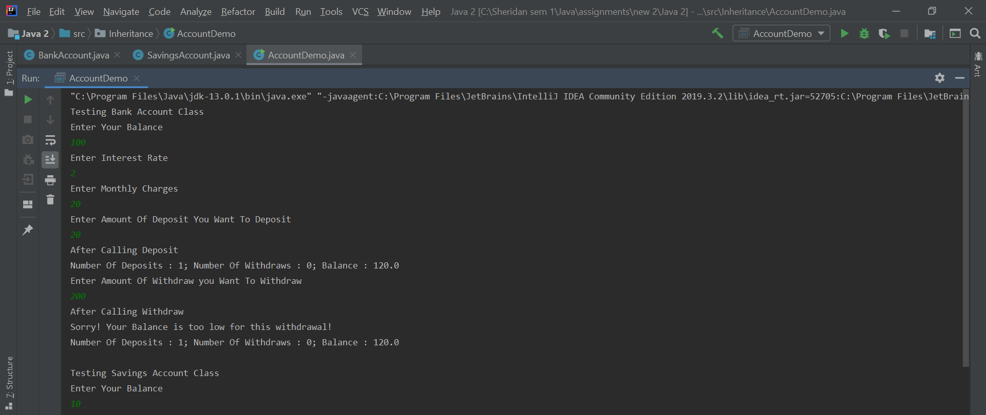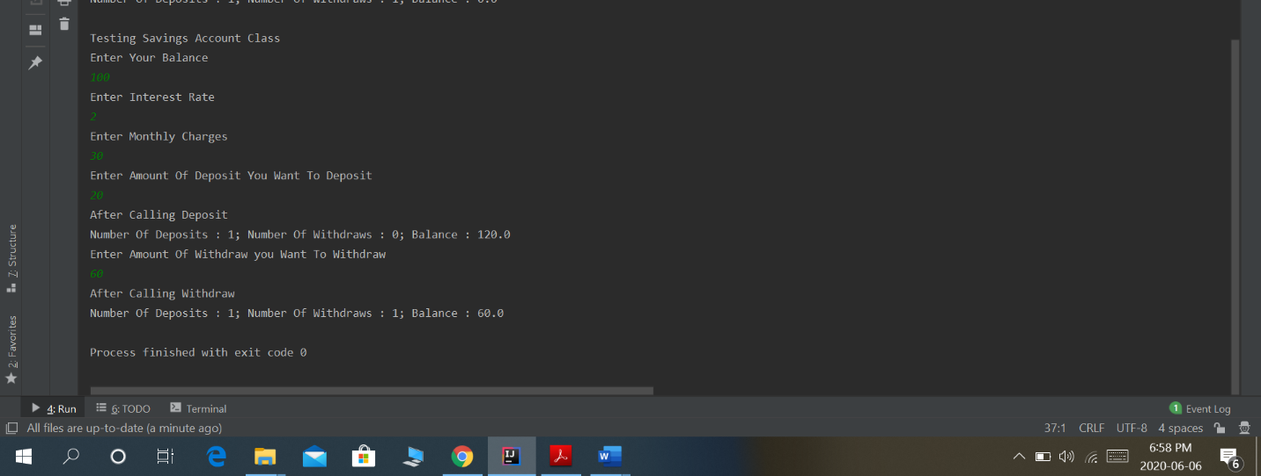

**Sample Run2 :**

