Git – Commands Assignment

TASK 1: Local Repository Setup
- Create a new project folder. 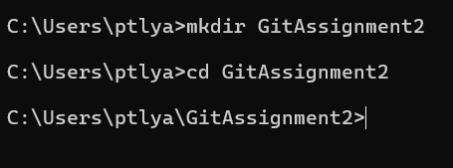
- Initialize Git in the folder.
- Create a file named index.txt
- Add content to the file.
- Check repository status. 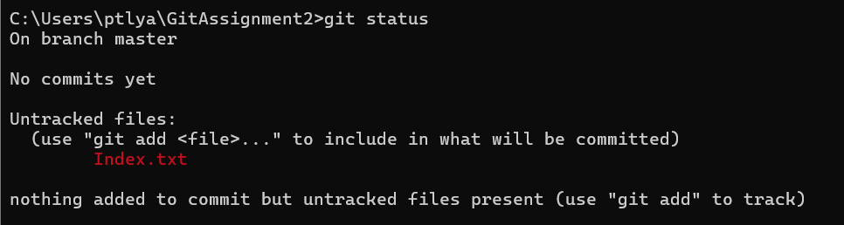
- Stage all changes.
- Commit the changes with an appropriate message. 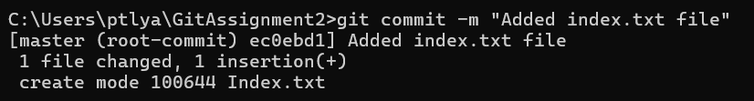

TASK 2: Remote Repository Creation
- Create a new GitHub repository. 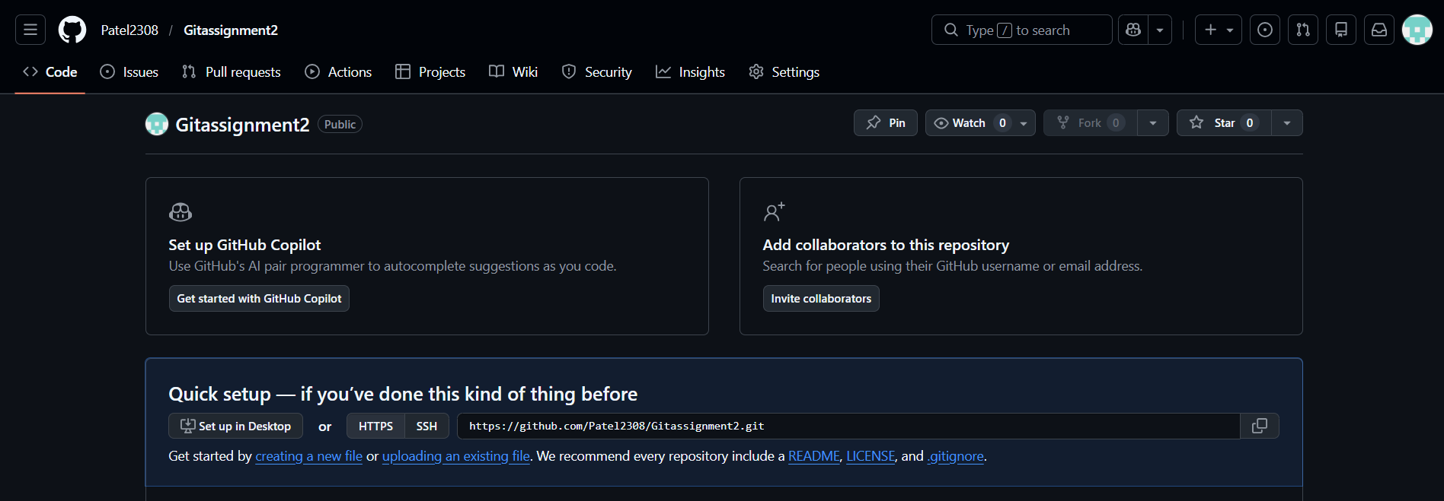

TASK 3: Connect Local Repository to Remote
- Add the GitHub repository as remote origin.
- Verify remote connection. 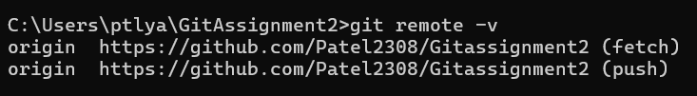
- Rename the current branch to main.

TASK 4: Push Local Changes to Remote
- Push the local main branch to the remote repository. 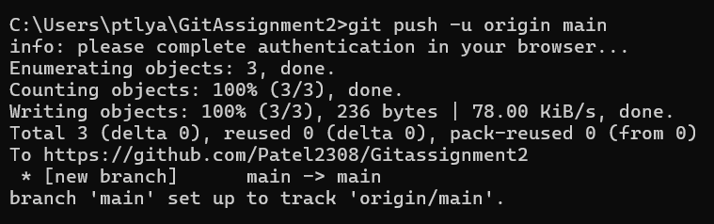

TASK 5: Branch Creation and Work
- Create a new branch named FirstBranch.
- Switch to the newly created branch. 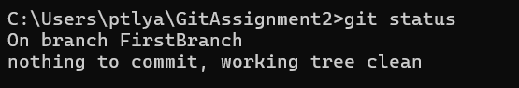
- Create a new file named notes.txt.
- Add content to the file. 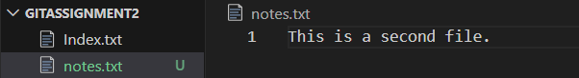
- Stage the changes.
- Commit the changes. 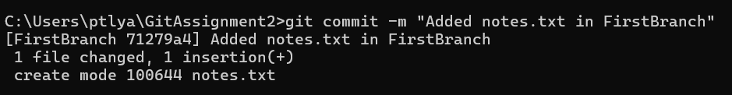

TASK 6: Merge Branch into Main
- Switch back to the main branch. 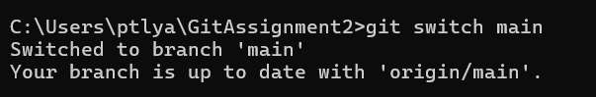
- Merge FirstBranch into main. 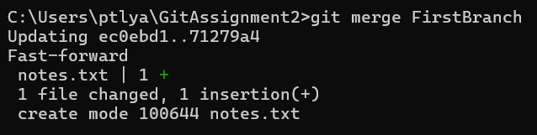

TASK 7 – Final Sync with Remote
- Push the updated main branch to the remote repository. 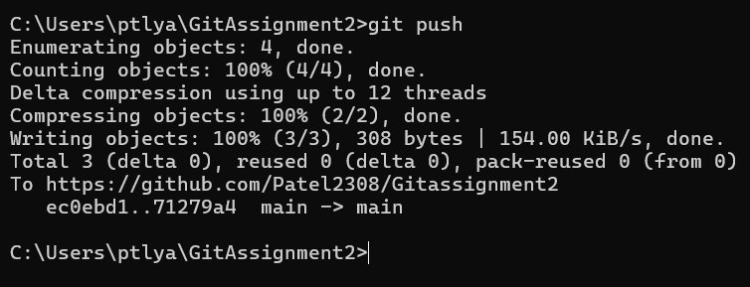

TASK 8 – Simple Pull
- Navigate to the correct local Git repository folder. 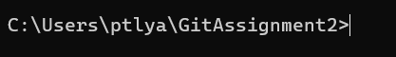
- Verify the current branch is main. 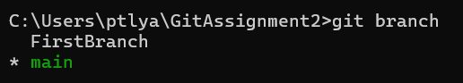
- Check the working tree status. 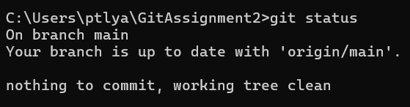
- Pull the latest changes from the remote repository. 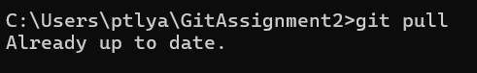
- Verify that the pull is successful. 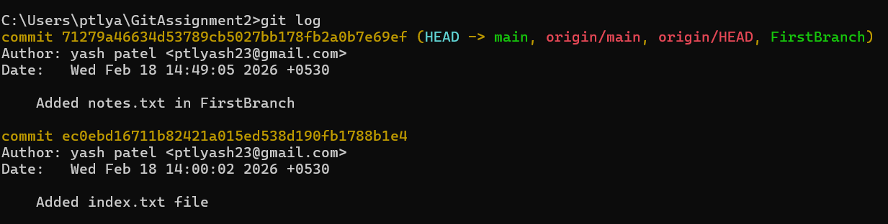

TASK 9 – Push and Pull with Conflict Resolution
- Navigate to the correct local Git repository folder. 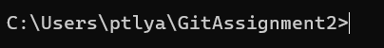
- Ensure you are on the main branch. 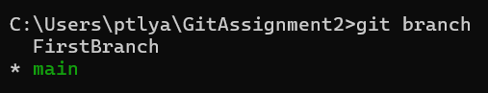
- Change the content of the index.txt file and save the changes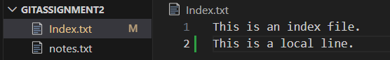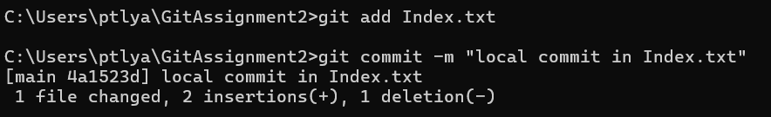
- Navigate to the correct remote Git repository folder.
- Ensure you are on the main branch.
- Change the content of the index.txt file and save the changes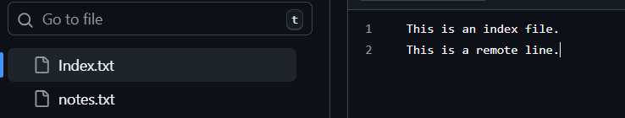
- Attempt to push local changes to the remote repository.
- Observe the push rejection error. 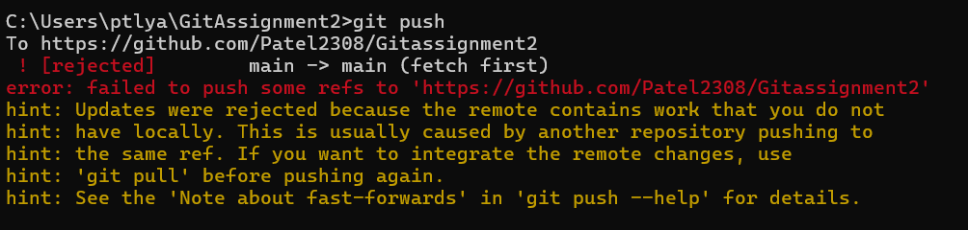
- Pull remote changes into the local branch. 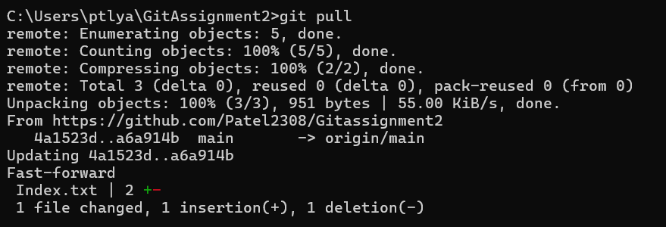
- Resolve merge conflict if it occurs. 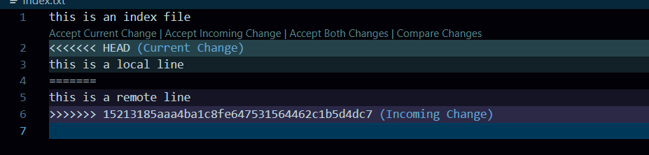
- Commit the merge resolution. 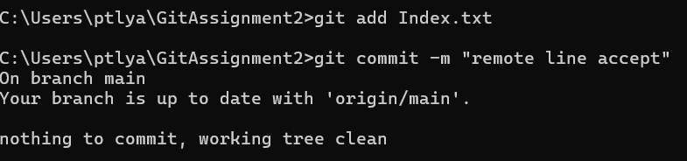
- Push the updated branch to the remote repository. 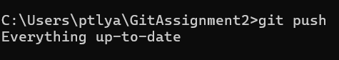

TASK 10 - Clone an Existing Repository
- Copy the GitHub repository URL. 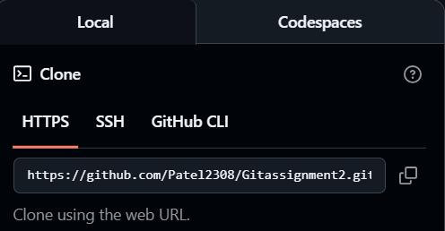
- Navigate to a parent directory (not inside another repo) in local.
- Clone the remote repository.
- Navigate into the cloned folder.
- Verify the current branch.
- Verify the remote connection.

