ASSIGNMENT 3.1

HNO:2303A51159
BATCH:27

Question 1: Zero-Shot Prompting – Palindrome Number
Task
Generate a Python function to check whether a given number is a palindrome using zero-shot prompting.
Prompt (Zero-Shot)
Write a Python function that checks whether a given integer is a palindrome or not.
Code
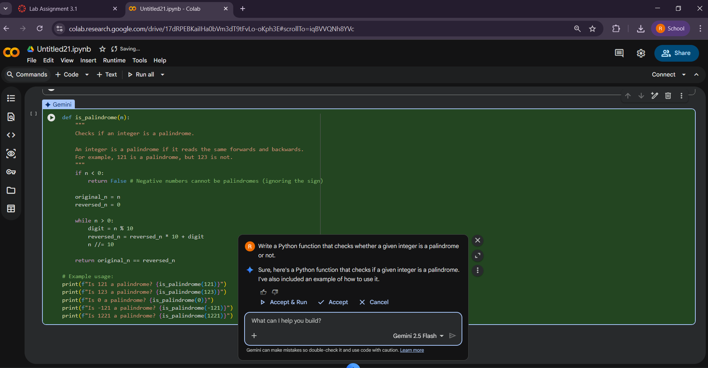
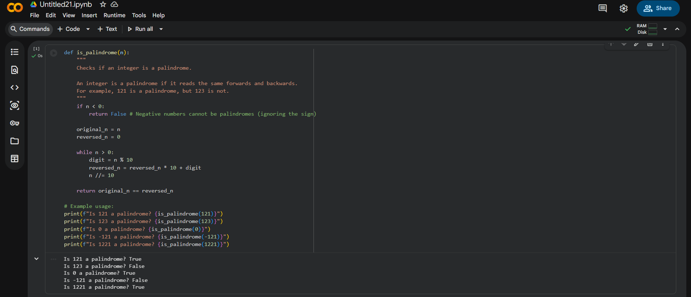
Output:
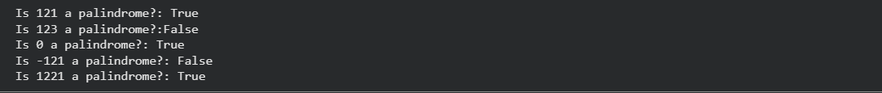
Inputs:
Input | Expected Output | Actual Output
121 | True | True
123 | False | False
0 | True | True
7 | True | True
1221 | True | True
1001 | True | True
-121 | False | Incorrect
10 | False | False

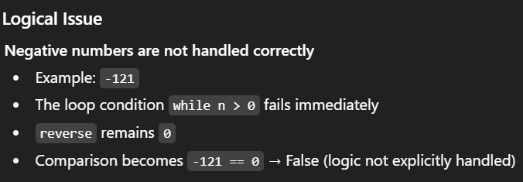
Improved Version (Fixing the Issue)
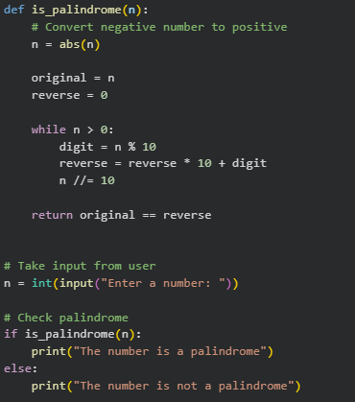

Justification:
This zero-shot prompt produces correct logic without examples. The AI inferred the palindrome logic using reverse calculation. However, it does not handle negative numbers or non-integer inputs, showing limitations of zero-shot prompting.
Output:
Justification:
This program checks whether a given number is a palindrome by first converting any negative input into a positive number using the absolute value. It then reverses the number using arithmetic operations without converting it into a string. The reversed number is compared with the original value to determine whether they are the same. If both values match, the number is identified as a palindrome. This approach allows the program to handle both positive and negative inputs effectively.

Question 2: One-Shot Prompting – Factorial Calculation
Task
Generate a factorial function using one example.
Prompt (One-Shot)
Write a Python function to calculate factorial.
Example: Input: 5 → Output: 120
Code
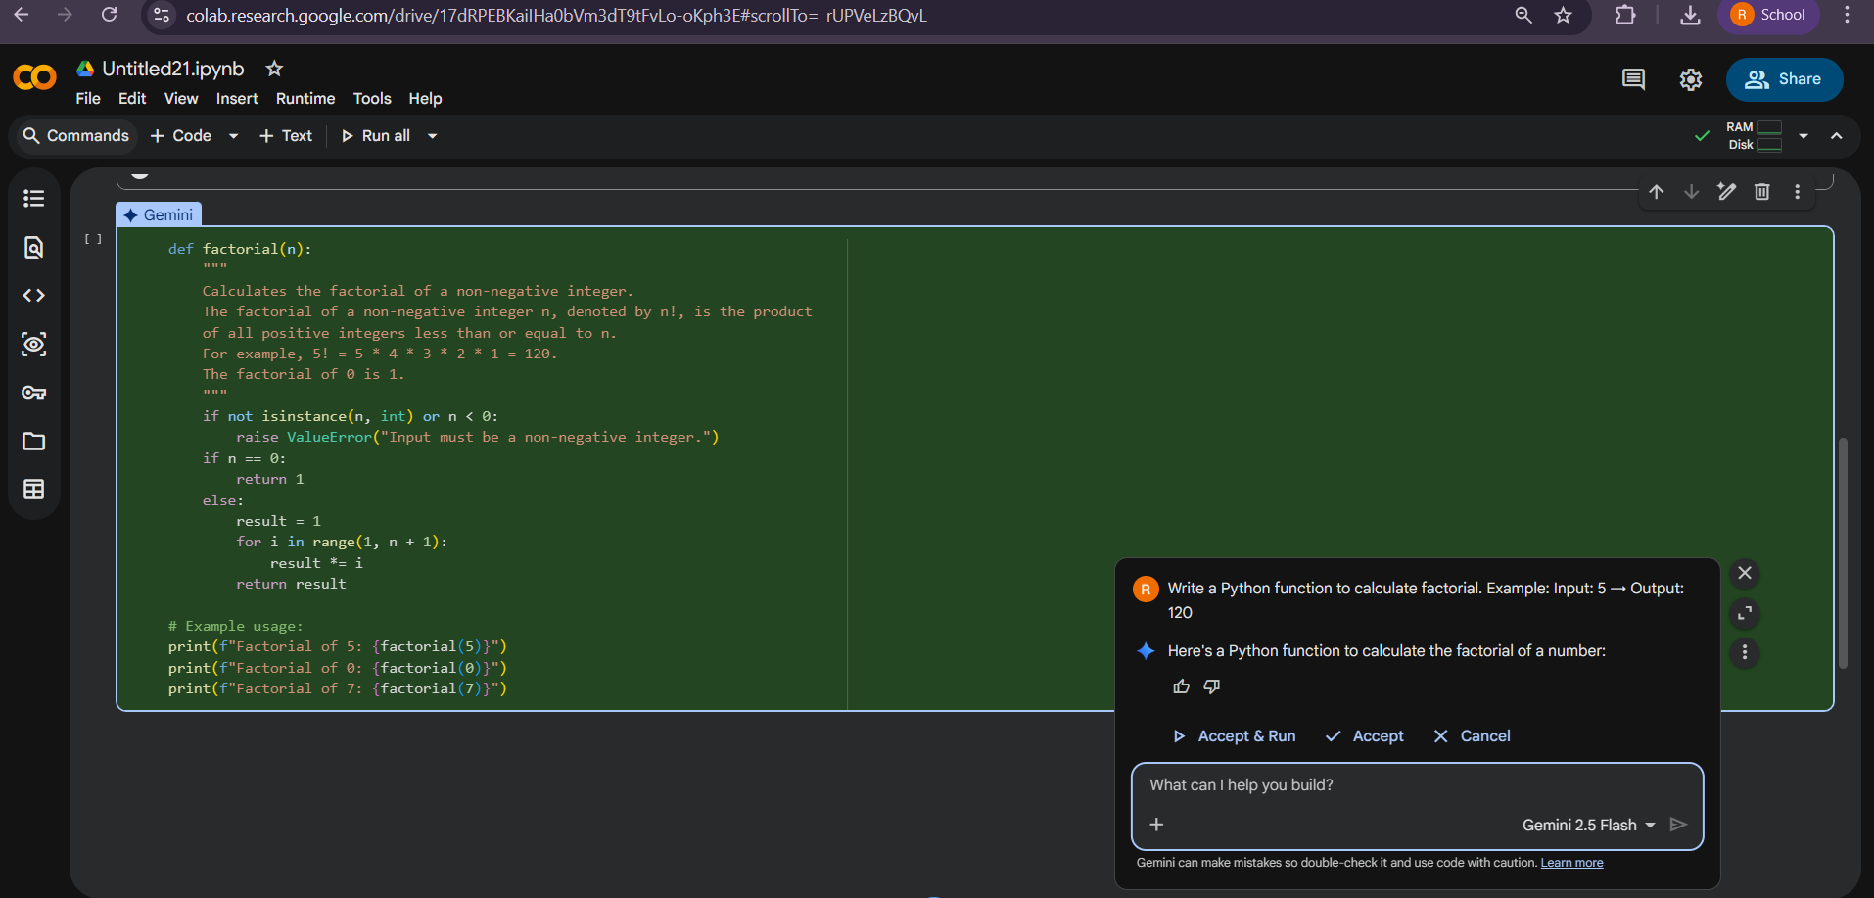
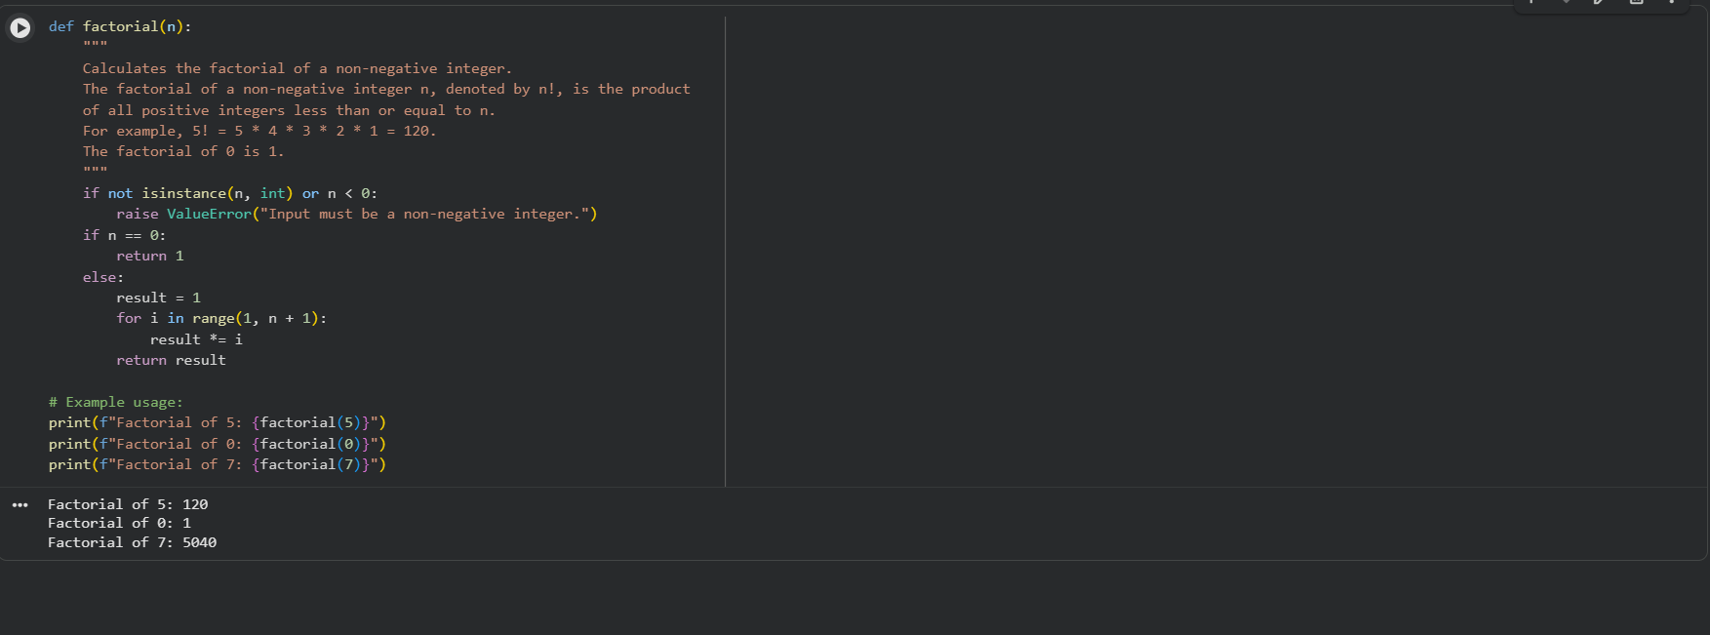

Output:
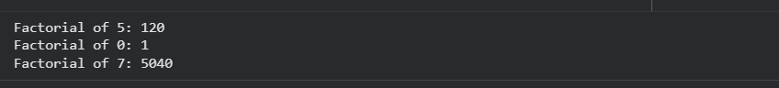
ZERO-SHOT PROMPT:
Write a Python function to compute the factorial of a given number.
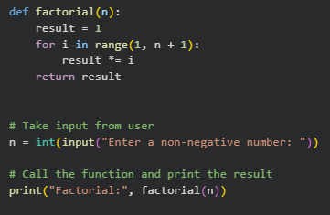

OUTPUT:
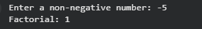
Comparison:
Aspect | Zero-Shot Solution | One-Shot Solution
Example provided | No | Yes (5 → 120)
Handling negative input | Not handled | Handled
Code clarity | Basic | More explicit
Correctness | Partial | More robust
Output reliability | Lower | Higher

Justification:
One-shot prompting helps the AI generate clearer and more complete logic by providing an explicit input–output example. This guidance improves output format, correctness, and inclusion of edge-case handling such as negative inputs. Overall, one-shot prompting results in more structured and reliable code compared to zero-shot prompting.
Question 3: Few-Shot Prompting – Armstrong Number
Task
Generate an Armstrong number checker using multiple examples.
Prompt (Few-Shot)
Write a Python function to check Armstrong numbers.
Input: 153 → Output: Armstrong Number
Input: 370 → Output: Armstrong Number
Input: 123 → Output: Not an Armstrong Number
Code
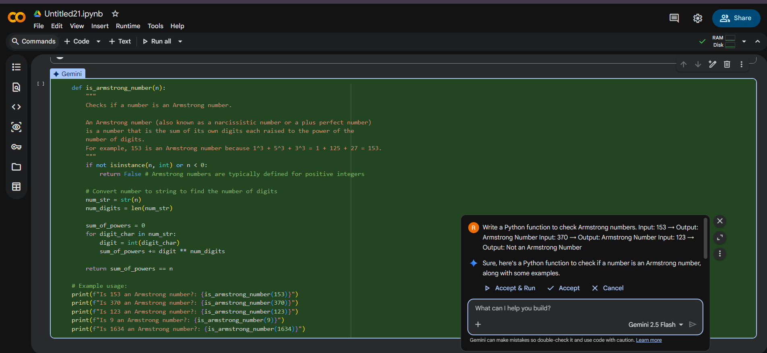
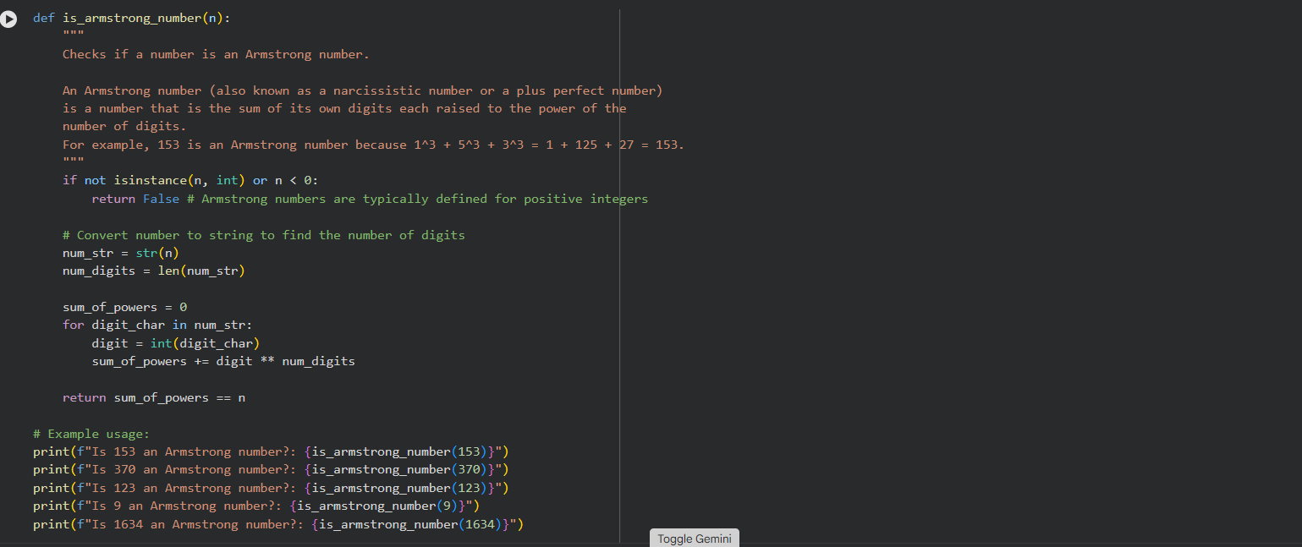
Output:
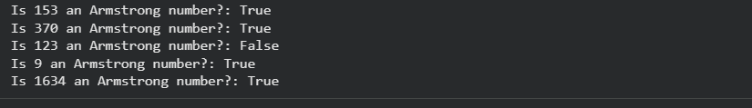

Input | Output
153 | Armstrong Number
370 | Armstrong Number
123 | Not an Armstrong Number
9474 | Armstrong Number
9475 | Not an Armstrong Number
-153 | Not an Armstrong Number
0 | Armstrong Number

Analysis:
examples clarify the output format (“Armstrong Number” vs “Not an Armstrong Number”)
The AI includes edge-case handling (negative numbers, zero)
Code is more structured, readable, and accurate compared to zero-shot or one-shot prompting
Accuracy improves because AI can generalize from several examples rather than just one

Justification:
Few-shot prompting improves clarity, correctness, and robustness of the generated code. By providing multiple examples, the AI better understands the task requirements, handles edge cases, and produces code that matches the expected output format reliably.

Question 4: Context-Managed Prompting – Prime / Composite / Neither
Task
Classify a number as prime, composite, or neither with optimized logic.
Prompt (Context-Managed)
Write an optimized Python program to classify a number as prime, composite, or neither.
Conditions:
– Validate input
– Use efficient logic
– Handle edge cases like 0 and 1
Code
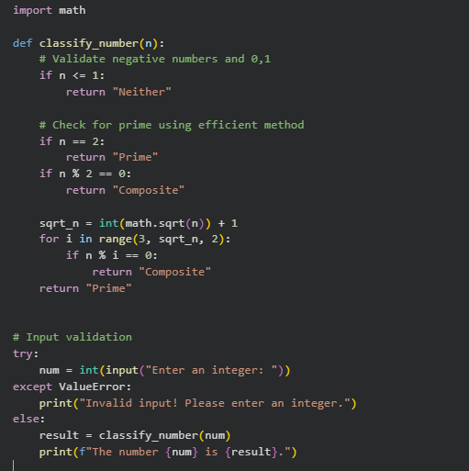
Output:
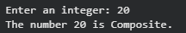
Strategy | Accuracy | Clarity | Optimization | Edge-Case Handling
Zero-Shot | Moderate | Basic | Not optimized | Limited
One-Shot | Better | Clearer | Some optimization | Limited
Few-Shot | High | Structured | Moderate | Handles examples provided
Context-Managed | Highest | Very Clear | Optimized (sqrt(n)) | Handles all edge cases & input validation

Justification:
Context-managed prompting provides precise instructions and constraints, leading to highly optimized, robust, and readable code. It outperforms zero-shot, one-shot, and few-shot strategies by explicitly guiding the AI on efficiency, input validation, and output formatting.

Question 5: Zero-Shot Prompting – Perfect Number
Task
Generate a perfect number checker using zero-shot prompting.
Prompt (Zero-Shot)
Write a Python function to check whether a number is a perfect number.
Code
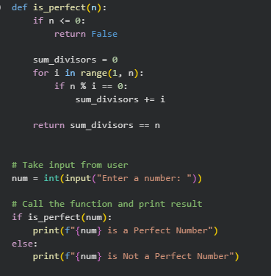
Output:
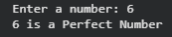
Input | Expected Output | Actual Output
6 | True | True
28 | True | True
12 | False | False
1 | False | False
0 | False | False
-6 | False | False

Missing Conditions / Inefficiencies
Inefficient: Checks all numbers from 1 to n-1 → Can be optimized by checking up to n//2 (since no proper divisor is greater than n/2)
Could include input validation to ensure integer input
Could be optimized further using square root method for large numbers
Question 6: Few-Shot Prompting – Even or Odd with Validation
Task
Generate a program to check even or odd numbers with validation.
Prompt (Few-Shot)
Write a Python program to check even or odd.
Input: 8 → Output: Even
Input: 15 → Output: Odd
Input: 0 → Output: Even
Code
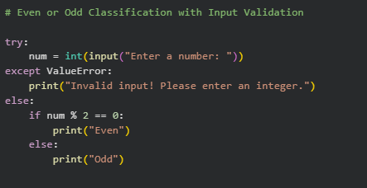
Output:
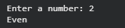
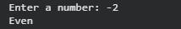

ANALYSIS:
Providing multiple input-output examples helps the AI understand the expected behavior and output format more clearly. For instance, showing examples with positive numbers, zero, and odd numbers guides the model to classify numbers correctly in all these cases. It also signals that the program should handle edge cases, such as negative numbers or zero. Furthermore, including examples implicitly emphasizes the importance of consistent output formatting (“Even” vs “Odd”) and encourages input validation to manage non-integer inputs. Overall, examples make the generated code more robust, user-friendly, and aligned with expected results compared to zero-shot prompting.
Justification:
Few-shot prompting provides multiple input-output examples, which helps the AI understand the task requirements clearly. It guides the program to handle edge cases like zero and negative numbers correctly. Examples also ensure consistent output formatting, such as printing “Even” or “Odd” as expected. Including these examples encourages input validation, so non-integer inputs are handled gracefully. Overall, few-shot prompting produces code that is robust, accurate, and user-friendly compared to zero-shot prompting.

