AI & AC
Lab 5.1
Name:P.Harshit
Batch:27
Hall-ticket:2303A51159
Task 1:
Use an AI tool to generate a Python program that connects to a
weather API.
Prompt:
Generate code to fetch weather data securely without exposing API keys
in the code
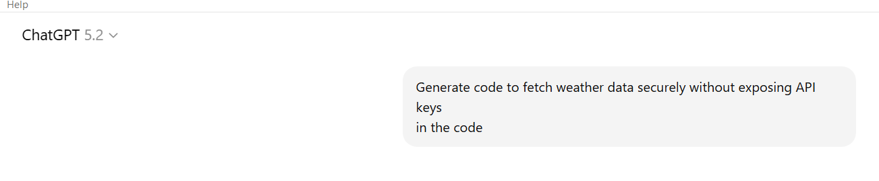
Output:
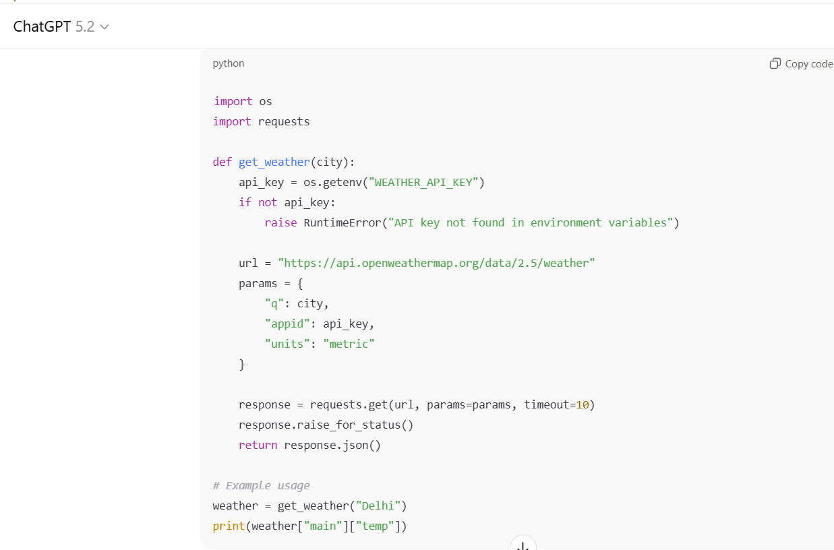

Secure code:
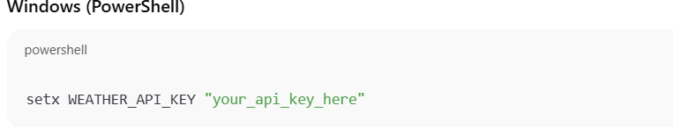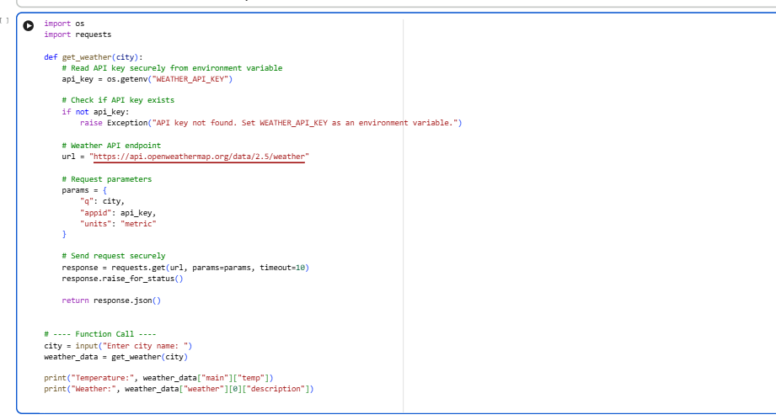
- Explanation:
Original AI code is insecure because the API key is hardcoded directly in the source code.
- Hardcoded keys can be easily exposed if the code is shared, pushed to GitHub, or leaked.
- Secure version removes the API key from code and stores it in environment variables instead.
- Environment variables protect sensitive data by loading the API key only at runtime.
- This approach follows secure coding best practices, allowing easy key rotation without code changes
Task 2:
Use an AI tool to generate a Python script that stores user data
(name, email, password) in a file.
Analyze: Check if the AI stores sensitive data in plain text or without
Encryption
Prompt:
Generate a Python script that stores user data (name, email, and password) in a file.

Output:

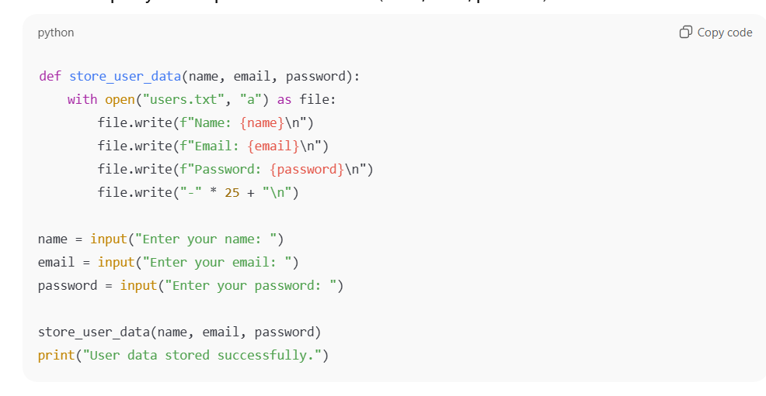
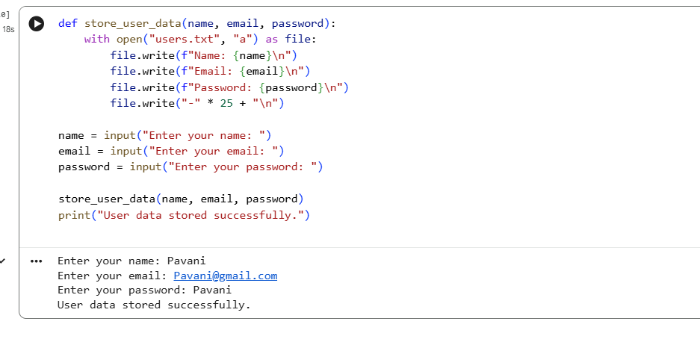
Explanation:
- Passwords are stored in plain text, so anyone can read them directly.
- No encryption or hashing is used to protect sensitive data.
- If the file is leaked or stolen, all user accounts are compromised.
- Even authorized users can see passwords, enabling insider misuse.
- This approach violates basic security and privacy standards
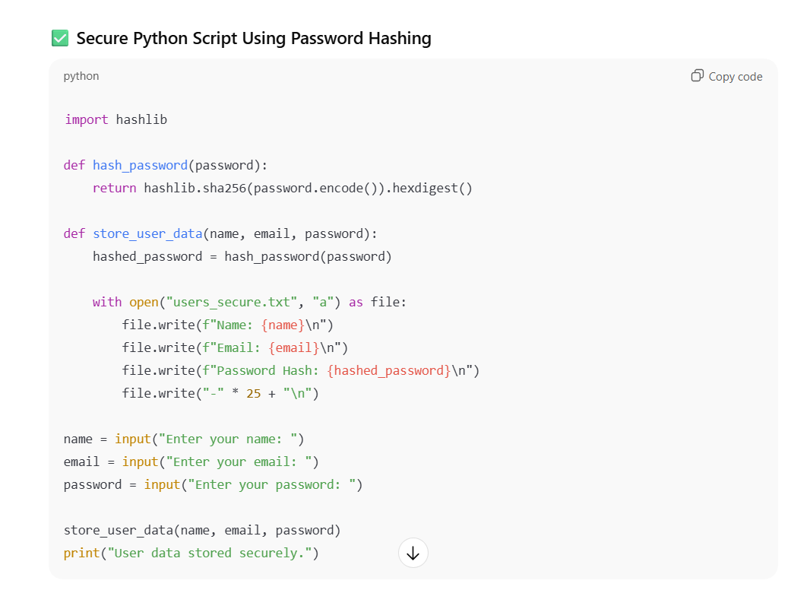
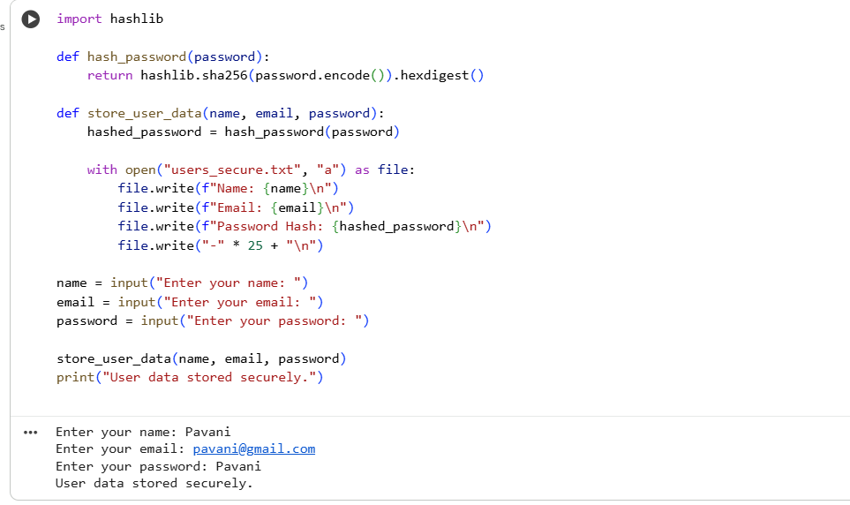
Why This Version Is Secure
- Passwords are never stored in plain text.
- Hashing is one-way, so the original password cannot be retrieved.
- Even if the file is exposed, real passwords are not revealed.
- The approach follows secure coding best practices.
Task 3:
Objective: Use AI to generate an Armstrong number checking function
with comments and explanations.
Prompt:
Generate a Python function to check whether a given number is an Armstrong number.
Include clear comments in the code.
After the code, explain the program line by line in simple and easy-to-understand language.
Ensure the explanation accurately matches what each line of the code does.

Output:
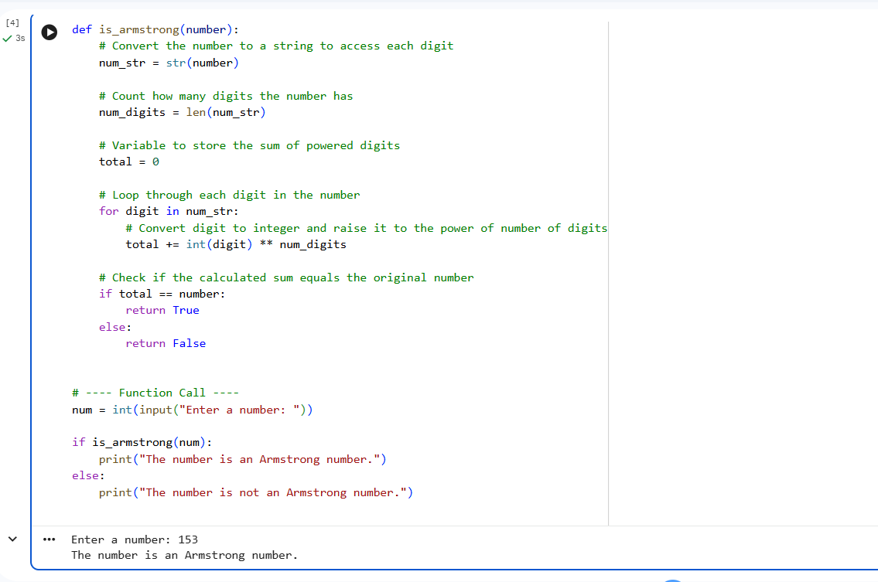

- Explanation:
The code is transparent and easy to read because each step is clearly written and logically structured.
- Meaningful comments explain what every important line does, making the code beginner-friendly.
- The logic is simple and explicit, so there is no hidden or confusing behavior in the program.
- The function works only on user input and does not store or expose any sensitive data, ensuring safety.
- Clear structure and comments help in easy debugging, maintenance, and secure understanding of the program.
Task 4:
Use AI to implement two sorting algorithms (e.g., QuickSort and
BubbleSort)
Prompt:
Generate Python code for QuickSort and BubbleSort, and include
comments explaining step-by-step how each works and where they differ
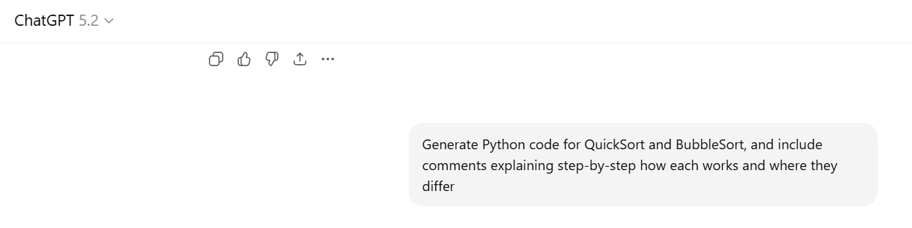

Output:
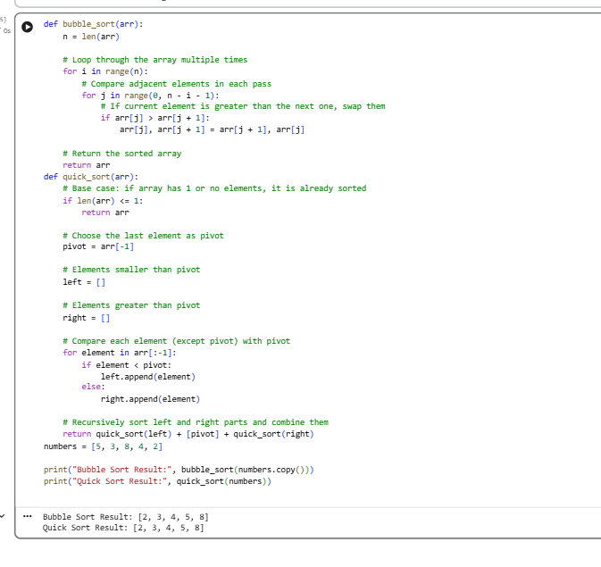
- Explanation:
Bubble Sort is easy to understand but inefficient for large inputs.
- Quick Sort is faster and more efficient using recursion and partitioning.
- Comments make both codes transparent and easy to follow.
- The difference lies in comparison method and performance.
Task 5:
Use AI to create a product recommendation system.
Prompt:
Generate a recommendation system that also provides reasons for each
suggestion.

Output:
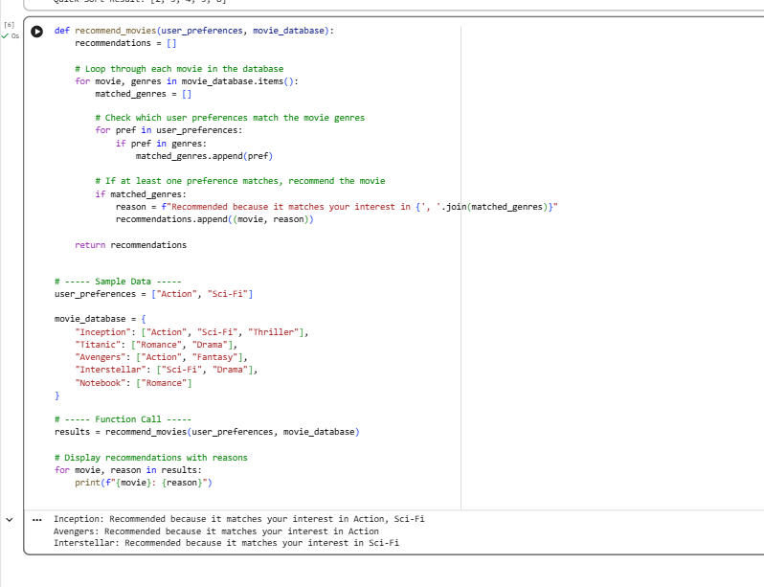
Explanation:
- The code generates recommendations along with clear reasons for each suggestion.
- Each explanation directly states which user preferences matched the item.
- The recommendation logic is transparent and easy to follow.
- Explanations are written in simple, human-readable language.
- Users can easily understand and trust why each recommendation is made.

