AI & ASSISTED CODING LAB-5.3
NAME:P.harshit
BATCH:27
HT NO.:2303A51159
Task 1: Privacy and Data Security in AI-Generated Code Scenario
AI tools can sometimes generate insecure authentication logic. Task Description
Use an AI tool to generate a simple login system in Python. Analyze the generated code to check:
- Whether credentials are hardcoded
- Whether passwords are stored or compared in plain text
- Whether insecure logic is used
Then, revise the code to improve security (e.g., avoid hardcoding, use input validation).
Expected Output
- AI-generated login code
- Identification of security risks
- Revised secure version of the code
- Brief explanation of improvements
Prompt: Generate a simple login system in Python.
Code & Output:

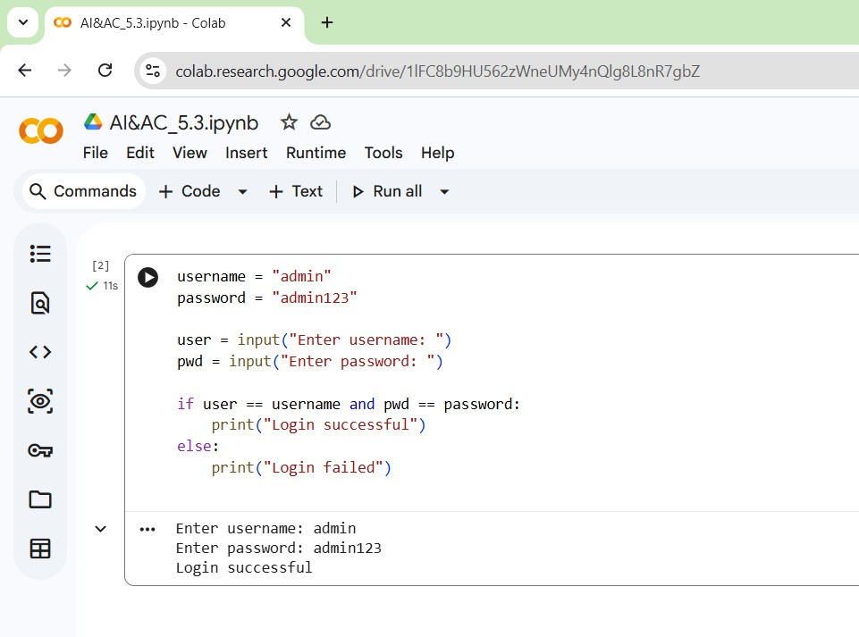
Explanation:
→The program stores username and password directly in the code.
→It takes user input and compares it with stored credentials.
→If both match, login is successful.
➔Security Issues Identified
→Credentials are hardcoded
→ Password stored and compared in plain text
→No input validation
→Vulnerable to data leakage and brute-force attacks

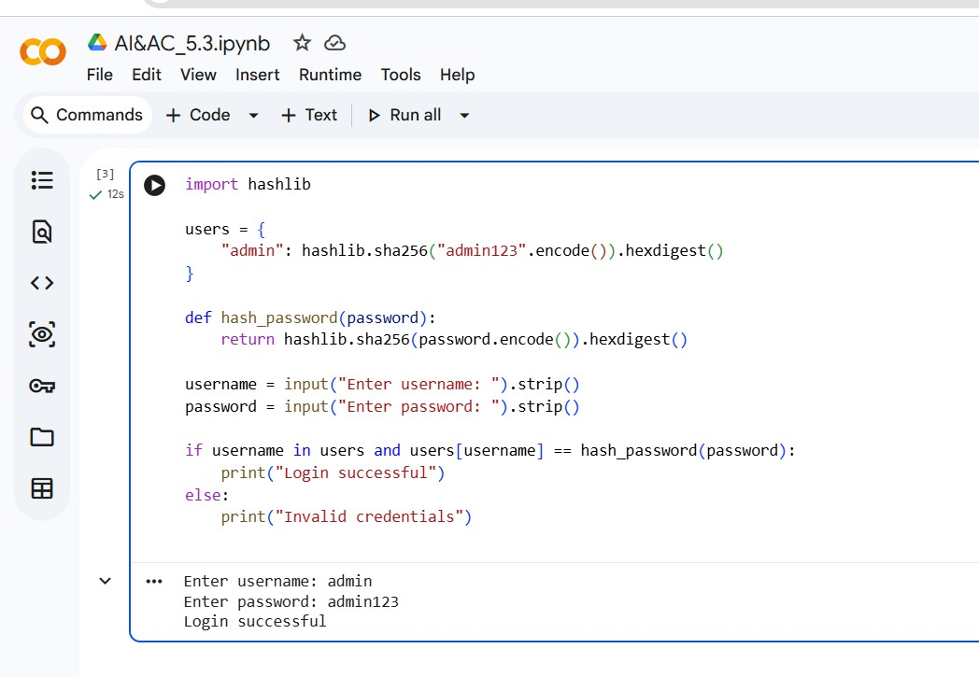
➔Revised secure version of the code
Explanation of Improvements:
→Passwords are hashed using SHA-256.
→No plain-text password storage.
→Improved security and privacy protection.
Task 2: Bias Detection in AI-Generated Decision Systems Scenario
AI systems may unintentionally introduce bias. Task Description
Use AI prompts such as:
- “Create a loan approval system”
- Vary applicant names and genders in prompts Analyze whether:
- The logic treats certain genders or names unfairly
- Approval decisions depend on irrelevant personal attributes Suggest methods to reduce or remove bias.
Expected Output

- Python code generated by AI
- Identification of biased logic (if any)
- Discussion on fairness issues
- Mitigation strategies
Prompt: Create a loan approval system in Python. Code & Output:
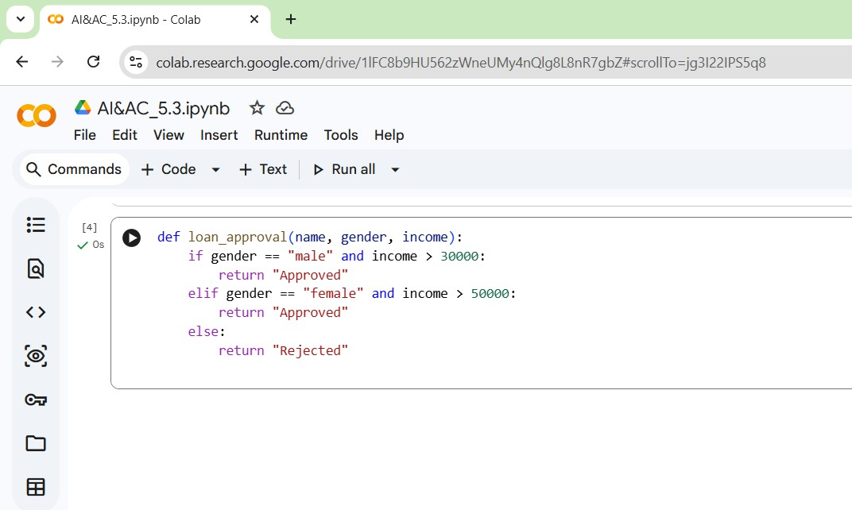
Explanation:
  - Loan approval is based on income and gender.
  - Different income thresholds are used for males and females.

Bias Analysis:
→ Gender-based discrimination
→ Female applicants require higher income
→ Gender is an irrelevant factor for loan approval.

Bias-Free Revised Code:-

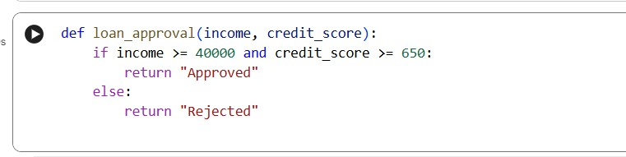

Bias Mitigation Explanation
  - Removed gender and name.
  - Approval depends only on financial criteria.
  - Ensures fairness and equality.
Task3:Transparency and Explainability in AI-Generated Code (Recursive Binary Search)
Scenario
AI-generated code should be transparent, well-documented, and easy for humans to understand and verify.
Task Description
Use an AI tool to generate a Python program that:
- Implements Binary Search using recursion
- Searches for a given element in a sorted list
- Includes:
- Clear inline comments
- A step-by-step explanation of the recursive logic After generating the code, analyze:
- Whether the explanation clearly describes the base case and recursive case
- Whether the comments correctly match the code logic
- Whether the code is understandable for beginner-level students Expected Output
- Python program for recursive binary search
- AI-generated comments and explanation
- Student’s assessment on clarity, correctness, and transparency

Prompt: Write a Python program for recursive binary search with explanation. Code & Output:
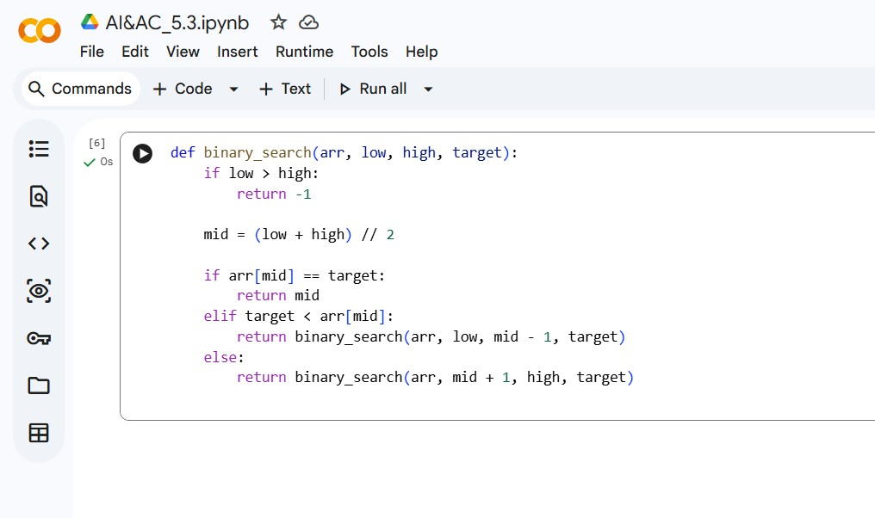
Explanation:
→Base case: when low > high, element not found.
→ case: search left or right half based on comparison.
→Efficient search with time complexity O(log n).

Transparency Analysis:
→ Base case clearly defined
→ Recursive calls are understandable
→Beginner-friendly logic and comments
Task 4:Ethical Evaluation of AI-Based Scoring Systems Scenario
AI-generated scoring systems can influence hiring decisions. Task Description
Ask an AI tool to generate a job applicant scoring system based on features such as:

- Skills
- Experience
- Education
Analyze the generated code to check:
- Whether gender, name, or unrelated features influence scoring
- Whether the logic is fair and objective Expected Output
- Python scoring system code
- Identification of potential bias (if any)
- Ethical analysis of the scoring logic
Prompt:Create a job applicant scoring system in Python. Code and Output:
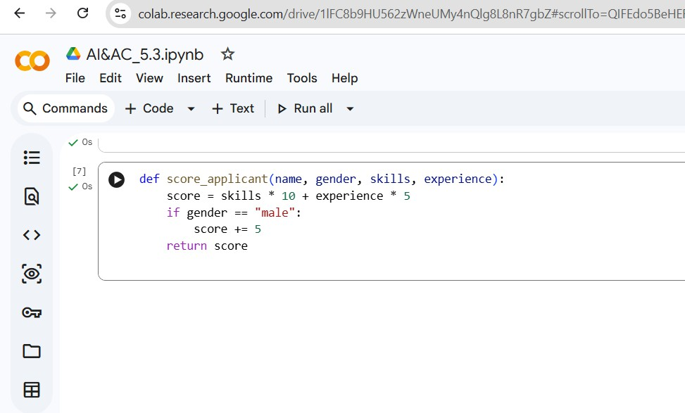
Explanation:
→Applicant score depends on skills, experience, and gender.

→Ethical Revised Code

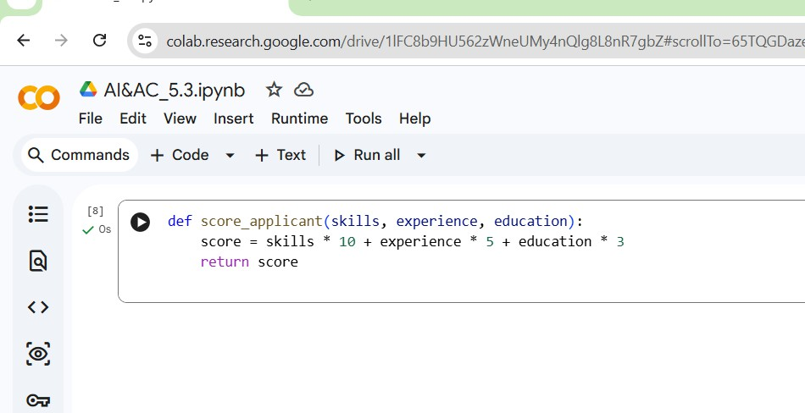
Ethical Improvement Explanation:
→Removed gender and name.
→Used job-related features only.
→Promotes objective and fair hiring.
→Male applicants receive extra points.

Ethical Issues Identified:
→ Gender bias
→Unfair hiring advantage
→ Violates ethical hiring standards
Task 5: Inclusiveness and Ethical Variable Design Scenario
Inclusive coding practices avoid assumptions related to gender, identity, or roles and promote fairness in software design.
Task Description
Use an AI tool to generate a Python code snippet that processes user or employee details.
Analyze the code to identify:
- Gender-specific variables (e.g., male, female)
- Assumptions based on gender or identity

- Non-inclusive naming or logic
Modify or regenerate the code to:
- Use gender-neutral variable names
- Avoid gender-based conditions unless strictly required
- Ensure inclusive and respectful coding practices Expected Output
- Original AI-generated code snippet
- Revised inclusive and gender-neutral code
- Brief explanation of:
- What was non-inclusive
- How inclusiveness was improved
Prompt: Write a Python program to process employee details. Code & Output:
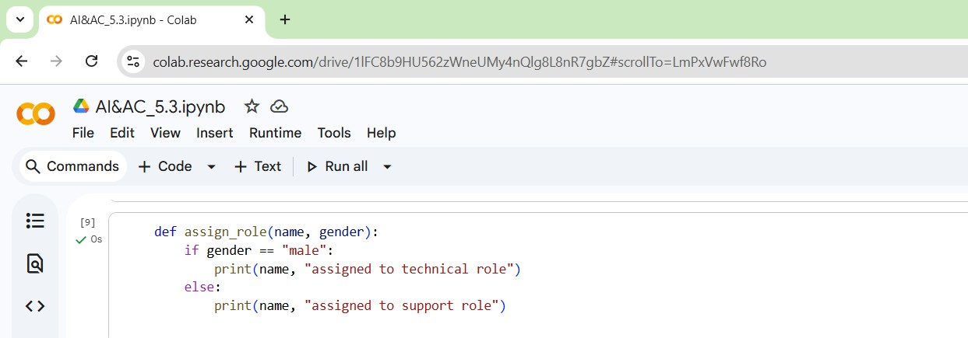
Explanation:
→Role assignment is based on gender.
→Assumes technical roles are for males.

Inclusiveness Issues:
→ Gender stereotypes
→ Non-inclusive logic
→ Unethical role assignment

Inclusive Revised Code:

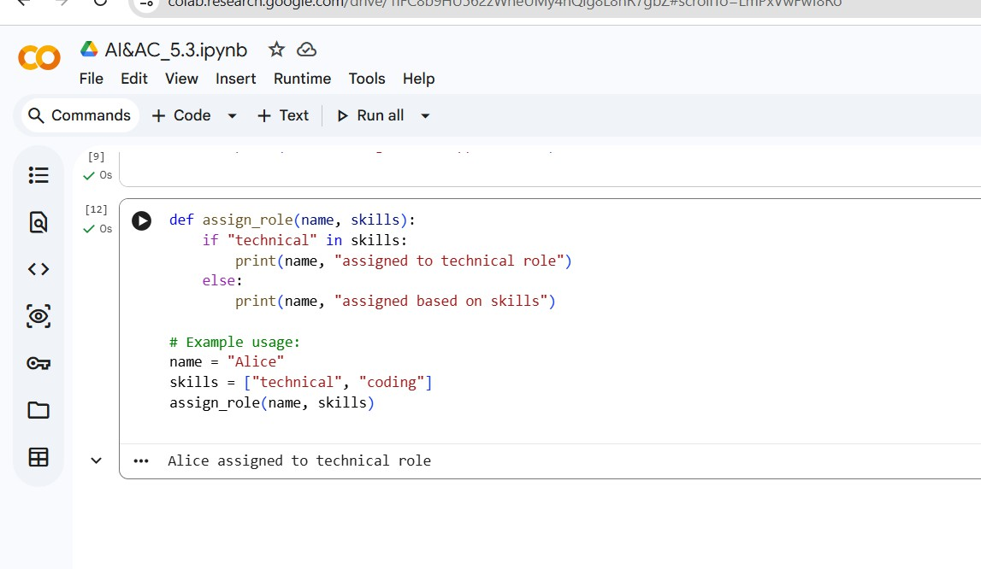
Inclusiveness Improvement Explanation:
→Removed gender-based assumptions.
→Role assignment depends on skills.
→Encourages inclusive and ethical coding.

