A
Project Report
On
Chat App
Project report submitted to Ganpat University in the partial fulfillment of the requirement for the award of the Degree of Master of Computer Applications.

MCA Sem-4 [2024-2026]
24034211051
PATEL HEMIT DILIPBHAI

Under the Guidance of
Ms. Priyansi Patel
Assistant Professor


Acharya Motibhai Patel Institute of Computer Studies,
Ganpat University, Ganpat Vidyanagar – 384012.
MAY-2026
PLAGIARISM DECLARATION FORM
This form must be completed, signed and attached to all assignments/ projects / dissertations.
Please complete the information below (using BLOCK LETTERS):
Student’s Name: PATEL HEMIT DILIPBHAI Enrollment No: 24034211051
Batch Code: MCA 2024-2026
Subject Name: M.C.A. SEM – IV P14A1SDP2 System Development Project - II
The following definition of plagiarism is taken from the MLA Handbook for Writers of Research Papers, Theses and Dissertations (MLA: New York, 1977, 99 4-5) “Plagiarism may take the form of repeating another’s sentences as your own, adopting a particularly apt phrase as your own, paraphrasing someone else’s argument as your own, or even presenting someone else’s line of thinking in the development of a thesis as though it were your own. In short, to plagiarize is to give the impression that you have written or thought something that you have in fact borrowed from another. Although a writer may use other person’s words and thoughts they must be acknowledged as such (by the use of the appropriate reference, and by the insertion of quotation marks around any words directly quoted.”

PLAGIARISM DECLARATION
- I acknowledge and understand that plagiarism is wrong and that it constitutes academic theft.
- I understand that my written work must be accurately referenced. I have followed the rules and conventions concerning referencing laid out in the course outline for this course.
- I have not allowed, nor will I in the future allow, anyone to copy my work with the intentions of passing it off as his or her work. I also accept that submitting identical work to someone else (a syndicate assignment) constitutes a form of plagiarism. I accept that the same principle applies to authorized group work.
PLAGIARISM WARNING
- Any student found to have committed or aided and abetted the offence of plagiarism may be subjected to the following penalties depending on the severity of his involvement in the offence.
i. The student shall receive no marks or a reduction of marks for the relevant academic assignment, project or dissertation;
ii. Subsequent offences will attract more severe penalties, including possible termination of studies.
- Students should seek clarification from their respective lecturers, tutors or supervisors if they are unsure whether they are plagiarizing the work of another person.

DECLARATION BY STUDENT
I have read and understood the above definition of plagiarism. I am aware of and understand the Institute’s policy on plagiarism. I declare that all material in this assignment/project/dissertation is my own work and does not involve plagiarism.

Student’s Signature
……………………………………………
Date
……………………

COMPANY CERTIFICATE


20 April 2026

CERTIFICATE

TO WHOM SO EVER IT MAY CONCERN

This is to certify that the following students of M.C.A. Semester-IV (P14A1SDP2 - System Development Project – II) have completed their project work titled A Customer-Centric WhatsApp Business Communication Platform satisfactorily fulfill the requirement of M.C.A Semester-IV, Ganpat University, Ganpat Vidyanagar, in the Year 2025-26.

Enrollment No | Name | Exam No
24034211051 | PATEL HEMIT DILIPBHAI | 24034211051

External/Internal Guide | Project Co-ordinator | Principal
(Ms. Priyansi Patel) | (Dr. C. D. Patel) | (Dr. Nirbhay Chaubey)

PREFACE

This project report entitled “Chat App” has been prepared as a part of the System Development Project – II course in the Master of Computer Applications (MCA) program at Ganpat University.
The primary objective of this project is to design and develop a mobile-based Chat Application that enables users to communicate instantly and securely through real-time messaging. The application provides features such as one-to-one and group chats, multimedia sharing, and voice/video calling, all within a single platform. The system aims to replace traditional communication methods like SMS and email with a fast, secure, and user-friendly digital communication solution, ensuring reliable message delivery, data privacy, and easy accessibility across devices.
During the development of this project, we gained practical exposure to mobile application development, modern UI/UX design, and full-stack application architecture. The project enhanced our understanding of React Native with Expo for frontend development, Node.js and Express.js for backend services, and MongoDB for database management. Additionally, we learned about OTP-based authentication, file handling,which are widely used in real-world applications.During the development of this project, we gained practical exposure to mobile application development, modern UI/UX design, and full-stack application architecture. The project enhanced our understanding of React Native with Expo for frontend development, Node.js and Express.js for backend services, and MongoDB for database management. Additionally, we learned about OTP-based authentication, file handling, and PDF report generation, which are widely used in real-world applications.
ACKNOWLEDGEMENT

CONTENTS
No. |  | Name of Content | Page No.
1 |  | INTRODUCTION | 8
 | 1.1 | Project Profile | 8
 | 1.2 | About the Organization | 8
2 |  | SYSTEM STUDY AND ANALYSIS | 9
 | 2.1 | Problem Statement | 9
 | 2.2 | Existing System Drawbacks | 9
 | 2.3 | Proposed System  - Advantages / Comparison Study  - Modules (with short description) | 9
3 |  | DEVELOPMENT ENVIRONMENT | 10
 | 3.1 | Hardware Requirement | 10
 | 3.2 | Software Requirement | 10
 | 3.3 | Programming Environment  - About Front-End  - About Back-End | 10
 |  |  | 10
 |  |  | 10
4 |  | SYSTEM DESIGN AND DEVELOPMENT | 11
 | 4.1 | Time line chart (Gantt chart) | 11
 | 4.2 | Data Dictionary | 11
 | 4.3 | E-R Diagram | 11
 | 4.4 | User Modeling Language Diagrams  - Use Case Diagrams  - Activity Diagrams  - Sequence Diagrams  - Collaboration Diagrams  - Class Diagrams | 11
 |  |  | 11
 |  |  | 11
 |  |  | 11
 |  |  | 11
 |  |  | 11
 | 4.5 | Input Design | 11
 | 4.6 | Output Design | 11
5 |  | SYSTEM TESTING | 12
 | 5.1 | System Testing | 12
 |  | - Output Testing | 12
 |  | 5.1.2 Validation and Verification Testing | 12
6 |  | CONCLUSION AND FUTURE ENHANCEMENT | 13
 | 6.1 | Conclusion | 13
 | 6.2 | Future Enhancements | 13
7 |  | BIBLIOGRAPHY & REFERENCES | 14
 | 7.1 | Books References | 14
 | 7.2 | Web References | 14
Chapter – 1 INTRODUCTION
1.1 Project Profile
Project Title | Chat App
Objectives | To provide a digital platform for instant and real-time communication between users. To enable secure text messaging, voice notes, image, video, and document sharing.  To provide secure login using mobile number and OTP verification
Frontend | Technology : React Native with Expo  Styling: Stylesheet (React Native)  Navigation: Expo Router
Backend | Technology: Node.js, Express.js  Database : MongoDB  Authentication & Security : JWT, bcryptjs  Data Handling: Rasteful APIS  File Generation: PDF Generation for Reports
Others | Version Control: Git, Github  API Testing: Postman  Deployment & Build: Expo (APK Build)  Security: Environment variables using .env file
Group No | 11
Enrollment No. | 24034211051
Name of Partners | Patel Hemit DilipBhai
Company Name | Bytesved Technologies
Company Address | A-507, The Landmark, Kudasan, Gandhinagar, Gujarat, 382421
External Guide | Joshi Smit
Internal Guide | Ms. Priyansi Patel

1.2 About the Organization
- Bytesved Technologies is a professional software development and IT solutions company specializing in web and mobile application development
- The organization focus on delivering real-world business applications with modern design, scalability, and performance
- Core Methodology: They focus on building real-world business applications, providing exposure to practical workflows, clean coding standards, and real deployment strategies
- Technological Focus: The company emphasizes using modern web technologies (like React Native, Node.js, MongoDB, and cloud based tools to build efficient and scalable systems.
- The organization’s goal is to digitally transform traditional processes by developing user-friendly and secure applications tailored to business and consumer needs.

Chapter – 2 SYSTEM STUDY AND ANALYSIS
2.1 Problem Statement
- Traditional communication methods like SMS and email are slow and limited.
- SMS has no multimedia support and high costs.
- Lack of real-time interaction in emails.
- No centralized chat history across devices.
- Security and privacy issues in basic communication systems.
2.2 Existing System Drawbacks
- SMS, calls, or emails.
- No centralized chat history.
- Limited multimedia support.
- Time-consuming communication.
- Difficult group communication
2.3 Proposed System
- Real-time chat application.
- Centralized chat storage.
- Supports images, videos, audio & documents.
- Instant messaging.
- Easy group chats

2.3.1 Advantages / Comparison Study
- Efficiency:
The Chat Application enables instant real-time communication, significantly reducing the time required compared to traditional methods such as SMS, emails, or phone calls.
- Accuracy:
Real-time message delivery, read receipts, and message synchronization ensure accurate and reliable communication without loss of information.
- Data Security:
Secure user authentication using mobile number and OTP, along with encrypted message storage, ensures that user conversations remain private and accessible only to authorized users.
- Accessibility:
Users can access their chats anytime and anywhere through their mobile devices, with cloud-based synchronization across multiple devices.
- Advanced Features:
The application supports multimedia sharing, group chats, voice and video calling, chat backups, and notifications, providing a complete and modern communication experience compared to traditional systems.

2.3.2 Modules (with short description)
- User Module – Manages user registration, login, and profile details.
- Contact Management Module – Handles adding and managing contacts for chatting.
- One-to-One Chat Module – Enables private real-time messaging between two users.
- Group Chat Module– Allows multiple users to communicate in a group.
- Media Sharing Module – Supports sharing images, videos, audio, and documents.
- Voice & Video Call Module – Enables real-time audio and video calls.
- Authentication Module – Provides secure login using mobile number and OTP verification.
- Security Module – Ensures encrypted and safe communication.

Chapter – 3 DEVELOPMENT ENVIRONMENTS
3.1 Hardware Requirement

Component | Minimum Requirement | Recommended Requirement
Processor(CPU) | Intel Core i3 / AMD Ryzen 3 (2.0 GHz+) | Intel Core i5 / AMD Ryzen 5 or Apple M1/M2
RAM | 8 GB (Required for Docker containers) | 16 GB or more
Storage | 256 GB SSD (with ~20GB free space) | 512 GB SSD or higher (NVMe preferred)
Display | 1366 × 768 resolution monitor | Full HD (1920 × 1080) resolution monitor
Network | 5 Mbps stable Internet connection | 50 Mbps+ High-speed Broadband

3.2 Software Requirement
Component | Minimum Requirement | Recommended Requirement
Processor(CPU) | Intel Core i3 / AMD Ryzen 3 (2.0 GHz+) | Intel Core i5 / AMD Ryzen 5 or Apple M1/M2
RAM | 8 GB (Required for Docker containers) | 16 GB or more
React Native(Expo) | 0.81 | Mobile Application Development
Android Studio | Latest | Android Emulator
Express.js | v4.x or above | Backend web framework for building RESTful APIs
React.js | v19.x or above | Frontend library for building the user interface
Vite | v7.x or above | Frontend build tool and development server
JWT (jsonwebtoken) | Latest | Authentication mechanism for secure login and session management
VS Code / IDE | Latest | Code editor/IDE used for development
Postman / Browser | Latest | API testing tool for verifying backend endpoints
Browser (Chrome/Firefox/Edge) | Latest | Tools for testing APIs and verifying frontend functionality
3.3 Programming Environment
3.3.1 About Front-End
The front-end of the Chat application is developed using React Native with Expo, enabling a smooth and responsive mobile user interface.
Front-End Technologies Used:
- React Native
  - Builds reusable and scalable UI components.
- Expo Router
  - Manages screen navigation efficiently.
- Context API
  - Handles global state such as authentication and wedding data.
- JavaScript (ES6+)
  - Implements application logic and user interactions.
- Responsive Design
  - Ensures compatibility across different screen sizes.

3.3.2 About Back-End
The back-end of the Chat application is developed using Node.js and Express.js, providing secure and scalable server-side functionality.
Back-End Technologies Used:
- Node.js
  - Handles asynchronous operations efficiently.
- Express.js
  - Builds RESTful APIs for frontend communication.
- MongoDB
  - Stores wedding data, guest details, Chat App records, and expenses.
- JWT Authentication
  - Secures user sessions and API endpoints.
- OTP Service
  - Enables secure mobile number verification.
This architecture ensures that the Chat application is secure, scalable, and suitable for real-world use.

Chapter – 4 SYSTEM DESIGN AND DEVELOPMENT
4.1 Time line chart (Gantt chart)
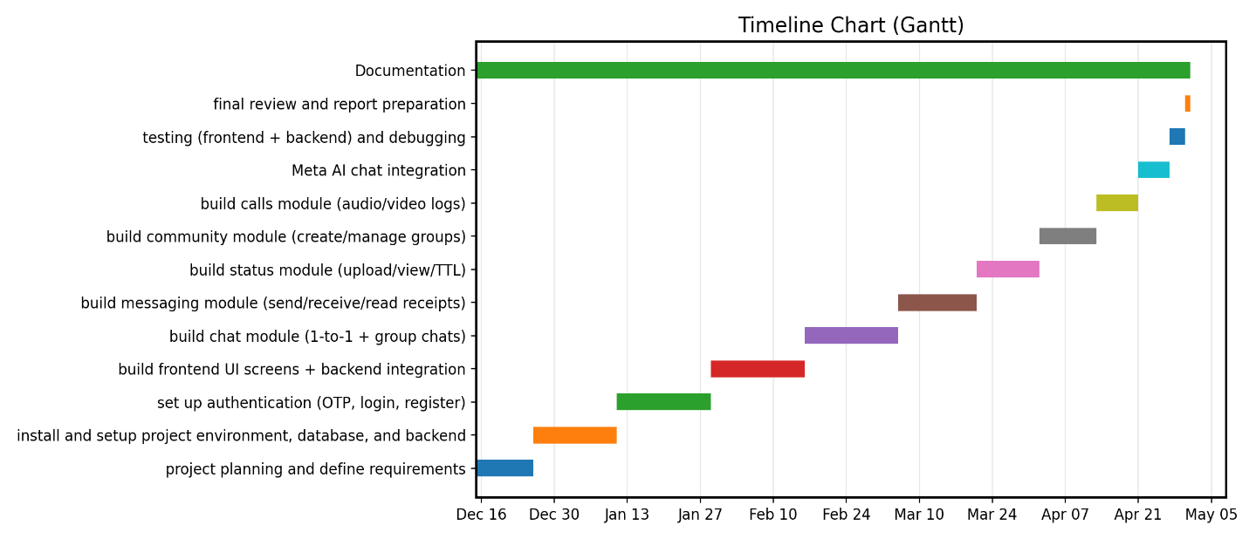

4.2 Data Dictionary
Table Name: User
No | Field Name | Constraints | File Type | Field Size | Description
1 | _id | Primary Key | ObjectId | 24 | Unique identifier
2 | phone | Required, Unique | String | 15 | User phone number
3 | name | Optional | String | 50 | User full name
4 | about | Optional | String | 150 | User about/status text
5 | profilePic | Optional | String | 255 | Profile image URL
6 | createdAt | Auto | Date | 8 | Created timestamp
7 | updatedAt | Auto | Date | 8 | Updated timestamp

Table Name: Chat
No | Field Name | Constraints | File Type | Field Size | Description
1 | _id | Primary Key | ObjectId | 24 | Unique chat identifier
2 | chatName | Optional | String | 60 | Chat display name
3 | isGroupChat | Default false | Boolean | 1 | 1-to-1 or group chat flag
4 | users | Required | Array<ObjectId> | - | Participants (User references)
5 | latestMessage | Optional | ObjectId | 24 | Latest message reference
6 | groupAdmin | Optional | ObjectId | 24 | Group admin (User reference)
7 | createdAt | Auto | Date | 8 | Created timestamp
8 | updatedAt | Auto | Date | 8 | Updated timestamp

Table Name: Message
No | Field Name | Constraints | File Type | Field Size | Description
1 | _id | Primary Key | ObjectId | 24 | Unique message identifier
2 | sender | Required | ObjectId | 24 | Sender user reference
3 | content | Required | String | 500 | Message text content
4 | chat | Required | ObjectId | 24 | Chat reference
5 | readBy | Optional | Array<ObjectId> | - | Users who have read the message
6 | status | Enum | String | 10 | sent/delivered/read
7 | createdAt | Auto | Date | 8 | Created timestamp
8 | updatedAt | Auto | Date | 8 | Updated timestamp

Table Name: Community
No | Field Name | Constraints | File Type | Field Size | Description
1 | _id | Primary Key | ObjectId | 24 | Unique community identifier
2 | name | Required | String | 60 | Community name
3 | description | Optional | String | 200 | Community description
4 | profilePic | Optional | String | 255 | Community image URL
5 | admin | Required | ObjectId | 24 | Admin user reference
6 | groups | Optional | Array<ObjectId> | - | Group chats (Chat references)
7 | users | Optional | Array<ObjectId> | - | Community members (User references)
8 | createdAt | Auto | Date | 8 | Created timestamp
9 | updatedAt | Auto | Date | 8 | Updated timestamp

Table Name: Status
No | Field Name | Constraints | File Type | Field Size | Description
1 | _id | Primary Key | ObjectId | 24 | Unique status identifier
2 | user | Required | ObjectId | 24 | User reference who posted status
3 | mediaUrl | Required | String | 255 | Status media URL
4 | mediaType | Enum | String | 10 | image/video
5 | caption | Optional | String | 200 | Caption text
6 | viewedBy | Optional | Array<ObjectId> | - | Users who viewed the status
7 | createdAt | TTL 24h | Date | 8 | Auto delete after 24 hours
8 | updatedAt | Auto | Date | 8 | Updated timestamp

Table Name: Call
No | Field Name | Constraints | File Type | Field Size | Description
1 | _id | Primary Key | ObjectId | 24 | Unique call log identifier
2 | caller | Required | ObjectId | 24 | Caller user reference
3 | receiver | Required | ObjectId | 24 | Receiver user reference
4 | type | Enum | String | 10 | audio/video
5 | status | Enum | String | 10 | missed/answered/rejected
6 | duration | Default 0 | Number | 8 | Duration in seconds
7 | startedAt | Default now | Date | 8 | Call start time
8 | createdAt | Auto | Date | 8 | Created timestamp
9 | updatedAt | Auto | Date | 8 | Updated timestamp

Table Name: AI Message
No | Field Name | Constraints | File Type | Field Size | Description
1 | _id | Primary Key | ObjectId | 24 | Unique AI message identifier
2 | user | Required | ObjectId | 24 | User reference
3 | sender | Enum | String | 10 | user/ai
4 | content | Required | String | 1000 | AI chat content
5 | createdAt | Auto | Date | 8 | Created timestamp
6 | updatedAt | Auto | Date | 8 | Updated timestamp

Table Name: Notification
No | Field Name | Constraints | File Type | Field Size | Description
1 | _id | Primary Key | ObjectId | 24 | Unique notification identifier
2 | user | Required | ObjectId | 24 | Receiver user reference
3 | sender | Enum | String | 10 | user/ai
4 | type | Enum | String | 15 | message/call/status/community/system
5 | content | Required | String | 1000 | Content of notification
6 | isRead | Default false | Boolean | 1 | Read/unread status
7 | createdAt | Auto | Date | 8 | Created timestamp
8 | updatedAt | Auto | Date | 8 | Updated timestamp

4.3 E-R Diagram
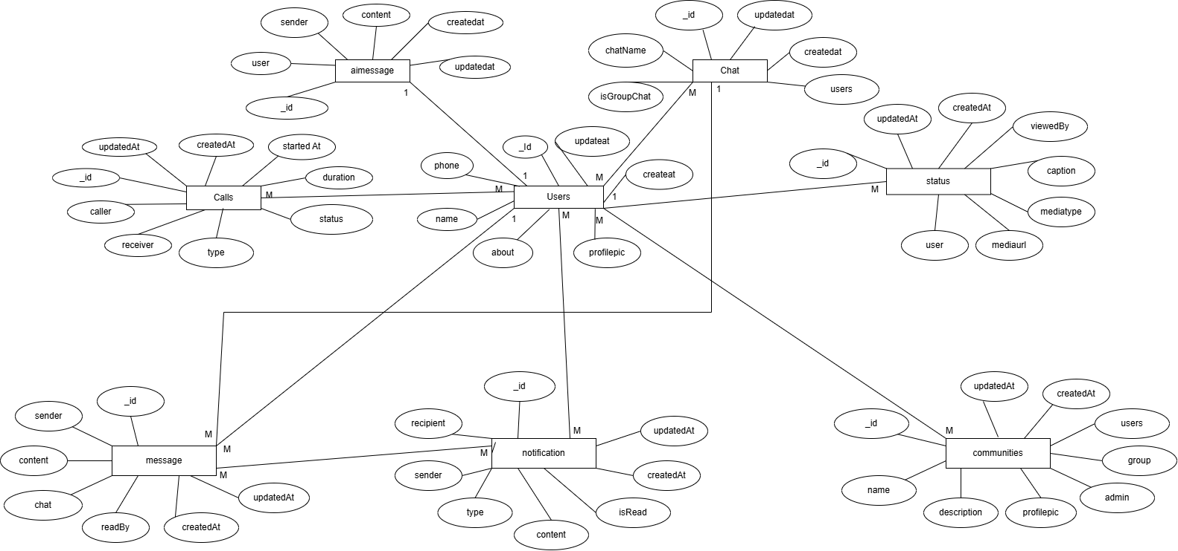

4.4 User Modeling Language Diagrams
4.4.1 Use Case Diagrams
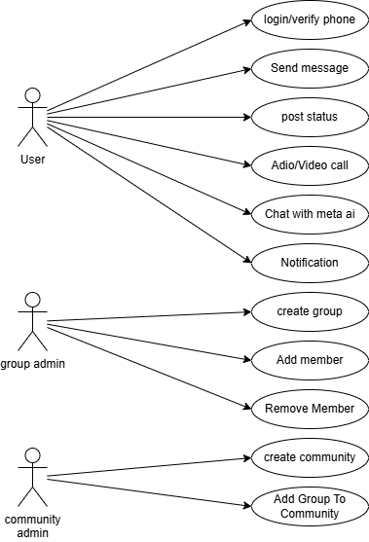

4.4.2 Activity Diagrams
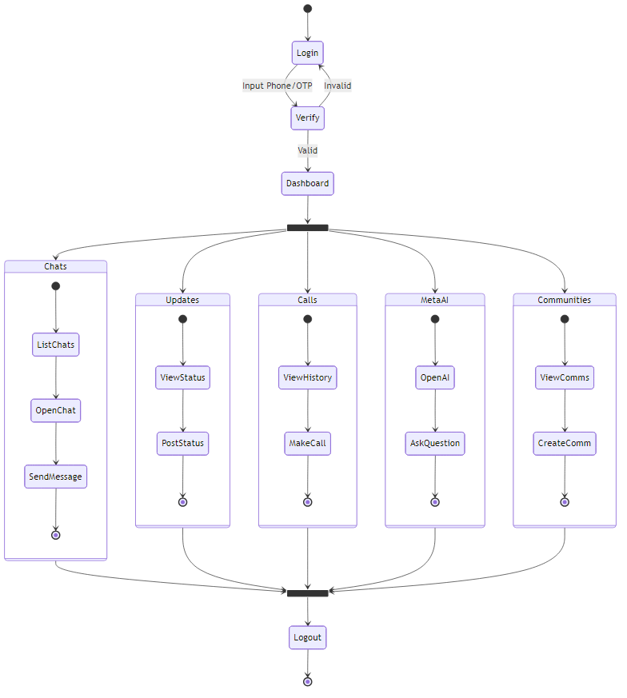

4.4.3 Sequence Diagrams
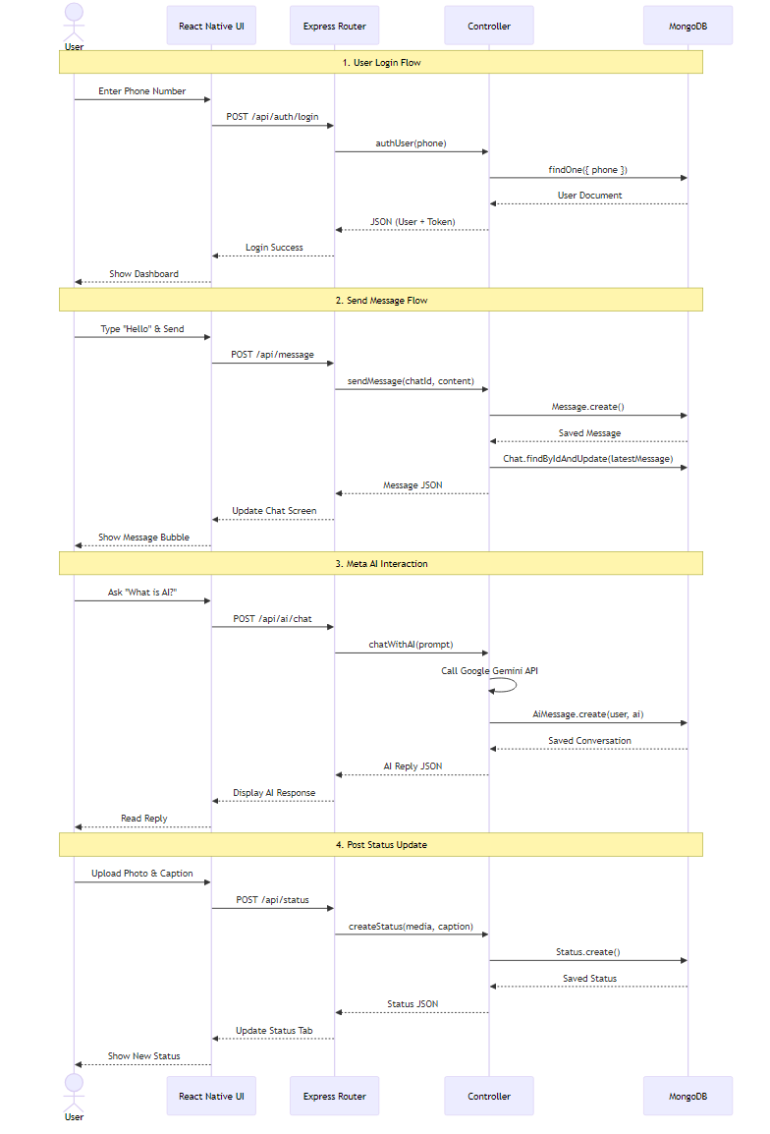
4.4.4 Collaboration Diagrams
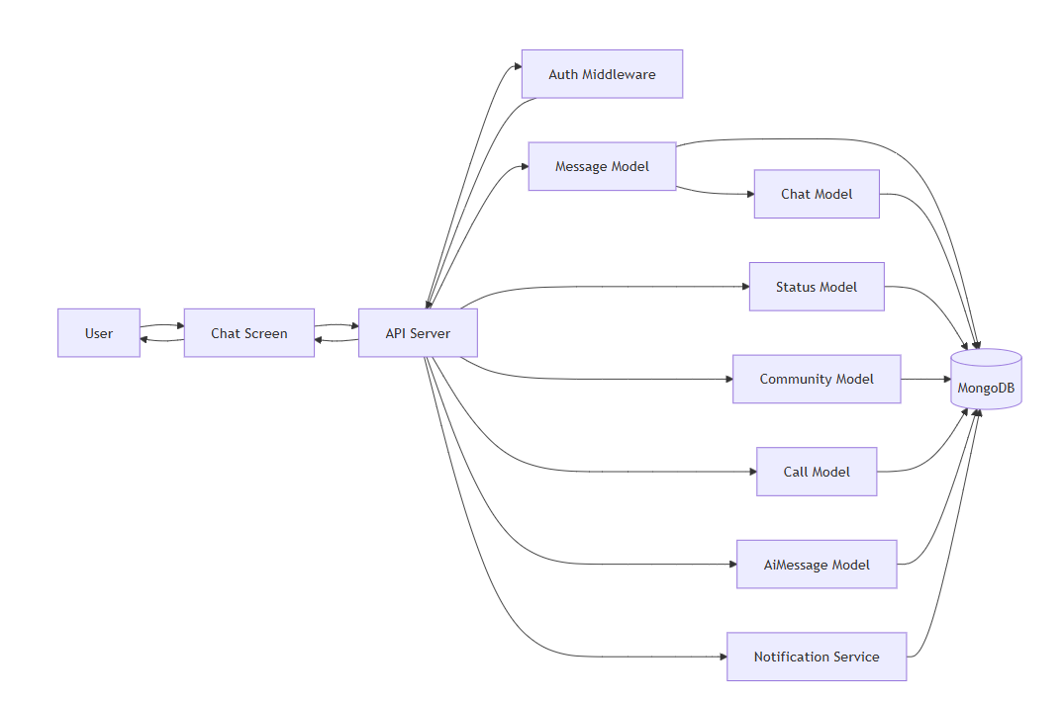

4.4.5 Class Diagrams
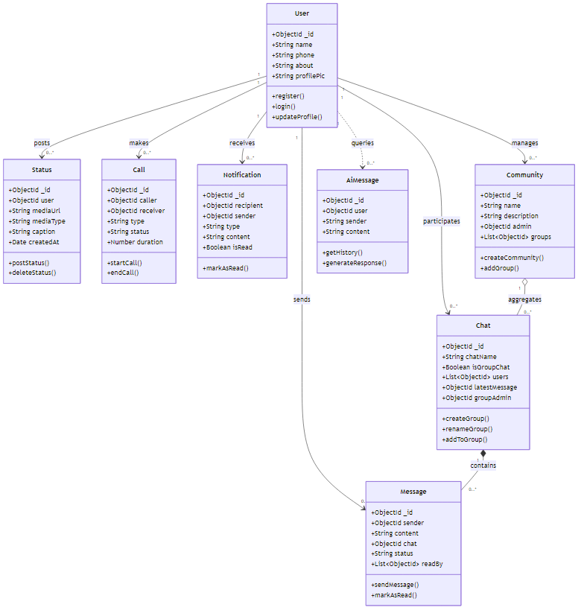

4.5 Input Design
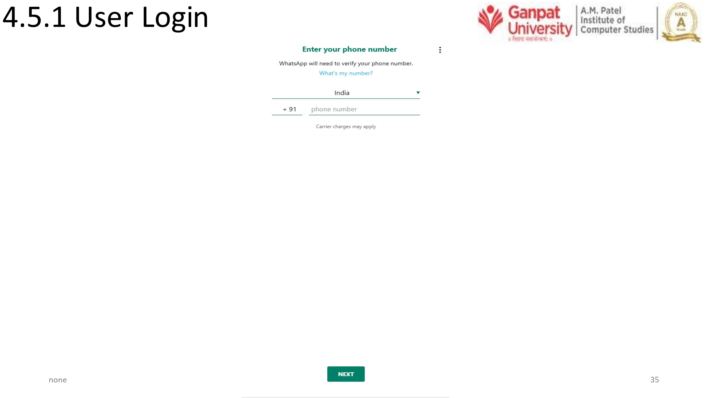

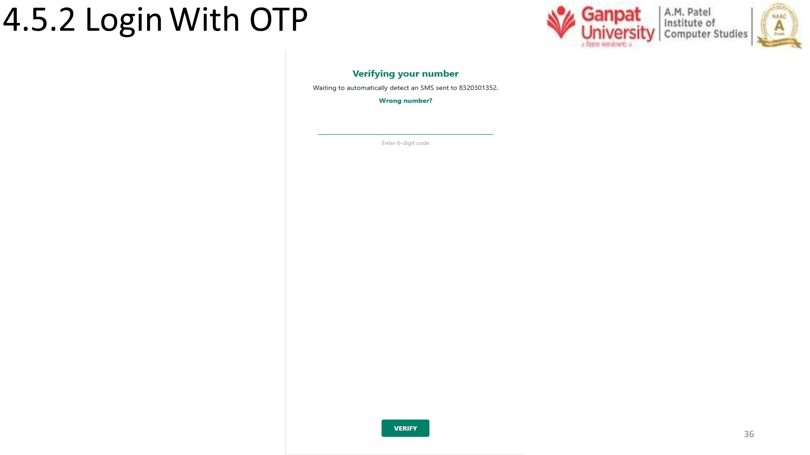

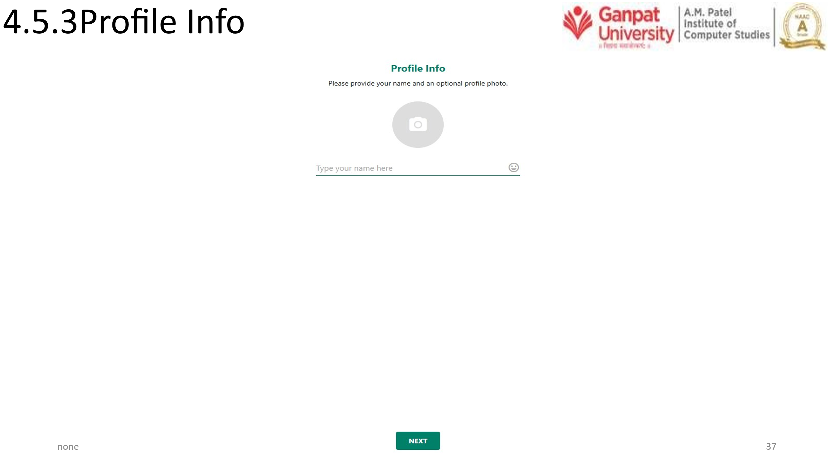

4.6 Output Design
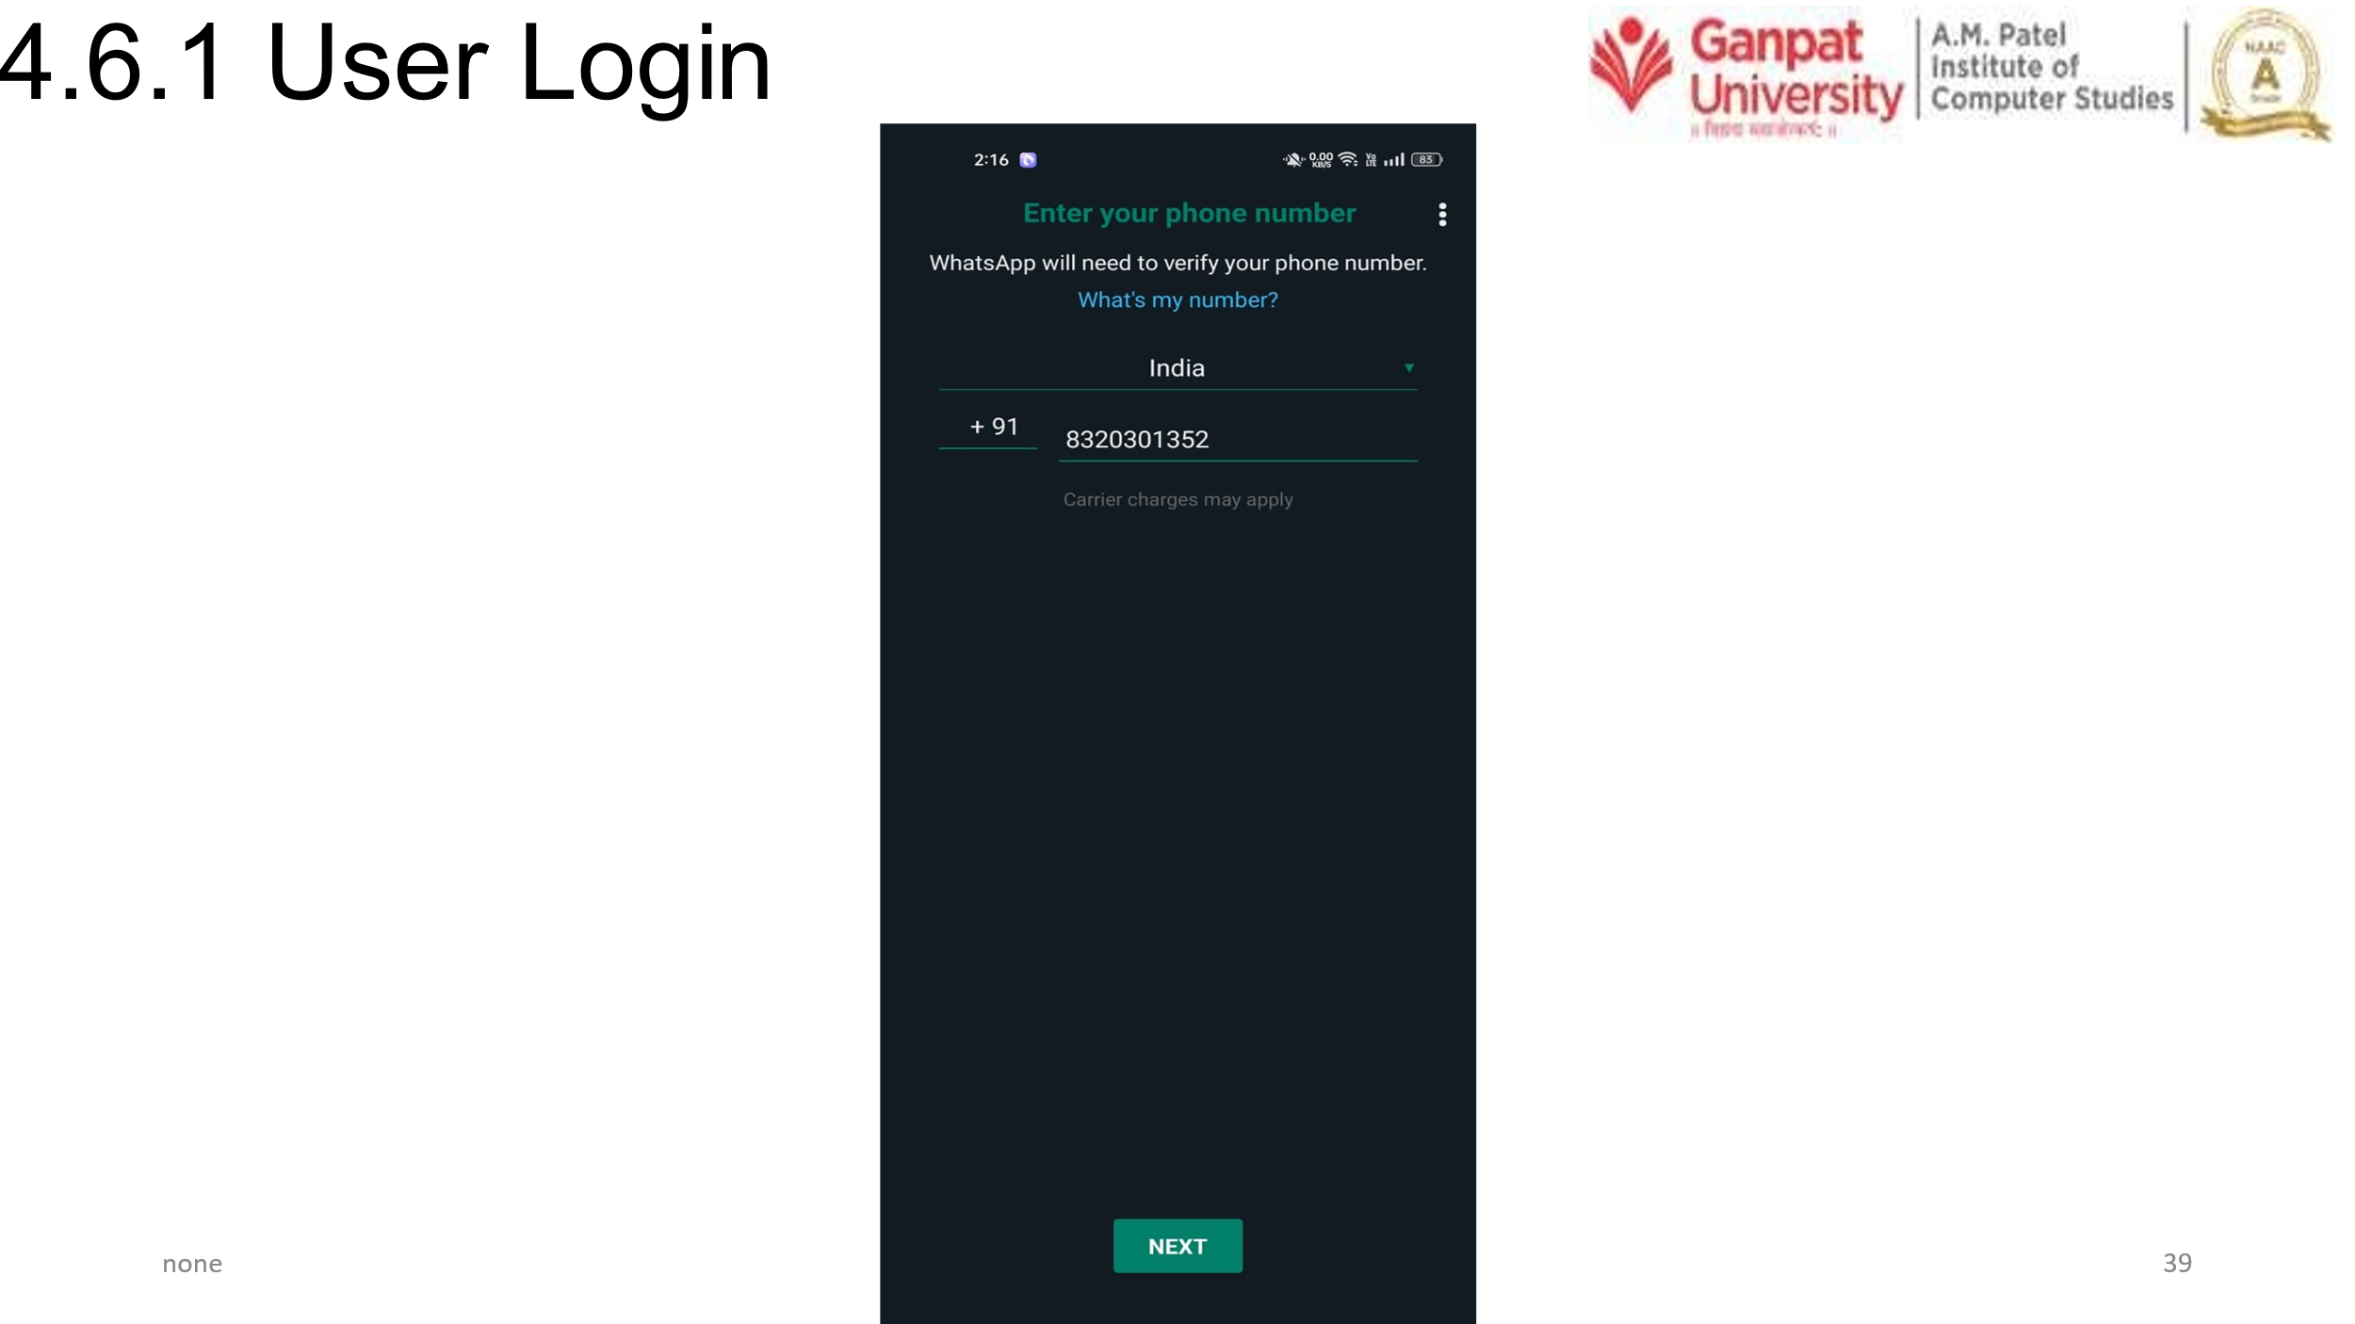
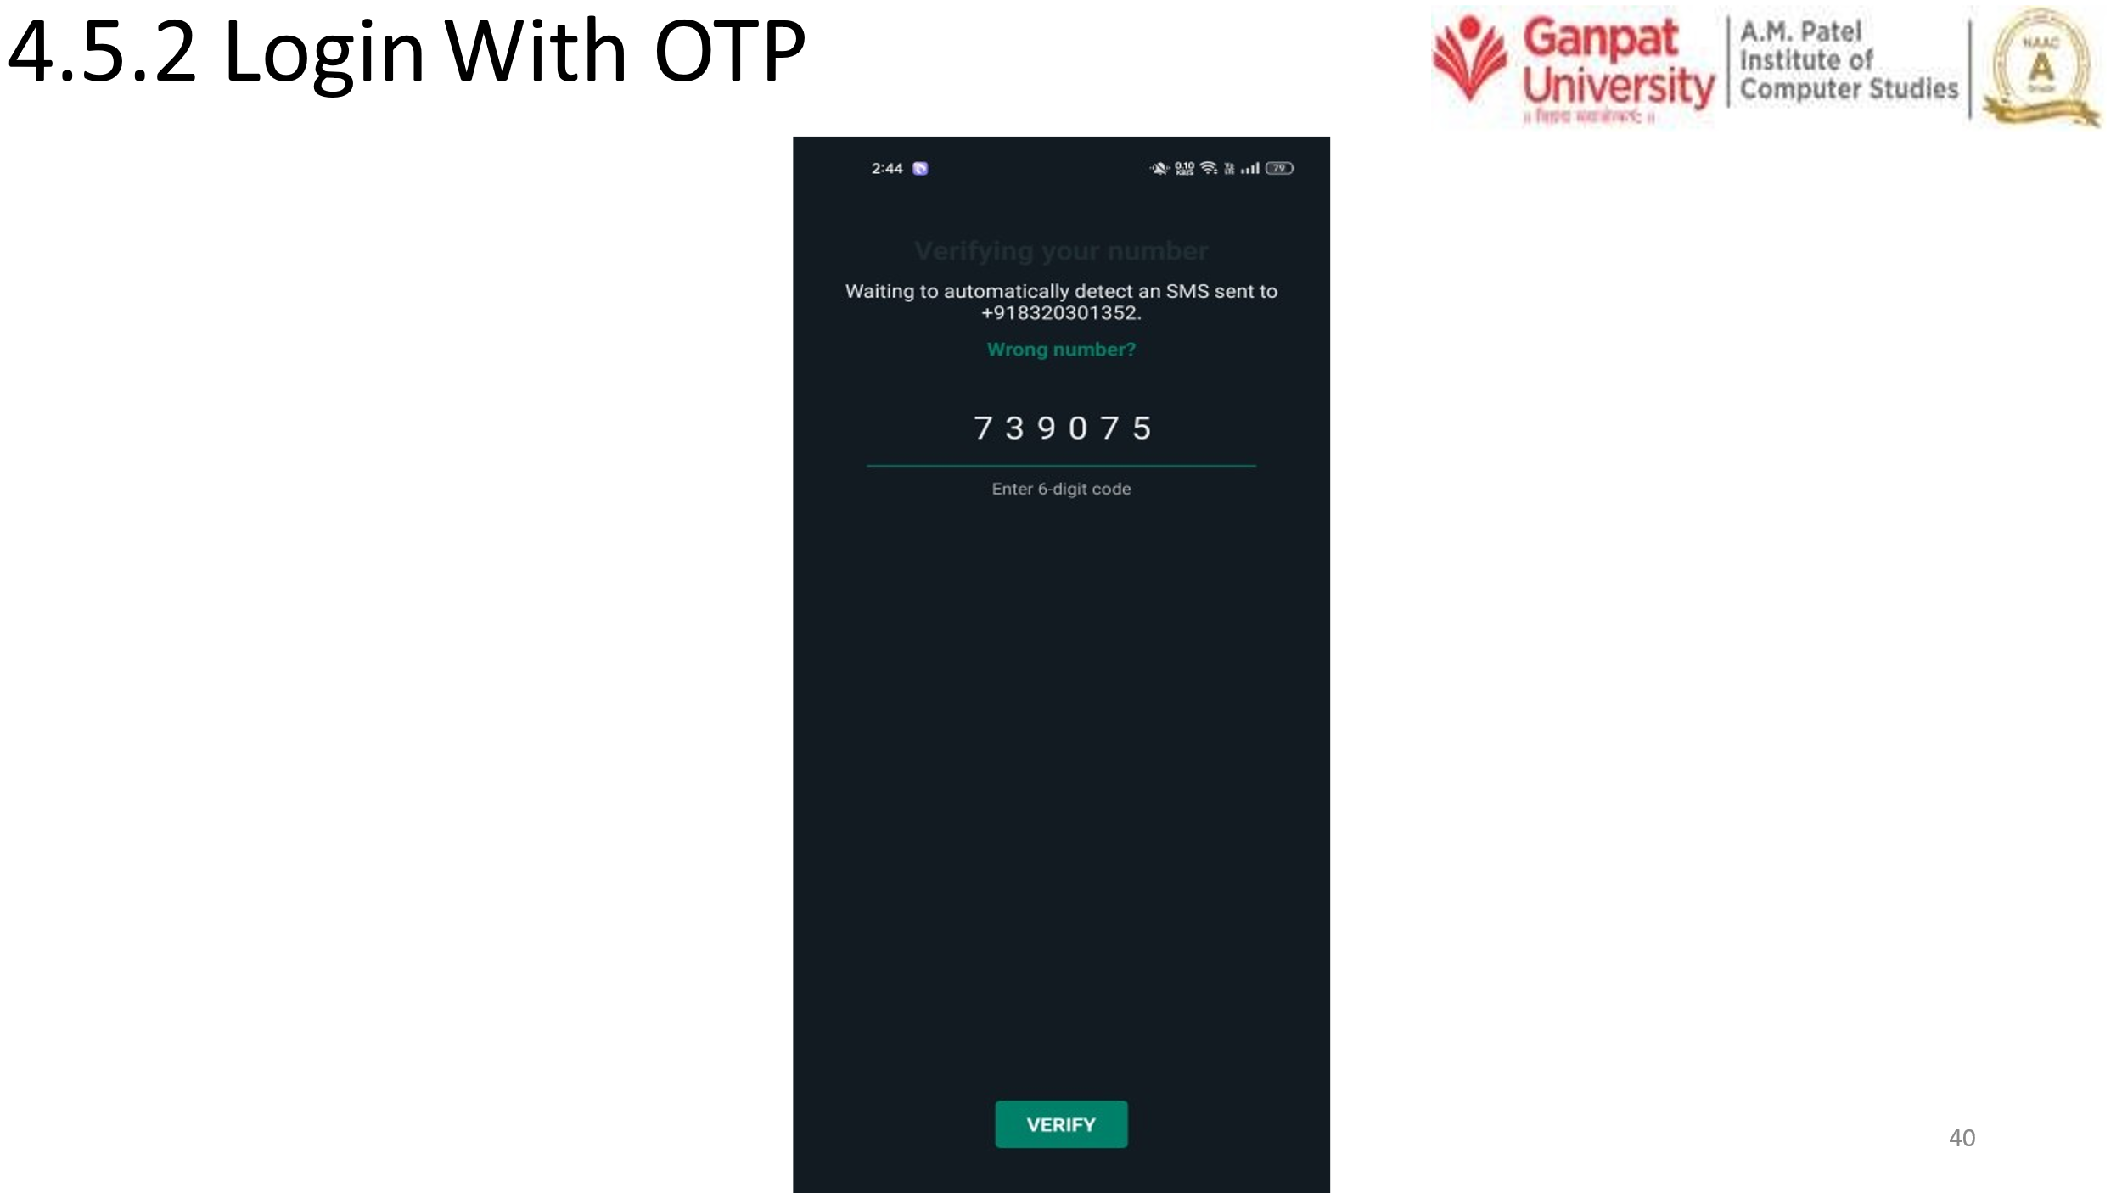

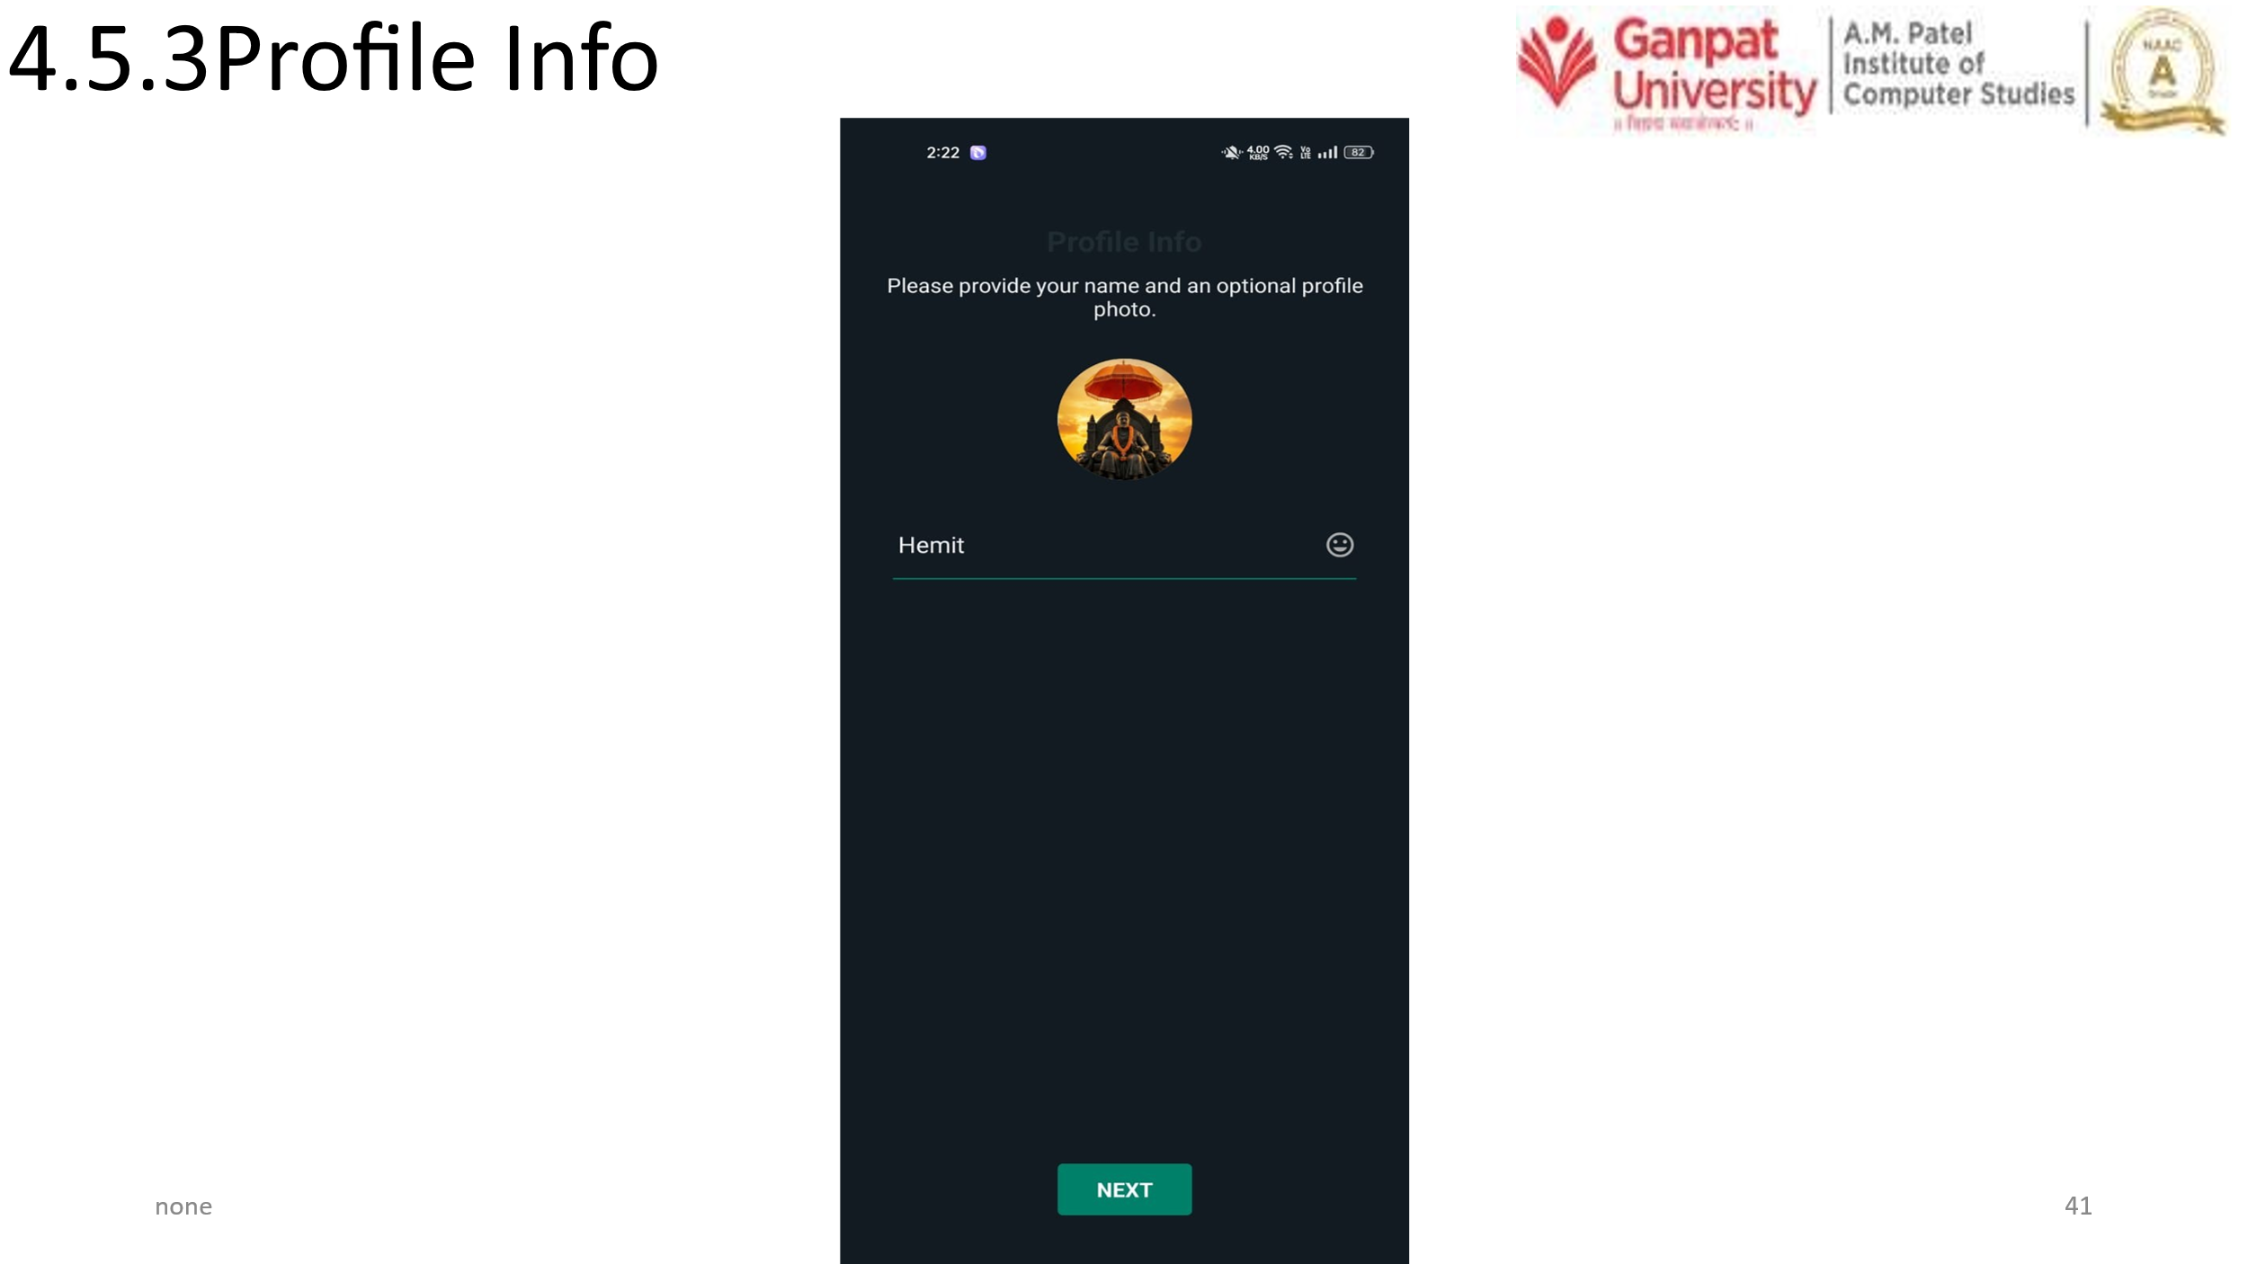

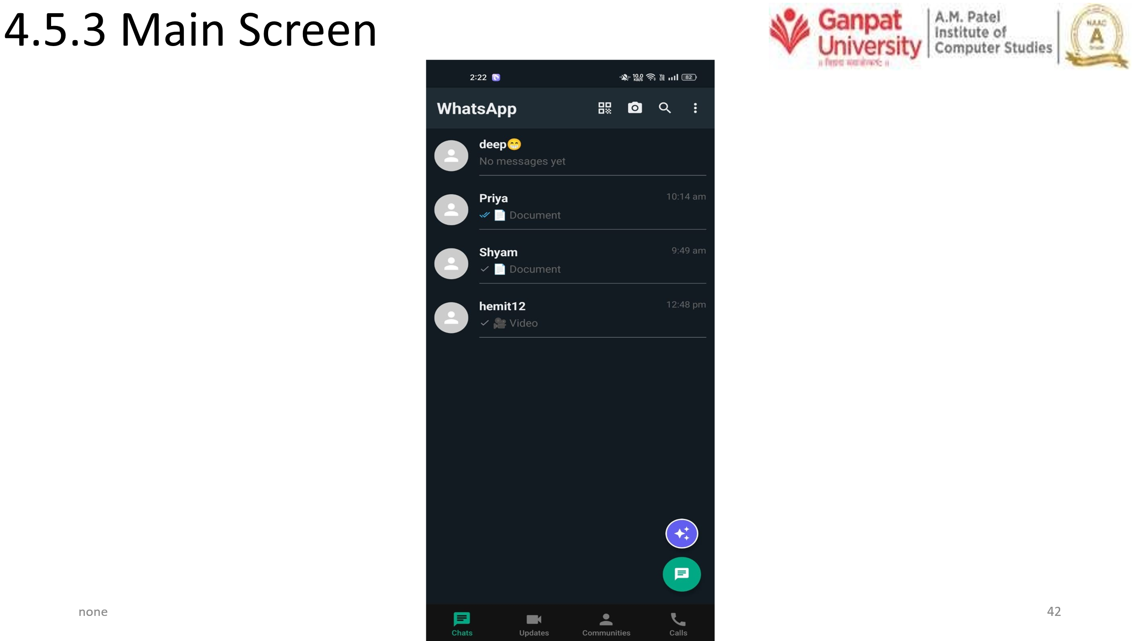

Chapter – 5 SYSTEM TESTING
5.1 System Testing
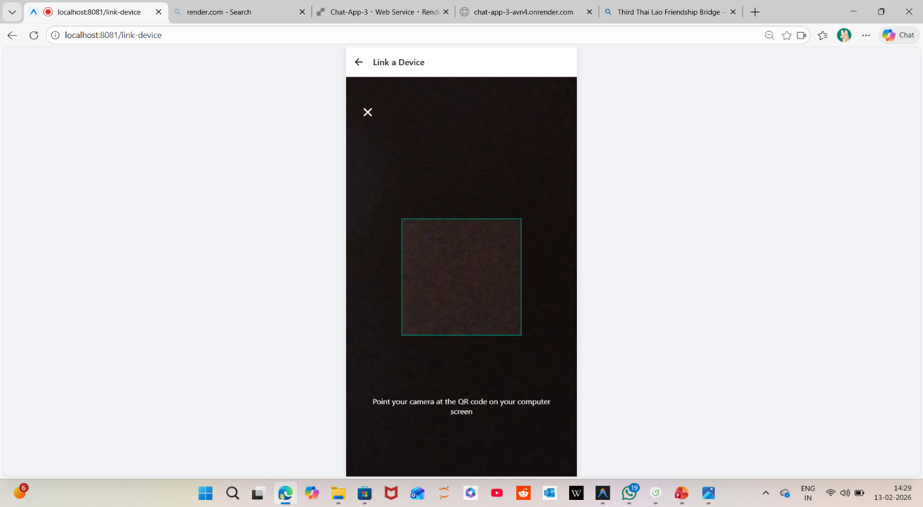
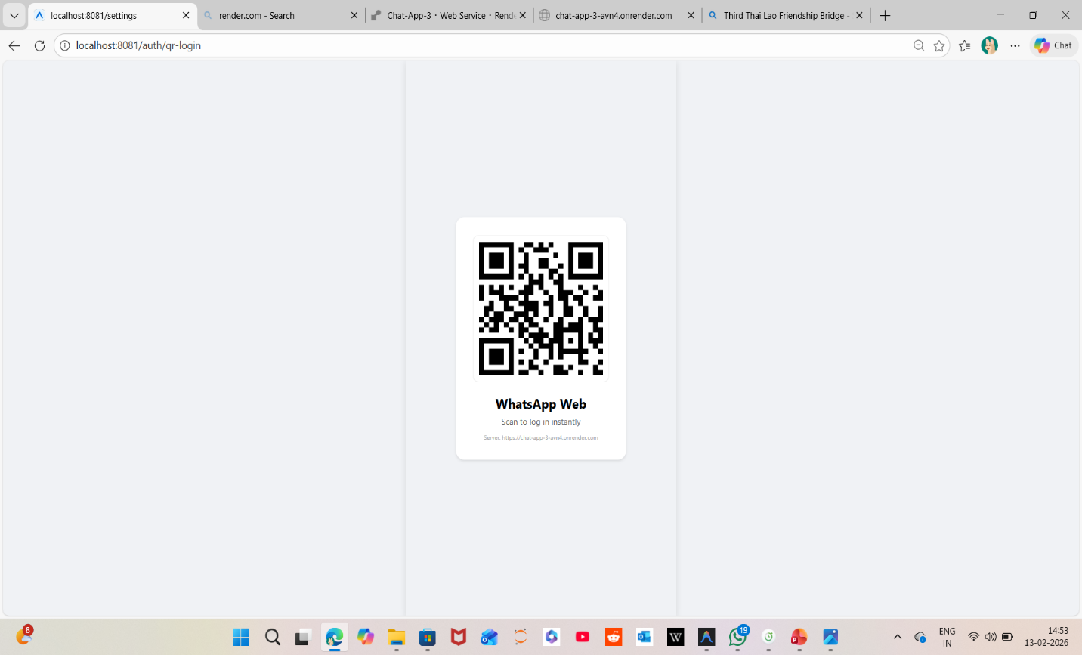
5.5.1 Output Testing
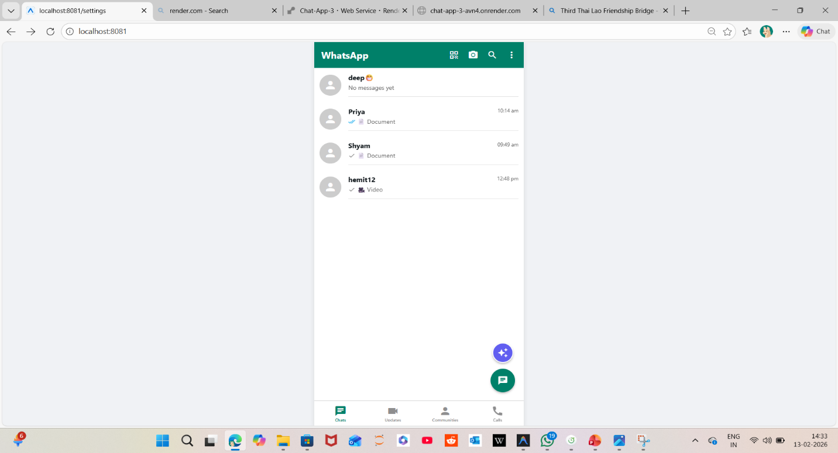

5.5.2 Validation and Verification Testing
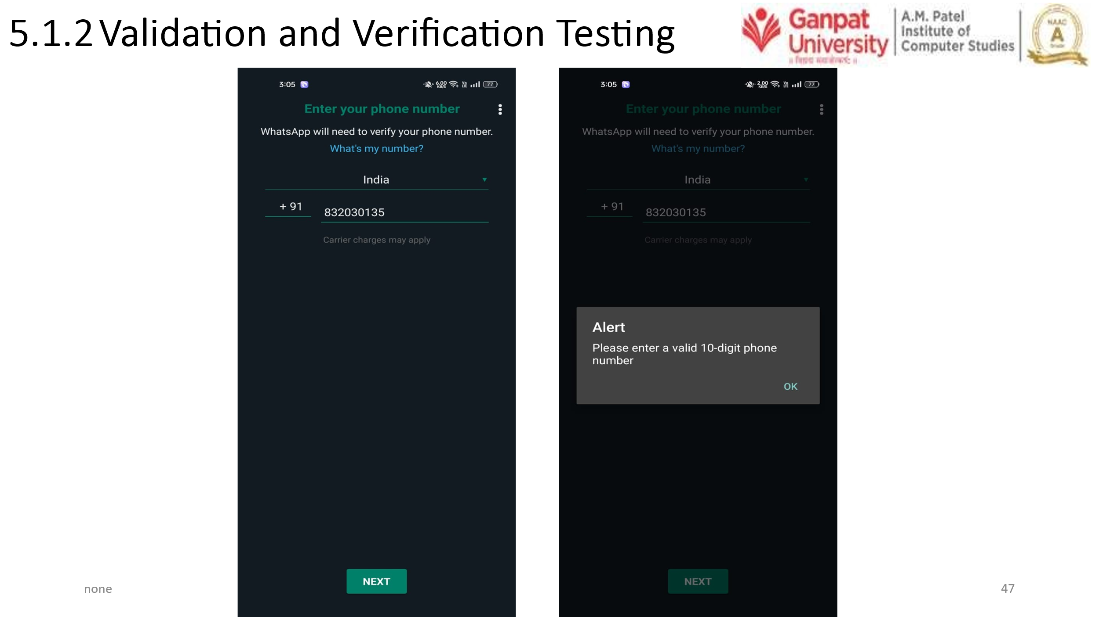
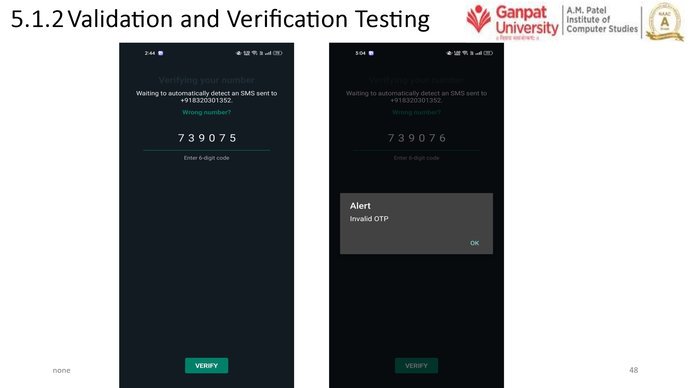
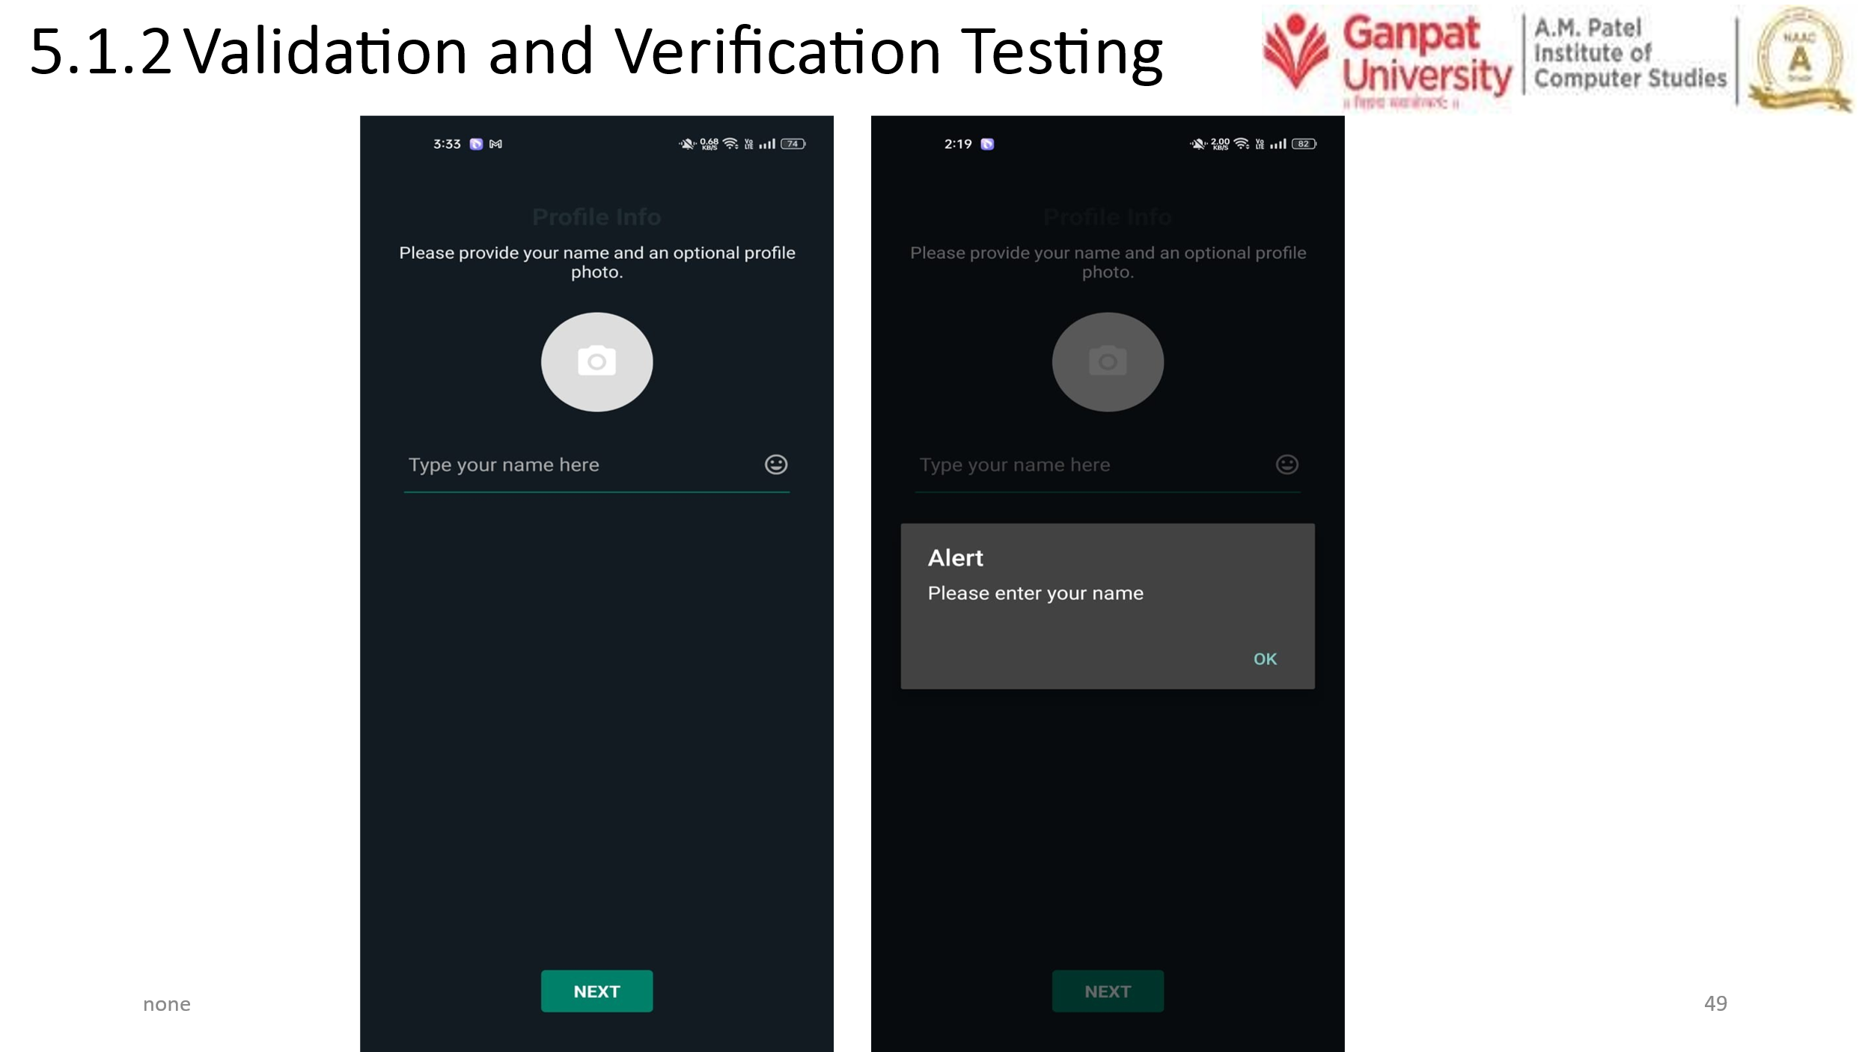

Chapter – 6 CONCLUSION AND FUTURE ENHANCEMENT
6.1 Conclusion
- Real-time Communication: Seamless 1-on-1 and group messaging powered by Socket.io.
- Advanced Status System: A complete "Updates" ecosystem including multiple status uploads, segmented progress rings, and automatic user transitions.
- Privacy First: Fine-grained status privacy controls (My Contacts, Except, Only Share) with strict server-side filtering.
- Rich Media Support: Handling of images, videos, and documents with optimized uploading and viewing.
- Community & Groups: Structured organization for large-scale and topical communication.
- Integrated Call System: Real-time voice and video calling via ZegoCloud.
- AI Integration: Meta AI features using the Gemini API for intelligent interactions.
- Production Ready: Full deployment on Render with a centralized configuration for easy environment switching.

6.2 Future Enhancements
1. Security & Privacy
- End-to-End Encryption (E2EE): Implement Signal Protocol or similar for absolute message privacy.
- Two-Step Verification: Add an extra layer of security for user accounts.
- View Once Media: Allow users to send photos/videos that disappear after being opened.
2. Media & Interaction
- Stickers & GIFs: Integration with Giphy or custom sticker packs to enhance expression.
- Rich Link Previews: Automatically generate previews for URLs shared in chats.
- Message Reactions: Allow users to react to messages with any emoji (expanding beyond the basic set).
3. Voice & Video Improvements
- Group Calling: Support for multiple participants in a single voice or video call.
- Call Recording: Enable recording of calls with user consent.
- Picture-in-Picture (PiP): Allow users to continue video calls while navigating other parts of the app.

4. Technical Optimizations
- Message Search: Implement a high-performance search engine (like ElasticSearch or MongoDB Atlas Search) for messages and media.
- Offline Support: Better local caching (SQLite/WatermelonDB) to allow reading messages without an active internet connection.
- Virtualized Lists: Extreme optimization for chat history to handle thousands of messages with zero lag.
5. UI/UX Enhancements
- Custom Themes: Allow users to choose custom chat wallpapers or accent colors.
- Localization: Support for multiple languages (Hindi, Gujarati, etc.) for a broader user base.
- Dark Mode Perfection: Ensure every single screen and component is perfectly optimized for a sleek dark mode experience.

Chapter – 7 BIBLIOGRAPHY & REFERENCES
7.1 Books References
- Web Technologies: HTML, CSS, JavaScript — Uttam K. Roy, Oxford University Press.
- Full-Stack: React Projects Shama Hoque, Packt Publishing.
- Learning React: Modern Patterns for Developing React Apps — Alex Banks & Eve Porcello, O’Reilly Media.
- Node.js: Design Patterns — Mario Casciaro & Luciano Mammino, Packt Publishing.
- Mastering Express.js: A Practical Guide to Building Web Applications — Azat Mardan.
- MongoDB: The Definitive Guide — Shannon Bradshaw, Kristina Chodorow, and Eoin Brazil, O’Reilly Media.
- Artificial Intelligence: A Modern Approach — Stuart Russell & Peter Norvig, Pearson Education

7.2 Web References
- React.js Official Documentation
https://react.dev/
- Node.js Official Documentation
https://nodejs.org/en/docs
- Express.js Official Documentation
https://expressjs.com/
- MongoDB Documentation
https://www.mongodb.com/docs/
- Tailwind CSS Documentation
https://tailwindcss.com/docs
- JSON Web Token (JWT) Guide
https://jwt.io/introduction

