

**Embedded System Design Project**

# The Whisperer

**Winter 2020**

**INSTRUCTOR:** Takis Zourntos

# CLASS: ESE 4009

|  |  |
| --- | --- |
| Student Name | Student ID |
| Yukti Behal | C0745796 |
| Manush Patel | C0741063 |
| Mohit Gohil | C0730205 |

*\*By signing above you attest that you have contributed to this submission and confirm that all work you have contributed to this submission is your own work. Any suspicion of copying or plagiarism in this work will result in an investigation of Academic Misconduct and may result in a “0” on the work, an “F” in the course, or possibly more severe penalties.*

*Project Dedicated to professor Mohsen Salahi-Sir, we will never be late again……*

|  |  |  |
| --- | --- | --- |
| **Serial Number** | **Title** | **Page Number** |
| **1** | The Need | 3 |
| **2** | The Solution | 4 |
| **3** | How This project works? | 5 |
| **4** | ASMR Functional Block Diagram | 6 |
| **5** | Hardware Block Diagram | 7 |
| **6** | Software Block Diagram | 9 |
| **7** | Conclusion | 10 |
| **8** | Reference | 10 |

**The Need**

Necessity is the mother of all inventions.

Humans have reached beyond the horizon and all the way into the everlasting space with the help of the technology. Unfortunately, they fail to understand the depths of their own heart and explore their own sorrows, and when they fail to do that, they fall into the deep well of depression and anxiety, a void from where there is no rope that pulls them out.

The modern time requires a desperate need to understand and find a rather instant solution for mental health. According to research, female is more vulnerable to mental health at a young age of 16-21 (Koskie, 2019). When the society fails to provide a solution for such problems, the youth tries to find solution in Drugs, Alcohol and other abusive substances which have more harmful effects on body rather than providing any kind of help.

Since its invention and implementation, Embedded system has always provided a solution to any problem or any questions that we wondered. If embedded system can successfully communicate with us even after going beyond our solar system. It is definitely possible that it will be a ray of hope for the problems that we face with mental health.

Embedded system can be defined as any intelligent circuit system that performs a specific task targeted for a special purpose. The embedded family includes IoT-Internet of things, AL – Artificial intelligence and various other automated devices.

Embedded system functions on RTOS-Real Time Operating System which uses C as its core language and is independent of any secondary device like Computer.

**The Solution**

In the year 2010, Jennifer Allen was searching through the videos of cosmic space, when she felt a tingling sensation across her spine. It provided a vibe of sensation which she always used to feel whenever she listened to similar soothing noises but never noticed about them until that time.

Later she started a blog where she shared her experience about the sensational feeling from the sound of space. To her surprise, people begin to notice this feeling and they all shared their own similar experiences with different other form of sound. This let to a discovery that human can have sensational felling from a typical frequency of sound which triggers their sensory and motor nervous system of their brain. The sound can be any simple thing like brushing of hair, folding of sheets, sound of rain or ‘The Whisper’.

In the year 2010, Allen did establish her company and did debut on Steady Health under the name: A.S.M.R Group. The A.S.M.R stands for:

A-Autonomous: feeling from within.

S-Sensory: for the sensation.

M-Meridian: peak, orgasm and energy pathways of traditional Chinese medicine.

R-Response: Reaction to the set of stimuli. (Keiles, 2019)

The main motto of the company was to introduce the world to different kinds of soothing and sensational sounds which would trigger their sensory motor nerves and relax anyone who listens to them.

Today ASMR has become a YouTube phenomenon with over a hundred YouTube stars featuring in ASMR videos, each having millions of followers.

ASMR has proven to be a new field of study which can be used to relax ourselves and heal ourselves from mental problems.

**How this project works?**

ASMR are special sound effects which gives pleasuring sensations in your head while you’re listening to some specific sounds like blowing wind, the sound of a trimmer, bonfire sound etc.

This project we created a custom ASMR device in which records whichever sound you produce as your ASMR sound input it will store multiple sounds like that and after you can listen to your own created custom ASMR, also you can mix two or more sounds together as well.

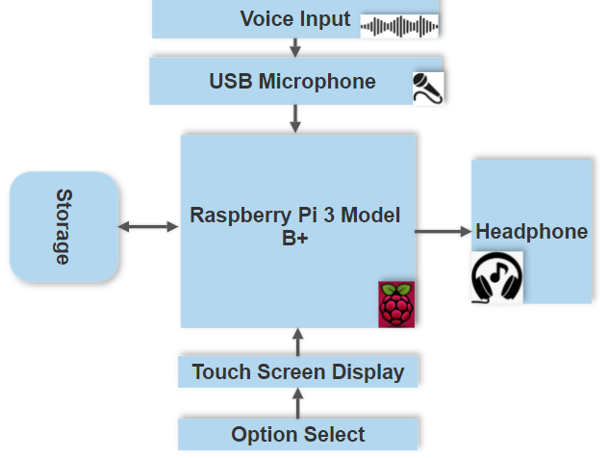

**ASMR Functional Block Diagram**

Initially, you will need to create some sounds for your ASMR and store it in the memory storage which will be recorded by the microphone connected to your raspberry pi. Then you can record multiple sound files and they will be shown into the display connected to the raspberry pi, you will see the options to select the sounds and play it separately or you can choose to play multiple sounds together everything just in touch of your fingertips. Everything is set! Plug your earphones in and enjoy!

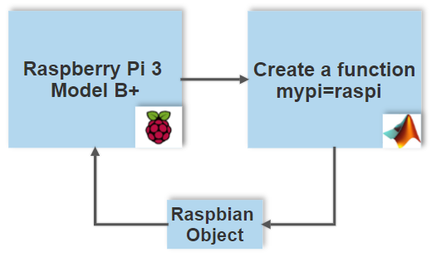

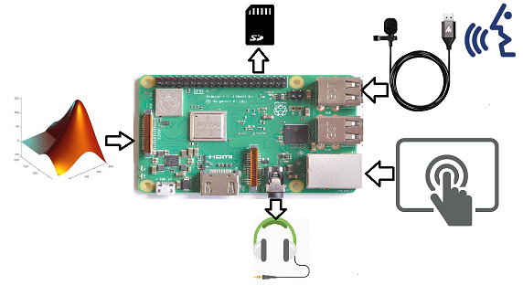

**Hardware Block Diagram**

Raspberry pi will be connected to all the peripheral devices and the recorded sounds will be stored into the SD card. The core code will be in the c language, our plan is to create an independent device which records the voice instead of getting them from the internet and play them as a speaker. We are trying to make it compact and interface easy to understand with simple icons on the screen.

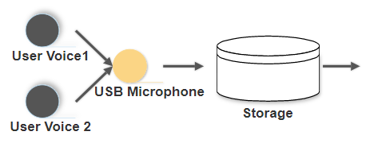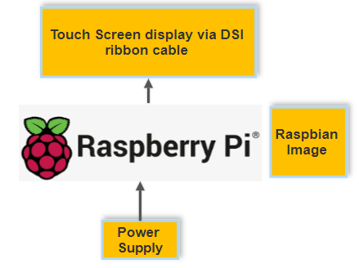

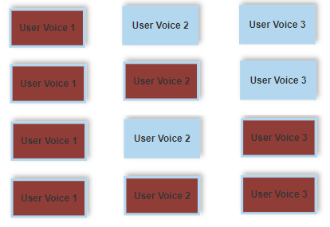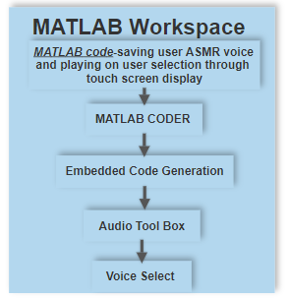

**Software Block Diagram**

Here is an example how the process follows from the display and the user input to the voice select. Multiple voices will be stored into different available voice slots and you can see it on the touch screen display.

Empty user slots will be easy to identify by the icon color so you can use the empty slots as you need. Touch on the icon to play and touch again to stop the recording, if you touch on another icon while one clip is being played it will play both of the clips together up to all multiple clips recorded.

For each slot you will have option to delete the sound stored into it, so if you wish to record a new sound into the slot you can do that by deleting the existing clip. We are planning on creating a permanent storage too to save the previously recorded voice too so you can assign them to slots to play them again. It will also add one more user interface to it to see the recordings and show it in to the SD card storage.

**Conclusion**

The following project focuses on the mental health issues and provides relaxation to mind with the help of embedded system.

The project does user-oriented sound mixing using MATLAB and Raspberry-Pi.

MATLAB is an excellent platform for audio signal processing and Raspberry Pi is a modern time microcontroller capable of interfacing different modules like sound, memory and headphone with simple C language.

The Ultimate Goal of producing ‘The Whisperer’ is to cure anxiety and depression issues with the help of A.S.M.R and lead the humanity to a better and prosperous future.

# References

Keiles, J. L. (2019). How A.S.M.R. Became a Sensation. *The New York Times Magazine*.

Koskie, B. (2019). Depression: Facts, Statistics, and You.