**Description:** As a manager I want to add/remove trainers so I can update my list of employees.

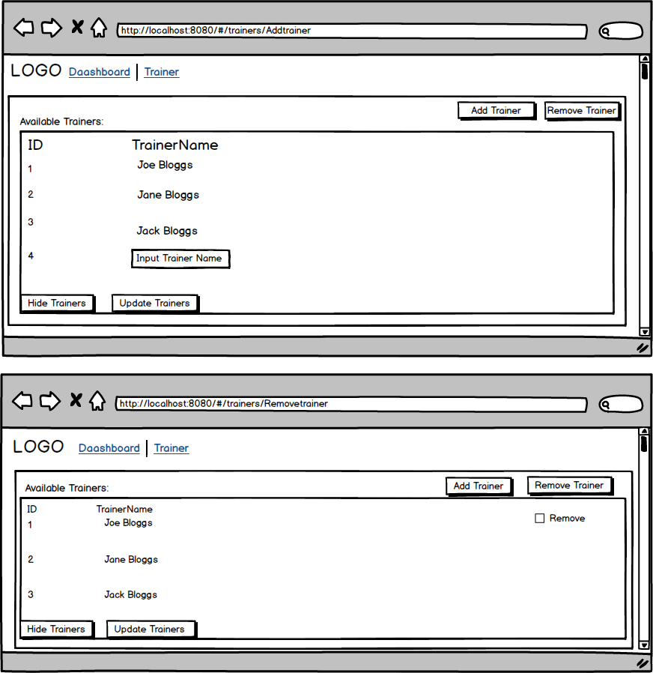

Select Add Trainer button ID is produced and Input trainer name and select update Trainers. Trainer will be updated.

Select Add Trainer button ID is produced and Input trainer name and select update Trainers.



Select Remove Trainer Checkbox is produced select that and select update Trainers. Trainer will be removed.

**Accepetence Criteria:**

* Given I am on the trainer page, when I press the Add trainer button, then a textbox is produced to add a trainer name and I click the update trainer buttons then I can see the new trainer I have added
* Given I am on the trainer page, when I press the remove trainer button, then a checkbox is produced to remove a trainer name and I select the textbox and I click the update trainer buttons then I can see the trainer is removed.