# VISVESVARAYA TECHNOLOGICAL UNIVERSITY

**Jnana Sangama, Belagavi – 590018.**



**DBMS MINI PROJECT REPORT ON**

“Railway Management System”

Submitted in partial fulfilment for the requirement of V Semester for the Degree of

### BACHELOR OF ENGINEERING IN

**INFORMATION SCIENCE & ENGINEERING**

For the Academic Year 2023-24

### SUBMITTED BY MadanPatel K S (1DB21IS078)

**Under the Guidance of Mrs. Nivedita Hebbale** Assistant Professor

Dept. of Information Science and Engineering



### Department of Information Science and Engineering

DON BOSCO INSTITUTE OF TECHNOLOGY

Kumbalagodu, Mysuru Road, Bengaluru – 560074

**2023-24**

# DON BOSCO INSTITUTE OF TECHNOLOGY

Kumbalagodu, Mysuru Road, Bengaluru – 560074

**DEPARTMENT OF INFORMATION SCIENCE AND ENGINEERING**



# CERTIFICATE

This is to certify that the Project Report entitled **“Railway Management System”** is a bonafide Project work carried out by **MadanPatel K S (1DB21IS078)** in partial fulfilment of V semester for the Degree of **Bachelor of Engineering in Information Science and Engineering** of Visvesvaraya Technological University, Belagavi, during the academic year 2023-24. It is certified that all corrections/suggestions indicated for Internal Assessments have been incorporated with the degree mentioned.

|  |  |
| --- | --- |
| Signature of Guide | Signature of HoD |
| **Mrs. NIVEDITA HEBBALE**  Asst. Professor Dept. of ISE,  DBIT, Bengaluru. | **Dr. B K RAGHAVENDRA**  Professor & Head Dept. of ISE,  DBIT, Bengaluru. |
| **External Viva** | |
| **Name of the Examiners** | **Signature with Date** |
| 1. ………………………… | .………………………… |
| 2. …………………………. | …………………………. |

# ACKNOWLEDGEMENT

At the various stages in making the mini project, a number of people have given me invaluable comment on the manuscript. I take this opportunity to express our deepest gratitude and appreciation to all those who helped us directly or indirectly towards the successful completion of this project.

I would like to thank our **Principal Dr. B. S. NAGABHUSHANA, Don Bosco Institute of Technology, Bengaluru** for his support throughout this project.

I express our whole hearted gratitude to **Dr. B. K. RAGHAVENDRA,** who is our respectable **Professor and Head of Department of Information Science and Engineering**. I wish to acknowledge for his valuable help and encouragement.

In this regard i owe a heartfelt gratitude to our guide **Mrs. Nivedita Hebbale Assistant Professor, Department of Information Science and Engineering**, DBIT, Bengaluru for his constant help and support extended towards us during the course of the project.

I would also like to thank the teaching and non-teaching staff members of Departmentof Information Science and Engineering for their corporation.

MadanPatel (1DB21IS078)

# ABSTRACT

Railway management systems play a pivotal role in ensuring the smooth operation, safety, and efficiency of railway networks. In this abstract, we present an overview of a comprehensive Railway Management System (RMS) designed to address the multifaceted challenges encountered in modern railway operations. The RMS encompasses various subsystems including infrastructure management, rolling stock management, scheduling and dispatching, passenger information, and maintenance planning.

The infrastructure management component focuses on the monitoring and maintenance of tracks, signaling systems, and other critical infrastructure elements to ensure safe and reliable train operations. Rolling stock management involves the tracking of locomotives, freight cars, and passenger coaches, optimizing their usage, and scheduling maintenance activities to minimize downtime.

Scheduling and dispatching modules utilize advanced algorithms to optimize train schedules, allocate resources efficiently, and minimize delays. Real-time data integration and predictive analytics enable proactive decision-making, reducing the impact of unforeseen events such as equipment failures or adverse weather conditions.

Passenger information systems provide travelers with real-time updates on train schedules, delays, and alternative routes, enhancing the overall passenger experience. Additionally, these systems facilitate ticketing, seat reservations, and onboard amenities, further improving customer satisfaction.

Maintenance planning subsystems employ predictive maintenance algorithms to anticipate equipment failures, schedule preventive maintenance, and optimize maintenance workflows. This proactive approach reduces the risk of service disruptions and enhances the reliability of railway operations.

Furthermore, the RMS incorporates advanced communication and control technologies, including GPS tracking, telemetry, and remote monitoring, to enable seamless coordination between various stakeholders and ensure compliance with safety regulations.

# TABLE OF CONTENTS

## Sl. No. CHAPTERS Page No

### INTRODUCTION 1-3

* 1. Overview
  2. Problem Statement
  3. Objective of the Project
  4. Limitations
  5. Literature Survey

### SYSTEM ANALYSIS 4-5

* 1. Existing System
  2. Proposed
  3. Aim
  4. Objectives
  5. Technology Used
  6. System Requirements

### REQUIREMENT SPECIFICATION 6

* 1. Software Requirements
  2. Hardware Requirements

### SYSTEM DESIGN 7-9

* 1. Schema Diagram
  2. ER Diagram
  3. Data Flow Diagram

### DATA BASE TABLES 10-13

1. **IMPLEMENTATION 14-15**
   1. Platform Used For Implementation
   2. SQL Commands And Queries

### RESULTS AND DISCUSSION 16

1. **SNAPSHOTS 17-19**

### CONCLUSION AND 20-21

**FUTURE ENHANCEMENT**

**REFERENCES 22**

|  |  |  |
| --- | --- | --- |
|  | **LIST OF FIGURES** |  |
| **Figure No.** | **Name of the Figure** | **Page No** |
| 4.1 | Schema Diagram | 7 |
| 4.2 | ER Diagram | 8 |
| 4.3 | Data Flow Model | 9 |
| 8.1 | Home Page | 17 |
| 8.2 | Reservation List Page | 17 |
| 8.3 | Train List Page | 18 |
| 8.4 | Schedule List Page | 18 |
| 8.5 | User List Page | 19 |
| 8.6 | Inquiry Page | 19 |

|  |  |  |
| --- | --- | --- |
|  | **LIST OF TABLES** |  |
| **Table No.** | **Name of the Figure** | **Page No** |
| 5.1 | Users Table | 10 |
| 5.2 | Reservation List Table | 10 |
| 5.3 | Schedule List Table | 11 |
| 5.4 | Train List Table | 12 |
| 5.5  5.6 | Message List Table  System Info | 12  13 |

CHAPTER 1

* 1. **OVERVIEW**

# INTRODUCTION

A railway management system is a complex infrastructure designed to efficiently operate, maintain, and regulate railway networks. At its core, such a system integrates various components, including infrastructure, rolling stock, personnel, scheduling, and safety protocols, to ensure smooth and reliable transportation of passengers and freight.

One key aspect of railway management is infrastructure maintenance and expansion. This involves the upkeep of tracks, signaling systems, stations, and other facilities to guarantee safe and reliable operation. Additionally, the system must account for the expansion of infrastructure to accommodate growing demand or new routes, which requires careful planning and investment. Rolling stock management is another critical element. This involves the maintenance, scheduling, and allocation of trains and other vehicles to optimize their usage and ensure timely service. Regular maintenance schedules are essential to prevent breakdowns and minimize disruptions to service.

Personnel management is also crucial in railway operations. This includes staffing stations, trains, and maintenance crews, as well as training employees on safety procedures and customer service. Effective personnel management contributes to the overall efficiency and safety of railway operations. Safety is paramount in railway management. Strict safety protocols and regulations govern every aspect of operations, from track maintenance to passenger boarding procedures. Advanced signaling systems, automatic braking systems, and regular safety inspections help mitigate the risk of accidents and ensure the well-being of passengers and staff. Overall, a well-designed railway management system integrates various components and processes to deliver safe, efficient, and reliable transportation services. Continuous innovation and investment in technology are essential to meet the evolving needs of passengers and freight operators while ensuring the sustainability and resilience of railway networks. Rolling stock management is another critical element. This involves the maintenance, scheduling, and allocation of trains and other vehicles to optimize their usage and ensure timely service.

* 1. **PROBLEM STATEMENT**

The railway management system plays a crucial role in ensuring the smooth and efficient operation of railway networks, which are vital components of transportation infrastructure worldwide. At its core, this system encompasses a wide array of functions, including scheduling, ticketing, maintenance, and safety protocols. One of the primary challenges faced by railway management is optimizing the utilization of resources while maintaining high levels of service quality and safety standards. This involves strategic planning to allocate trains, tracks, and personnel effectively to meet the demands of passengers and freight transport.

Moreover, ensuring passenger satisfaction and safety is paramount in railway management. This entails implementing robust ticketing systems that offer convenience and flexibility to travelers while also integrating advanced safety measures to mitigate risks associated with train operations. Additionally, efficient maintenance protocols must be in place to upkeep infrastructure and rolling stock, minimizing downtime and ensuring reliability.

### OBJECTIVES OF THE PROJECT

A comprehensive railway management system aims to enhance the efficiency, safety, and reliability of railway operations while also prioritizing passenger satisfaction and environmental sustainability. One primary objective is to optimize scheduling and resource allocation to minimize delays and maximize the utilization of railway infrastructure. This involves implementing advanced algorithms and data analytics to predict and prevent potential disruptions, such as equipment failures or adverse weather conditions, thus ensuring smooth and punctual train services.

Another key objective is to prioritize safety across all aspects of railway operations. This includes implementing rigorous feedback and data analytics allows operator’s maintenance programs to keep tracks, signals, and rolling stock in optimal condition, as well as investing in modern safety technologies such as automatic train control systems and collision avoidance systems.

### LIMITATIONS

**Infrastructure Constraints:** Railway management systems often face limitations due to the infrastructure of the railway network itself. This includes issues such as outdated tracks, limited capacity, and the need for extensive maintenance.

**Safety Concerns:** Safety is paramount in railway management systems, and any shortcomings in safety measures can lead to accidents and disruptions. Ensuring comprehensive safety protocols and equipment can be challenging due to various factors such as human error, technical failures, and external hazards.

**Capacity Limitations:** Railway systems can experience capacity limitations during peak hours or when there is an unexpected increase in demand. Overcrowding, delays, and scheduling conflicts may occur as a result, leading to customer dissatisfaction and operational inefficiencies.

**Security Risks:** Railway systems are vulnerable to security threats such as vandalism, theft, and terrorism. Protecting infrastructure, rolling stock, and passenger safety requires robust security measures and constant vigilance.

### LITERATURE SURVEY

A comprehensive literature survey on railway management systems reveals a rich landscape of research and development aimed at enhancing the efficiency, safety, and sustainability of railway operations. One prominent area of focus is the application of advanced technologies, such as artificial intelligence (AI), machine learning (ML), and Internet of Things (IoT), to optimize various aspects of railway management. Researchers have explored the use of AI and ML algorithms for predictive maintenance, fault detection, and real-time scheduling, which can help minimize downtime, improve reliability, and reduce operating costs. Additionally, IoT-enabled sensors and data analytics have been leveraged to monitor infrastructure conditions, track assets, and enhance situational awareness, thereby enhancing safety and operational performance. Moreover, the literature highlights the significance of incorporating sustainability considerations into railway management systems.

CHAPTER 2

# SYSTEM ANALYSIS

### EXISTING SYSTEM

Railway management systems play a crucial role in ensuring the smooth operation of railway networks, handling everything from scheduling trains to managing passenger information and ensuring safety protocols are followed. These systems typically consist of various subsystems that work together to streamline operations and improve efficiency.

Overall, railway management systems are complex, integrated systems that play a vital role in ensuring the safety, efficiency, and reliability of railway networks. Continuous advancements in technology, such as the adoption of artificial intelligence and data analytics, are further enhancing the capabilities of these systems to meet the evolving needs of modern rail transportation.

### PROPOSED SYSTEM

A modern railway management system is essential for ensuring the efficient operation of railway networks, enhancing passenger satisfaction, and optimizing freight transportation. This proposed system integrates advanced technologies to streamline various aspects of railway operations, including scheduling, ticketing, maintenance, and security.

At its core, the system will feature a sophisticated scheduling module capable of dynamically managing train timetables to accommodate passenger demands and maximize resource utilization. Utilizing predictive analytics and real-time data feeds, the system will anticipate fluctuations in passenger traffic and adjust schedules accordingly to minimize delays and optimize route efficiency.

Furthermore, the ticketing system will be seamlessly integrated with the scheduling module to provide passengers with convenient and flexible booking options. From traditional ticket counters to online platforms and mobile apps, passengers will have multiple channels to purchase tickets, check seat availability, and receive real-time updates on their journey.

* 1. **AIM**

A railway management system aims to streamline and optimize various aspects of railway operations, from scheduling and ticketing to maintenance and safety. At its core, the primary goal is to ensure the efficient and reliable transportation of passengers and goods while maximizing operational efficiency and safety standards.

One of the key aims of a railway management system is to enhance the overall passenger experience. This involves providing convenient booking options, timely and accurate information regarding schedules and delays, comfortable onboard amenities, and efficient handling of passenger queries and complaints. By focusing on improving customer satisfaction, railway authorities can attract more passengers and encourage repeat business.

Efficient resource allocation is another important aim of railway management systems. This includes optimizing train schedules to minimize idle time and maximize utilization of infrastructure and rolling stock. By employing advanced algorithms and predictive analytics, railway operators can anticipate demand patterns, optimize routes, and allocate resources effectively, thereby reducing operational costs and improving overall profitability.

### OBJECTIVES

A comprehensive railway management system aims to optimize the efficiency, safety, and reliability of railway operations while enhancing customer satisfaction. One primary objective is to streamline scheduling and routing processes to minimize delays and maximize resource utilization. By employing advanced algorithms and predictive analytics, the system can anticipate potential disruptions and proactively adjust schedules to mitigate their impact, ensuring trains run on time and passengers reach their destinations promptly.

Another crucial objective is to prioritize safety across all aspects of railway operations. This involves implementing robust safety protocols, such as automated signaling systems, grade- crossing protection, and collision avoidance technologies. Additionally, the system should facilitate real-time monitoring of track conditions, train speeds, and equipment health too promptly and predictive analytics, the system identify and address safety hazards.

CHAPTER 3

# REQUIREMENT SPECIFICATION

### SOFTWARE REQUIREMENTS

* Operating system: Windows 98, XP, 7,8 or 10 or Linux

**Languages used**

* Front end: HTML, PHP and Bootstrap
* Back end: SQL
* Web-Server: Apache Tomcat Web Server
* Web-Browser: Any Browser
* IDE : Notepad++, Xampp and MySQL

### HARDWARE REQUIREMENTS

* Processor: Intel Core 3 or above
* Processor speed: 250MHz to 833MHz
* RAM: Minimum 512MB RAM
* Hard Disk: 100GB

CHAPTER 4

# SYSTEM DESIGN

### SCHEMA DIAGRAM

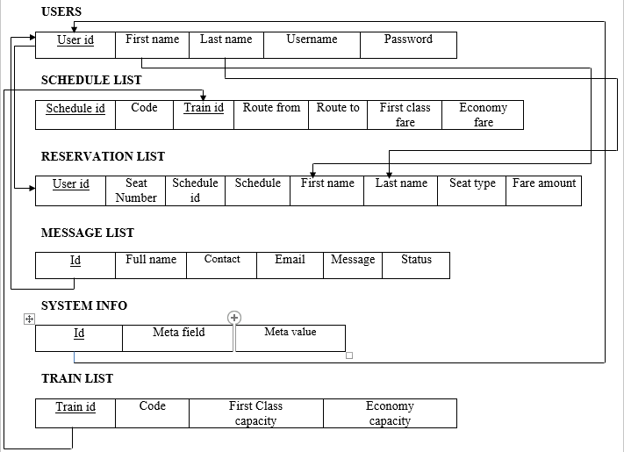

Figure 4.1 Schema Diagram

A database schema is a structure that represents the logical storage of the data in a database. Figure 4.1 which represents the organization of the data and provides information about the relationships. Refer to which shows that the data between the tables in a given database. In this topic, we will understand more about database schema and its types.

### ER DIAGRAM

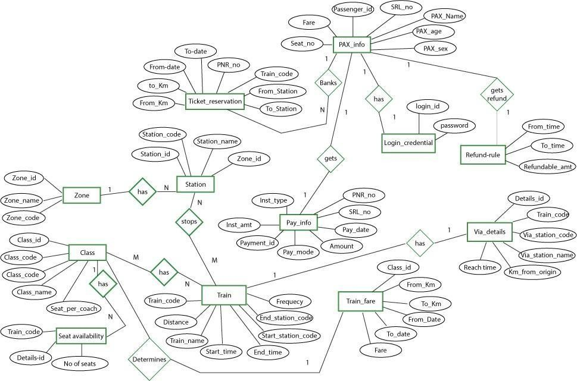

Figure 4.2 ER Diagram

The Railway Management System employs the Entity-Relationship model to depict interrelated elements in its domain. This model comprises entity types and outlines relationships between them. Figure 4.2 illustrates the ER for Railway Management, depicting visual representations of database tables and relationships between components like passenger records, trains, queries, and administrative functions.

### DATA FLOW DIAGRAM

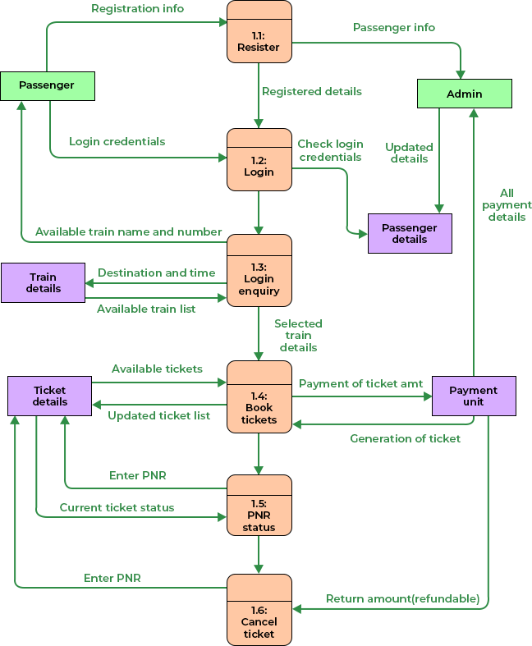

Figure 4.3 Data Flow Diagram

A data flow model is diagrammatic representation of the flow and exchange of information within a system. Data flow models refer Figure 4.3 are used to graphically represent the flow of data in an information system by describing the processes involved in transferring data from input to file storage and reports generation.

CHAPTER 5

**DATA BASE TABLE**

**USER**

|  |  |  |  |  |
| --- | --- | --- | --- | --- |
| **Column** | **Type** | **Attributes** | **Null** | **Default** |
| id | int(30) |  | No | None |
| firstname | text |  | No | None |
| middlename | text |  | No | None |
| lastname | text |  | No | None |
| username | text |  | No | None |
| password | tinyint(1) |  | No | 0 |

Table 5.1 User Table

The Table 5.1 represents the Admin where the admin can login his credentials by giving his username and password to get into the website. The Admin table captures essential admin information, including id, firstname, middlename, lastname, username, and password. This table facilitates secure access to the Railway Management System.

## RESERVATION

|  |  |  |  |  |
| --- | --- | --- | --- | --- |
| **Column** | **Type** | **Attributes** | **Null** | **Default** |
| id | int(30) |  | No | None |
| seat_num | varchar(50) |  | No | None |
| schedule_id | int(30) |  | No | None |
| schedule | datetime |  | No | None |
| firstname | text |  | No | None |
| middlename | text |  | No | None |
| lastname | text |  | No | None |
| seat_type | tinyint(1) |  | No | None |
| fare_amount | float |  | No | None |

Table 5.2 Reservation List Table.

The Table 5.2 represents the details of the employee like id, seat_num, schedule_id, schedule, firstname, middlename, lastname, seat_type and fare_amount.

## SCHEDULE LIST

|  |  |  |  |  |
| --- | --- | --- | --- | --- |
| **Column** | **Type** | **Attributes** | **Null** | **Default** |
| id | int(30) |  | No | None |
| code | varchar(10) |  | No | None |
| train_id | int(30) |  | No | None |
| route_from | text(1) |  | No | None |
| route_to | text(30) |  | No | None |
| date_schedule | date |  | Yes | None |
| time_schedule | time |  | No | None |
| first_class_fare | float |  | No | None |
| economy_fare | float |  | No | None |

Table 5.3 Schedule List Table

The Table 5.4 represents the information about the trains that are available. The Schedule List table stores information on train availability, including id, code, train_id, route_from, route_to, date_schedule, time_schedule, first_class_fare and date economy_fare. It serves as a dynamic record of the schedule_list, updating with each date_schedule and request fulfillment

## TRAIN LIST

|  |  |  |  |  |
| --- | --- | --- | --- | --- |
| **Column** | **Type** | **Attributes** | **Null** | **Default** |
| id | int(30) |  | No | None |
| code | varchar(100) |  | No | None |
| name | text |  | No | None |
| firstclasscapacity | float |  | No | None |
| economycapacity | float |  | No | None |

Table 5.4 Train List Table

The Table 5.4 represents the list of train available. The Train List table contains id, featuring id, code, name details, firstclasscapacity and economycapacity.

## MESSAGE LIST REQUEST

|  |  |  |  |  |
| --- | --- | --- | --- | --- |
| **Column** | **Type** | **Attributes** | **Null** | **Default** |
| id | int(30) |  | No | None |
| fullname | text |  | No | None |
| contact | text |  | No | None |
| email | text |  | No | None |
| message | text |  | No | None |

Table 5.5 Message List request Table

The Table 5.5 TheMessage List table logs messages of passengers. The Message List containing id, fullname, contact, email and message. This table reflects the queries regarding trains etc.

## SYSTEM

|  |  |  |  |  |
| --- | --- | --- | --- | --- |
| **Column** | **Type** | **Attributes** | **Null** | **Default** |
| id | int(30) |  | No | None |
| meta_field | text |  | No | None |
| meta_value | text |  | No | None |

Table 5.5 System Info Table

The Table 5.5 The System Info table logs information of the system. The System Info containing id, meta_field and meta_value.

CHAPTER 6

## IMPLEMENTATION

This section deals with the implementation details of the system designed in the previous section. Implementation is the process of converting design to code. The entities identified from design are to be implemented considering the association between them and how they communicate with each other.

### Prerequisite

The interface for this system has been designed using python and MYSQL has been used for data storage.

PhpMyAdmin can manage a whole MySQL server as well as a single database. To accomplish the later you'll need a properly set up MySQL user who can read/write only the desired database. It's up to you to look up the appropriate part in the MySQL manual.

* Browse and drop databases, tables, views, columns and indexes
* Maintenance server, databases and tables, with proposals on server configuration
* Execute, edit and bookmark any SQL-statement, even batch-queries
* Load text files into tables
* Create1 and read dumps of tables
* Export1 data to various formats: CSV, XML, PDF,ISO/IEC 26300 – Open Document Text and Spreadsheet, Word, and LATEX formats
* You need PHP 5.2.0 or new, with session support, the Standard PHP Library (SPL) extensionand JSON support.

• To support uploading of ZIP files, you need the PHP zip extension.

• For proper support of multibyte strings (eg. UTF-8, which is currently the default).

* You need GD2 support in PHP to display inline thumbnails of JPEGs ("image/jpeg: inline") with their original aspect ratio.
* When using the "cookie" authenticated method, the mcrypt extension is strongly suggested for most users and is required for 64–bit machines. Not using encrypt will cause phpMyAdmin to load pages significantly

## .MODULE DESCRIPTION

In ODJMS project we use PHP and MySQL database. It has two main modules.

* + 1. Admin Module
    2. User Module

### Admin Module

1. Dashboard: An admin dashboard in a railway management system serves as a centralized interface for administrators to monitor, manage, and analyze various aspects of the railway operations.
2. Reservation: In a railway management system, an "admin reservation" typically refers to the process by which administrators or authorized personnel can reserve tickets or accommodations on behalf of passengers. This functionality is crucial for managing bookings, ensuring availability, and addressing special cases or requirements.
3. Inquiry: Admin inquiries in a railway management system typically revolve around various aspects of managing the railway infrastructure, operations, and resources.

### User Module

User can view the website and check out the information about available data, but cannot add a new user.

# RESULTS AND DISCUSSION

The implementation of a comprehensive railway management system has yielded significant improvements across various aspects of rail operations. One of the most notable outcomes has been the enhancement of safety measures. By integrating advanced technologies such as sensors, predictive analytics, and automated control systems, the railway management system has effectively minimized the occurrence of accidents and incidents. Real-time monitoring of tracks, signals, and train movements allows for immediate response to potential risks, thereby ensuring the safety of passengers and employees.

In addition to safety, the railway management system has also brought about considerable improvements in operational efficiency. Through optimized scheduling algorithms and route planning mechanisms, rail operators can maximize the utilization of resources while minimizing delays and congestion. This not only improves the overall punctuality of train services but also enhances the capacity of the rail network to handle increasing passenger demands. Furthermore, the implementation of predictive maintenance algorithms has enabled proactive upkeep of infrastructure and rolling stock, reducing the frequency and duration of service disruptions due to equipment failures.

### Discussion

A railway management system encompasses a complex network of infrastructure, personnel, and technology dedicated to the efficient operation of trains and the safety of passengers and cargo. At its core, effective railway management involves overseeing various aspects such as scheduling, maintenance, safety protocols, and customer service.

This includes regular inspections, repairs, and upgrades to tracks, signals, bridges, tunnels, and trains. Predictive maintenance techniques, leveraging data analytics and sensor technology, can help identify potential issues before they escalate, minimizing downtime and improving service reliability.

CHAPTER 8

**SNAPSHOTS**

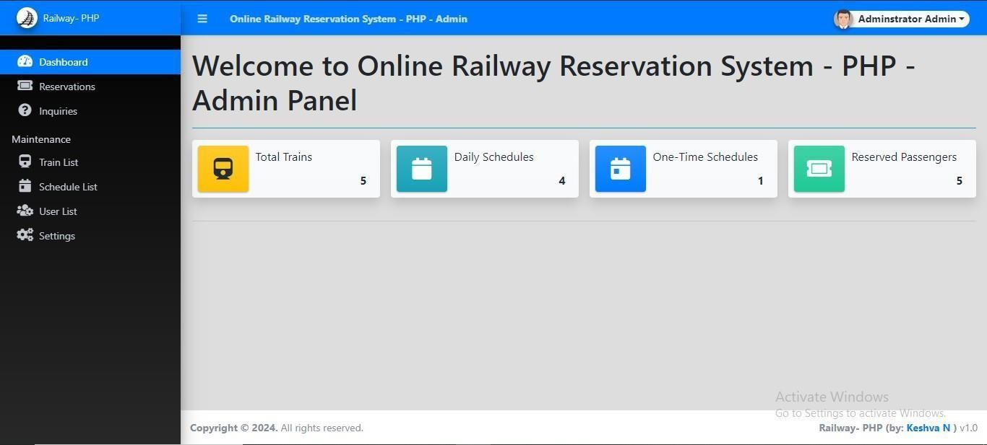**HOME PAGE**

Figure 8.1 Home Page

The Figure 8.1 shows the list of total trains, daily schedules, one-time-schedules and reservation passengers.

## RESERVATION LIST PAGE

. Figure 8.2 Reservation List Page

The Figure 8.2 shows the list of reservations along with passenger’s details.

## TRAIN LIST PAGE

Figure 8.3 Train list Page

The Figure 8.3 shows the list of available trains along with the capacity and fares.

## SCHEDULE LIST PAGE

Figure 8.4 Schedule list Page

The Figure 8.4 shows that user can schedule their train based on their journey by paying appropriate fare.

## USER LIST PAGE

Figure 8.5 User list Page

The Figure 8.5 shows the information about the users.

## INQUIRY PAGE

Figure 8.6 Inquiry Page

The Figure 8.6 shows that the passengers can enquire about train.

## CONCLUSION AND FUTURE ENHANCEMENT

**CONCLUSION**

The implementation of an efficient railway management system is crucial for ensuring the smooth operation and safety of railway networks. Through the integration of advanced technologies and streamlined processes, such a system aims to optimize various aspects of railway operations, including scheduling, maintenance, ticketing, and passenger safety.

One of the primary benefits of a well-designed railway management system is enhanced operational efficiency. By utilizing real-time data analytics and predictive modeling, rail operators can better anticipate demand patterns, optimize train schedules, and allocate resources effectively. This not only improves the overall punctuality and reliability of train services but also minimizes operational costs and maximizes revenue generation.

Moreover, a robust railway management system plays a vital role in ensuring passenger safety and security. By implementing state-of-the-art surveillance systems, automated signaling systems, and emergency response protocols, rail authorities can mitigate the risks associated with accidents, trespassing, and other safety hazards. Additionally, the integration of passenger information systems enables timely communication of relevant updates and alerts to passengers, enhancing their overall travel experience.

Furthermore, the adoption of a comprehensive railway management system facilitates better asset management and maintenance practices. Through remote monitoring and condition-based maintenance techniques, operators can proactively identify and address potential issues before they escalate into costly disruptions. This proactive approach not only extends the lifespan of railway infrastructure and rolling stock but also minimizes downtime and improves overall service reliability.

### GOALS ACHIVIED

* Efficient Operations.
* Enhanced Safety.
* Improved Customer Experience.
* Resource Optimization.
* Financial Management.
* Environmental Sustainability.
* Regulatory Compliance.

### FUTURE ENHANCEMENT

In the realm of railway management systems, the future holds exciting prospects for enhancing efficiency, safety, and passenger experience. One significant advancement lies in the integration of artificial intelligence (AI) and machine learning algorithms into the existing infrastructure. These technologies enable predictive maintenance, where sensors embedded in railway components collect real-time data on wear and tear. AI algorithms analyze this data to forecast potential failures, allowing maintenance crews to address issues proactively, minimizing downtime and improving overall safety.

Moreover, the implementation of Internet of Things (IoT) devices further refines railway management systems. IoT sensors placed along the tracks monitor various parameters such as temperature, humidity, and track conditions. Another area of advancement is the utilization of big data analytics to optimize scheduling and resource allocation. By analyzing vast amounts of historical data on passenger flows, train schedules, and infrastructure usage, railway operators can fine-tune schedules to minimize congestion and delays. Advanced analytics also facilitate dynamic pricing strategies, allowing operators to adjust fares based on demand, maximizing revenue while ensuring affordability for passengers.

## REFERENCES

1. "Railway Management and Engineering: Techniques, Practices, and Challenges" by Chengming Li, Chris Risbey, and Jiaqiang E.
2. "Railway Management System: A Case Study of Indian Railways" by R. Srinivasan and

P. Satyanarayana. The Accidental Systems Librarian" by Rachel Singer Gordon.

1. Black book - Wiley Dreamtech
2. SQL Server-2000 - Dusan Petkovic
3. Microsoft SQL Server-2000 - Rankin,Paul & Jensen
4. [www.w3schools.com/ph](http://www.w3schools.com/ph)p
5. [www.w3schools.com/mysql](http://www.w3schools.com/mysql)
6. [www.greeksforgreeks.com](http://www.greeksforgreeks.com/)