**Assignment 4**

**Name: Sowmya Patlolla**

Step 1: Go to the Google Cloud Console and activate the cloud shell by clicking on the following icon. After clicking on it a pop-up appears asking to authorize the cloud shell then click on authorize.

Testing the hostname and Date. Executing the “gcloud auth list” command to find out the active existing user. Configuring the project by running the “gcloud config list project” command.

Step 2: Creating the bucket named 16338256sowmyapatlolla.



Output: Bucket was created.

Step 3:

Downloading the object to the bucket from the public location.

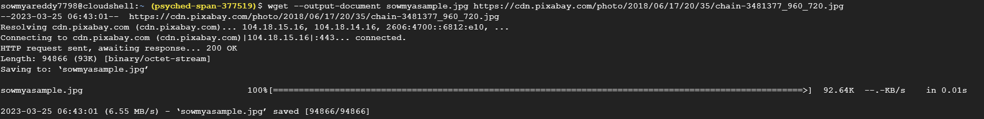

Step 4: Copying the object to the bucket folder.

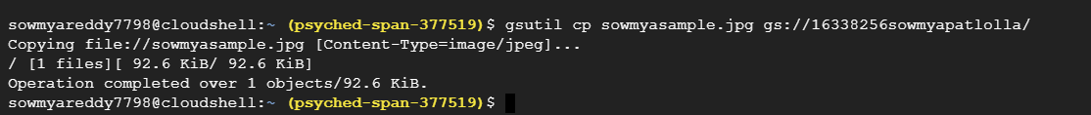

OUTPUT:

Step 5: Removing the local object using the rm command.



Step 6: Copying the object to the bucket main folder.



Step 7: Copy obj to the new folder from the bucket main folder.



OUTPUT:

Step 8: Listing the contents of the folder using the ‘ls’ command.



Step 9: Listing the contents of the folder with the details using command ‘ls -l’.



Step 10: Making the object publicly accessible, using the acl command.



Step 11: (output of the step10)

url: https://storage.googleapis.com/16338256sowmyapatlolla/sowmyasample.jpg

Step 12: Composing two objects’ data into the single one using the compose command.



OUTPUT:

Listing the details of the contents.

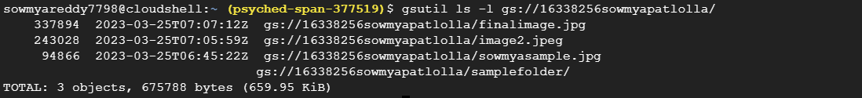

Step 13:

Removing public access and making the object private.



Step 14: Delete the object from the bucket.



We can see from the following output that no file with name sowmyasample.jpg

Step 15: Deleting the bucket by using the following command.



OUTPUT:

There is no bucket named **16338256sowmyapatlolla**

Step 16:

**Epilog:**

**Challenging part:**

* We won't be able to finish the process if we don't have the required permissions to create a bucket. Make sure that our Google Cloud Platform account has the proper roles allocated.
* In case our preferred name has already been taken, we may need to come up with another name since bucket names must be distinct across all Google Cloud Platform accounts.
* We will need to decide which region and storage class we want to use for our bucket because this can be challenging if we're not familiar with the different options available and the implications of choosing one over the other.
* We will also carefully consider the cost implications of creating a bucket and manage its lifecycle to avoid unnecessary costs.

**Fun Part:**

We may configure permissions after creating our bucket to limit who can access it and what they can do with it. As we get to choose who has access to our bucket and to what extent, this may be a fun security exercise.

**1. AWS Extra Credit:**

Step 1: Open the AWS cloud console, then click on the terminal icon to activate the shell.



Step 2: Creating the bucket in AWS shell using the below command.

Result:

Bucket got created

Step 3: Downloading the publicly available object into the bucket.

Step 4: Copying the object from the cloud shell environment to bucket.

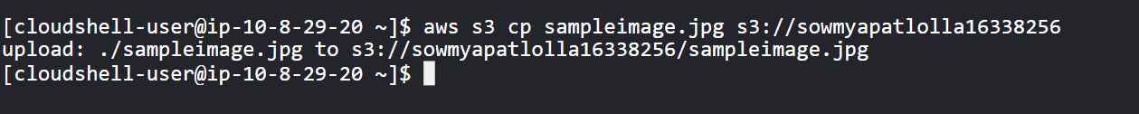

Result:

Step 5: Remove the object from the local environment.



Step 6: Copy the image in the bucket with the other name in the same location.



Step 7: Copying the image to the newly created folder.



Result:

Step 8: List the contents of the bucket created.

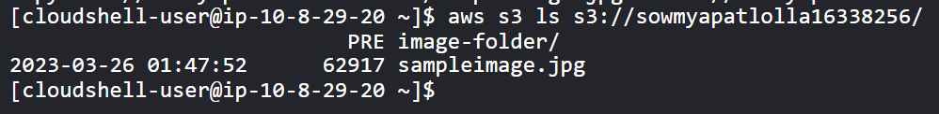

Step 9: Listing the details.

Step 10: Making the storage object publicly accessible with the following command.



Step 11:

url: https://sowmyapatlolla16338256.s3.amazonaws.com/sampleimage.jpg

Step 12: Now, again make the object as private using the –acl private flag.



Step 13: Removing the file from the bucket.



Result:

No File named sampleimage.jpg exists.

Step 14: Removing the bucket and non-empty bucket using the –-force flag.

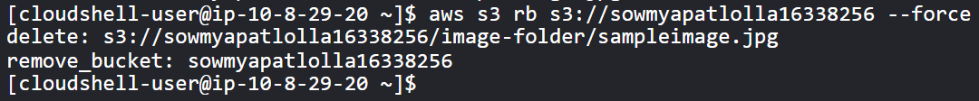

Bucket got removed from the cloud

**Extra Credit 2: Setting, adding and retrieving the metadata in GCP.**

Step 1: Setting the metadata to an object in GCP.



Step 2: Adding the metadata to an object in GCP using the below command.



Step 3: Retrieving the metadata of an object in google cloud platform using the following command.

