**Assignment -1**

**Name: Sowmya Patlolla**

**1. Plotting graphs on College.csv datasets.**

**I. Scatter Plot:**

**Syntax:** Clg <- read_csv("C:/Users/sowmy/Downloads/Data Lab 2/Data Lab 2/College.csv")

View (Clg)

plot (Clg$P.Undergrad, col="92")

**II. Histogram**

**Syntax:** Clg <- read_csv("C:/Users/sowmy/Downloads/Data Lab 2/Data Lab 2/College.csv")

hist (Clg$Grad.Rate, xlab = "Grad Rate",

col.lab = "darkgreen", col ="26")

**III. Scatter Plot with lines**

**Syntax:** Clg <- read_csv("C:/Users/sowmy/Downloads/Data Lab 2/Data Lab 2/College.csv")

plot (Clg$Apps, col = "pink", main = "Apps Vs Accept")

lines (Clg$Accept, col ="blue")

**2. Plotting graphs on Credit.csv datasets.**

**I. Sunflowerplot:**

**Syntax:** C<- read_csv("C:/Users/sowmy/Downloads/Data Lab 2/Data Lab 2/Credit.csv")

View(C)

sunflowerplot(C$Income,col="red")

**II. Plot with lines:**

**Syntax:** C<- read_csv("C:/Users/sowmy/Downloads/Data Lab 2/Data Lab 2/Credit.csv")

plot (C$Balance,type ="l",col="purple")

**III. Histogram:**

**Syntax:** C<- read_csv("C:/Users/sowmy/Downloads/Data Lab 2/Data Lab 2/Credit.csv")

hist (C$Education,border = "blue",density=20,col = "pink", breaks = 30)

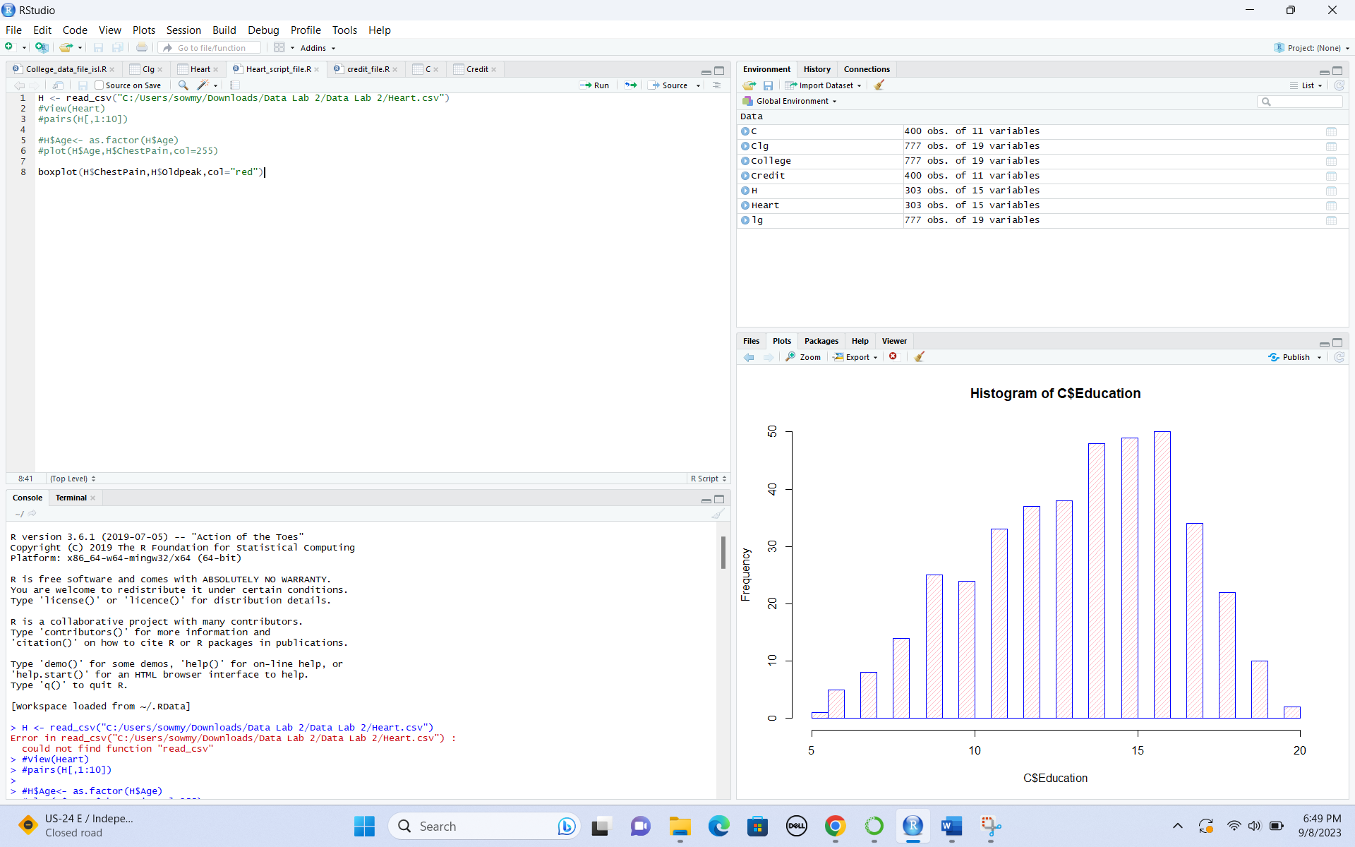

**3. Plotting graphs on BrainCancer.csv datasets.**

**I. Simple Scatterplot**

**Syntax:** BC <- read_csv("C:/Users/sowmy/Downloads/Data Lab 2/Data Lab 2/BrainCancer.csv")

View (BC)

attach (BC)

plot(ki,gtv)

plot(ki,gtv,col="purple")

**II. Sunflowerplot:**

**Syntax:** BC <- read_csv("C:/Users/sowmy/Downloads/Data Lab 2/Data Lab 2/BrainCancer.csv")

sex = as.factor(sex)

plot(sex,ki)

sunflowerplot(sex,ki)

**III. Pairs (matrix of scatter plot):**

**Syntax**: BC <- read_csv("C:/Users/sowmy/Downloads/Data Lab 2/Data Lab 2/BrainCancer.csv")

sex = as.factor(sex)

pairs(~sex+ki)

pairs(~sex+ki+gtv)

pairs(~sex+ki+gtv+status)

pairs(~sex+ki+gtv+status+time)

