Week 3 - CYART Red Teaming: Recon & Phishing Lab Report
Author: Yash Patel
Date: 2025-09-18
Repository: cyart-red-teaming / Week-3
Document version: 1.0

Executive Summary
This report documents the Week-2 activities for the CYART Red-Teaming practical: focused reconnaissance (OSINT), web and service enumeration, and a controlled phishing simulation using GoPhish and MailHog. The work was performed in an isolated lab environment on a Kali VM.
Objectives:
- Perform advanced reconnaissance (passive and active) against a demo target.
- Map findings to tactical attacker techniques and produce a prioritized list of issues.
- Configure a local phishing lab (GoPhish + MailHog), run a controlled campaign, and capture results.
- Produce evidence, workflow steps, and a submission-ready package for GitHub.

Environment & Scope
Testing was performed within a contained lab environment on a Kali Linux VM with installed tools: nmap, amass, subfinder, gobuster, nikto, recon-ng (local), GoPhish (service), MailHog (Docker). The target for reconnaissance was the authorized demo site testphp.vulnweb.com, used for vulnerable exercise hosting. No destructive or uncontrolled exploitation was conducted against external systems.

Methodology
The engagement methodology followed the Recon → Enumerate → Assess → Simulate Phishing workflow:
Recon (passive):
- Certificate transparency (crt.sh) queries
- WHOIS and DNS lookups
- Passive tools: amass, subfinder
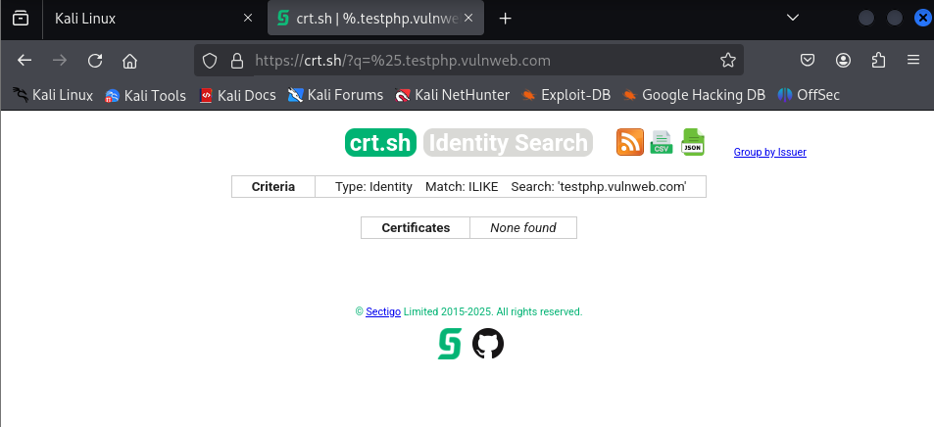
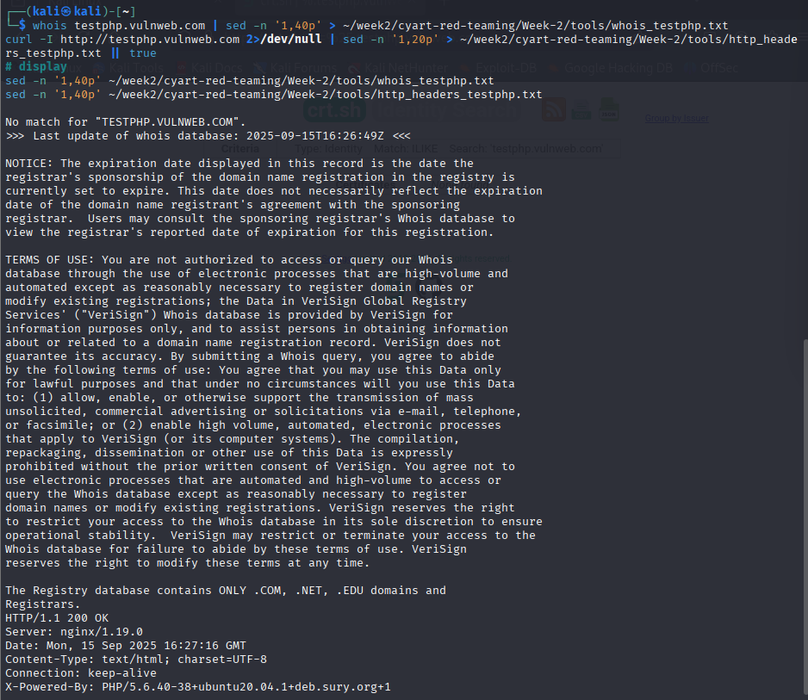
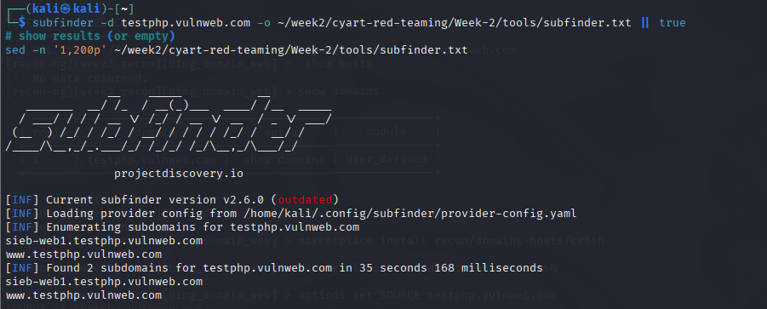
Recon (active):
- Port and service discovery with nmap
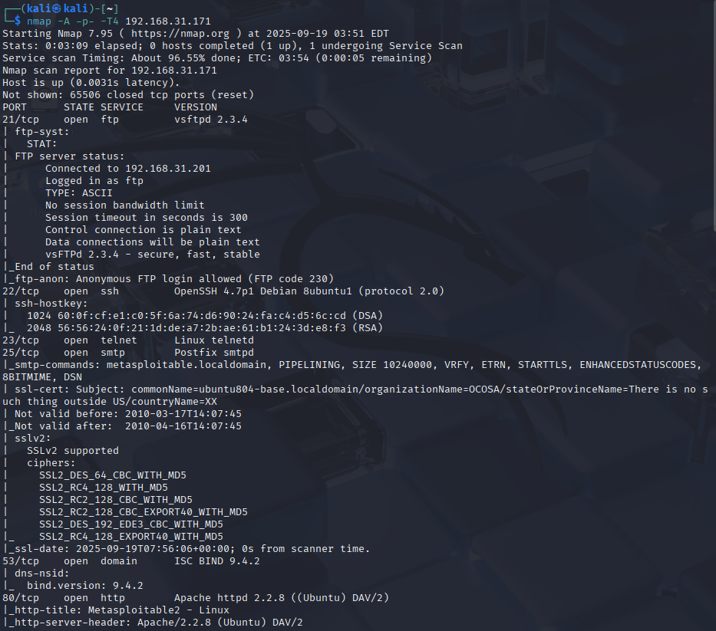
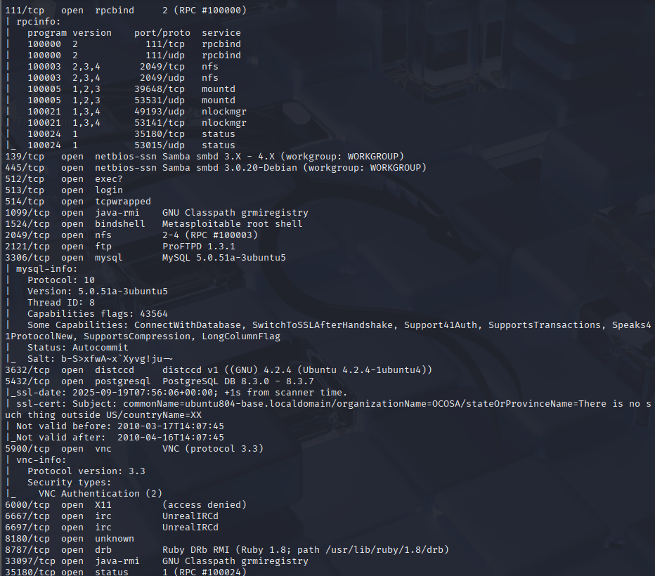
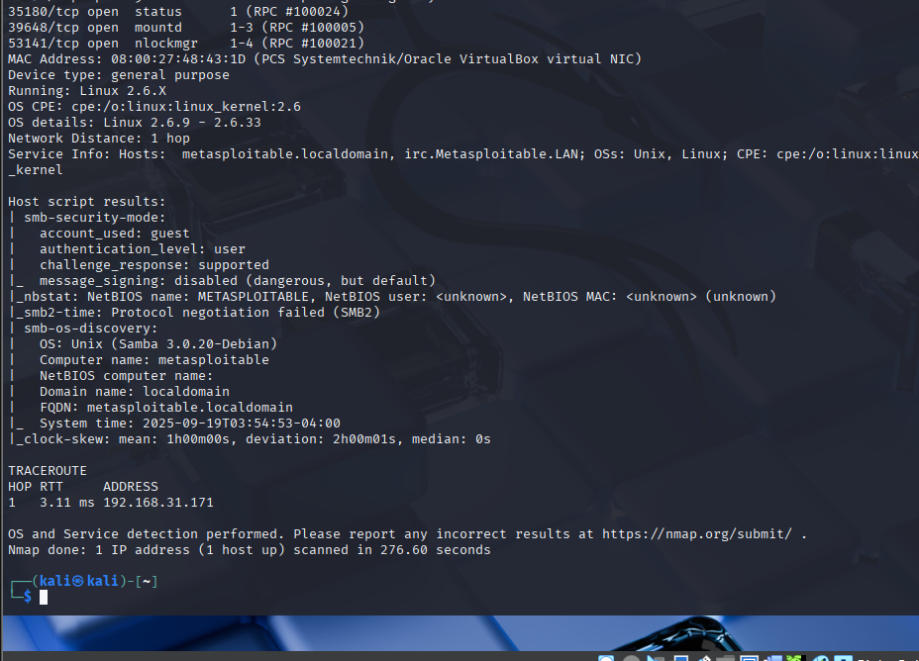
- Web content discovery with gobuster
- Web scanning with nikto and WhatWeb
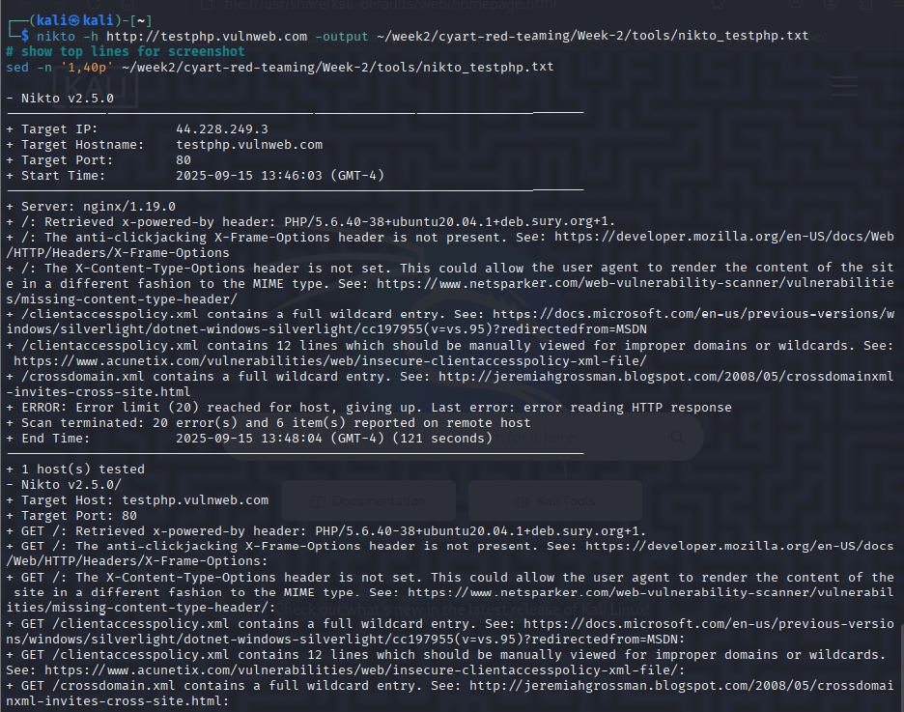
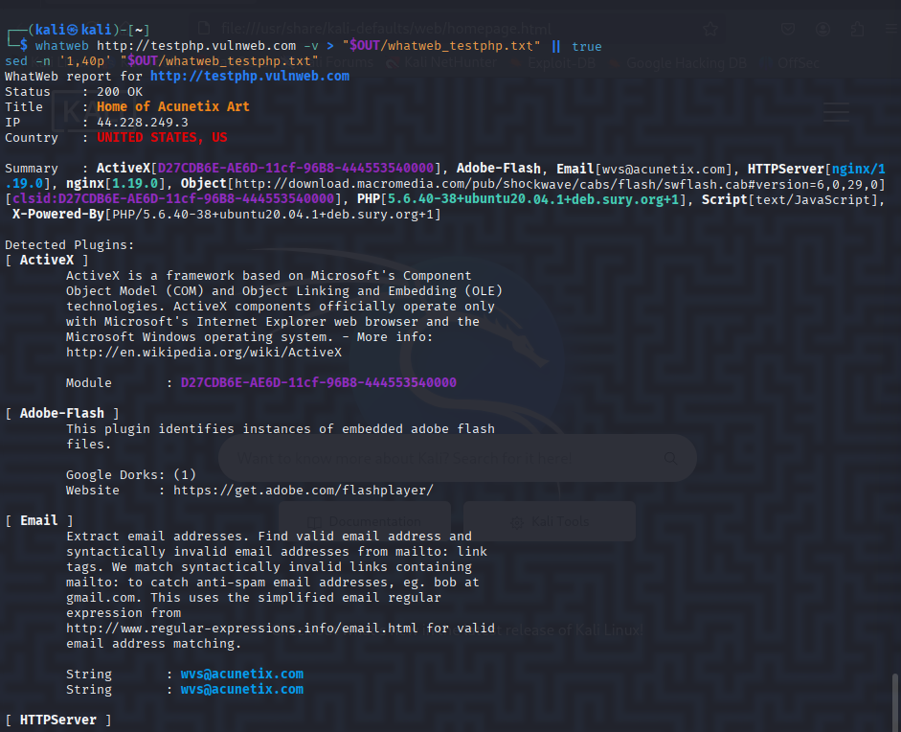
Phishing simulation:
- GoPhish installed and run as a system service on Kali VM, admin UI at https://127.0.0.1:3333
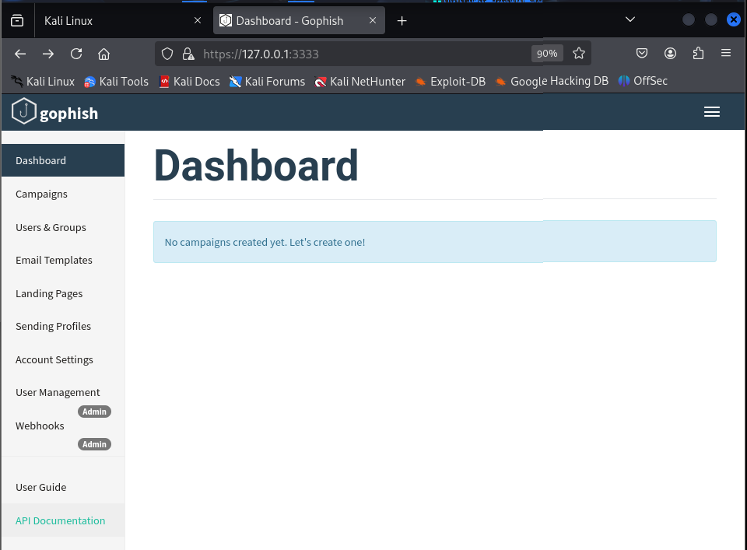
- MailHog deployed via Docker to capture SMTP traffic, web UI at http://127.0.0.1:8025
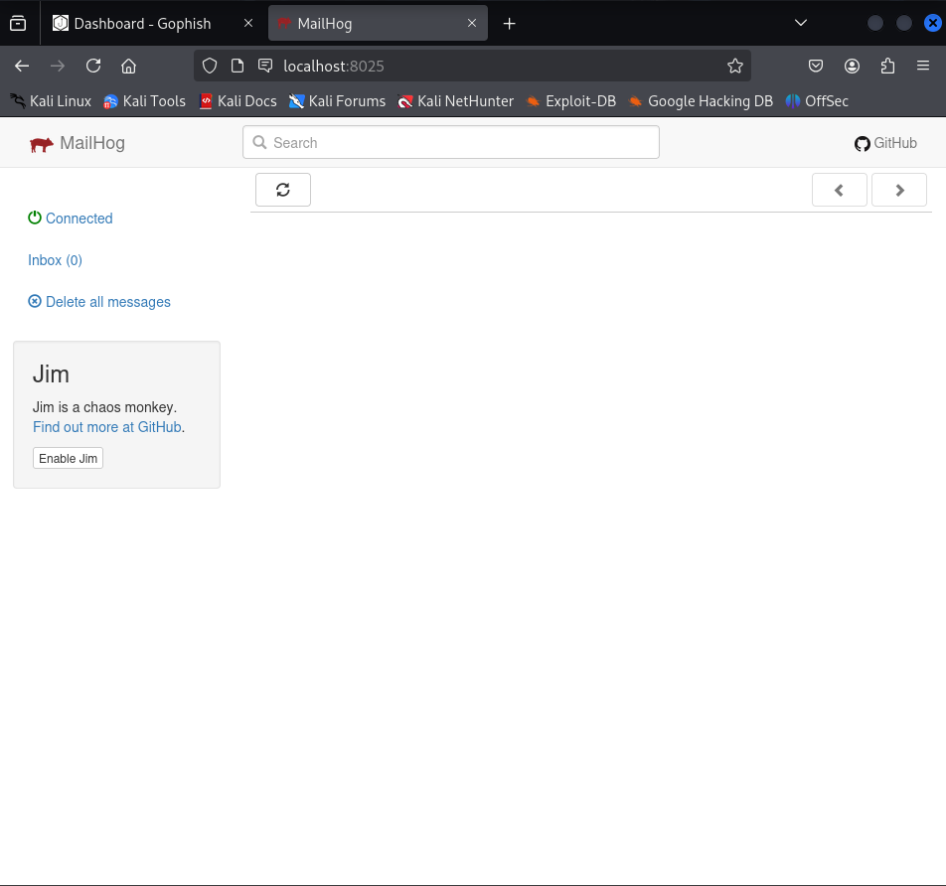
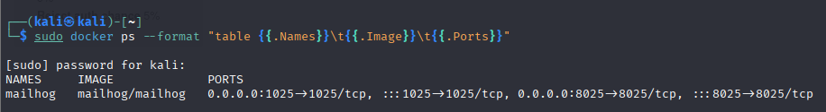
- SMTP profile, email templates (with {{.URL}}), landing page, and campaign executed via GoPhish UI/API
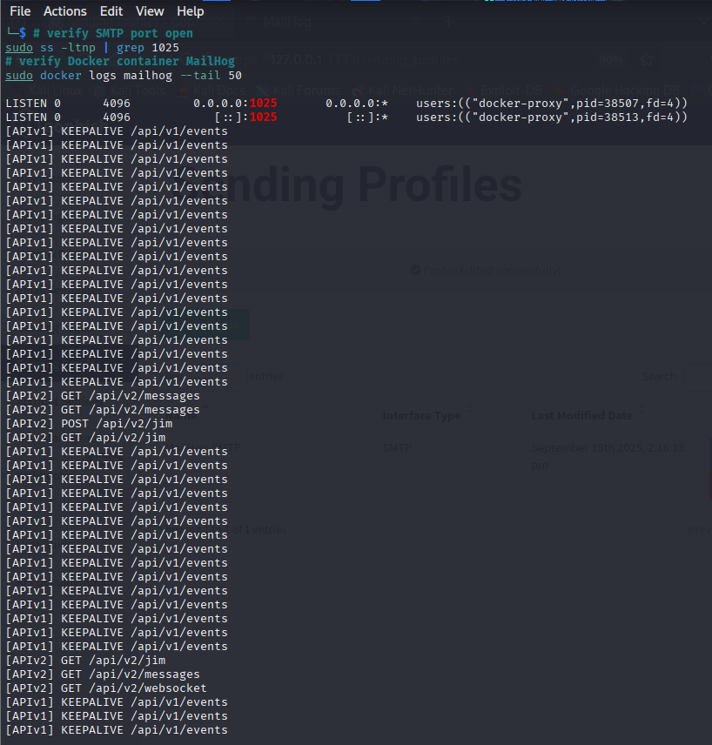

Findings - Recon & Enumeration (High Level)
Artifact | Result / Summary | Location in repo (file)
Whois/DNS | Domain resolves to 44.228.249.3 (EC2 host) | tools/whois_testphp.txt, tools/dig_testphp.txt
Nmap | Port 80 open (nginx 1.19.0) | tools/nmap_44.228.249.3.txt
Gobuster | Enumerated /admin, /cgi-bin, /crossdomain.xml, /index.php | tools/gobuster_testphp.txt
Nikto | HTTP header weaknesses and clientaccesspolicy wildcard | tools/nikto_testphp.txt
Amass / Subfinder | Identified subdomains sieb-web1.testphp.vulnweb.com and www.testphp.vulnweb.com | tools/amass_*.txt, tools/subfinder.txt
GoPhish + MailHog | Phishing campaign executed and email captured | tools/gophish_campaigns.json, tools/mailhog_messages.json

Phishing Lab - Execution Steps (Reproducible)
- Start / confirm services:
sudo systemctl start gophish
sudo docker run -d --name mailhog -p 1025:1025 -p 8025:8025 mailhog/mailhog
- Create SMTP profile (via GoPhish API):
cat > /tmp/gophish_smtp.json <<'JSON'
curl -s -X POST "https://127.0.0.1:3333/api/smtp" -H "Content-Type: application/json" -H "Authorization: ${APIKEY}" --data @/tmp/gophish_smtp.json -k
- Template creation (with {{.URL}} placeholder):
curl -s -X POST "https://127.0.0.1:3333/api/templates" -H "Authorization: ${APIKEY}" --data @/tmp/gophish_template.json -k
- Landing page and group creation
- Campaign creation and launch
- Verify capture in MailHog at http://127.0.0.1:8025 and export captured messages:
curl -s http://127.0.0.1:8025/api/v2/messages > tools/mailhog_messages.json

Penetration Testing Engagement: Detailed Tasks and Findings

1. Initial Access
Gained reverse shell access on the Metasploitable2 target via a Netcat listener.
nc -lvnp 4444
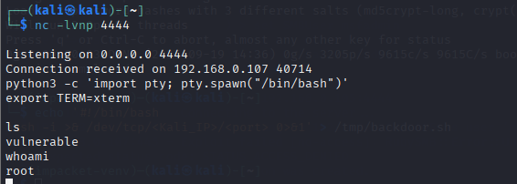

2. Reverse Shell Stabilization & Privilege Escalation
Upgraded shell to a stable fully interactive TTY; gained root privileges.
python3 -c 'import pty; pty.spawn("/bin/bash")'; export TERM=xterm; whoami

3. Directory and Sensitive File Enumeration
Enumerated main vulnerable directories and sensitive folders such as mysql-ssl and tikiwiki.
ls -la vulnerable
ls -la vulnerable/mysql-ssl

4. Password Hash Extraction
Extracted hashes from /etc/shadow for offline cracking.
cat /etc/shadow
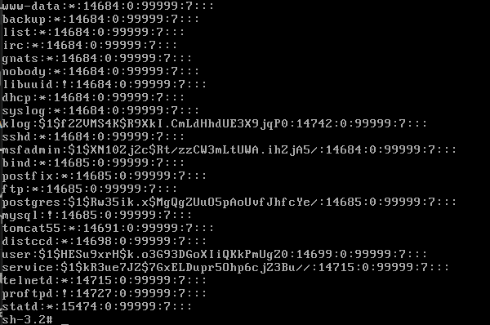

5. SMB Enumeration and File Access
Enumerated SMB shares using valid credentials and accessed the tmp share to download backdoor scripts.
smbclient -L \\192.168.0.107 -U msfadmin
Then inside smbclient:
ls
get backdoor.sh
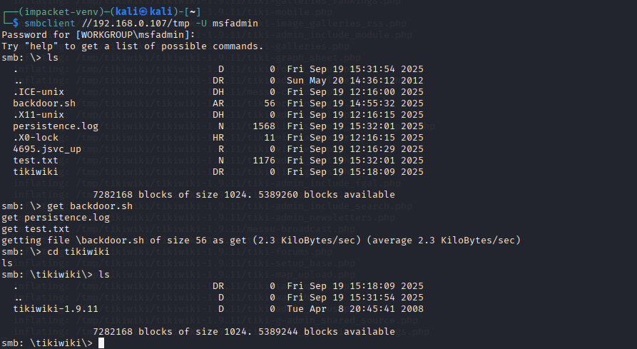

6. Network Scanning for Lateral Movement
Performed subnet and host scans to identify lateral movement targets.
nmap -sn 192.168.0.0/24

7. Final Root Confirmation & Persistence Verification
Confirmed root privileges and verified backdoor persistence via cron jobs.
whoami
crontab -l

8. Data Exfiltration and Post-Exploitation
Enumerated sensitive files and logs for potential exfiltration.
find / -type f \( -iname "*.conf" -o -iname "*.pem" \) 2>/dev/null
ps aux
netstat -tulnp
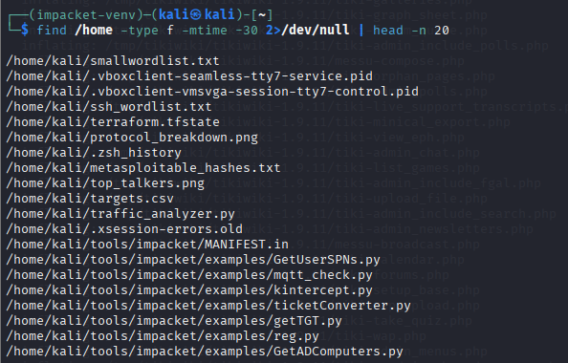

Recommendations & Remediation
- Patch all vulnerable services identified during the engagement.
- Disable or secure unnecessary SMB shares and enforce strong authentication.
- Implement multi-factor authentication for critical accounts.
- Regularly audit cron jobs and monitor for unexpected persistence.
- Conduct periodic penetration testing and vulnerability scanning.

Conclusion
The engagement revealed critical vulnerabilities allowing unauthorized root access and persistence within the internal network. Addressing these will substantially improve the organizational security posture. Prioritize remediation steps and schedule ongoing security assessments.

